Weekly Reporting

WBS 1.01.07 JLAB Management

Week of November 22-28, 2018

**Issues:**

Continued with responses to feedback in from reviews held the previous week.

Developed list of documents required to support shipment of J4. Reviewed with project. Shipment of J4 to SLAC delayed at project’s direction.

**Upcoming Reviews:**

Dec 4 & 5 CP Commissioning Workshop

Dec 13 CM Shipping Review

Jan/Feb 2018 DOE OPA Mini Review

Weekly Reporting

WBS 1.04.06 JLAB Cryomodules

Week of November 22-28, 2018

**Issues**:

1. High performing cavities for CMs may be late due to potential schedule delays due to Zanon furnace issues.
2. Current workload at JLab is being dominated by unplanned work compared with baseline. Re-assembly of J8 & J10 after HV bellows inspections is on-going. This will negatively impact cost and schedule performance indices going forward.

**Accomplishments this week:**

J4 shipment preparations continue. Shipment delayed at SLAC’s direction until Mid-December.

F5 is at SLAC and awaiting handling activities to commence. JLab staff will travel to SLAC to help with removal of accelerometers, restraints and shipping caps for return to FNAL.

Met to discuss release of J-04 for shipping and reviewed data analysis from shipping, design documents and installation/removal procedures.

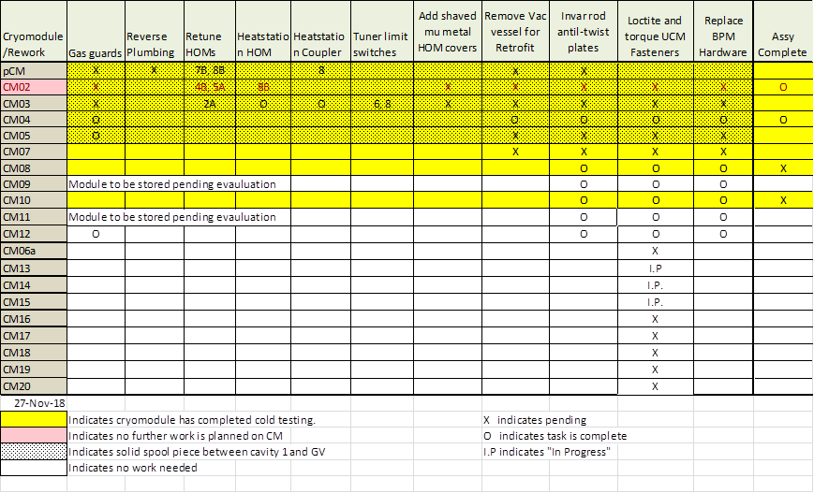

Two CMs (J-02, J-04) are completed and ready for shipment.

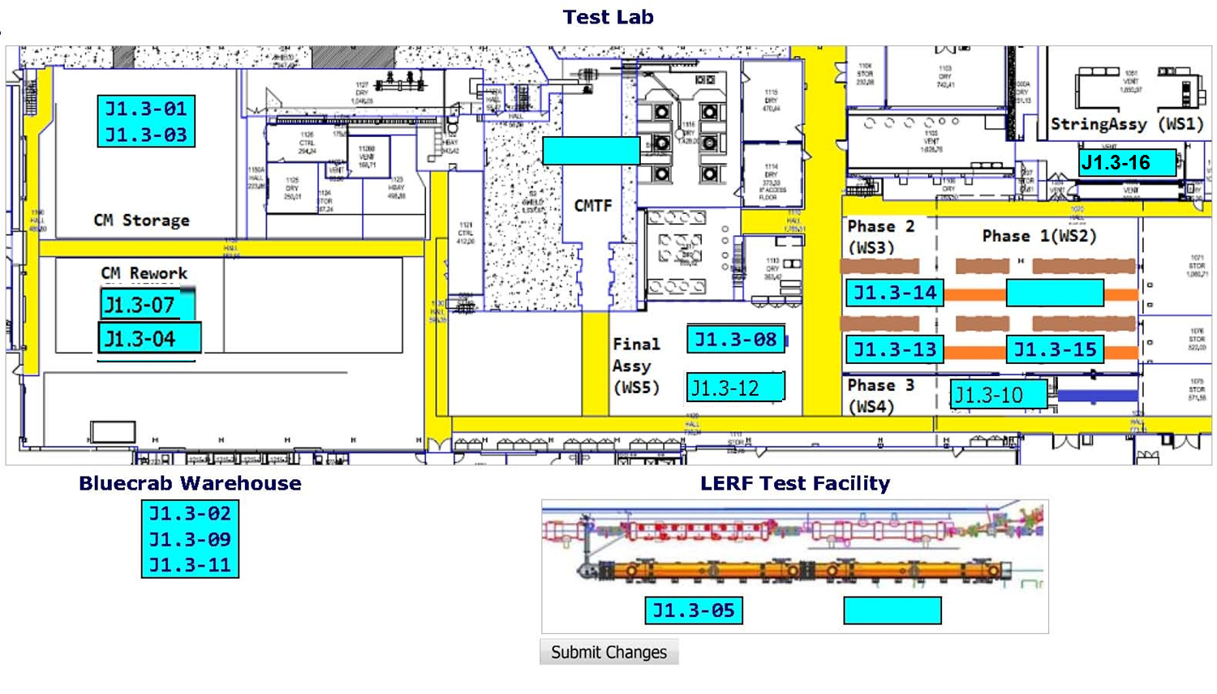

**QUALITY:**

* Document package assembly and review for installed Transfer Line, Cryo Can and additional added piping in the LERF for LCLS Cryomodule testing.
* LCLS-II QA team met via gotomeeting to discuss next steps. Tentative plan is to release the results of the partner Lab visits before the December 13 Shipping Review, and conduct/release results of a SLAC review before the DOE review at the beginning of February.

**Upcoming Travel/Meetings:**

* J4 Shipping Receipt at SLAC – TBC in mid December

Weekly Reporting

WBS 1.04.06 Cryomodules - LERF Conversion

Week of November 22-28, 2018

**Issues:** None

**Accomplishments this week:**

The leak checking of transferline and cryocan is progressing well. The last line is the 2K return to be pressure tested and leak checked

The instrumentation is being connected in the can.

Put recommendations from readiness review into tracking list, assigned responsibilities and set due dates.

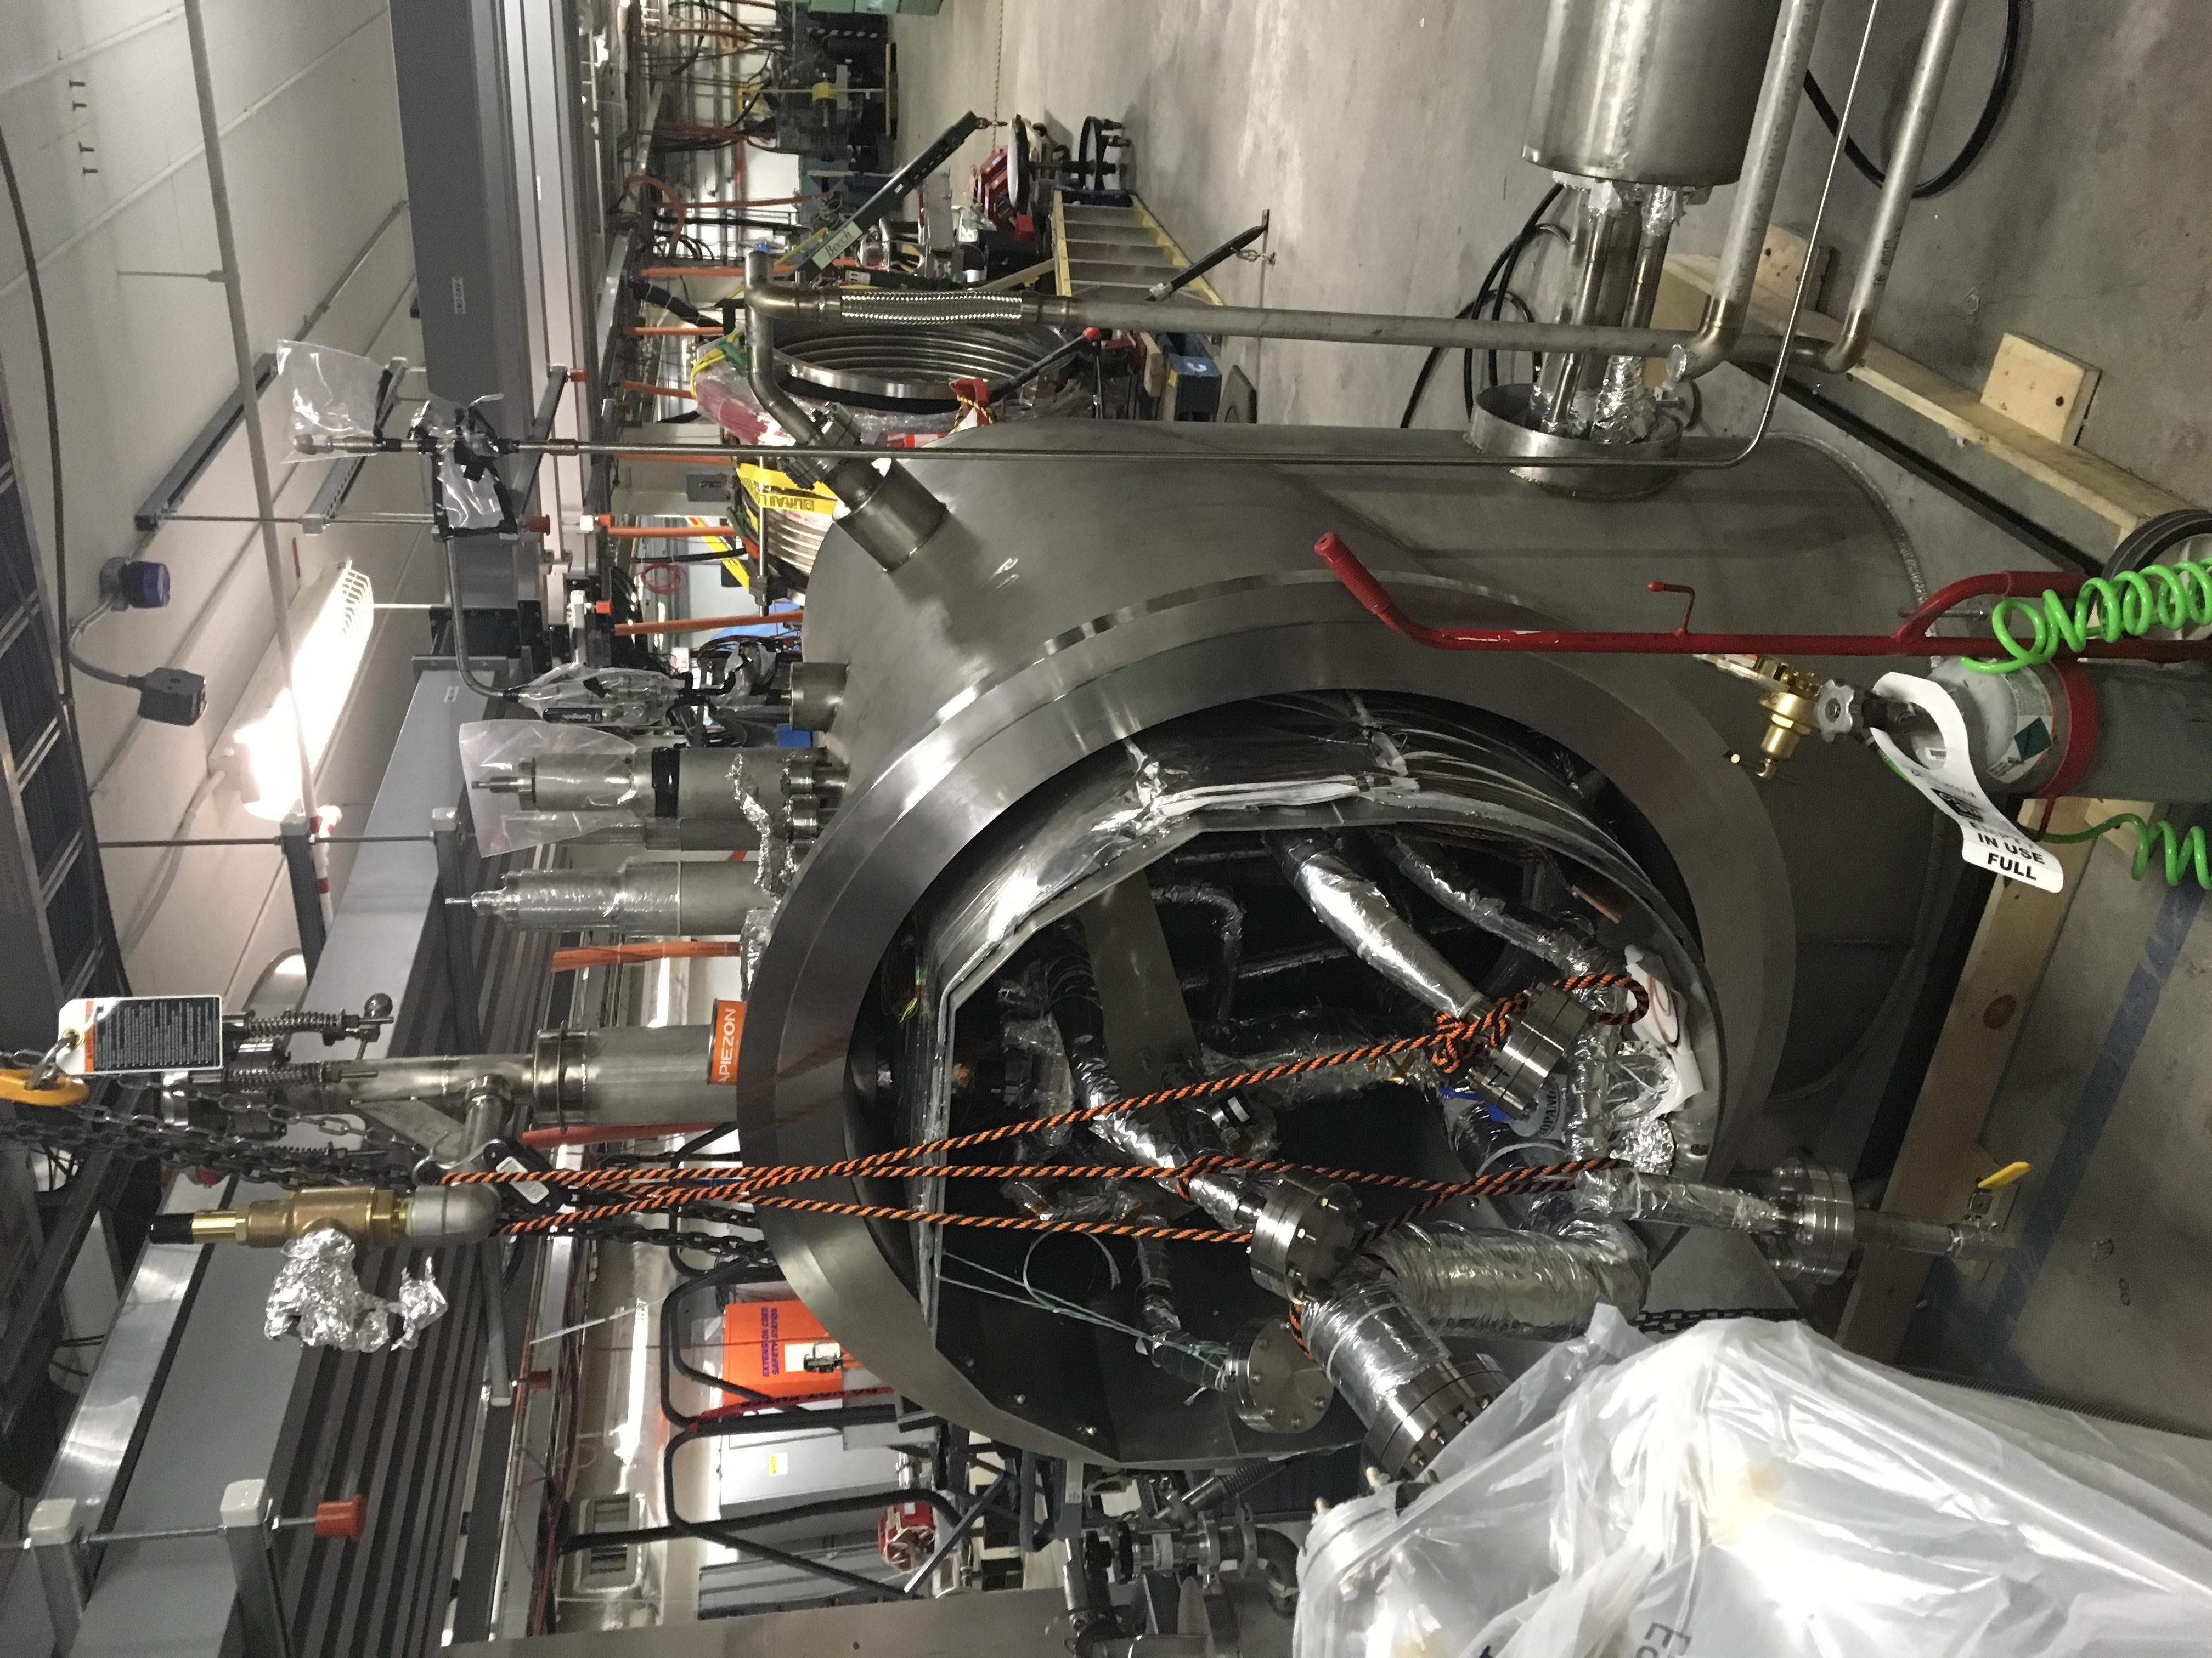

Weekly Reporting

WBS 1.04.08 JLAB Cryoplant System

Week of November 22-28, 2018

**Issues:**

1. Reduction in baseline resources (Return funding to contingency; the top-down EAC) without corresponding reduction in scope of cryoplant commissioning.
2. Resolution of structural interferences created during the design of the cold box room platforms and cable trays support systems (*identified in Nov 2017*).
3. Engineering change request associated with the interface box design-build subcontract resulting in increased cost and schedule delay.

**Accomplishments this week:**



**Recent Accomplishments**

**Software Development Review – Complete**

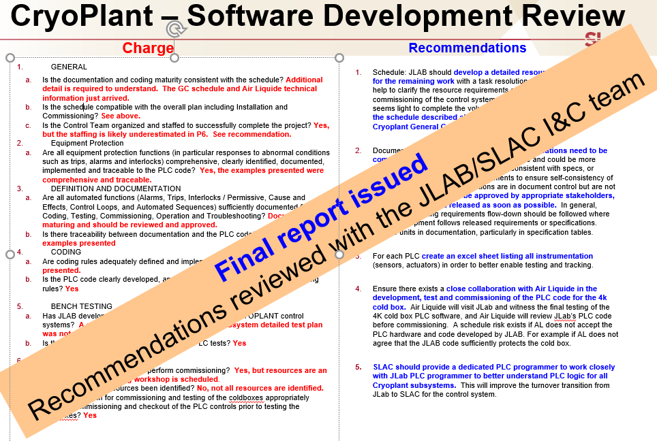

**Strong response to OPA recommendations to return funding to contingency.**

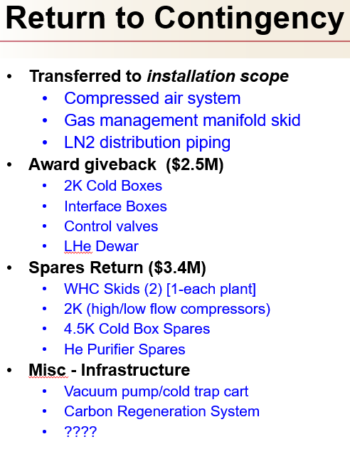

**Quality:**

* Successfully completed a formal review of the cryoplant software development.
* Successfully completed a final design review of the interface boxes.
* A comprehensive risk mitigation plan was developed and distributed to address the potential contamination associated with the oil removal vessels.
* Began reviewing acceptance welding documentation and inspection results for the first LN2 Dewar from AES for CryoPlant.

**Upcoming Travel/Deliveries/Reviews:**

* Monthly 4.5K Cold box status and update 29-Nov-2018
* CryoPlant Commissioning Workshop @JLab 4&5-Dec-2018
* LN2 Dewar witness of leak-check final acceptance 06-Dec-2018
* Helium purifier – Factory Acceptance Test 11-Dec-2018