Weekly Reporting

WBS 1.01.07 JLAB Management

Week of December 6-12, 2018

**Issues:**

STL and Lab Director visited 4.5K Cold Box Fabricator

Updated monthly ETC and responding to project questions

Shipped CM J1.3-04 to SLAC.

**Upcoming Reviews:**

Dec 13 CM Shipping Review

Jan/Feb 2018 DOE OPA Mini Review

Weekly Reporting

WBS 1.04.06 JLAB Cryomodules

Week of December 6-12, 2018

**Issues**:

1. High performing cavities for CMs are late due to potential schedule delays due to Zanon furnace issues.
2. Current workload at JLab is being dominated by unplanned work compared with baseline. Re-assembly of J8 & J10 after HV bellows inspections is ongoing. This will negatively impact cost and schedule performance indices going forward.

**Accomplishments this week:**

J4 shipped to SLAC departing Sunday 9-DEC with M-mounts installed.

F5 is at SLAC and awaiting handling activities to commence. JLab staff has traveled to SLAC arriving 12-DEC to help with removal of accelerometers, restraints and shipping caps for return to FNAL. This will likely be coordinated with J4 work at SLAC.

Completed FMEA of Berry Bolts and submitted to SLAC QA lead.

J-16 verified leak tight in clean room as of 10-DEC. Will roll-out after WS2 is cleared of J-15.

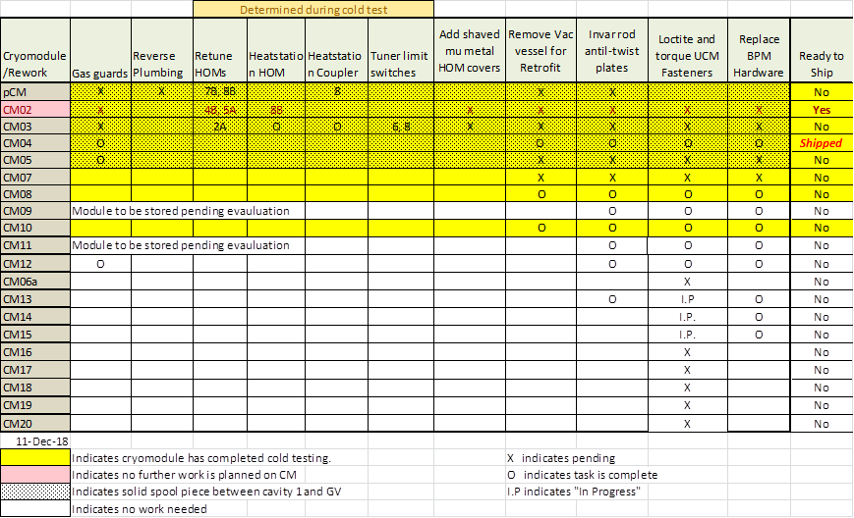

Two CMs (J-02, J-04) are completed.

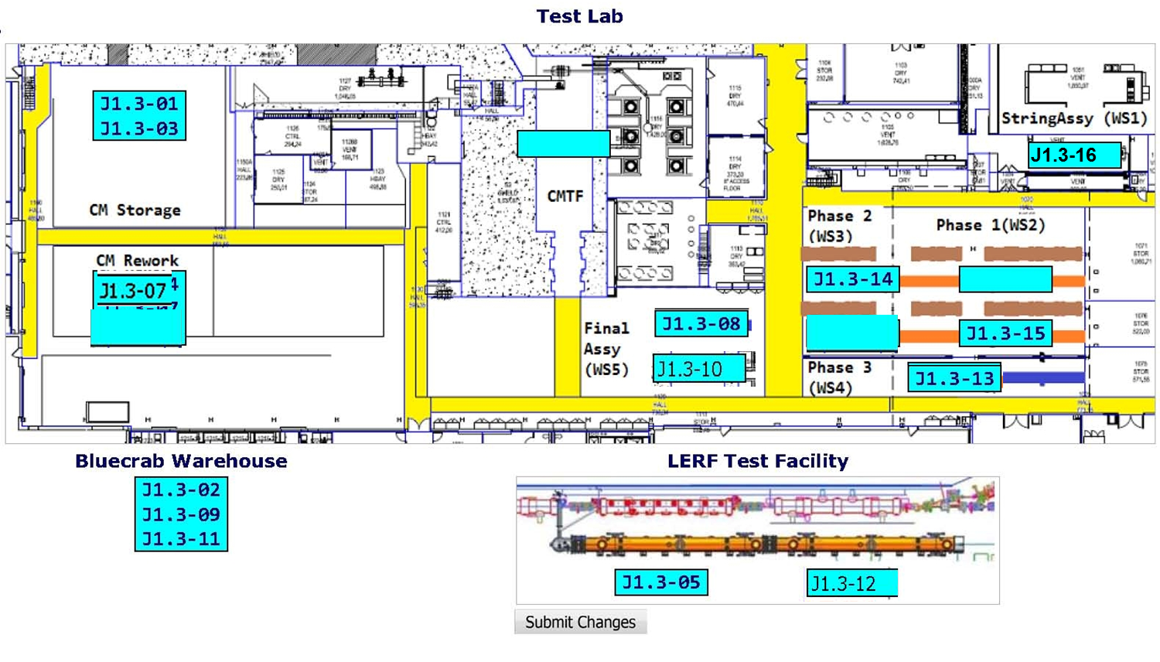

**QUALITY:**

* Inspections and pressure testing on LCLS LERF fast cool down and guard vacuum piping modifications required by Cryo.

**Upcoming Travel/Meetings:**

* J4 Shipping Receipt at SLAC – December 13 (Huque, Martin, King)
* Support M-mount installation on F-4 at FNAL (Legg)

Weekly Reporting

WBS 1.04.06 Cryomodules - LERF Conversion

Week of December 6-12, 2018

**Issues:** None

**Accomplishments this week:**

CM # 12 is in the LERF vault and being hooked up. The clean beamline connection is complete and LEAK TIGHT.

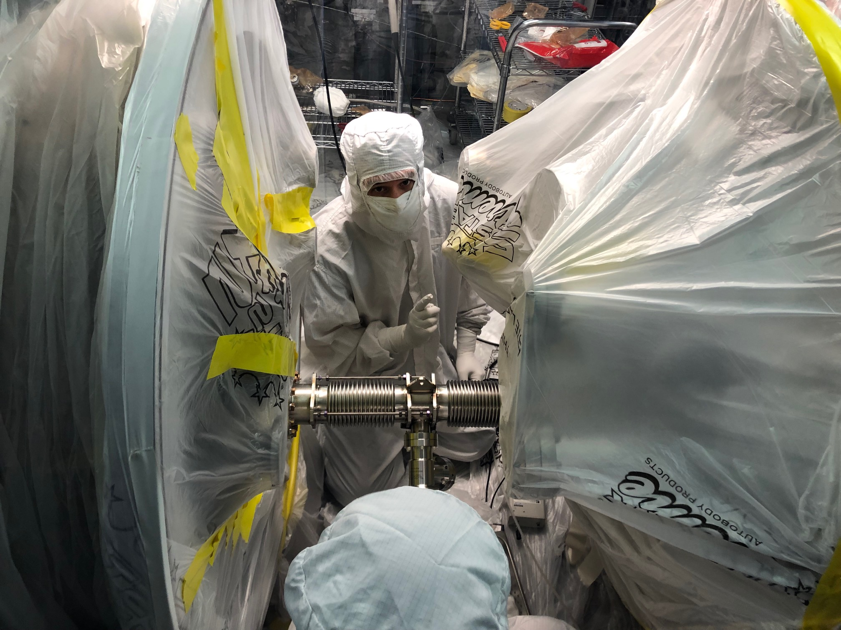

Weekly Reporting

WBS 1.04.08 JLAB Cryoplant System

Week of December 6-12, 2018

**Issues:**

1. Reduction in baseline resources (Return funding to contingency; the top-down EAC) without corresponding reduction in scope of cryoplant commissioning.
2. Resolution of structural interferences created during the design of the cold box room platforms and cable trays support systems (*identified in Nov 2017*).
3. Engineering change request associated with the interface box design-build subcontract resulting in increased cost and schedule delay.

**Accomplishments this week:** On travel;No report.

**Upcoming Travel/Deliveries/Reviews:**

* Helium Purifier – Factory Acceptance Test 12-Dec-2018
* LN2 Dewar witness of leak-check final acceptance TBD-Dec-2018