Weekly Reporting
WBS 1.01.07 JLAB Management
Week of December 13-19, 2018

Issues:
Successfully shipped a CM to SLAC. Vacuum and vibrations measured and analyzed. Both meet and or exceed requirements.

CB2 4.5 K Lower Cold Box witness leak check good. CB is being prepared for shipment to SLAC.

First LN2 dewar witness leak check good. Dewar is being prepared for shipment to SLAC.

Upcoming Reviews:
Feb 2018 DOE OPA Mini Review

Weekly Reporting
WBS 1.04.06 JLAB Cryomodules
Week of December 13-19, 2018

Issues:
- High performing cavities for CMs are late due to potential schedule delays due to Zanon furnace issues.

- Current workload at JLab is being dominated by unplanned work compared with baseline. Re-assembly of J8 & J10 after HV bellows inspections is ongoing. This will negatively impact cost and schedule performance indices going forward.

Accomplishments this week:

J4 arrived at SLAC on Wednesday 12-DEC vacuum leak tight with M-mounts installed. Accelerometer data reviewed and confirmed acceptable. J4 with trailer stored in Bldg 026 until after new year.

In support of F5 receipt and installation, JLab staff was at SLAC arriving 12-DEC to help with CM handling, removal of accelerometers, restraints and shipping caps for return to FNAL.

JLab planning to train FNAL staff on M-mount installation and removal.

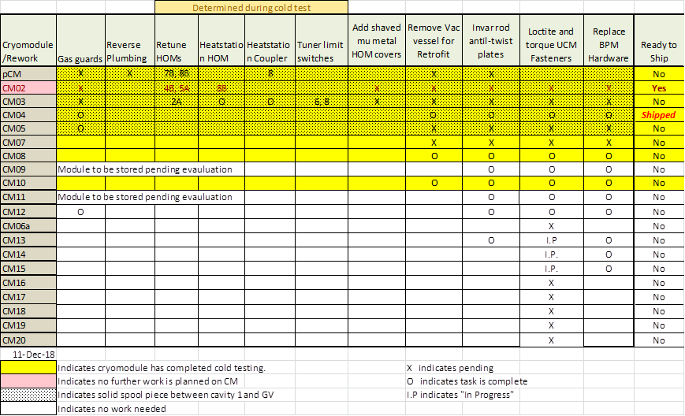
Two CMs (J-02, J-04) are completed.

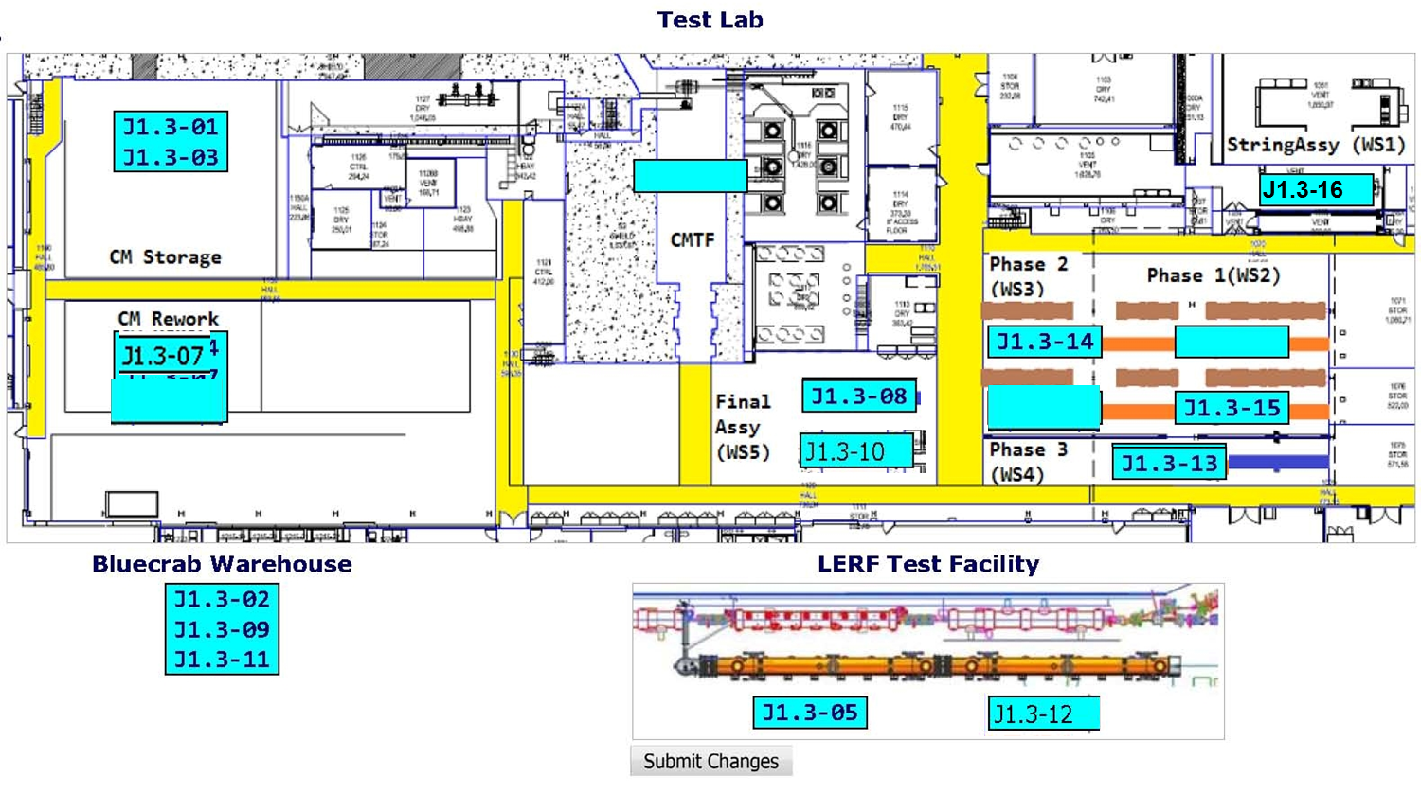
CTF planned maintenance down has been completed as of 16-DEC. Resuming VTA operations.

QUALITY: No report.

Upcoming Travel/Meetings:
- J4 Shipping Receipt at SLAC – December 13 (Huque, Martin, King)

Weekly Reporting
WBS 1.04.06 Cryomodules - LERF Conversion
Week of December 13-19, 2018

Issues: None
Accomplishments this week:
All process piping is leak tight and the outer vacuum vessel is being secured for pump down and leak check in the morning. The vacuum vessel and transferline will be pumped over the holiday break We are positioned to cooldown on January 8/9.

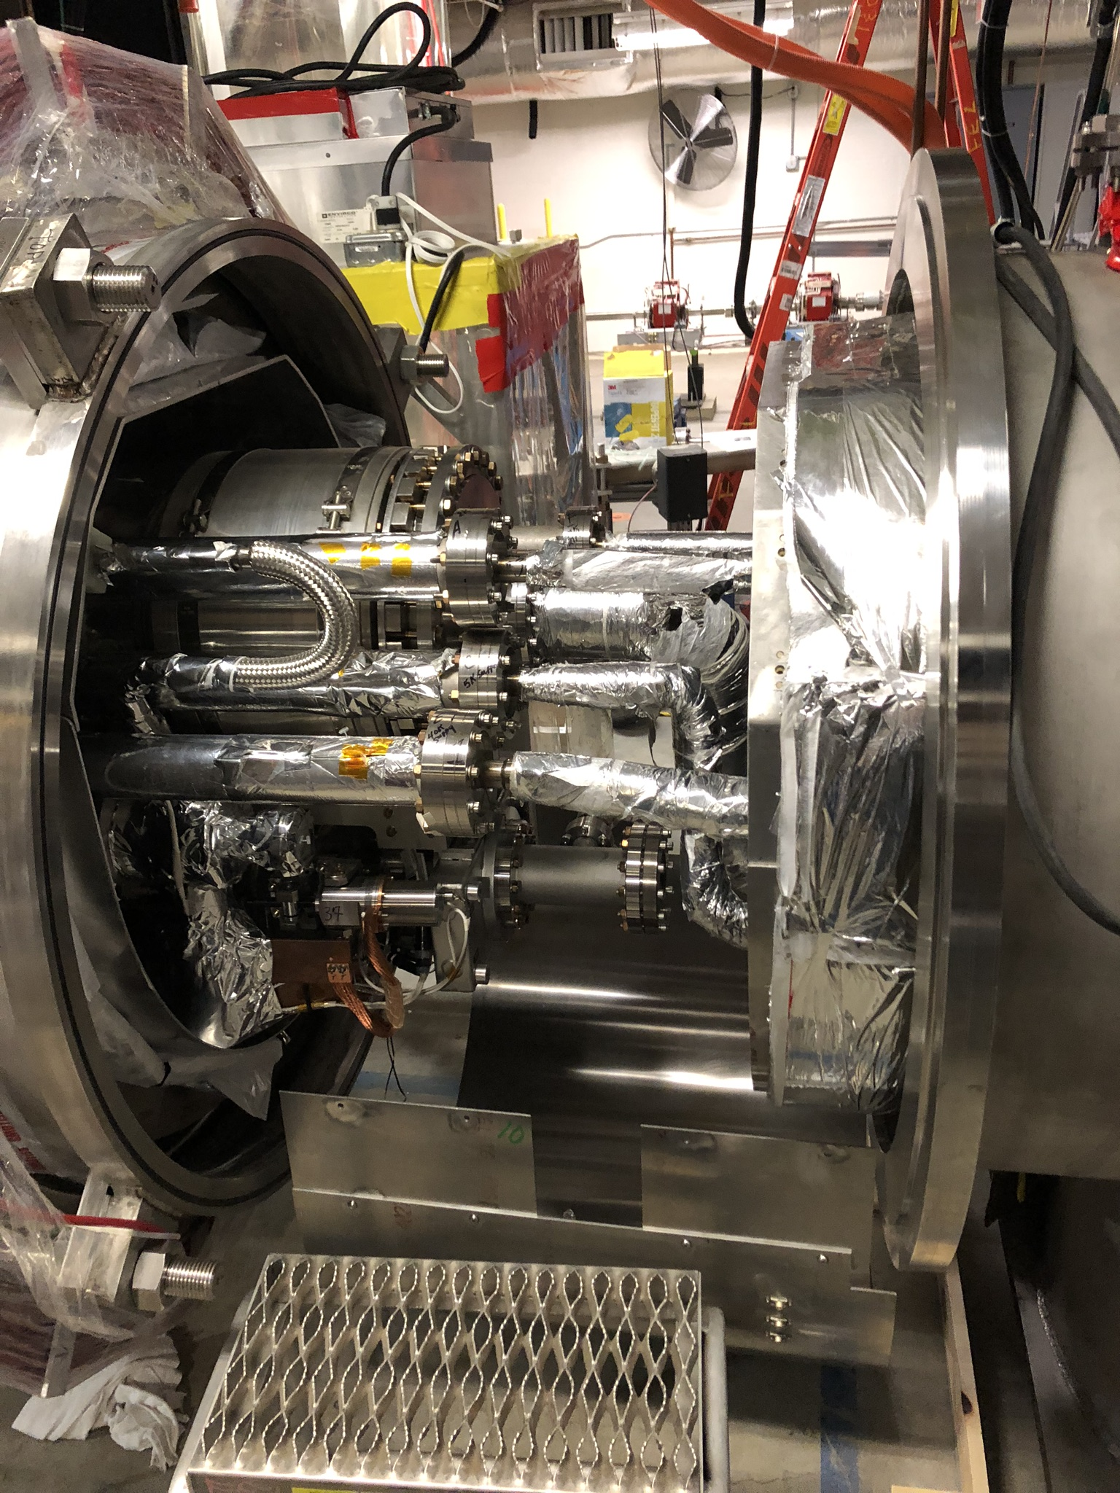 | 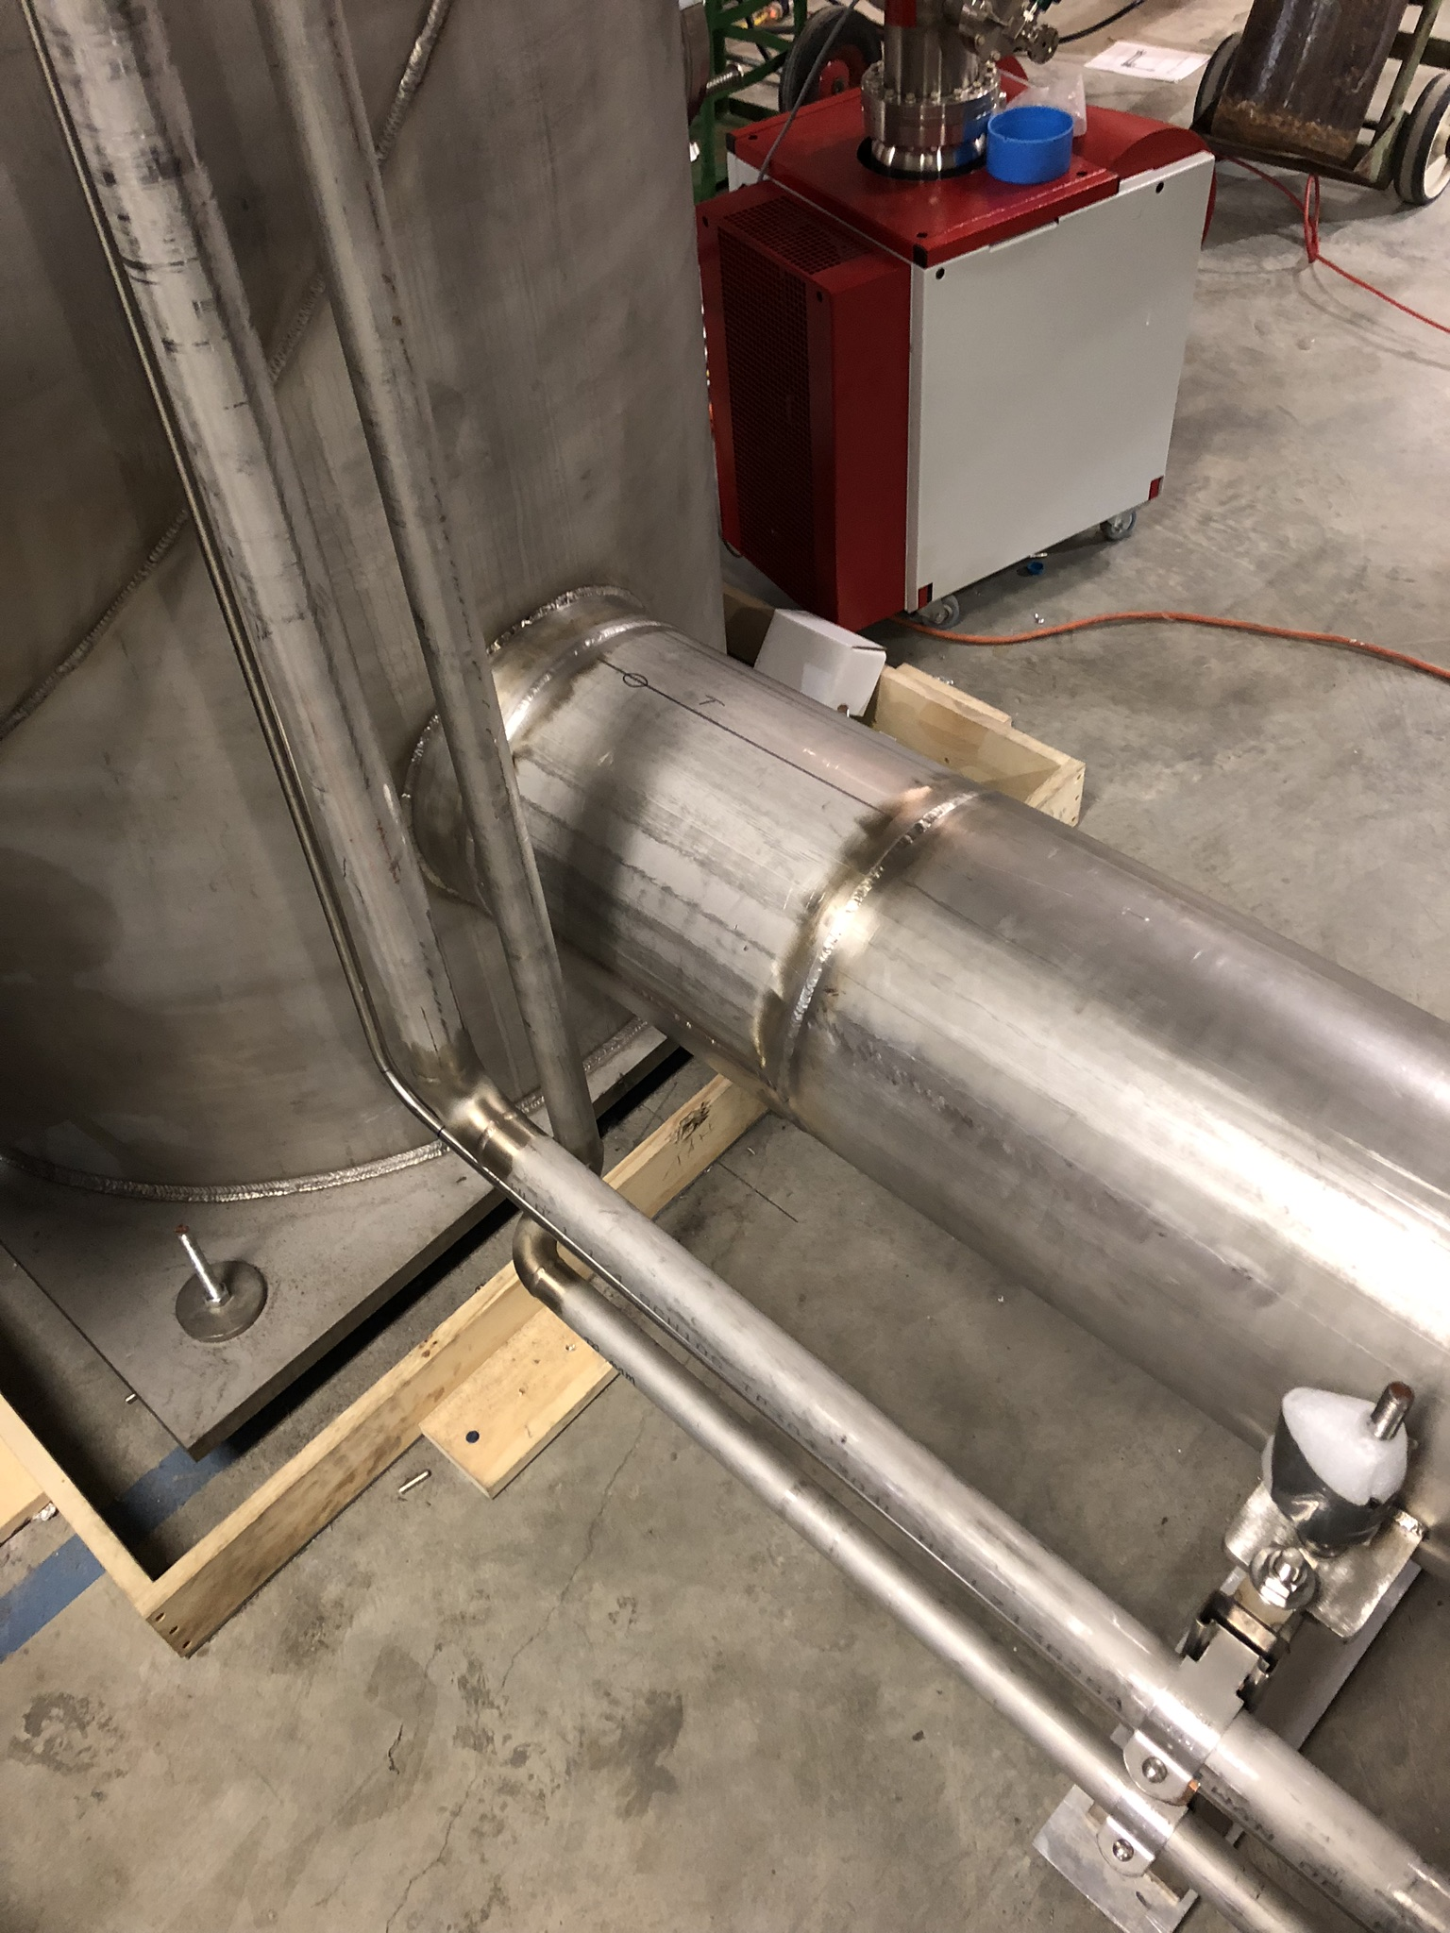
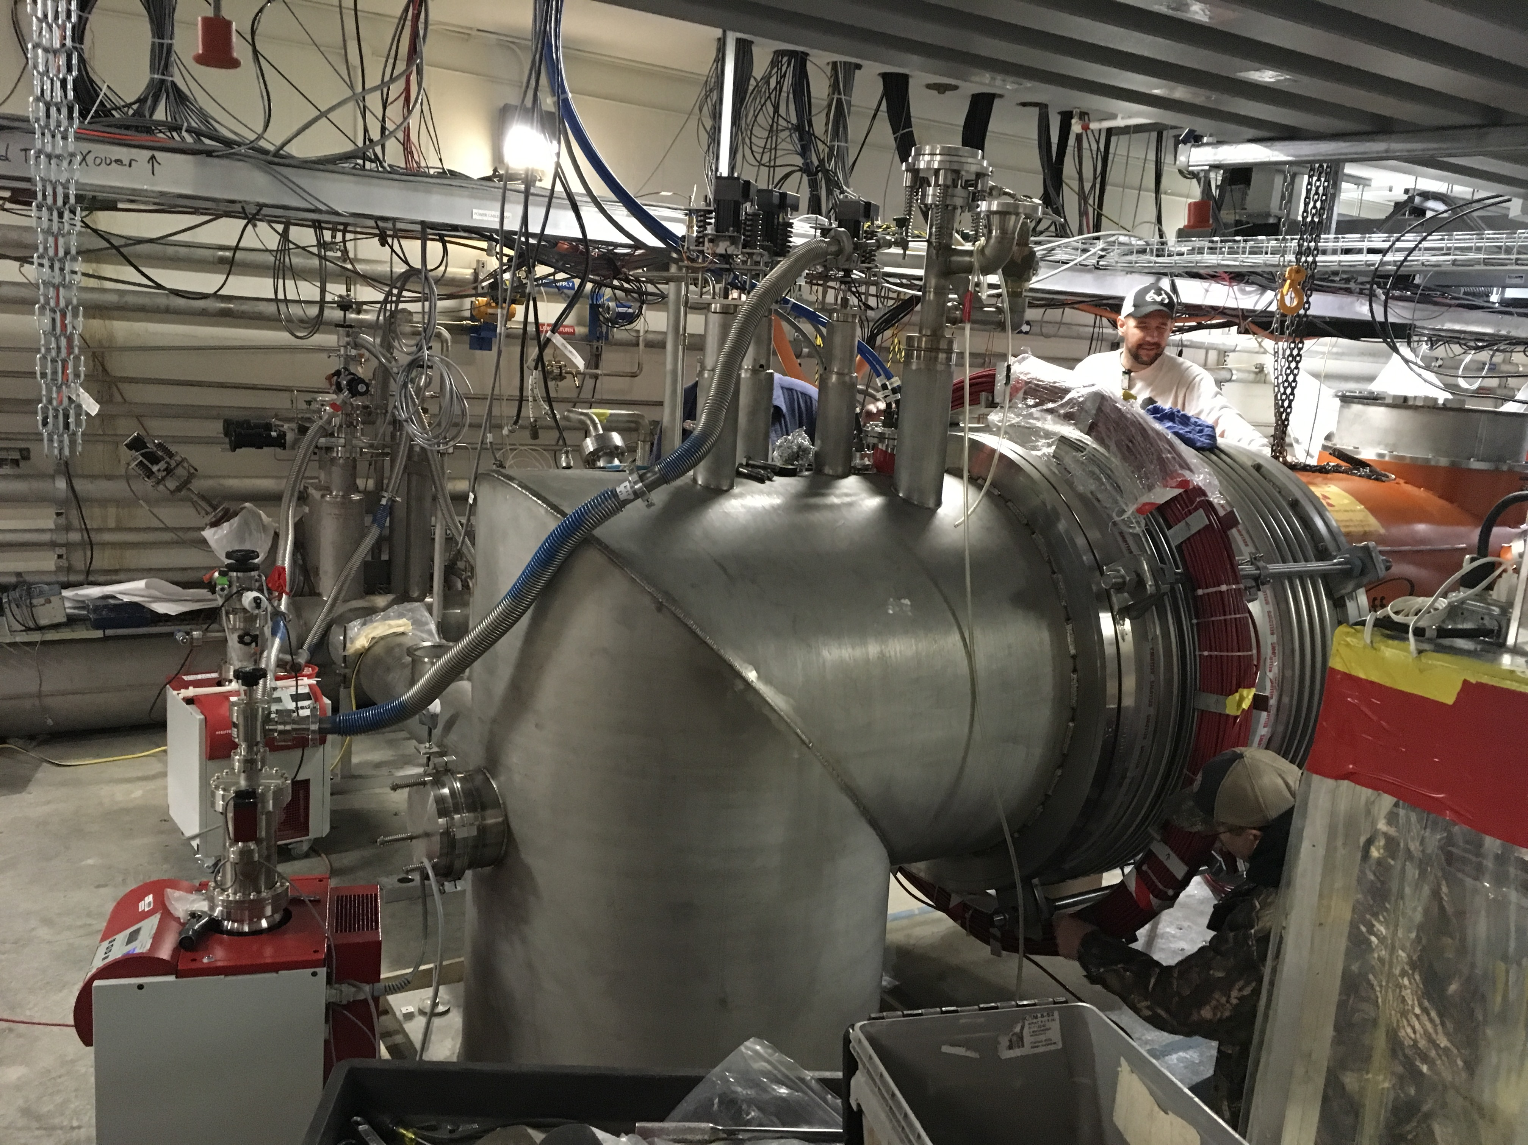 | 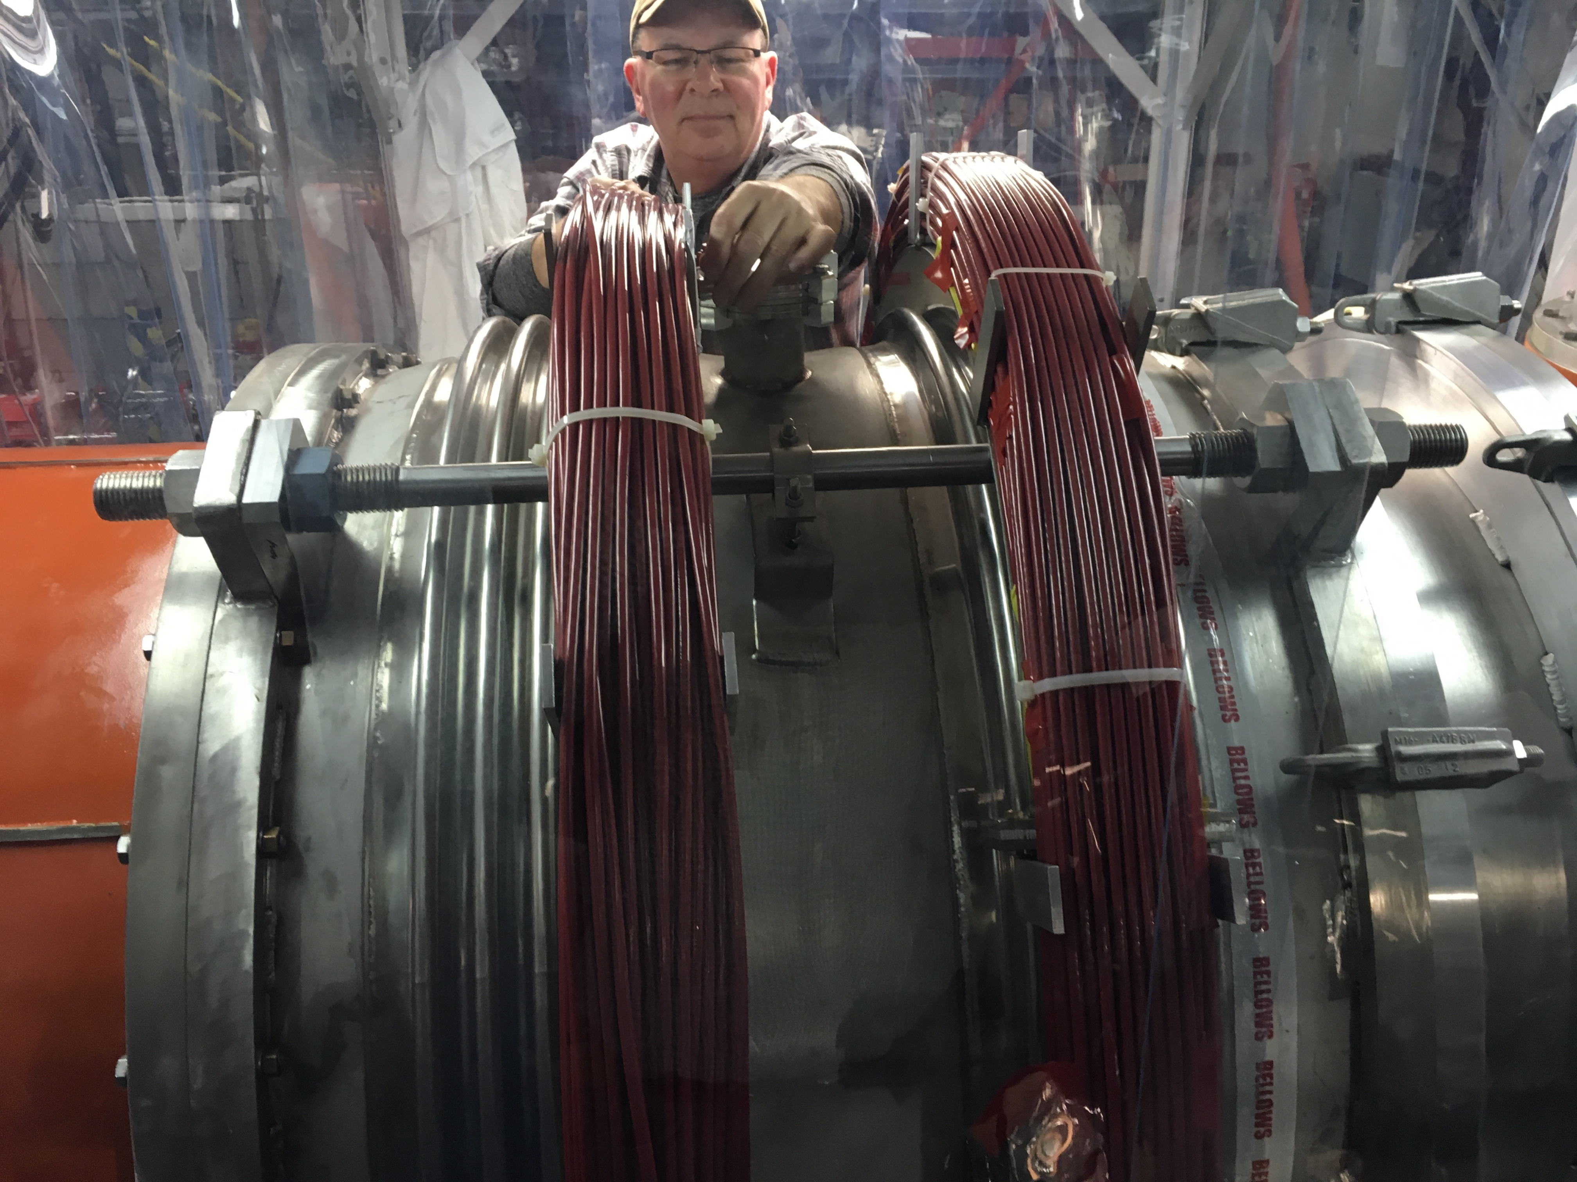
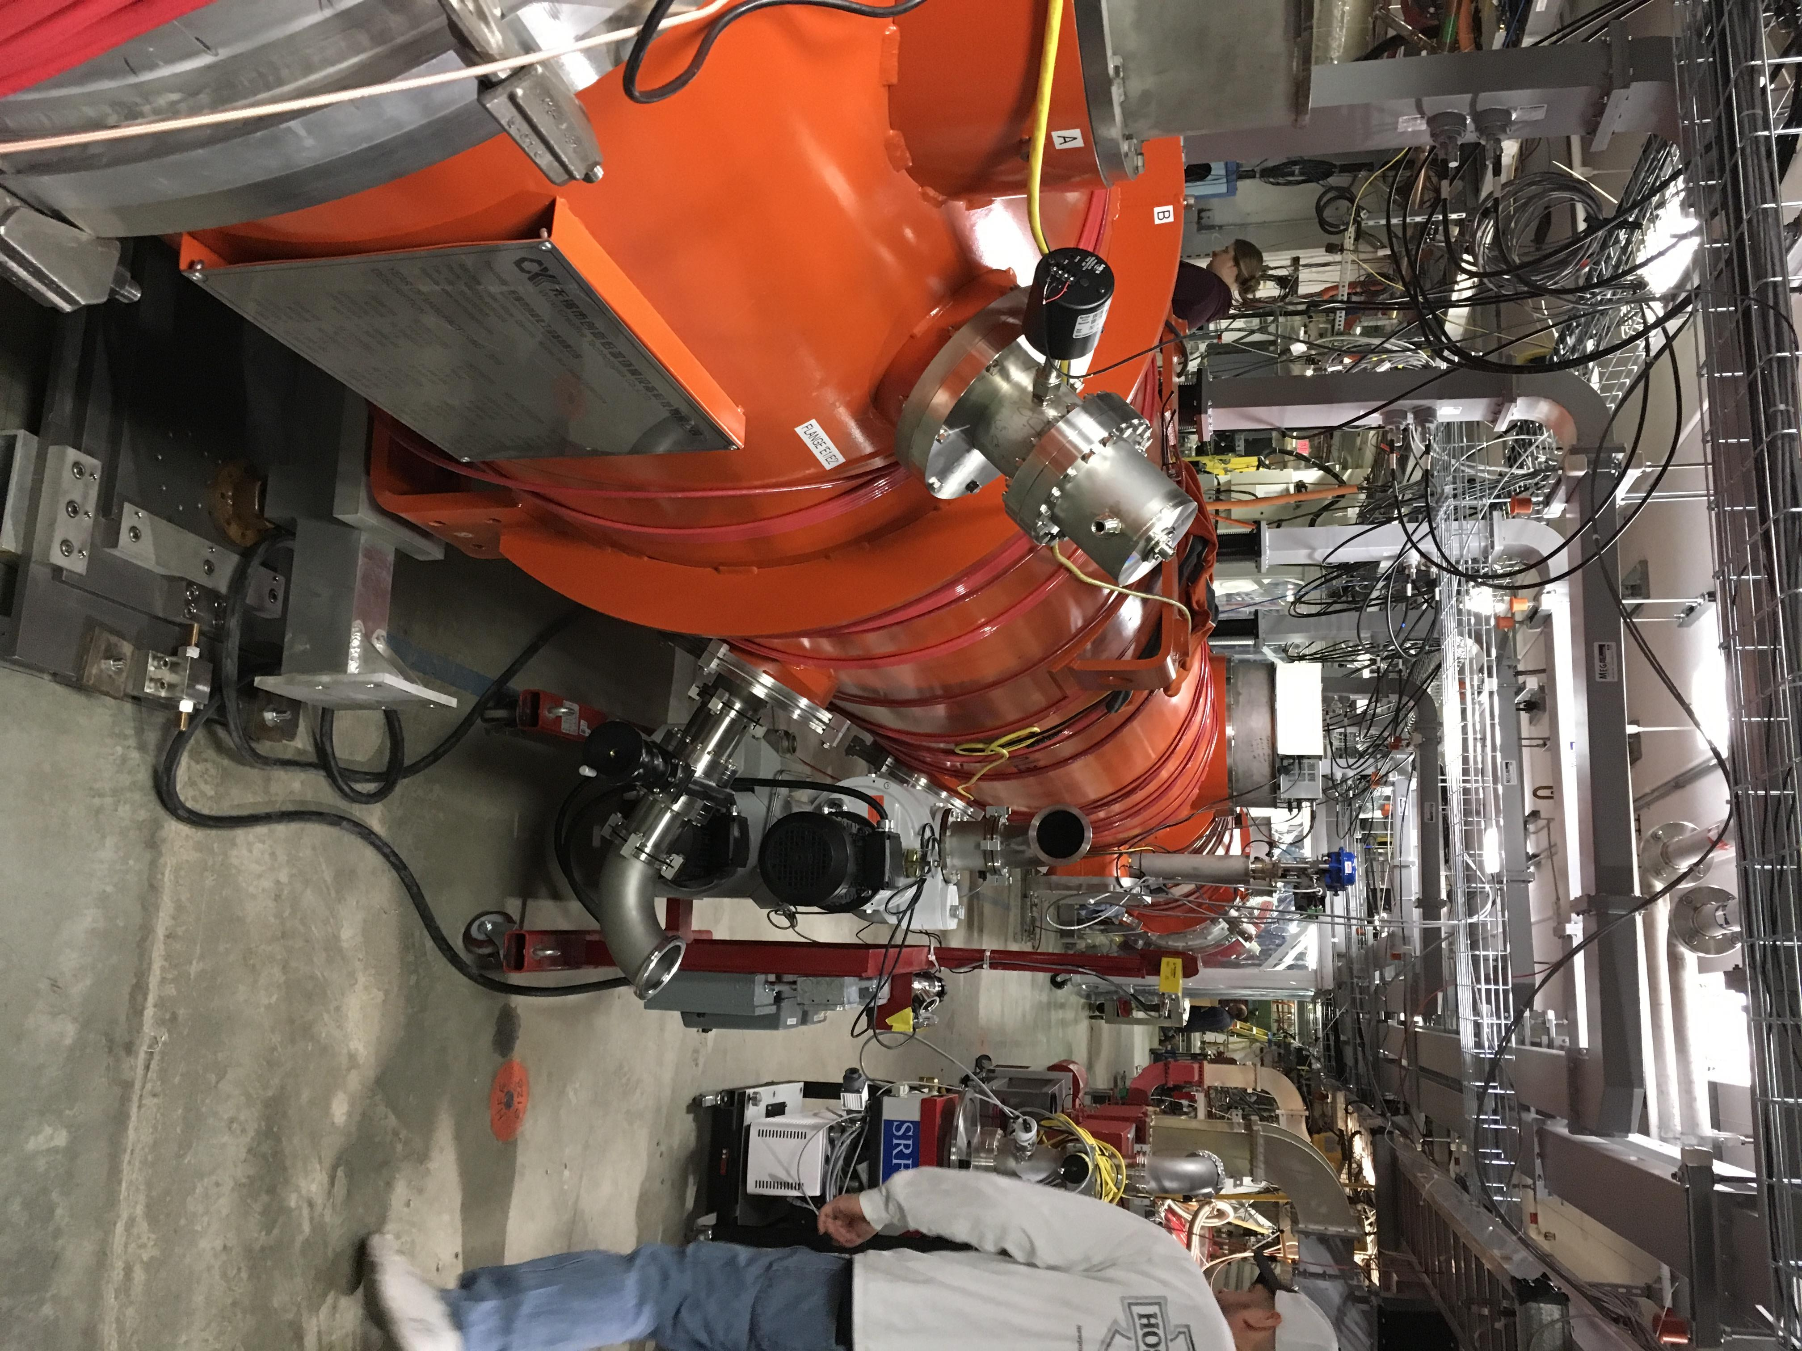

Weekly Reporting
WBS 1.04.08 JLAB Cryoplant System
Week of December 13-19, 2018
Issues:
- Reduction in baseline resources (return funding to contingency; top-down EAC) without corresponding reduction in scope of cryoplant commissioning.
- Resolution of structural interferences created during the design of the cold box room platforms and cable trays support systems (identified in Nov 2017).
- Engineering change request associated with the interface box design-build subcontract resulting in increased cost and schedule delay.
- Ongoing delays installing piping systems in cryoplant warm compressor room is delaying startup of commissioning activities.

Accomplishments this week:
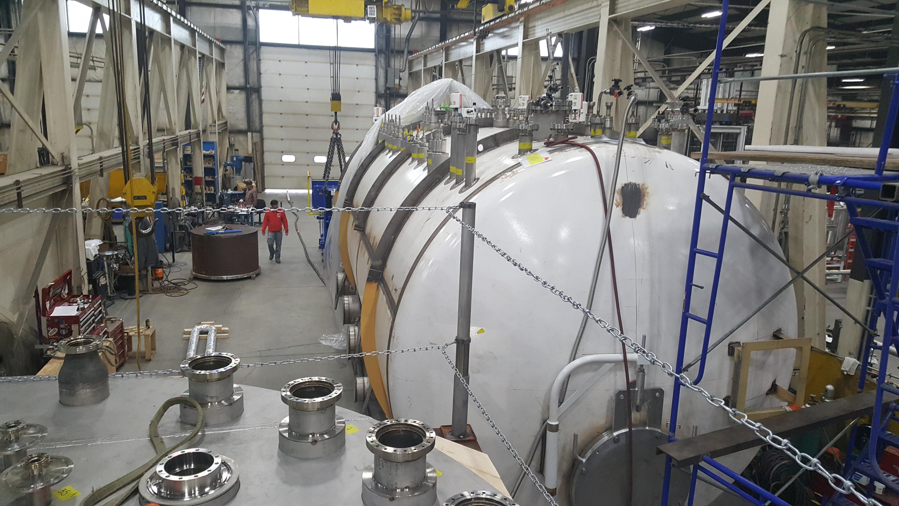
Factory acceptance test of 4.5K lower cold box successful & complete.
Scheduled for delivery to SLAC 26-Jan-2019.

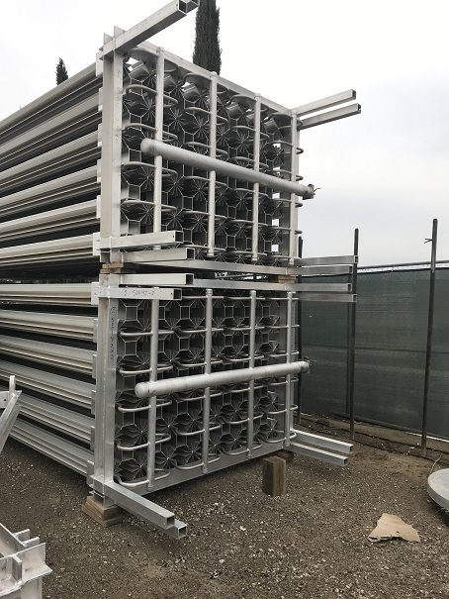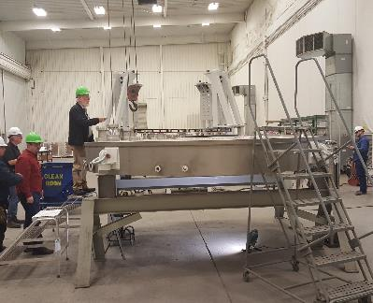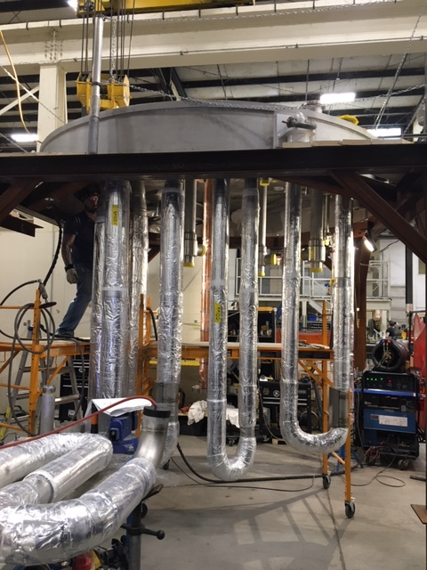
Site visit @ 2K cold box vendor (PHPK)

Site visit @ 2K cold box vendor (Linde)

HXs near complete (CRYOQUIP)

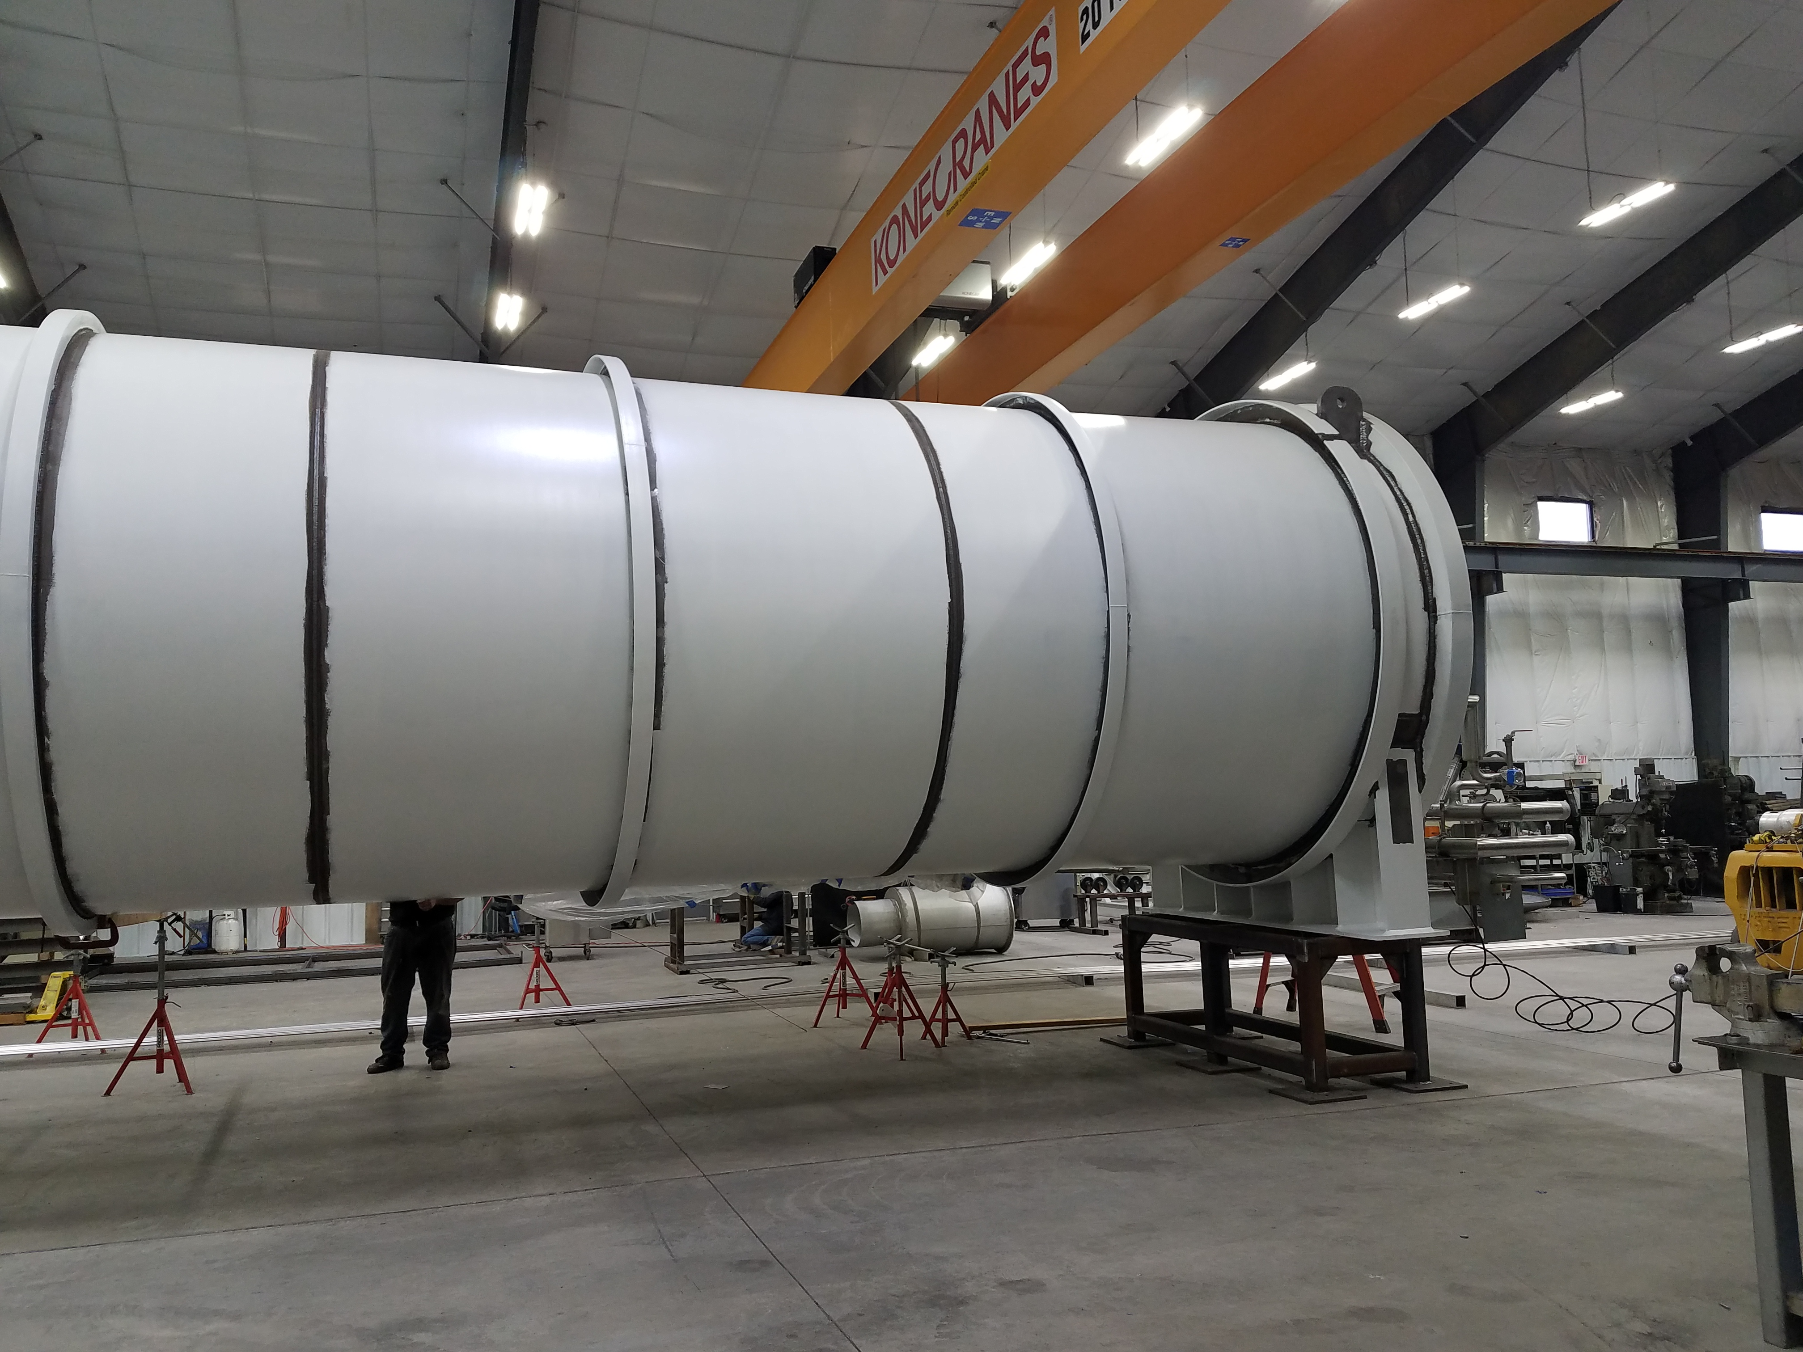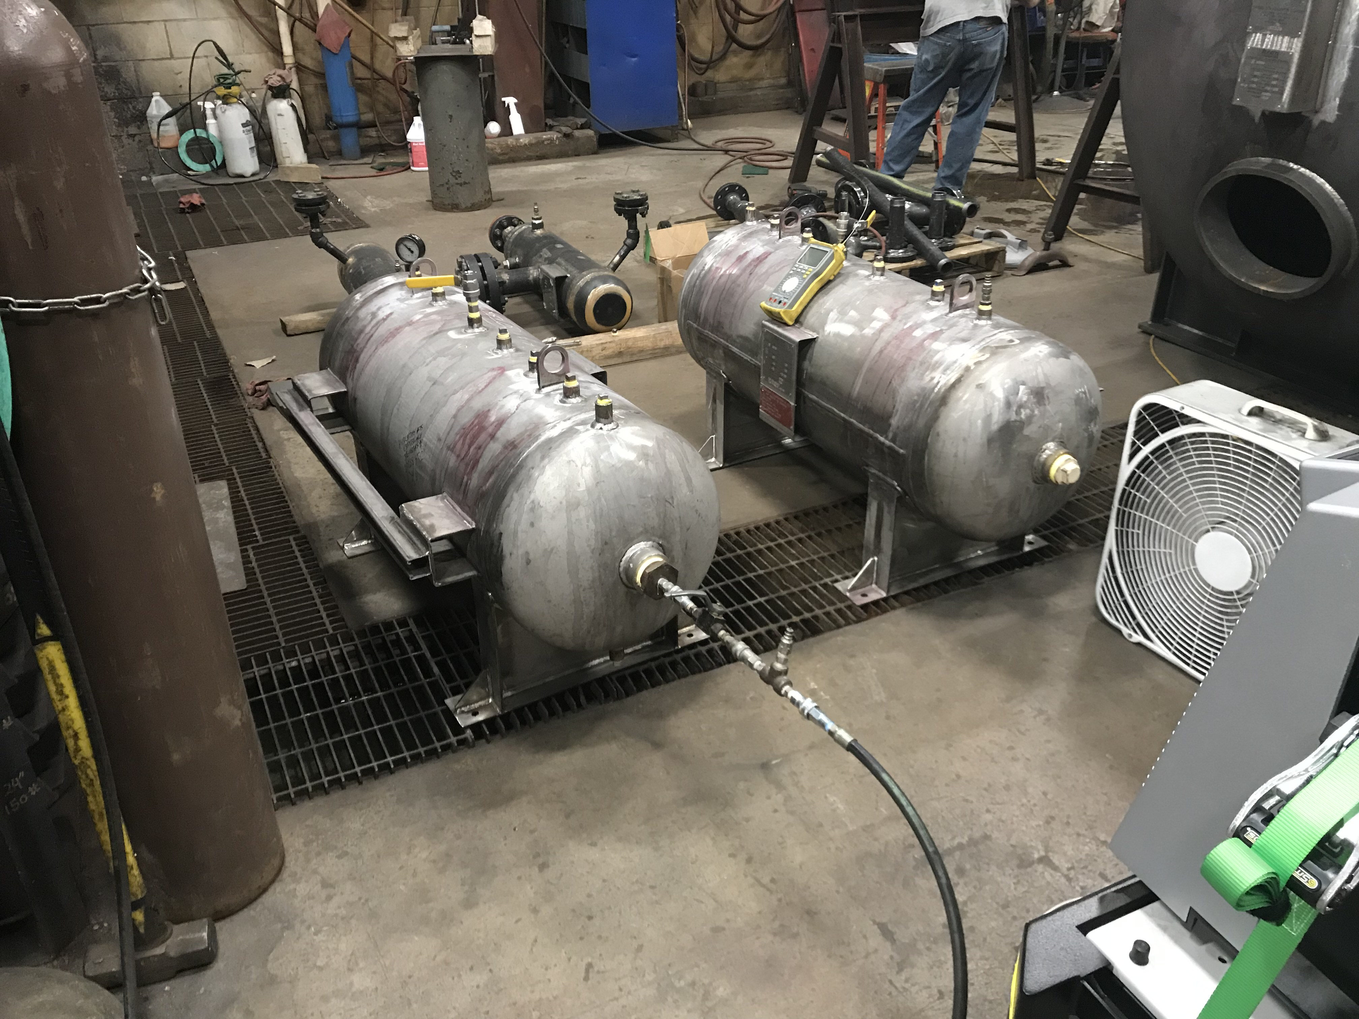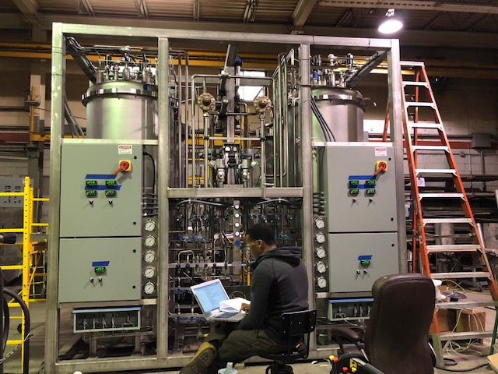
Factory acceptance test of LN2 Dewar (AES)

Factory acceptance test of 40-gallon oil tank (Buckeye)

Factory acceptance test of Helium Purifier (Ability)

Upcoming Travel/Deliveries/Reviews:
- LN2 Dewar delivery to SLAC 10-Jan-2019
- Helium Purifier skid delivery to SLAC 25-Jan-2019
- 4.5K Lower Cold Box delivery to SLAC 26-Jan-2019
- Vacuum pump carts (2) 28-Jan-2019
- Ambient heat exchangers (Vaporizers) 30-Jan-2019

