Weekly Reporting

WBS 1.01.07 JLAB Management

Week of December 20, 2018 to January 9, 2019

**Issues:**

**Accomplishments this week:**

CB2 4.5 K Lower Cold Box shipped from vendor to to SLAC on 4 January.

First LN2 dewar shipped from vendor to SLAC on 6 January.

Working the EAC.

**Upcoming Reviews:**

February 11, 2019 Director’s “Mission Success Review”

February 11-14, 2019 SRF Workshop at SLAC

February 19-21, 2019 EVMS Surveillance - tentative

March 19-21, 2019 DOE Mission Success Review

Weekly Reporting

WBS 1.04.06 JLAB Cryomodules

Week of December 20, 2018 to January 9, 2019

**Issues**:

1. Current workload at JLab is being dominated by unplanned work compared with baseline. Re-assembly of J8 & J10 after HV bellows inspections is nearly completed. This will negatively impact cost and schedule performance indices going forward.

**Accomplishments this week:**

Working on monthly VARs and EAC.

Revising production schedule to load level staff, fold in rework activities and target completion of last CM in March 2020.

The layout of the four poster for additional WS3 is completed. Expect tooling to be operational by end of next week.

Planning to unload J4 at SLAC S10 adit next week. Will remove M-mounts and train SLAC staff on procedure. Will remove caps and sensors then ship trailer back to JLab.

J8 & J10 RT inspection was completed. Preparing for shipment of J8 to SLAC prior to the end of January.

Cooldown of LERF CMs is on track for Friday 11-Jan.



One CM (J-04) are completed. Previously this was two but J-02 is being reconsidered for rework as part of EAC activities.

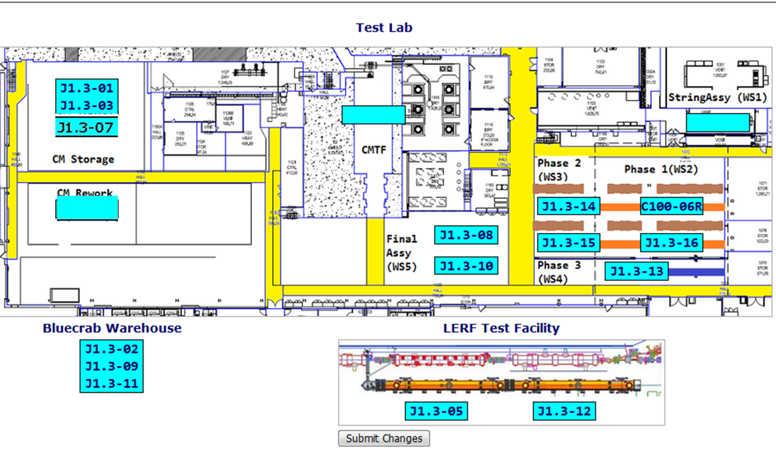

CTF planned maintenance down has been completed as of 16-DEC. However the system is running at reduced capacity on one main compressor for approximately one month until the second compressor is received and installed. VTA operations continue at reduced capacity. J13 cooldown will be gated by installation of the second compressor.

**QUALITY:** Final welding inspection on LCLS LERF installation piping (vacuum jackets). Saturday RT for LCLS CM10 and CM08 welds; all passed. Receipt welding review for LCLS UCM 026.

**Upcoming Travel/Meetings:**

* J4 Shipping Receipt at SLAC at s10 adit – Week of 14-Jan (Huque, Martin, King)
* Mission Success Director’s Review – 11-Feb
* Mission Success OPA Review – 17-19 March

Weekly Reporting

WBS 1.04.06 Cryomodules - LERF Conversion

Week of December 20, 2018 to January 9, 2019

**Issues:** None

**Accomplishments this week:**

We are in the final stretch to cool down on Friday 1/11/2018! There are still a couple pesky small leaks in the vacuum tank. There is a high background from helium circuit cleanup and purges, so a high helium background does not help.

Briant Lam & Kristi Luchini are here this week to commission the SC magnet racks; that work progressed very well.

Tonight both modules will be degaussed by Bob Legg in preparation for Friday’s cool down.

Weekly Reporting

WBS 1.04.08 JLAB Cryoplant System

Week of December 20, 2018 to January 9, 2019

**Issues:**

1. Reduction in baseline resources (return funding to contingency; top-down EAC) without corresponding reduction in scope of cryoplant commissioning.
2. Resolution of structural interferences created during the design of the cold box room platforms and cable trays support systems (*identified in Nov 2017*).
3. Engineering change request associated with the interface box design-build subcontract resulting in increased cost and schedule delay.
4. Ongoing delays installing piping systems in cryoplant warm compressor room is delaying startup of commissioning activities.

**Accomplishments this week:**



C1 & C2 - 4.5K Upper Cold Box Platforms Installed



C1 - 4.5K Lower Cold Box in transit to SLAC

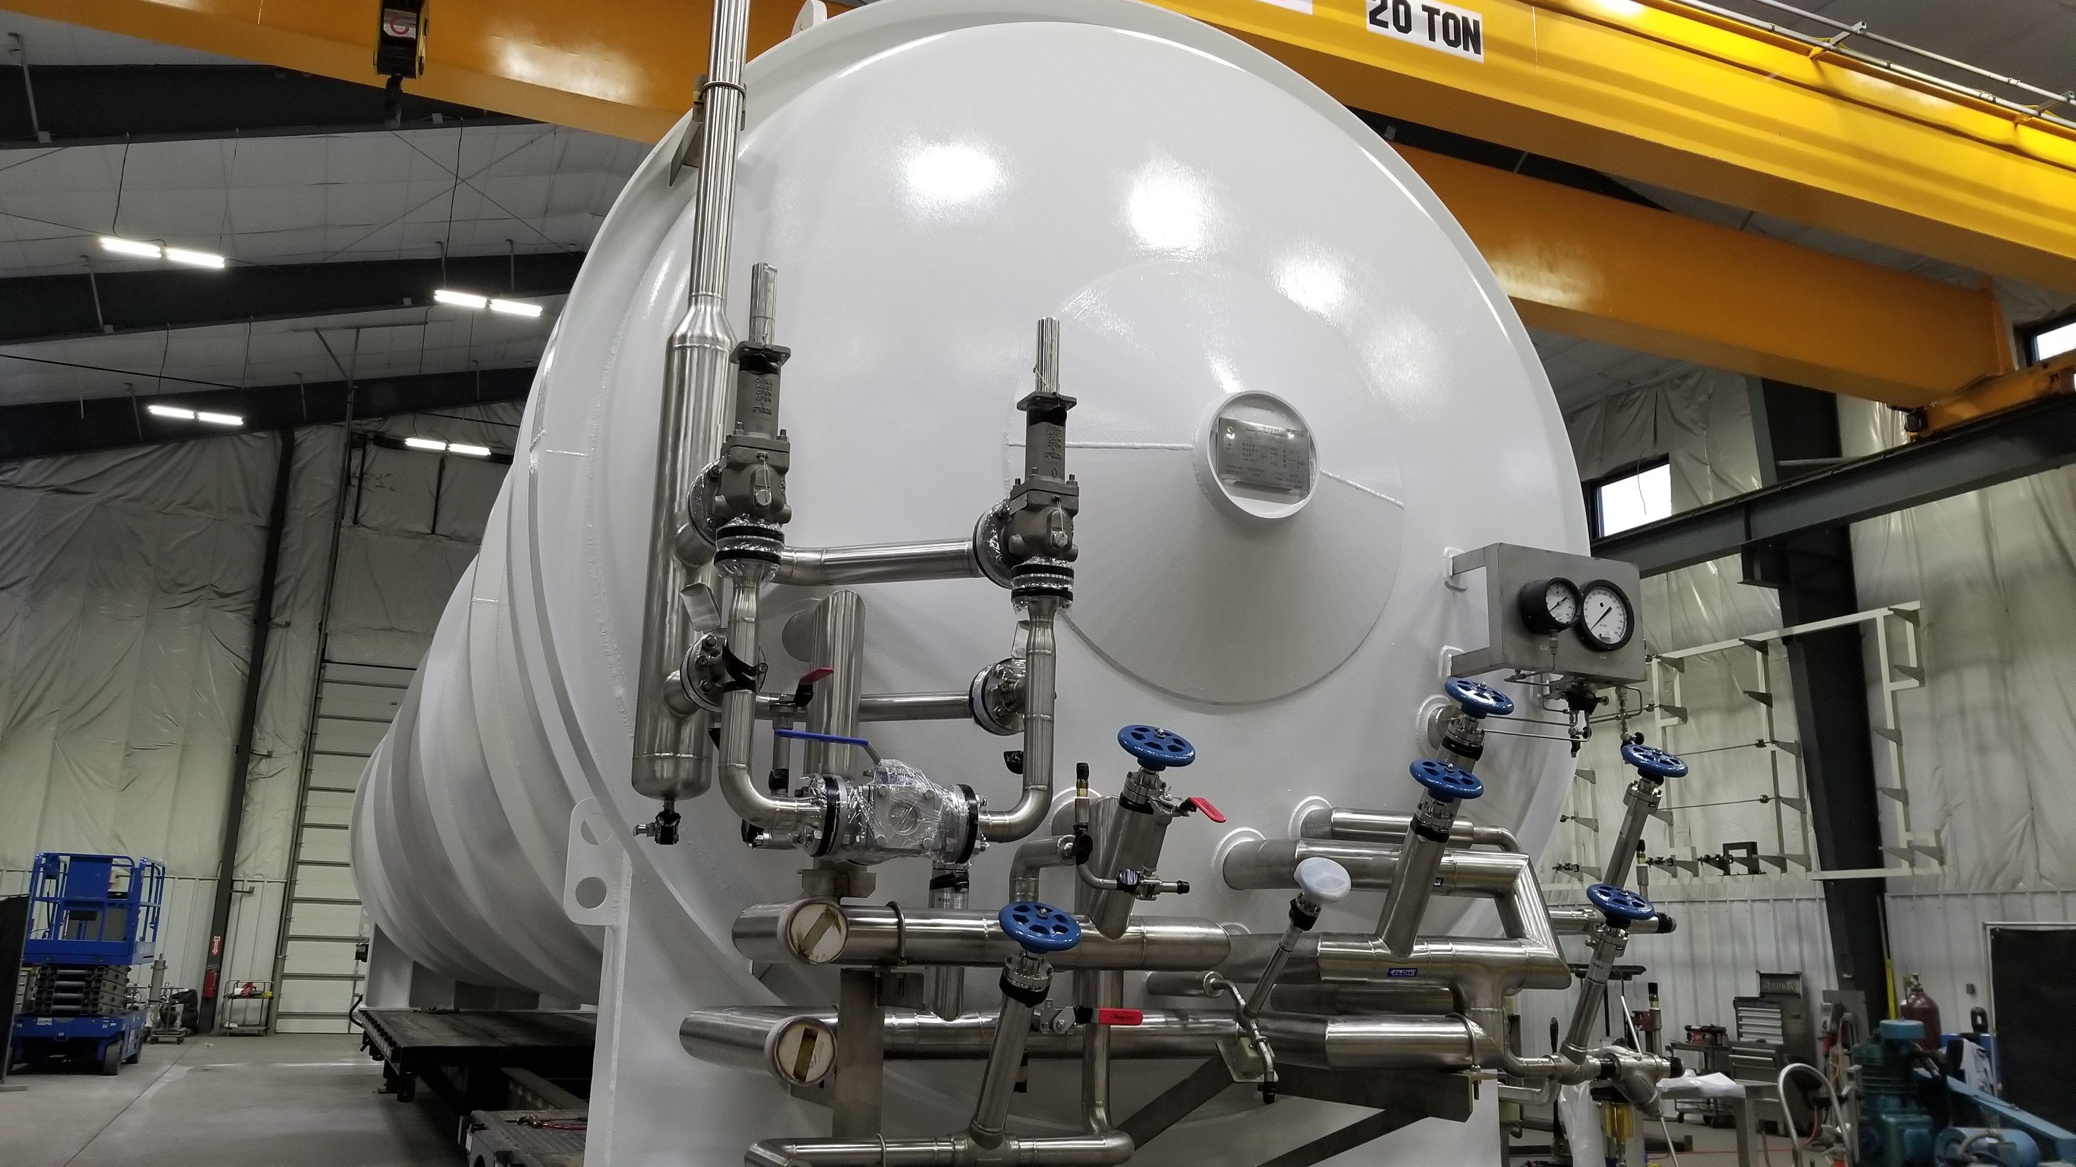

C1 – Liquid Nitrogen Dewar in transit to SLAC

**Upcoming Travel/Deliveries/Reviews:**

* LN2 Dewar delivery to SLAC 11-Jan-2019
* 4.5K Lower Cold Box delivery to SLAC 14-Jan-2019
* Vacuum pump carts (2) 28-Jan-2019
* Ambient heat exchangers (Vaporizers) 30-Jan-2019
* Helium Purifier skid delivery to SLAC 01-Feb-2019