Weekly Reporting

WBS 1.01.07 JLAB Management

Week of January 10-16, 2019

**Issues:**

**Accomplishments this week:**

CB2 4.5 K Lower Cold Box that shipped from vendor arrived at SLAC on 13 January.

First LN2 dewar that shipped from vendor arrived at SLAC and was set in place on 15 January.

Working the EAC.

Making plans for upcoming reviews.

**Upcoming Reviews:**

February 12-14, 2019 Director’s “Mission Success Review”

February 11-14, 2019 SRF Workshop at SLAC

February 19-21, 2019 EVMS Surveillance - tentative

March 19-21, 2019 DOE OPA Review

Weekly Reporting

WBS 1.04.06 JLAB Cryomodules

Week of January 10-16, 2019

**Issues**:

1. Current workload at JLab is being dominated by unplanned work compared with baseline. Re-assembly of J8 & J10 after HV bellows inspections is nearly completed. This will negatively impact cost and schedule performance indices going forward.

**Accomplishments this week:**

Working on EAC.

Revised production schedule to load level staff, fold in rework activities and target completion of last CM in March 2020. Sent to Burrill for review and comment.

The layout of the four poster for additional WS3 is completed. On track to complete by the end of this week.

J4 was unloaded at SLAC S10 adit. SLAC shipped trailer back to JLab. JLab staff (Martin, King) visiting SLAC this week to assist with M-mount and sensor removal.

Preparing for shipment of J8 to SLAC to depart JLab on 25-Jan.

Cooldown of LERF CMs started on 15-Jan. Was delayed to complete OSP and resolve issues with control valves on Cryo Can.

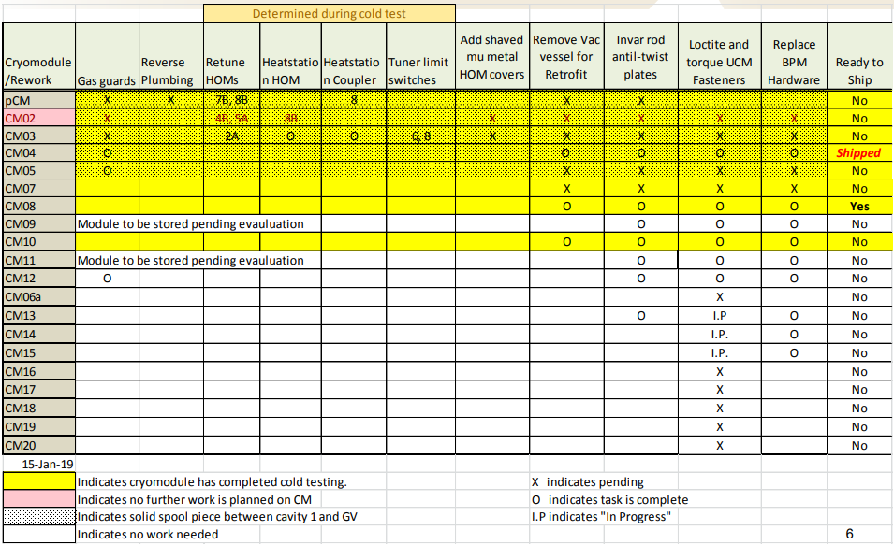

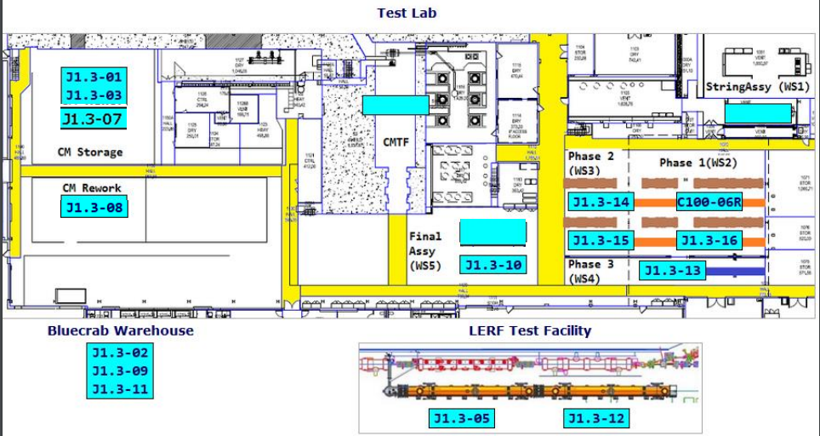

CTF continues to run at reduced capacity on one main compressor for approximately one month until the second compressor is received and installed. VTA operations continue at reduced capacity until the end of January. J13 cooldown will be gated by installation of the second compressor.

**QUALITY:**  Conducted the Final Pressure System Walk Through for the Cryo Can, Transfer Line and installation piping additions with Matt Marchlik. No issues.

**Upcoming Travel/Meetings:**

* J4 Shipping Receipt at SLAC at s10 adit – Week of 14-Jan (Martin, King)
* Director’s Review – 12-14 Feb
* OPA Review – 19-21 March

Weekly Reporting

WBS 1.04.06 Cryomodules - LERF Conversion

Week of January 10-16, 2019

**Issues:** None

**Accomplishments this week:**

Continued working on EPICs screens and controls.

Finalized OSP in advance of cooldown.

Trouble shot issues with several valve actuators on Cryo Can.

Completed Cryo/SRF pre-cooldown checklist.

Received approval to install u-tubes and begin cooldown.

Started cooldown on 15-Jan.

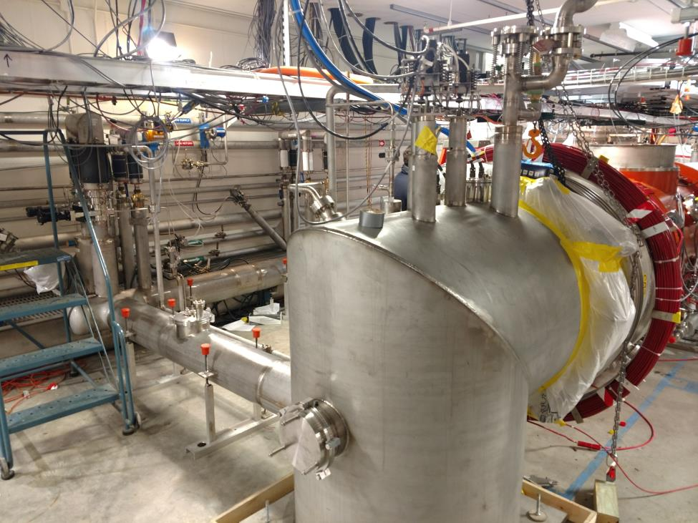

Weekly Reporting

WBS 1.04.08 JLAB Cryoplant System

Week of January 10-16, 2019

**Issues:**

1. Reduction in baseline resources (return funding to contingency; top-down EAC) without corresponding reduction in scope of cryoplant commissioning.
2. Resolution of structural interferences created during the design of the cold box room platforms and cable trays support systems (*identified in Nov 2017*).
3. Ongoing delays installing piping systems in cryoplant is delaying startup of commissioning activities.

**Accomplishments this week:**

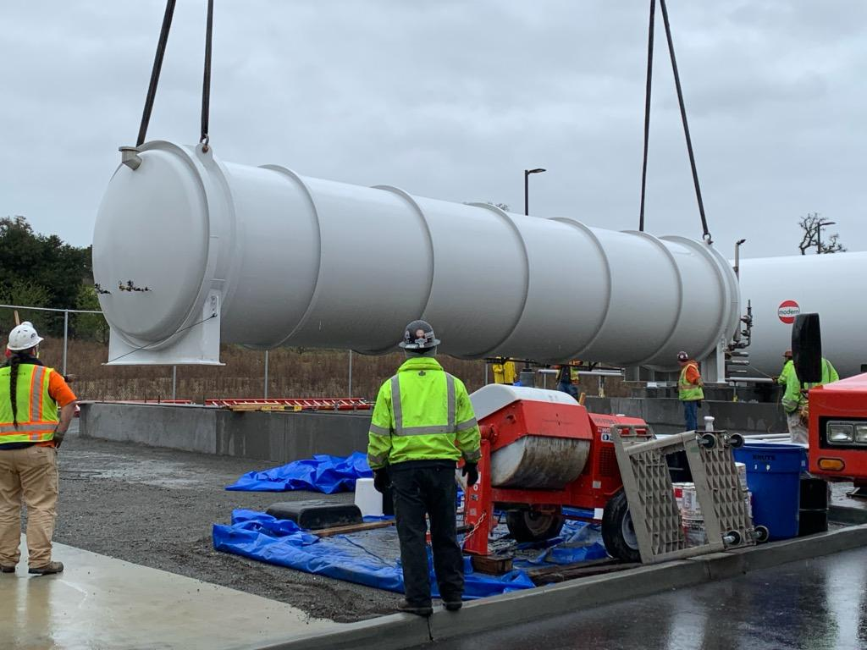

C1 Liquid Nitrogen Dewar set into position in the cryoplant tank farm

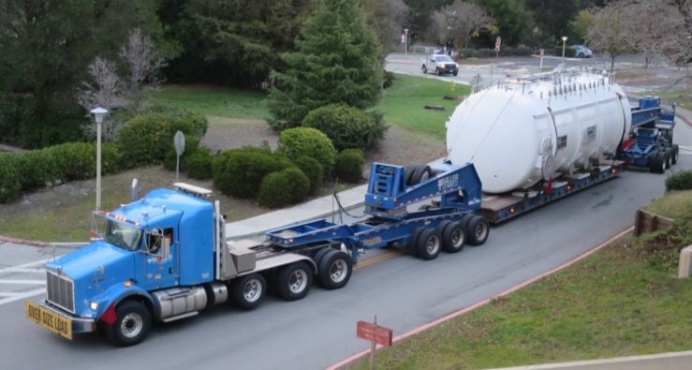 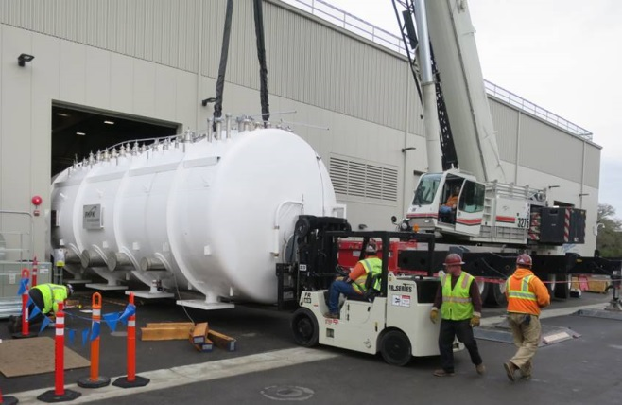

C1 4.5K Lower Cold Box delivered to SLAC and moved into the Cryoplant (B905)

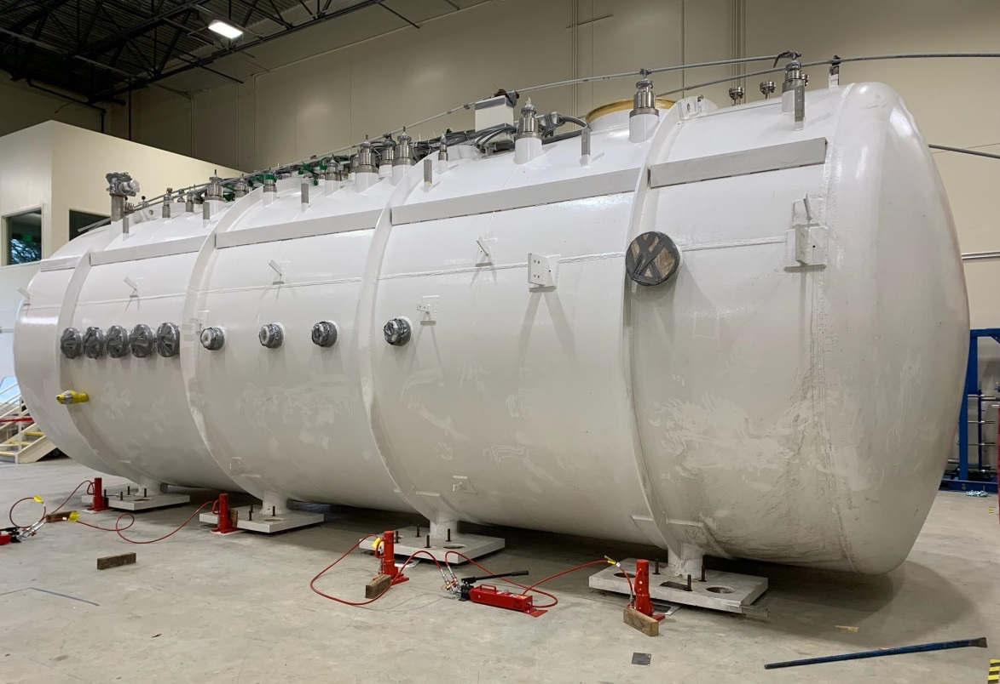

C1 4.5K Lower Cold Box set into position in the Cryoplant cold box room.

**Major Procurement Status:**



**Upcoming Travel/Deliveries/Reviews:**

* JLab engineers onsite @SLAC (14-16)-Jan-2019
* Weekly site visit to PHPK (2K & 4.5K CBs) 17-Jan-2019
* Helium Purifier skid delivery to SLAC 24-Jan-2019
* Weekly site visit to PHPK (4.5K CB) 24-Jan-2019
* Vacuum pump carts (2) 28-Jan-2019
* Ambient heat exchangers (Vaporizers) 30-Jan-2019
* LCLS-II Director’s Review (12-14)-Feb-2019