Weekly Reporting

WBS 1.01.07 JLAB Management

Week of January 17-23, 2019

**Issues:**

**Accomplishments this week:**

Submitted EAC numbers and slides.

Met to review SLAC staff proposal for an alternative IB & MTL fabrication plan.

Working o Director’s Review material.

Fast cooldown done in the LERF with 15-30 K/min rate.

Wringing out LERF interlocks and controls.

Changing the SRF cavity contract to implement a new doping recipe.

**Upcoming Reviews:**

February 12-14, 2019 Director’s “Mission Success Review”

February 19-21, 2019 EVMS Surveillance - tentative

March 19-21, 2019 DOE OPA Review

Weekly Reporting

WBS 1.04.06 JLAB Cryomodules

Week of January 17-23, 2019

**Issues**:

1. Current workload at JLab is being dominated by unplanned work compared with baseline. Re-assembly of J8 & J10 after HV bellows inspections is nearly completed. This will negatively impact cost and schedule performance indices going forward.

**Accomplishments this week:**

Working on EAC.

The four poster for additional WS3 is being aligned and nearly completed.

JLab staff (Martin, King) visited SLAC last week to assist with M-mount and sensor removal.

Preparing for shipment of J8 to SLAC to depart JLab on 26-Jan for arrival on Tuesday 29-Jan.

Cooldown of LERF CMs was completed. Practice run with fast cooldown was completed on 22-Jan in advance of CEBAF physics run. Achieved cooldown rates between 12 and 30 K/min.

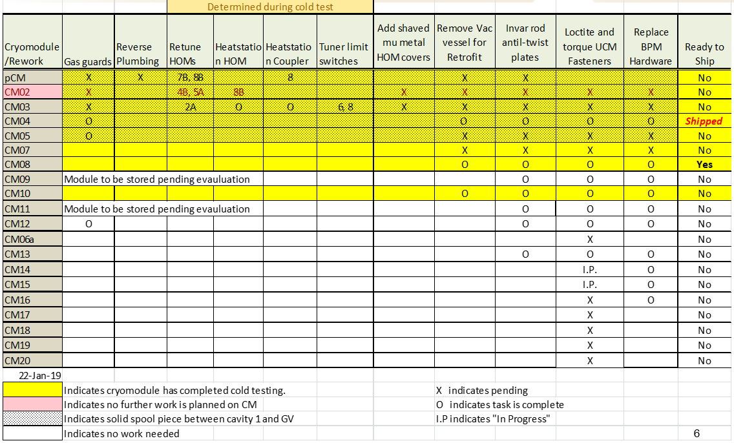

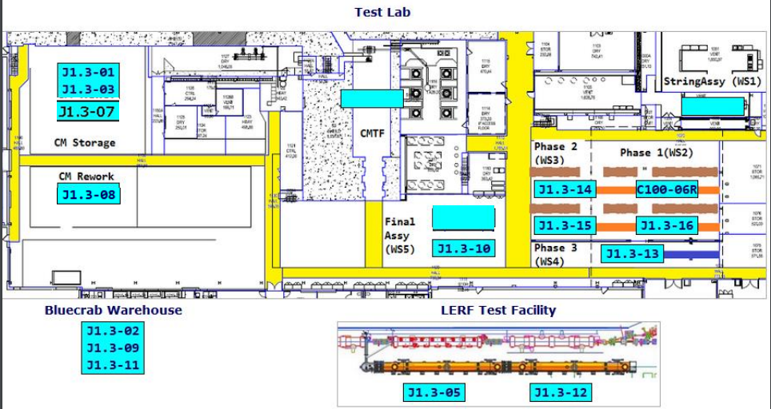

CTF continues to run at reduced capacity on one main compressor for approximately one month until the second compressor is received and installed. VTA operations continue at reduced capacity until the end of January. J13 cooldown will be gated by installation of the second compressor.

**QUALITY:**  Pressure tested LCLS CM 010 low pressure circuit (passed).

**Upcoming Travel/Meetings:**

* 3.9 GHz Delta FDR at FNAL – 29-30 Jan (Daly)
* Director’s Review – 12-14 Feb
* OPA Review – 19-21 March

Weekly Reporting

WBS 1.04.06 Cryomodules - LERF Conversion

Week of January 17-23, 2019

**Issues:** None

**Accomplishments this week:**

Weekly Reporting

WBS 1.04.08 JLAB Cryoplant System

Week of January 17-23, 2019

**Issues:**

1. Reduction in baseline resources (return funding to contingency; top-down EAC) without corresponding reduction in scope of cryoplant commissioning.
2. Resolution of structural interferences created during the design of the cold box room platforms and cable trays support systems (*identified in Nov 2017*).
3. Ongoing delays installing interconnecting piping systems in cryoplant is delaying startup of commissioning activities.

**Accomplishments this week:**

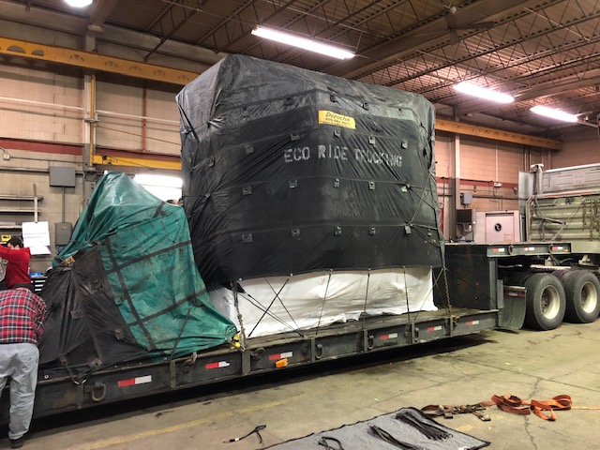 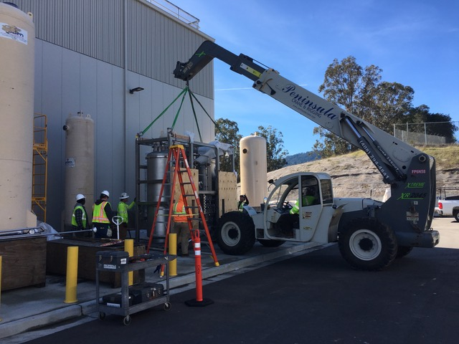

Helium Purifier Delivered to SLAC

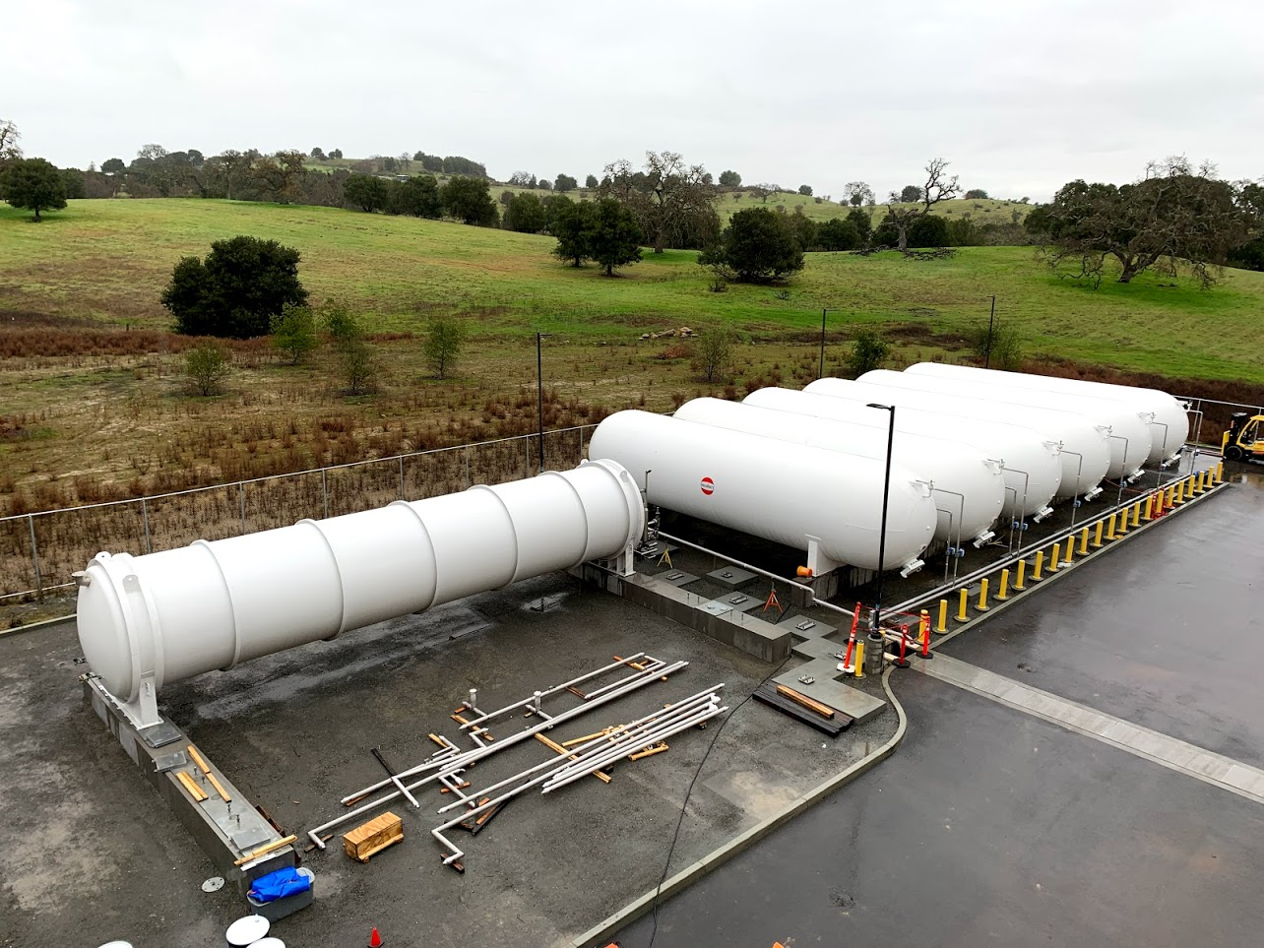

LN2 Dewar Installed into Tank Farm @SLAC

**Major Procurement Status:**



**Upcoming Travel/Deliveries/Reviews:**

* Helium Purifier skid delivery to SLAC 24-Jan-2019
* Weekly site visit to PHPK (4.5K CB) 24-Jan-2019
* Vacuum pump carts (2) 28-Jan-2019
* Ambient heat exchangers (Vaporizers) 30-Jan-2019
* PHPK Monthly Status Review 01-Feb-2019
* LCLS-II Director’s Review (12-14)-Feb-2019