Weekly Reporting

WBS 1.01.07 JLAB Management

Week of January 24-30, 2019

**Issues:**

**Accomplishments this week:**

Working on Director’s Review material.

Continue to wringing out LERF interlocks and controls.

Changing the SRF cavity contract to implement a new doping recipe.

**Upcoming Reviews:**

February 12-14, 2019 Director’s “Mission Success Review”

February 19-21, 2019 EVMS Surveillance - tentative

March 19-21, 2019 DOE OPA Review

Weekly Reporting

WBS 1.04.06 JLAB Cryomodules

Week of January 24-30, 2019

**Issues**:

**Accomplishments this week:**

Working on EAC.

The four-poster for additional WS3 is completed and ready for use.

Shipped J8 to SLAC - departed JLab on 26-Jan and arrived on Tuesday 29-Jan.

Preparing to ship J10 to SLAC – departing JLab on 15-Feb and arriving on 18-Feb.

Participating in FNAL’s 3.9 GHz delta FDR via telecon due to Chicago weather.

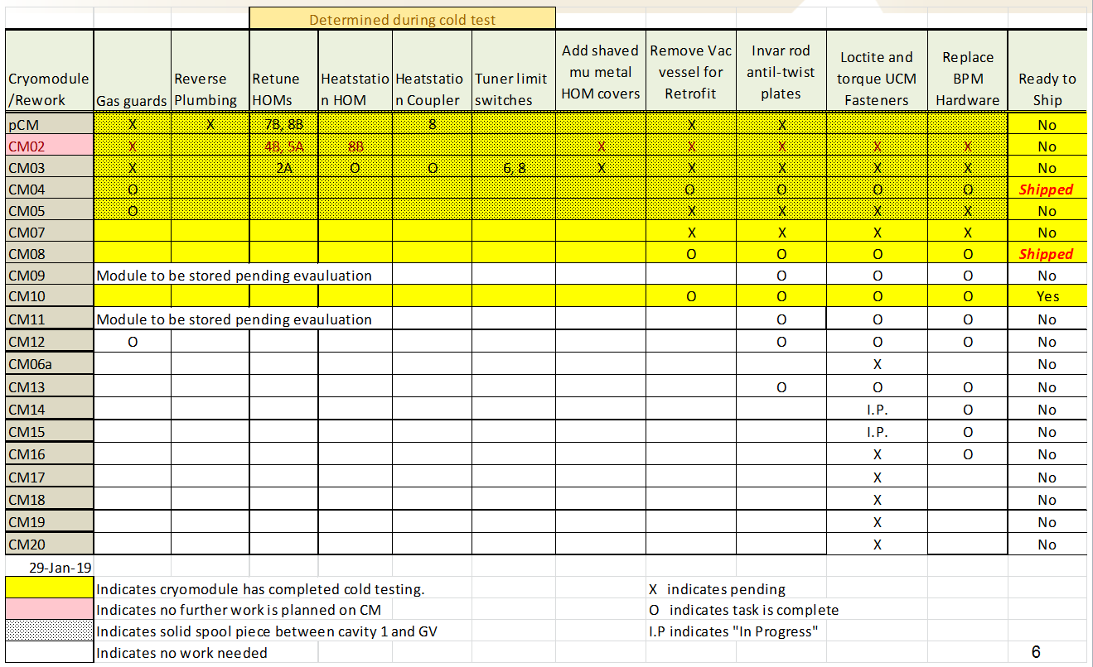

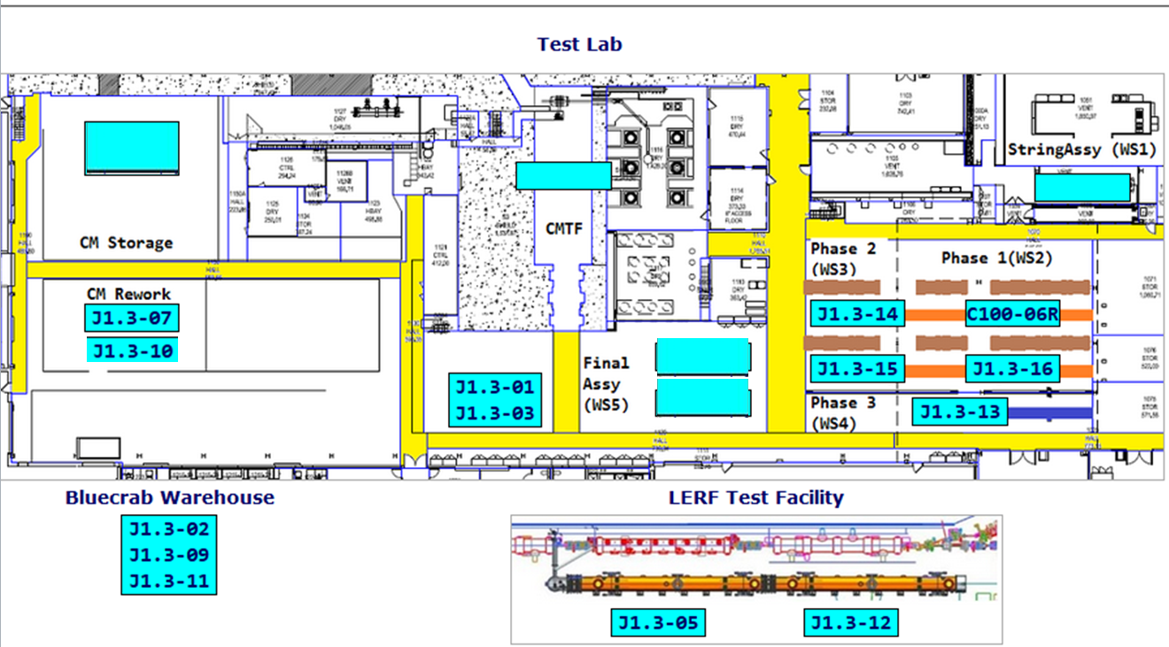

CTF continues to run at reduced capacity on one main compressor. VTA operations continue at reduced capacity until the end of January. J13 cooldown will be gated by installation of the second compressor.

**QUALITY:**  Starting this week, JLab, SLAC, and FNAL QA will start bi-weekly QA calls.

**Upcoming Travel/Meetings:**

* TTC – 5-8 Feb
* Director’s Review – 12-14 Feb
* OPA Review – 19-21 March

Weekly Reporting

WBS 1.04.06 Cryomodules - LERF Conversion

Week of January 24-30, 2019

**Issues:** None

**Accomplishments this week:**

Both CMs are at 2k and quite happy. A 30K temperature cycle was done with excellent results; cavity 1 - 30k/min, cavities 5 & 8 - 12k/min

The technician from Emerson was here this week to setup the Coriolis flow meters, two of the three came up. The third (4.5k Supply) has a wiring issue in the vacuum side of the cryocan. The readouts are all in EPICS and work fine.

A week was lost due to a chassis and firmware for the RF interlocks. Those opportunities are now behind us and interlock checkout is proceeding, next is to confirm that SSAs shut off when requested. The RF checklist will be delivered to management prior to turning on any SSA. Once the interlocks are checked OK then cavities will be brought on resonance and couplers will be tuned.

Weekly Reporting

WBS 1.04.08 JLAB Cryoplant System

Week of January 24-30, 2019

**Issues:**

1. Reduction in baseline resources (return funding to contingency; top-down EAC) without corresponding reduction in scope of cryoplant commissioning.
2. Resolution of structural interferences created during the design of the cold box room platforms and cable trays support systems (*identified in Nov 2017*).
3. Ongoing delays installing interconnecting piping systems in cryoplant is delaying startup of commissioning activities.

**Accomplishments this week:**

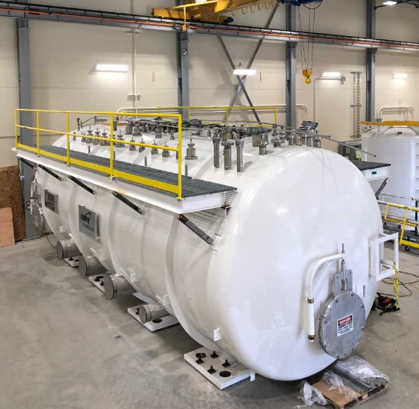

**CP1 4.5K Lower Cold Box Platforms Installed**

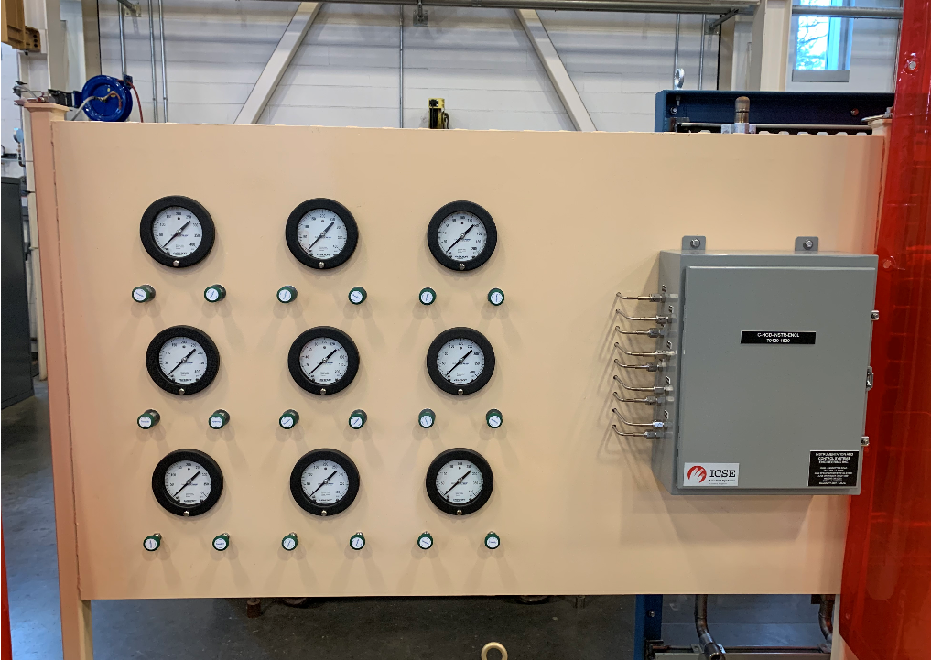

**Helium Gas Distribution Gauge Panel Assembly Complete**

**(JLab Cryo Fab Shop)**

**Major Procurement Status:**



**QUALITY:**

* Project CWI attended kick off meeting for Cryo Plant 2K Helium Test Dewar with Wessington
* Working with Demaco for onsite installation of Cryo Plant Main Transfer Lines and Distribution Boxes
* Working with AES on modified LN2 Dewar tag.

**Upcoming Travel/Deliveries/Reviews:**

* PHPK Monthly Status Review 01-Feb-2019
* LCLS-II Director’s Review (12-14)-Feb-2019
* Ambient heat exchangers (Vaporizers) 15-Feb-2019