Weekly Reporting

WBS 1.01.07 JLAB Management

Week of January 31 to February 6, 2019

**Issues:**

**Accomplishments this week:**

Working on Director’s Review material.

Continue to wringing out LERF interlocks and controls.

Changing the SRF cavity contract to implement a new doping recipe.

**Upcoming Reviews:**

February 12-14, 2019 Director’s “Mission Success Review”

February 19-21, 2019 EVMS Surveillance - tentative

March 19-21, 2019 DOE OPA Review

Weekly Reporting

WBS 1.04.06 JLAB Cryomodules

Week of January 31 to February 6, 2019

**Issues**:

**Accomplishments this week:**

Preparing to ship J10 to SLAC – departing JLab on 16-Feb and arriving on 19-Feb since 18-Feb is holiday with SLAC closed.



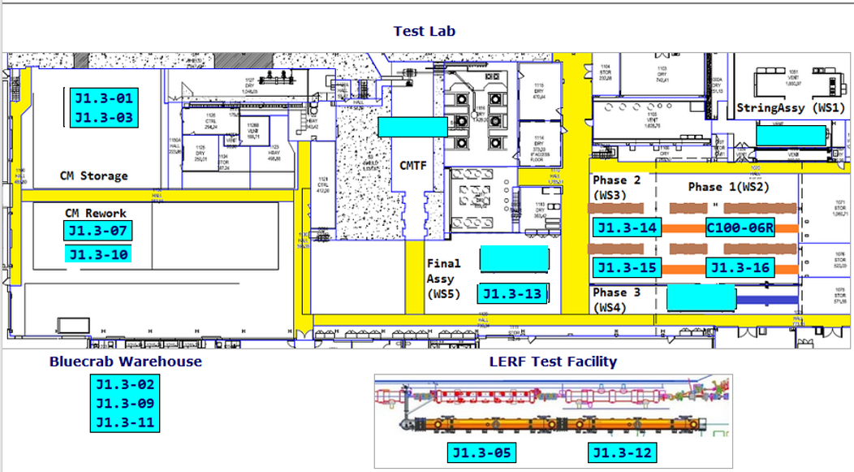

**QUALITY:**  In process high and low pressure welding inspections on CM013 to prepare for RT on 2-16.

**Upcoming Travel/Meetings:**

* TTC – 5-8 Feb
* Director’s Review – 12-14 Feb
* OPA Review – 19-21 March

Weekly Reporting

WBS 1.04.06 Cryomodules - LERF Conversion

Week of January 31 to February 6, 2019

**Issues:** None

**Accomplishments this week:**

RF interlock checks are nearly complete. Replacing the fiber option chassis solved most of the problems. Rama will finish RF checklist this week.

All other systems are operating without any issues.

Weekly Reporting

WBS 1.04.08 JLAB Cryoplant System

Week of January 31 to February 6, 2019

**Issues:**

1. Reduction in baseline resources (return funding to contingency; top-down EAC) without corresponding reduction in scope of cryoplant commissioning.
2. Resolution of structural interferences created during the design of the cold box room platforms and cable trays support systems (*identified in Nov 2017*).
3. Ongoing delays installing interconnecting piping systems in cryoplant is delaying startup of commissioning activities.

**Accomplishments this week:**

* Issued PO to vendor for 40 gal oil vessels manifold piping installation.
* Last batch of pressure regulators delivered to SLAC Feb 6th
* Prepared draft presentation for Director’s Review.

**Major Procurement Status:**

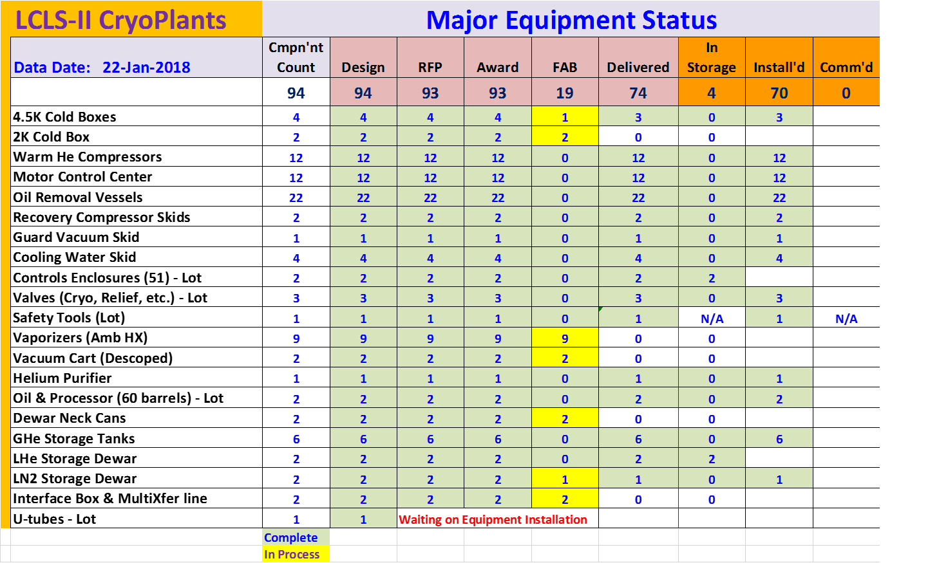

**QUALITY:**

Resolved the issue involving AES LN2 Dewar having a certification and modified tank ID tag. Submitted to SLAC for feedback.

Working with Demaco for onsite installation of Cryo Plant Main Transfer Lines and Interface Boxes.

**Upcoming Travel/Deliveries/Reviews:**

* PHPK Oversight 07-Feb-2019
* LCLS-II Director’s Review (12-14)-Feb-2019
* PHPK Oversight 14-Feb-2019
* Ambient heat exchangers (Vaporizers) 15-Feb-2019
* PHPK/Linde Oversight (20-21)-Feb-2019
* CP1 dewar neck can final leak test (Ability Engineering) 28-Feb-2019