Weekly Reporting

WBS 1.01.07 JLAB Management

Week of February 7-13, 2019

**Issues:**

**Accomplishments this week:**

Presented progress status and planning for Director’s Project Review at SLAC.

Continue to wringing out LERF interlocks and controls.

Changing the SRF cavity contract to implement a new doping recipe.

**Upcoming Reviews:**

February 12-14, 2019 Director’s “Mission Success Review”

February 27-March 1st, 2019 EVMS Surveillance Review

March 19-21, 2019 DOE OPA Review

Weekly Reporting

WBS 1.04.06 JLAB Cryomodules

Week of February 7-13, 2019

**Issues**: Delay in start of string 17 may impact CM test and delivery schedule.

**Accomplishments this week:**

Providing details to System Manager on cavity performance incentives earned at EZ.

Prepared presentations for and participating in Director’s Review at SLAC.

Preparing to ship J10 to SLAC – departing JLab on 16-Feb and arriving on 19-Feb since 18-Feb is holiday with SLAC closed.

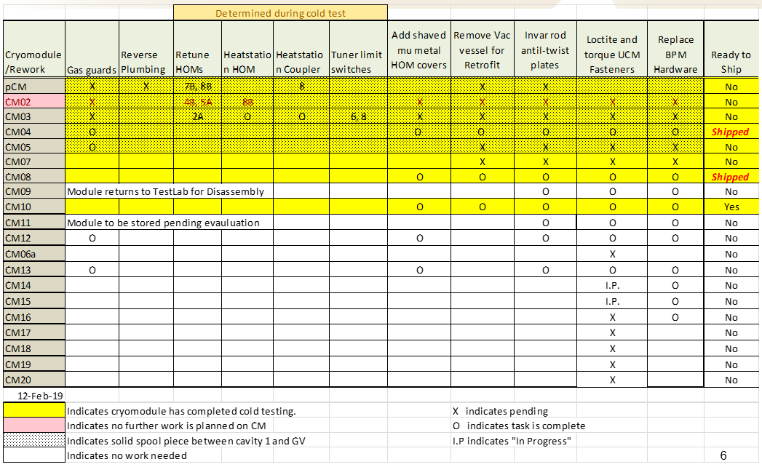

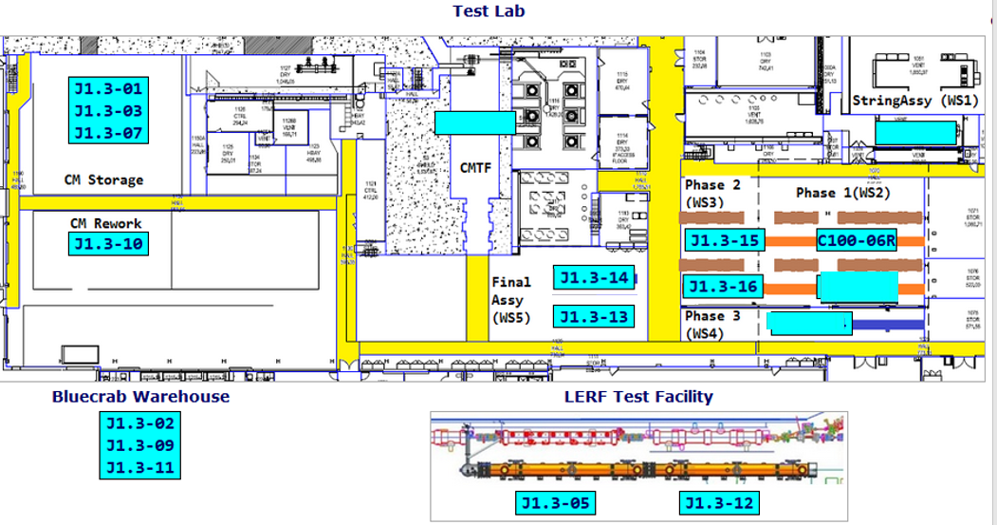

**QUALITY:**

* Continue in process high and low pressure welding inspections on CM013 to prepare for RT on 2-16.
* Pressure testing on low pressure circuit for CM013.
* In process inspections on the removal and replacement of leaking 4 inch 2 phase T piping component for CM015 (UCM026).

**Upcoming Travel/Meetings:**

* Director’s Review – 12-14 Feb
* Cavity Vendor Contract Close-out Visits to RI & EZ (Wilson, Laney) – 10-15 Feb
* OPA Review – 19-21 March

Weekly Reporting

WBS 1.04.06 Cryomodules - LERF Conversion

Week of February 7-13, 2019

**Issues:** None

**Accomplishments this week:**

Work continued on RF interlocks, testing to start when folks are done with commissioning workshop.

Weekly Reporting

WBS 1.04.08 JLAB Cryoplant System

Week of February 7-13, 2019

**Issues:**

1. Reduction in baseline resources (return funding to contingency; top-down EAC) without corresponding reduction in scope of cryoplant commissioning.
2. Resolution of structural interferences created during the design of the cold box room platforms and cable trays support systems (*identified in Nov 2017*).
3. Ongoing delays installing interconnecting piping systems in cryoplant is delaying startup of commissioning activities.

**Accomplishments this week:**

* First batch of gauge panels nearing completion for shipment this month.
* Shipping 40 gallon oil tanks to vendor for manifold installation.
* All pressure regulators delivered to SLAC.
* Presented Status and Planning for Director’s Review.

**Major Procurement Status:**



**Vendor Progress:**

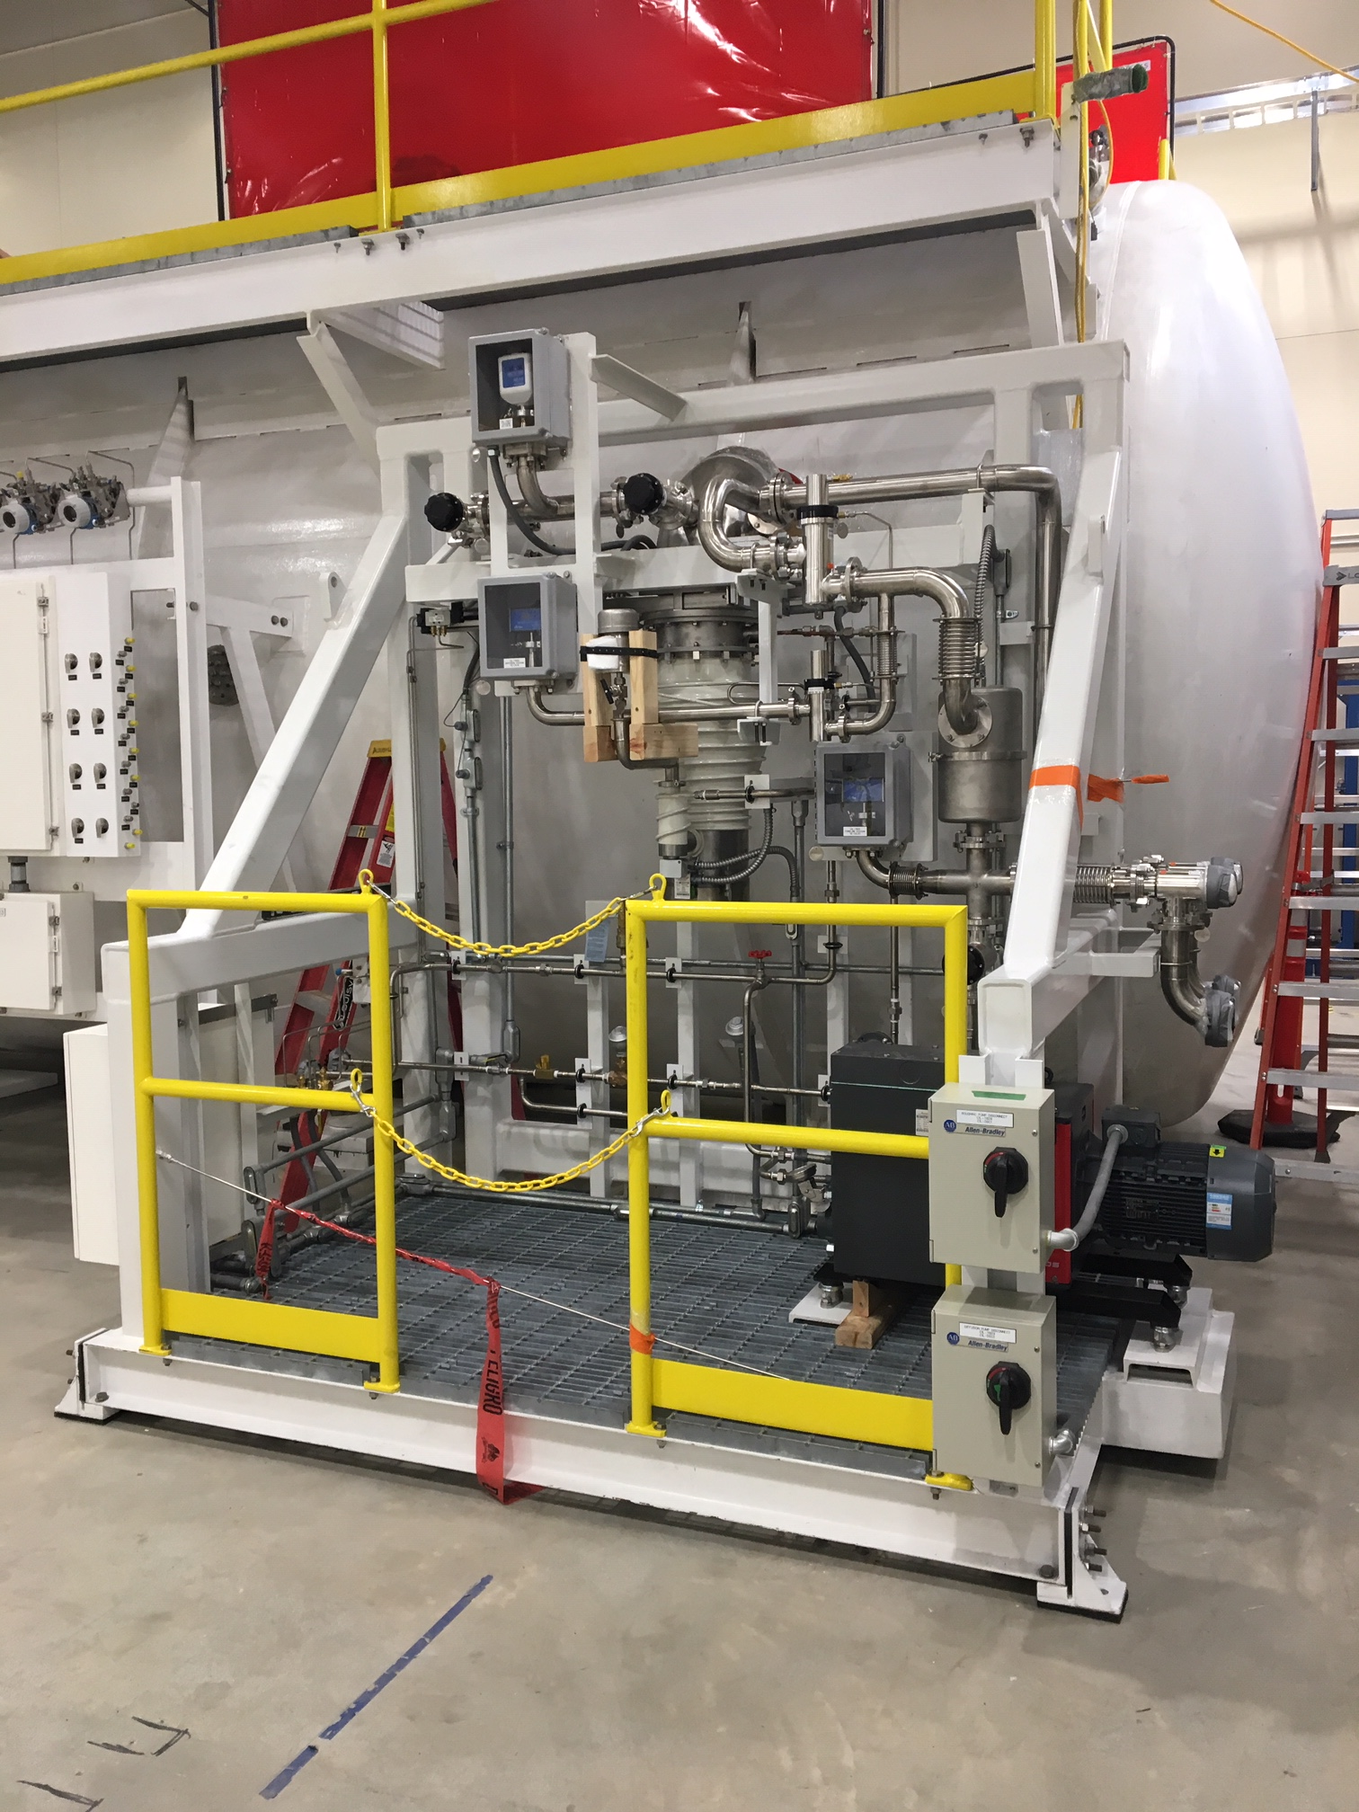 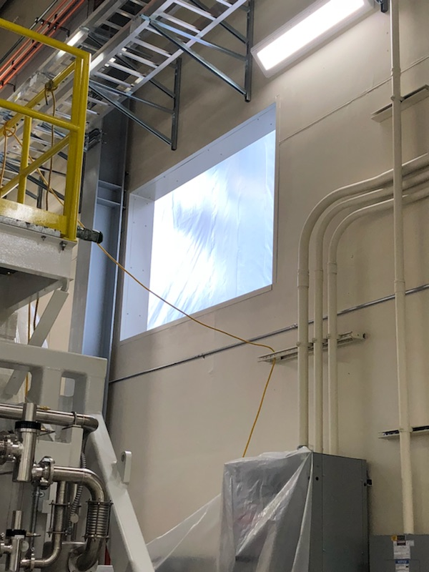

C1 Vacuum pump skid (Lower Cold Box) & access hole for CryoDuct installed @SLAC

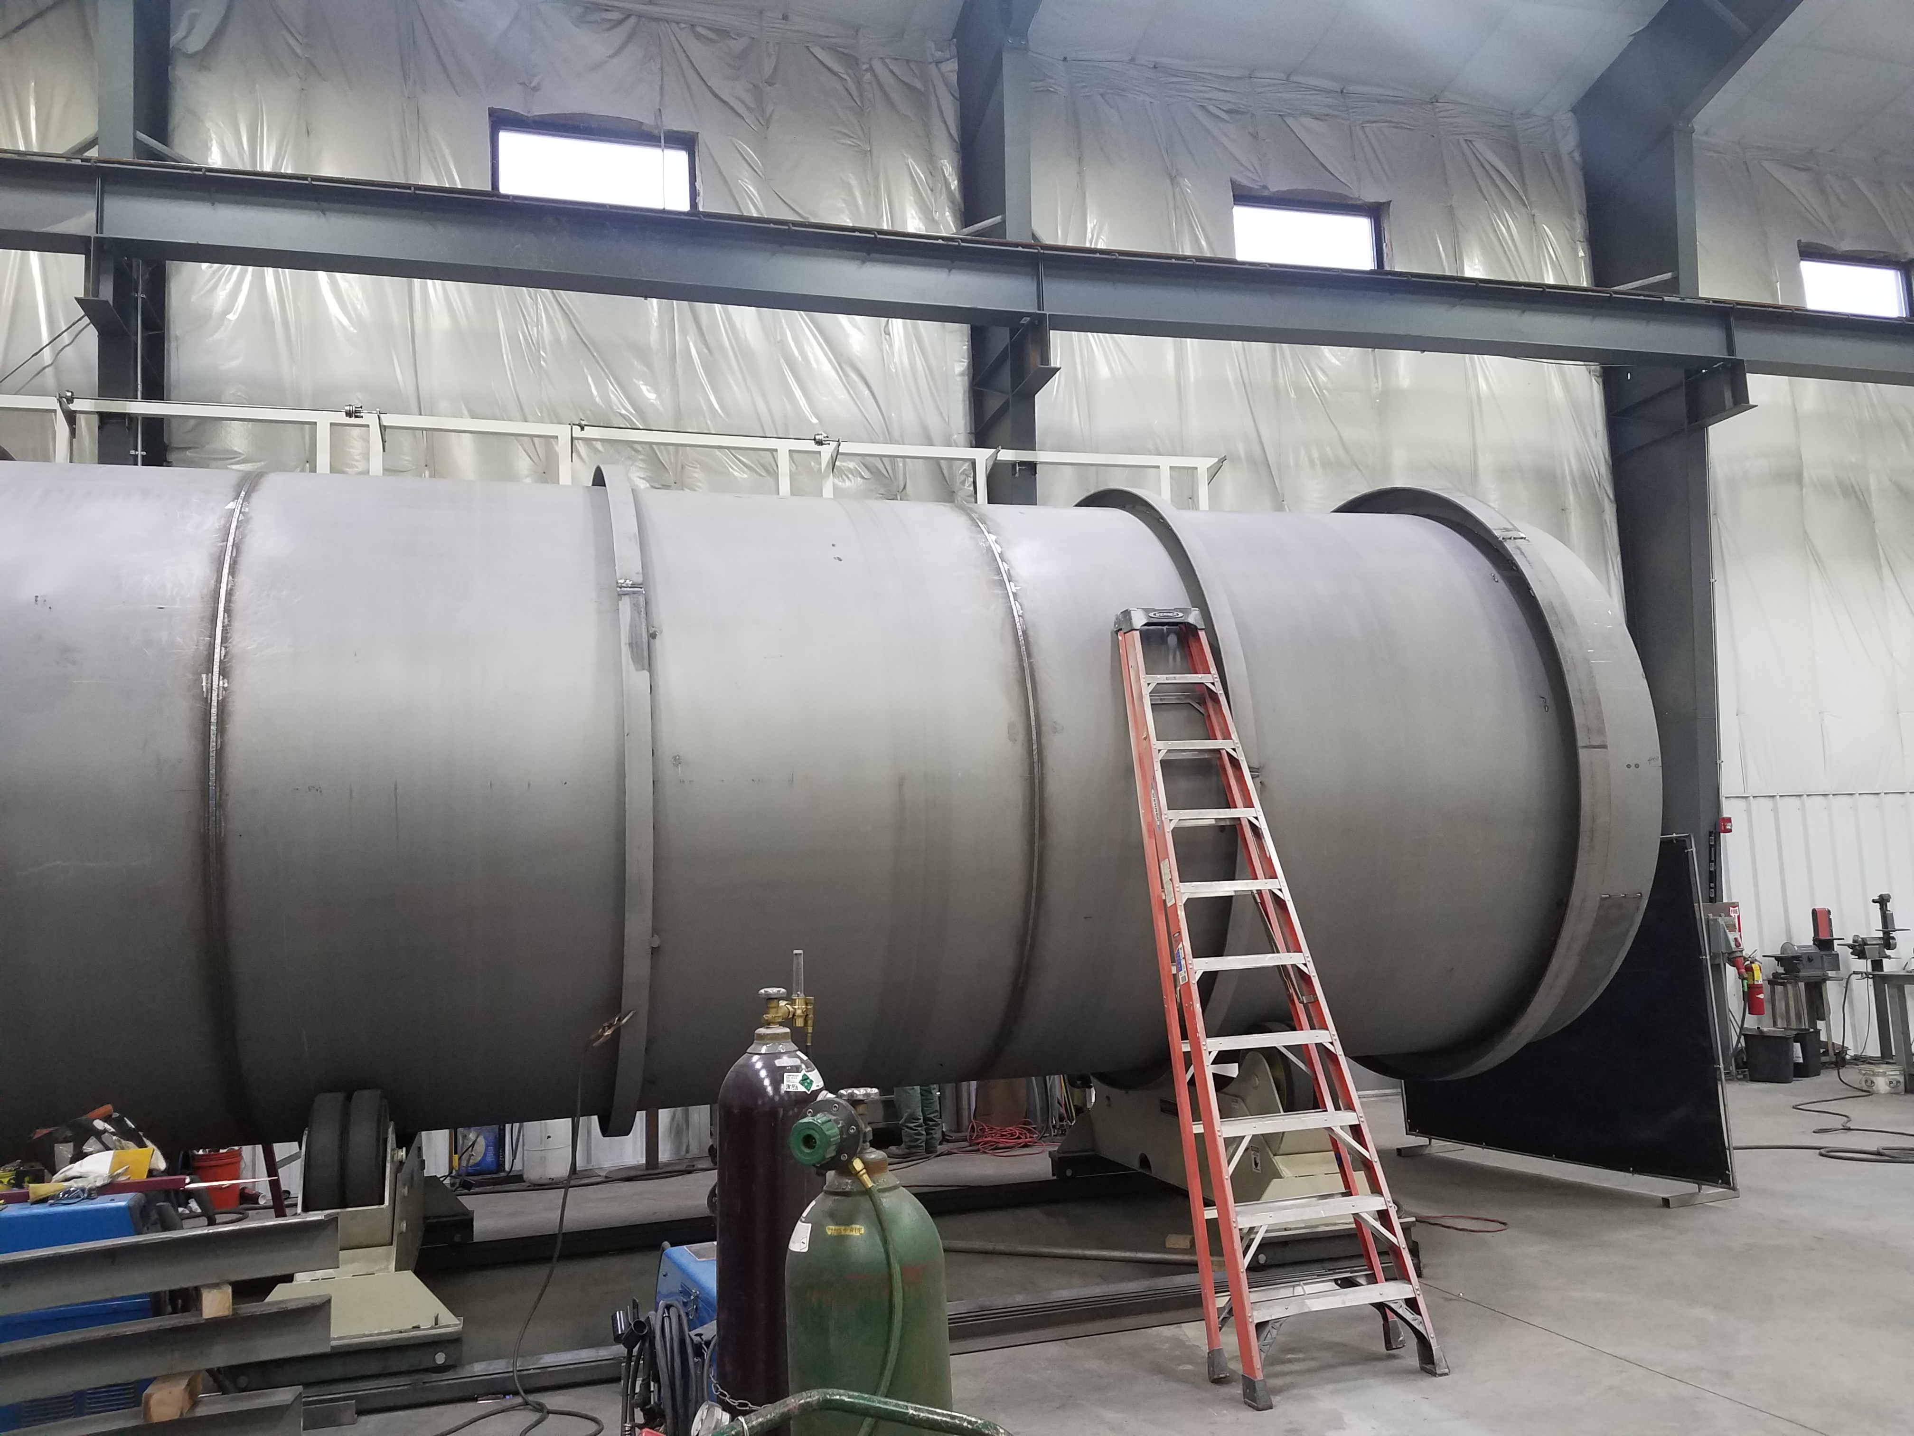

Outer vessel for 2nd LN2 Dewar nearing completion

**QUALITY:**

* Site visit to LN2 Dewar manufacturer to witness progress on second Dewar.
* Working with Demaco for onsite installation of Cryo Plant Main Transfer Lines and Interface Boxes.

**Upcoming Travel/Deliveries/Reviews:**

* LCLS-II Director’s Review (12-14)-Feb-2019
* PHPK Oversight 14-Feb-2019
* Ambient heat exchangers (Vaporizers) vendor site visit 19-Feb-2019
* 2K Cold box - PHPK/Linde Oversight (20-21)-Feb-2019
* Delivery of Vaporizers 26-Feb-2019
* CP1 Dewar neck can final leak test (Ability Engineering) 28-Feb-2019
* 4.5K Lower cold box Status meeting @PHPK 01-March-2019