Weekly Reporting

WBS 1.01.07 JLAB Management

Week of February 14-20, 2019

**Issues:**

**Accomplishments this week:**

* Participated in follow-up planning to address recommendations from Director’s Project Review held at SLAC.
* Progressing with wringing out LERF interlocks and controls.
* SRF cavity contract being modified to implement a new doping recipe.

**Upcoming Reviews:**

February 27-March 1, 2019 EVMS Surveillance Review

March 19-21, 2019 DOE OPA Review

Weekly Reporting

WBS 1.04.06 JLAB Cryomodules

Week of February 14-20, 2019

**Issues**: Delay in start of string 17 may impact CM test and delivery schedule.

**Accomplishments this week:**

Providing details to System Manager on cavity performance incentives earned at EZ.

Preparing proposal for reducing rework on J1.3-01 to improve schedule and reduce cost.

Participated in Director’s Review at SLAC. Received feedback on presentation and began folding comments into OPA slides.

Shipped J10 to SLAC – the CM arrived on 19-Feb with beamline vacuum intact.

J-13 is in the CMTF and will be cooled down beginning 22-Feb.

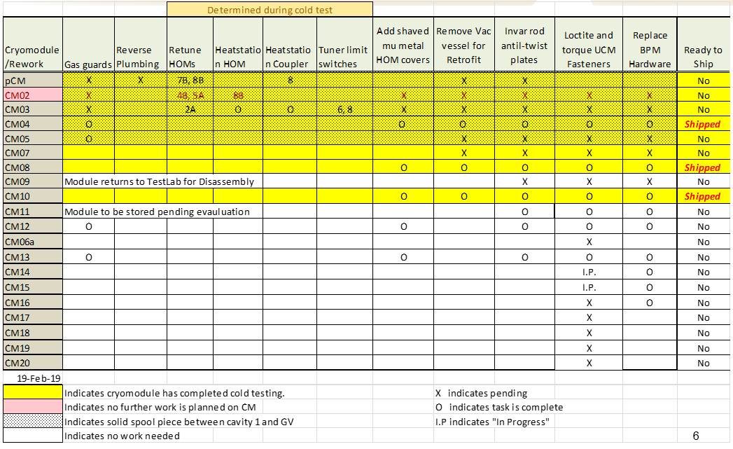

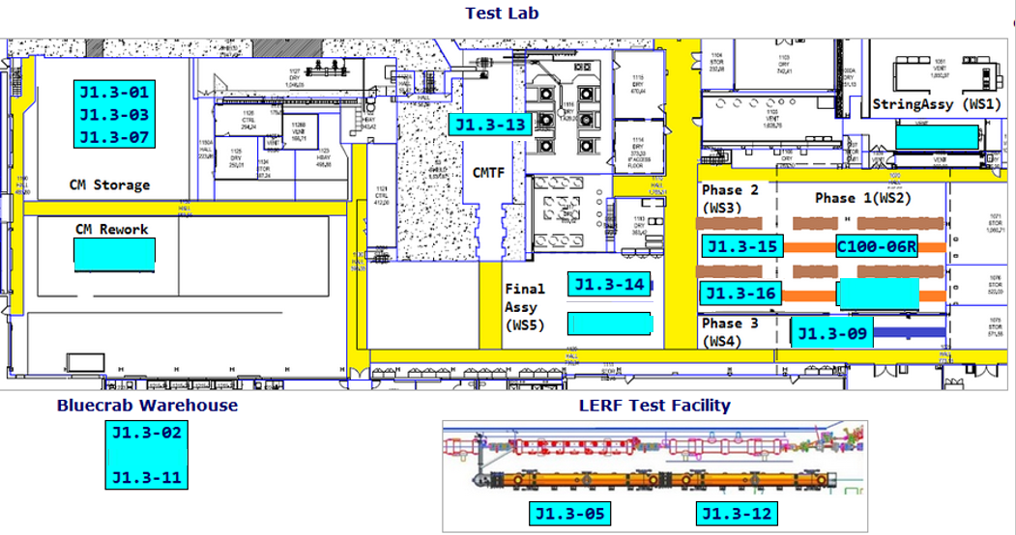

**QUALITY:**

* In process high and low pressure welding inspections on CM014 to prepare for RT on 2-16
* Pressure testing on low pressure circuit for CM014
* Inspections on the removal and replacement of leaking 4 inch 2 phase T piping component for CM015 (UCM026) are completed
* RT of high pressure welding on both CM013 and 014 done Saturday 2-16.  All welds passed

**Upcoming Travel/Meetings:**

* OPA Review – 19-21 March

Weekly Reporting

WBS 1.04.06 Cryomodules - LERF Conversion

Week of February 14-20, 2019

**Issues:** None

**Accomplishments this week:**

No report.

Weekly Reporting

WBS 1.04.08 JLAB Cryoplant System

Week of February 14-20, 2019

**Issues:**

1. Reduction in baseline resources (return funding to contingency; top-down EAC) without corresponding reduction in scope of cryoplant commissioning.
2. Resolution of structural interferences created during the design of the cold box room platforms and cable trays support systems (*identified in Nov 2017*).
3. Ongoing delays installing interconnecting piping systems in cryoplant is delaying startup of commissioning activities.

**Accomplishments this week:**

* First batch of gauge panels nearing completion for shipment this month.
* Shipping 40 gallon oil tanks to vendor for manifold installation.
* Review Risk Registryin prep for OPA Review.

**Major Procurement Status:**



**Gauge Panels (manufactured @Jefferson Lab):**

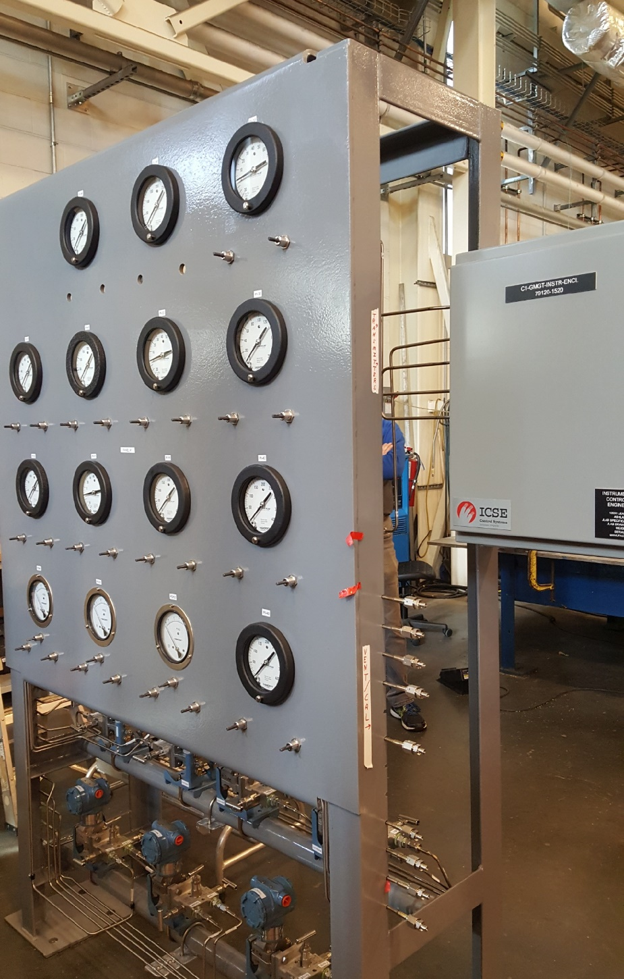 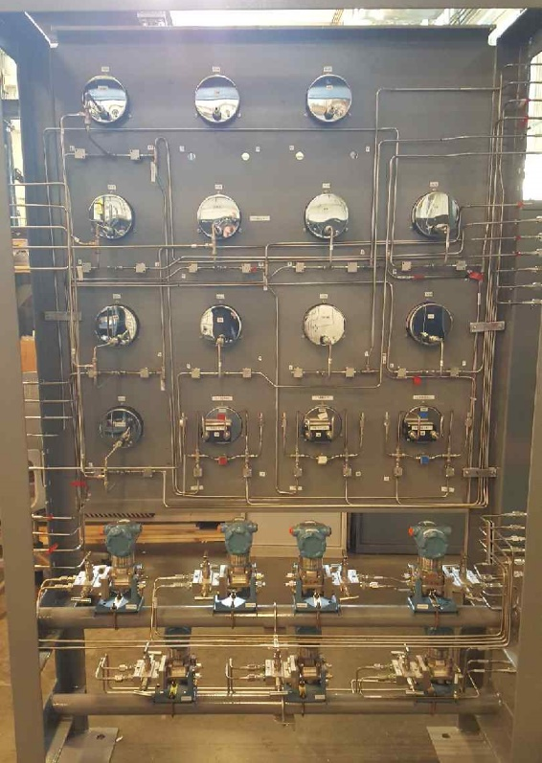

**QUALITY:**

* Site visits to 2K & 4.5K cold box and ambient vaporizers manufacturers to witness progress and push schedule.
* Working with Demaco for onsite installation of Cryo Plant Main Transfer Lines and Interface Boxes.

**Upcoming Travel/Deliveries/Reviews:**

* 2K Cold box - PHPK/Linde Oversight (P&ID checkout) (20-22)-Feb-2019
* Delivery of Vaporizers 26-Feb-2019
* CP1 Dewar neck can final leak test (Ability Engineering) 28-Feb-2019
* Lower cold box status meeting @PHPK 01-March-2019
* Ambient heat exchangers (Vaporizers) vendor site visit 09-Mar-20194.5K