Weekly Reporting

WBS 1.01.07 JLAB Management

Week of February 21-27, 2019

**Issues:**

**Accomplishments this week:**

* Participated in follow-up planning to address recommendations from Director’s Project Review held at SLAC.
* LERF:
  + Two CMs in vault (J-05, J-12)
  + Fast cooldown demonstrated Iate January
  + CMs cold, on resonance, FPCs tuned
  + Progressing with wringing out LERF interlocks and controls.
* SRF cavity contract being modified to implement a new doping recipe.

**Upcoming Reviews:**

February 27-March 1, 2019 EVMS Surveillance Review

March 19-21, 2019 DOE OPA Review

Weekly Reporting

WBS 1.04.06 JLAB Cryomodules

February 21-27, 2019

**Issues**: Delay in start of string 17 may impact CM test and delivery schedule.

**Accomplishments this week:**

Provided details to System Manager on cavity performance incentives earned at EZ and RI.

Preparing proposal for reducing rework on J1.3-01 to improve schedule and reduce cost.

Preparing presentations for dry run in advance of OPA review.

Submitting month end status. Preparing VARs for January.

J-13 is in the CMTF and cooled down. Cavity frequencies and coupler Qexts have been set. Started testing maximum gradients.

Worked on steady state Q0 measurement techniques in LERF while awaiting availability of LERF LLER system.

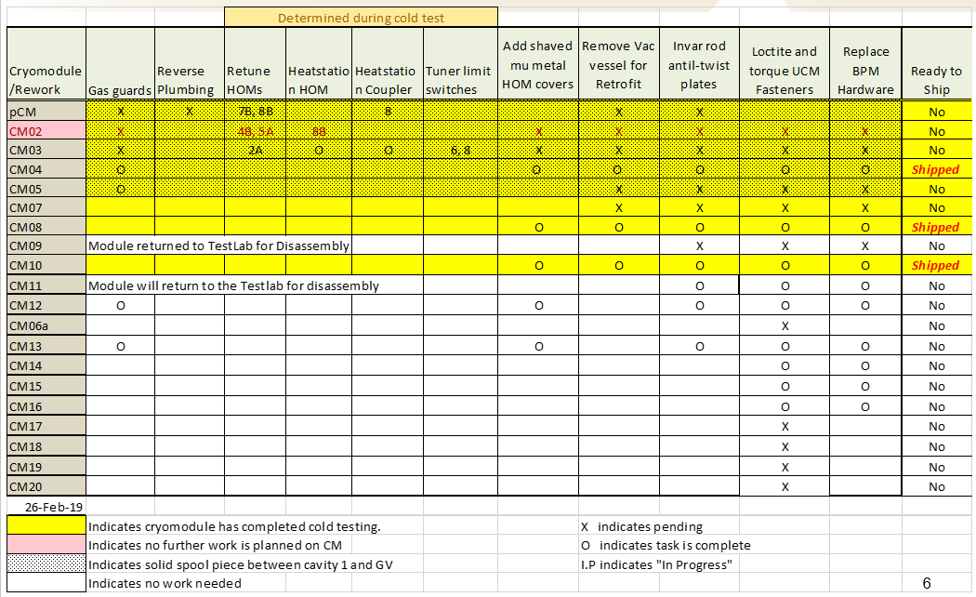

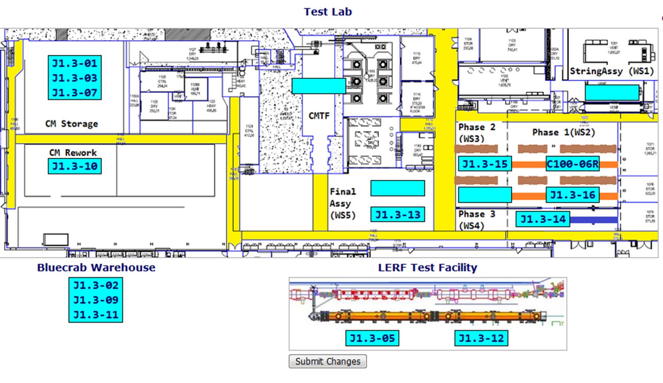

**QUALITY:** No report.

**Upcoming Travel/Meetings:**

* OPA Review – 19-21 March

Weekly Reporting

WBS 1.04.06 Cryomodules - LERF Conversion

Week of February 21-27, 2019

**Issues:** None

**Accomplishments this week:**

LLRF troubleshooting continues. The system integration is now in full swing and saving commissioning time at SLAC.

Weekly Reporting

WBS 1.04.08 JLAB Cryoplant System

Week of February 21-27, 2019

**Issues:**

1. Reduction in baseline resources (return funding to contingency; top-down EAC) without corresponding reduction in scope of cryoplant commissioning.
2. Resolution of structural interferences created during the design of the cold box room platforms and cable trays support systems (*identified in Nov 2017*).
3. Ongoing delays installing interconnecting piping systems in cryoplant is delaying startup of commissioning activities.

**Accomplishments this week:**

* Complete P&ID verification with 2K & 4.5K cold boxes @PHPK.
* Site visit to ambient vaporizer vendor to witness and expedite delivery to SLAC.
* Utility & gas management gauge panels scheduled for shipment in one week.
* 40-gallon oil tanks @ vendor for manifold installation.
* Review Risk Registry in prep for OPA Review.

**Major Procurement Status:**



**QUALITY:**

* CWI verification of LN2 Dewar manufacturing as per ASME code compliance.

**Upcoming Travel/Deliveries/Reviews:**

* 4.5K cold box monthly schedule update @PHPK 01-Mar-2019
* CP1 Dewar neck can final leak test (AET) 7-Mar-2019
* Vaporizers delivery to SLAC 8-Mar-2019
* First batch of gauge panels delivery to SLAC 12-Mar-2019
* DOE OPA Project Review 19-21-Mar-2019