**LCLS-II FEBRUARY PROJECT STATUS REPORT**

**DATE:** March 4, 2019

**LOCATION OF PROJECT:** Jefferson Lab

**SENIOR TEAM LEAD:** Joe Preble

**MONTHLY PROGRESS**

Summary

JLab continues to make significant progress in all areas. Cost, schedule, and scope are being managed to the baseline. We received earned value and variance data, analyzed data and submitted VARs.

EV performance is as of January close

Overall % complete = 85%, SPI = 0.93, CPI = 0.97

Management

Presented progress status and planning for the Director’s Project Review at SLAC, February 12-14.

Shipped J10 to SLAC February 16; cryomodule arrived at SLAC on February 19.

BCRs Awarded: CP Bundle Mod/Award

Cryoplant System:

EV Performance

Overall % complete = 83%, SPI = 0.93, CPI = 0.96

Issued PO to vendor for 40 gallon oil vessels manifold piping installation. Shipped the 40-gallon oil tanks to vendor for manifold installation. Last batch of pressure regulators delivered to SLAC Feb 6, 2019. First batch of gauge panels nearing completion. Presented Status and Planning for Director’s Review. Completed P&ID verification with 2K and 4.5K cold boxes at vendor. Attended schedule update at the 4.5 K CB fabrication vendor. The schedule for delivery of the last cold box and all associated equipment improved to 14 June.

Major Equipment

Component Count = 94. Delivered = 76. In Fabrication = 17. Installed = 72. In storage = 3.



Work continued on the 4.5K Cold Boxes:

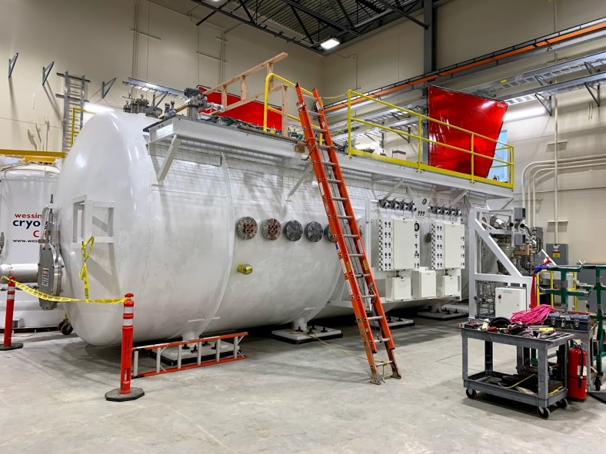

C1 4.5K Lower Cold Box Reassembly at SLAC.

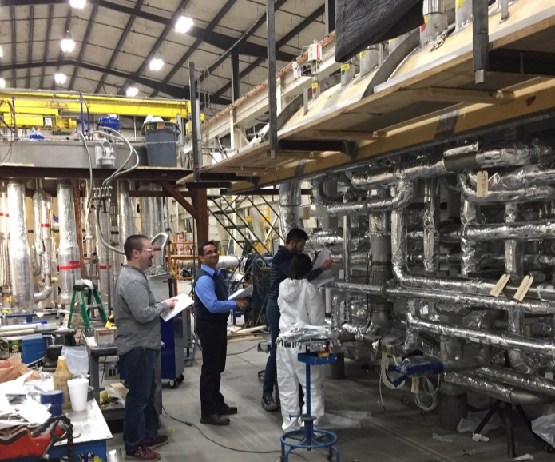

C2 4.5K Lower Cold Box fabrication at vendor.

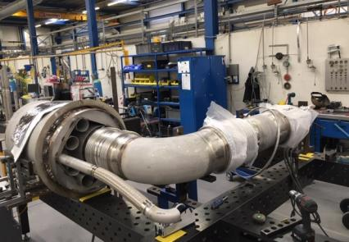 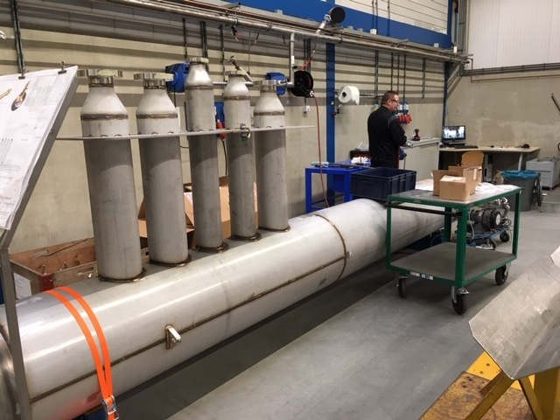

C1 Multi-transfer lines in fabrication at vendor.

Work continued on the 2K Cold Boxes at both vendors. The cold boxes are scheduled for delivery in April and May.

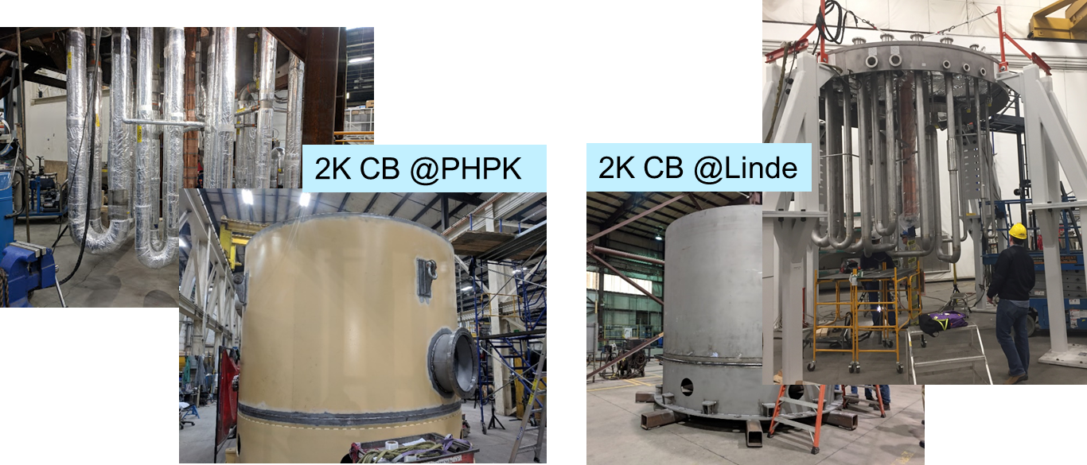

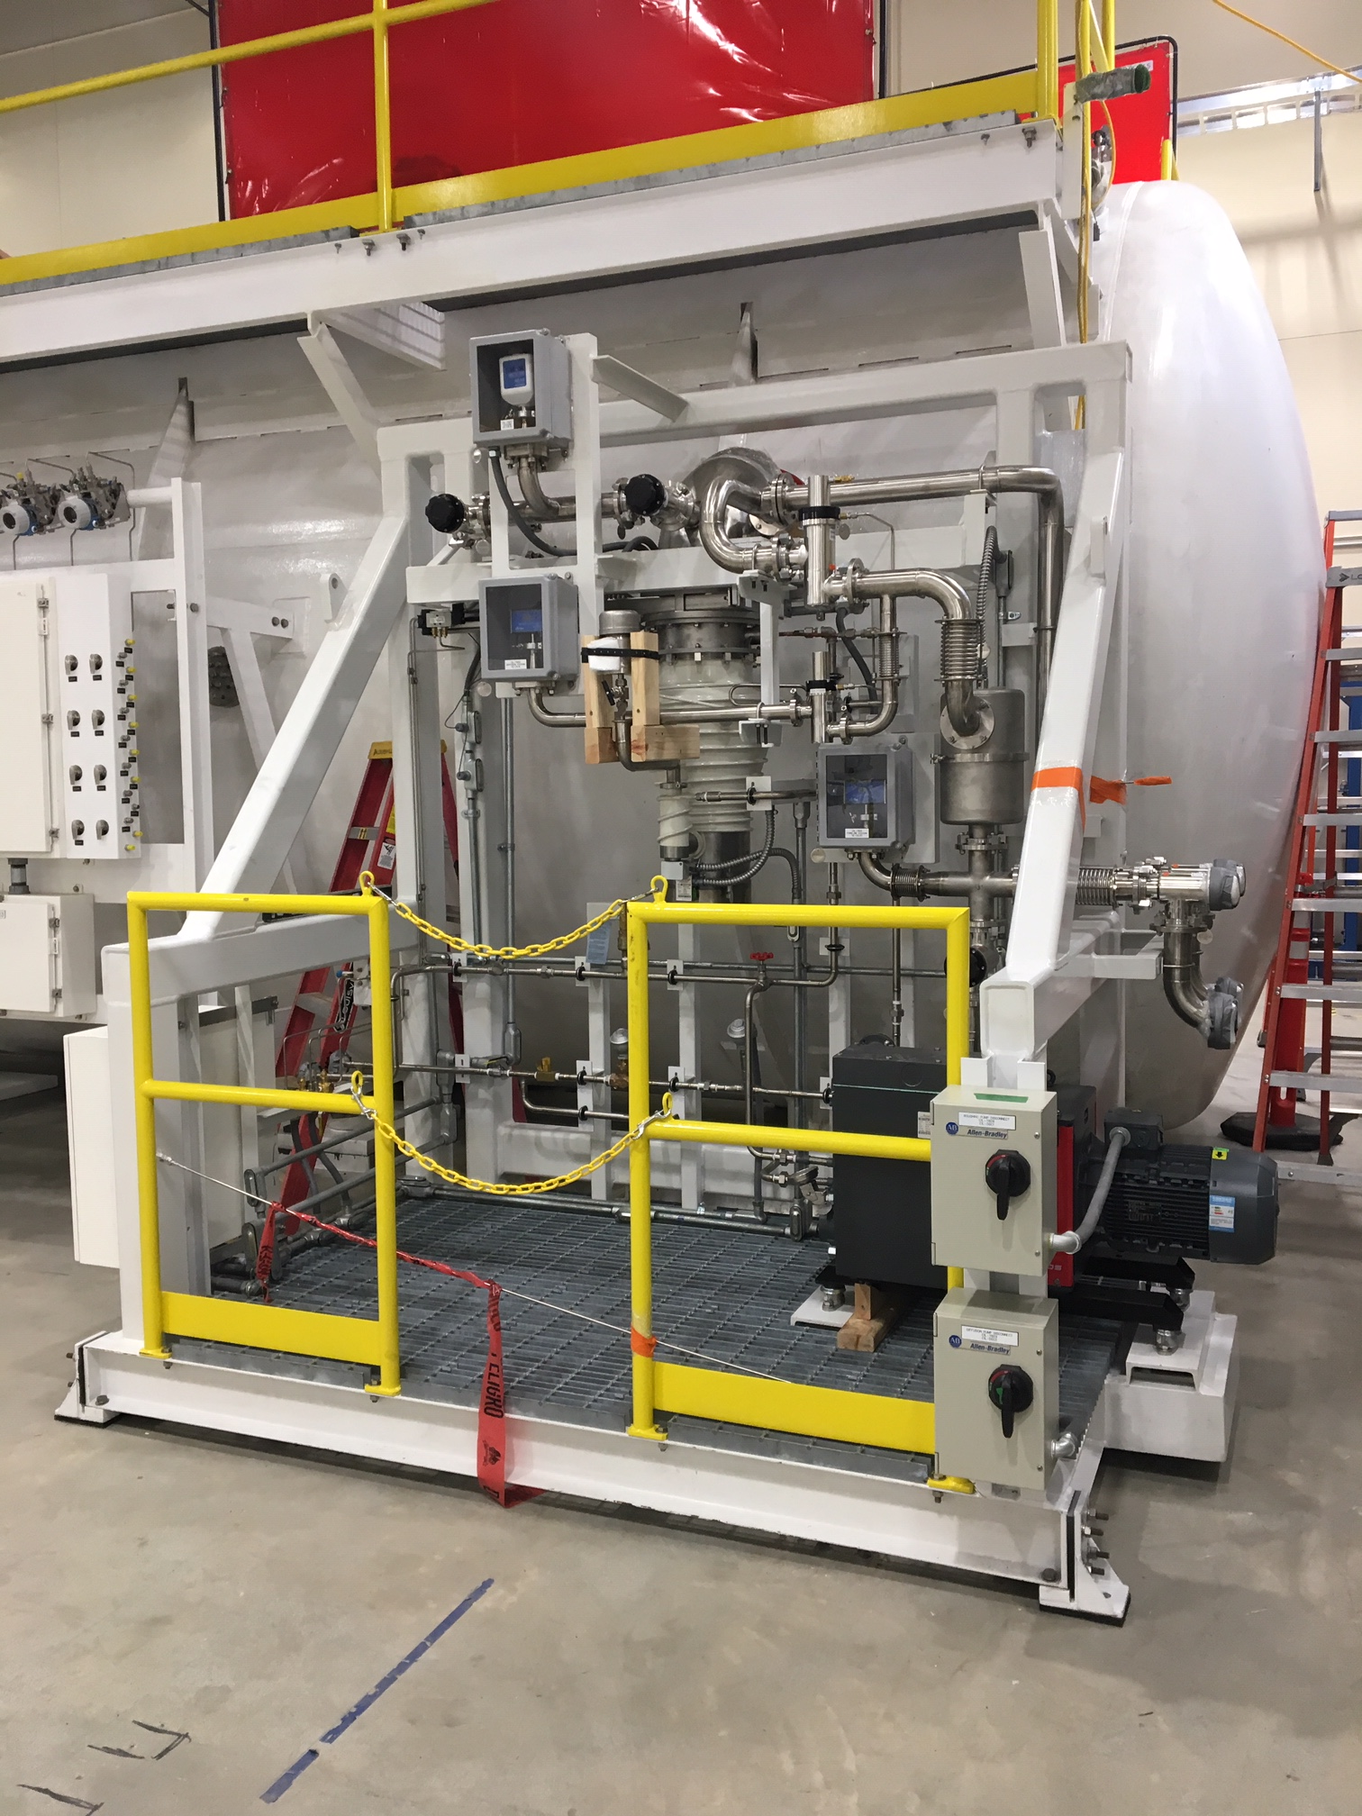

C1 Vacuum pump skid installed.

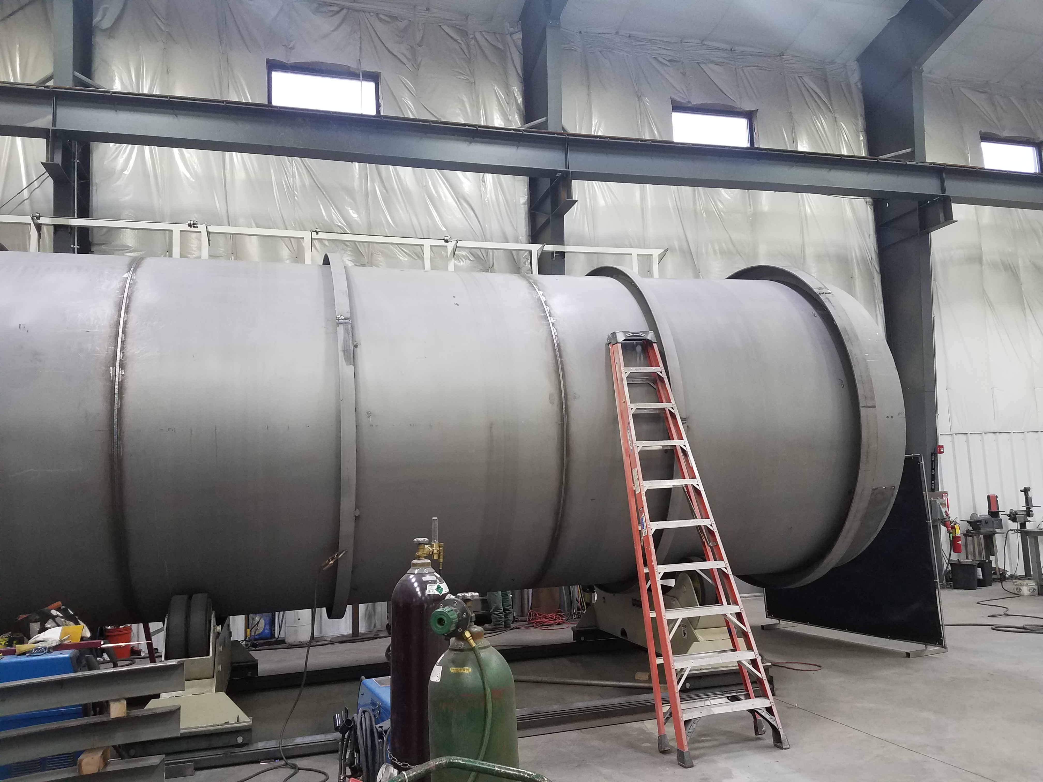

Outer vessel for 2nd LN2 Dewar nearing completion.

|  |  |
| --- | --- |
|  |  |

Gauge panels (manufactured at JLab).

Cryomodules:

EV performance

Overall % complete = 87%, SPI = 0.92, CPI = 0.96

Successfully shipped J10 to SLAC February 16; the cryomodule arrived on February 19 with beamline vacuum intact.

J-13 is in the CMTF and cooled down. Cavity frequencies and coupler Qexts have been set. Started testing maximum gradients.

Worked on steady state Q0 measurement techniques in LERF while awaiting availability of LERF LLER system.

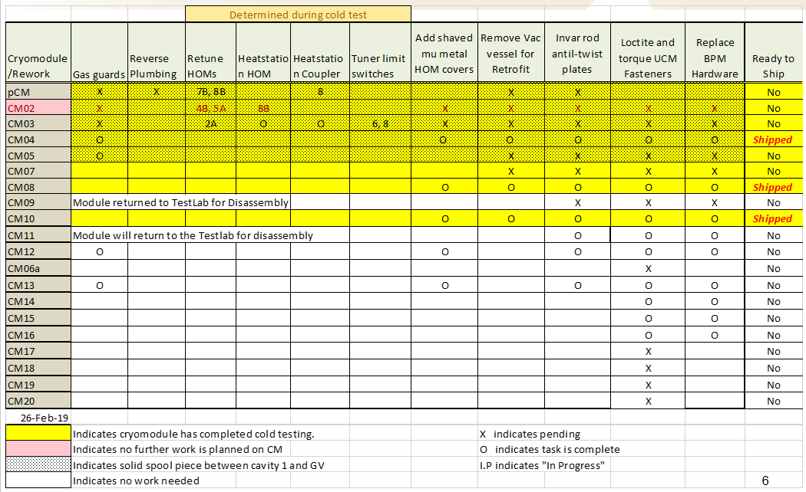

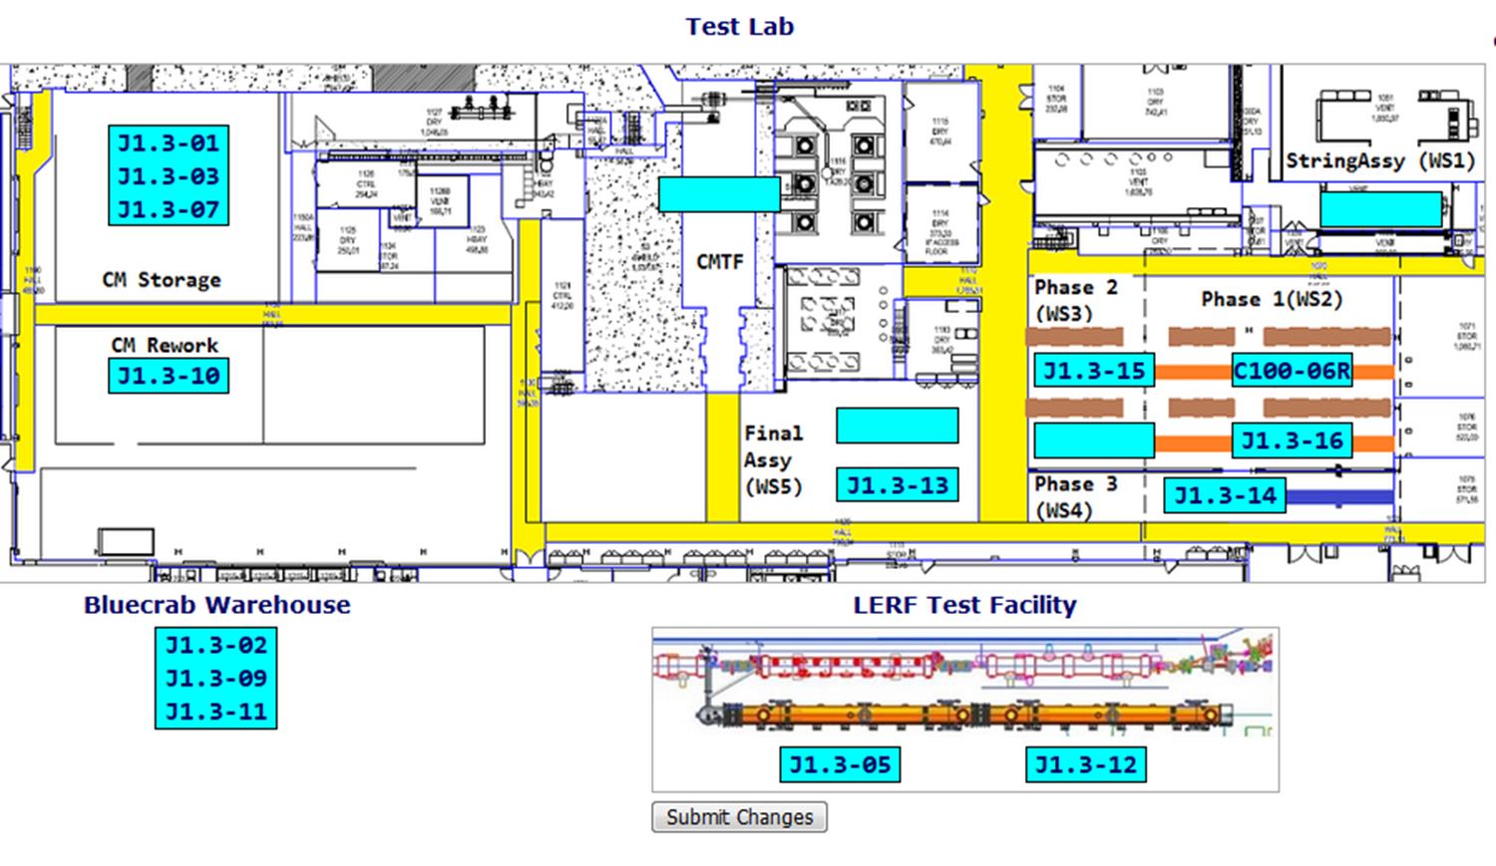

Low Energy Recirculating Facility (LERF): Two cryomodules (J1.3-05 and J1.3-12) are in vault. They are cold; on resonance; FPCs tuned. Progressing with wringing out LERF interlocks and controls software. Two LBNL and one SLAC staff members are coming to JLab the first week of March to fix the software.