Weekly Reporting

WBS 1.01.07 JLAB Management

Week of March 7-13, 2019

**Issues:**

**Accomplishments this week:**

* Preparations for the OPA review continue.
* LERF:
  + Experts from LBNL and SLAC have LLRF software working. Development work on software continues.
  + Began Emax testing on Monday 11-MAR.
* CMTF testing of CM 13 is ongoing; total voltage of > 150 MV. Q0 measurements and multi-cavity runs in progress. Pre-warm up review scheduled for 14-MAR.

**Upcoming Reviews:**

March 19-21, 2019 DOE OPA Review

Weekly Reporting

WBS 1.04.06 JLAB Cryomodules

Week of March 7-13, 2019

**Issues**: Delay in start of string 17 may impact CM test and delivery schedule.

**Accomplishments this week:**

Submitted proposal for reducing rework on J1.3-01 to improve schedule and reduce cost.

Final preparations for OPA review ongoing.

Received email authorization for two control accounts that need increased spending authorization (1.4.6.15, 1.4.6.20) in line with the EAC values.

J-9 disassembly ongoing at new WS3.

J-13 is in the CMTF. Tested maximum gradients – total CM voltage ~150 MV. Six cavities FE free, two with FE onset above 10 MV/m. Continuing Q0 testing with resulting values ranging from 2.6e10 to 3.0e10.

J-12 testing started in LERF on 11-Mar. Completed Cav 8 Emax Run at 18.9 MV/m; FE turn on at ~12.7 MV/m. Completed cavity 7 run at 19.6 for one hour. No FE seen. Completed cavity 4 ran up to 21 MV/m - no FE, no quench. One-hour run completed.



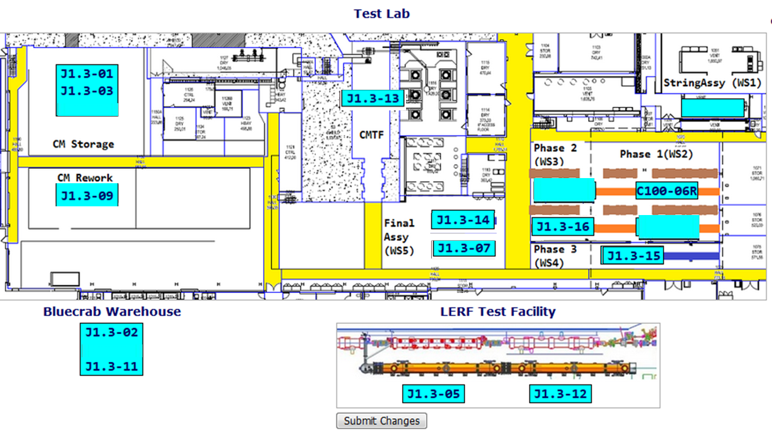

**QUALITY:** No report.

**Upcoming Travel/Meetings:**

* OPA Review – 19-21 March

Weekly Reporting

WBS 1.04.06 Cryomodules - LERF Conversion

Week of March 7-13, 2019

**Issues:** None

**Accomplishments this week:** No report.

Weekly Reporting

WBS 1.04.08 JLAB Cryoplant System

Week of March 7-13, 2019

1. Reduction in baseline resources (return funding to contingency; top-down EAC) without corresponding reduction in scope of cryoplant commissioning.
2. Resolution of structural interferences created during the design of the cold box room platforms and cable trays support systems (*identified in Nov 2017*).
3. Delays installing interconnecting piping systems in cryoplant is delaying startup of commissioning activities.

**Accomplishments this week:**

* Weekly site visit to witness and consult on status of the 4.5K cold box @PHPK.
  + Delivery pulled forward 2-weeks to mid-June.
* Utility & gas management gauge panels delivered to SLAC.
* Vaporizers (ambient heat exchangers) delivered to SLAC.
* Provide feedback to reviewer questions in prep for OPA Review.

**Major Procurement Status:**



**Deliveries:**

* First batch of Gauge panels (manufactured @ JLab) delivered to SLAC

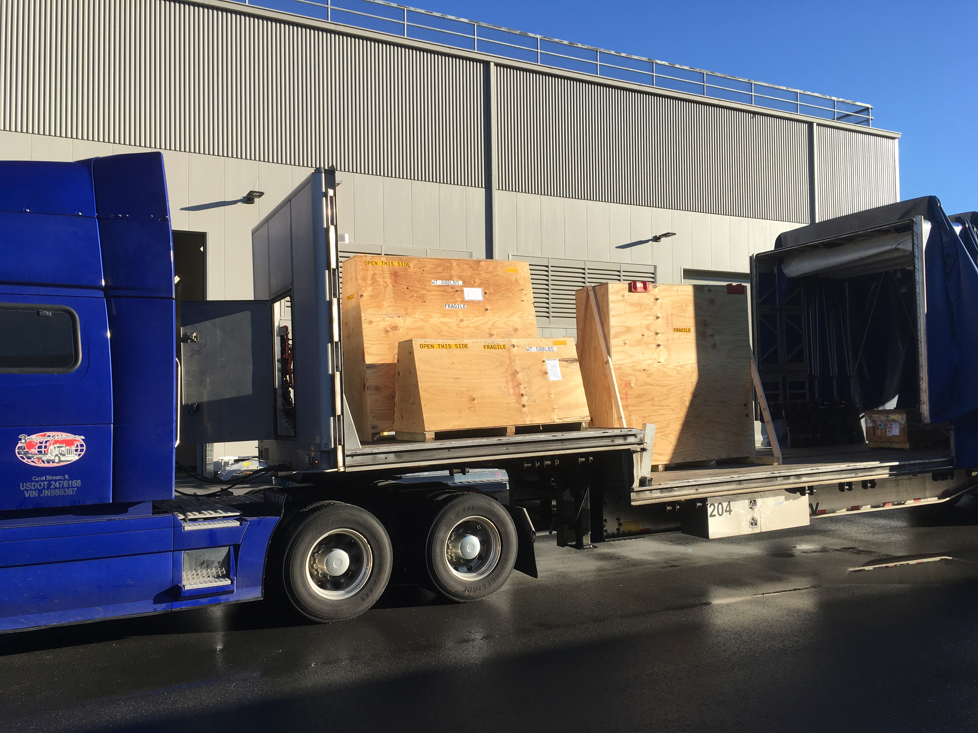

* Vaporizers delivered to SLAC

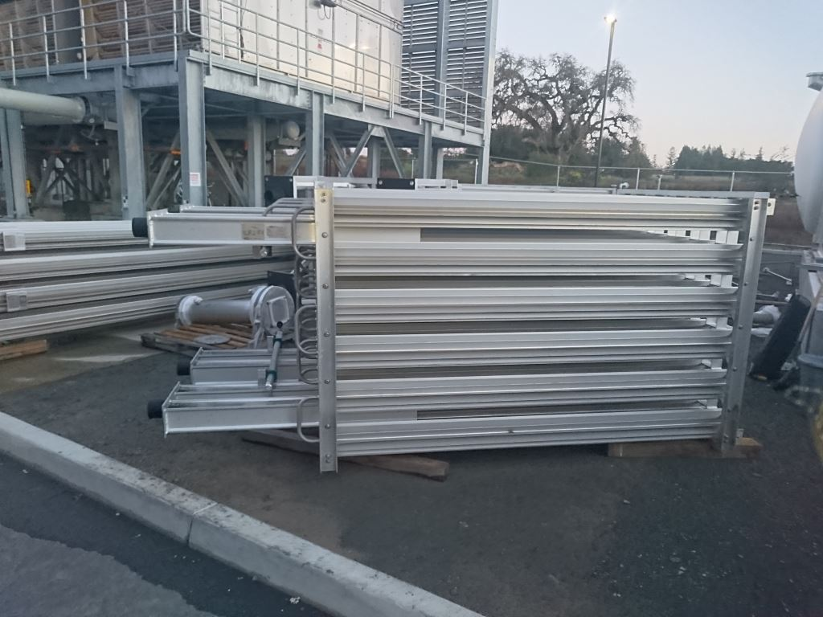 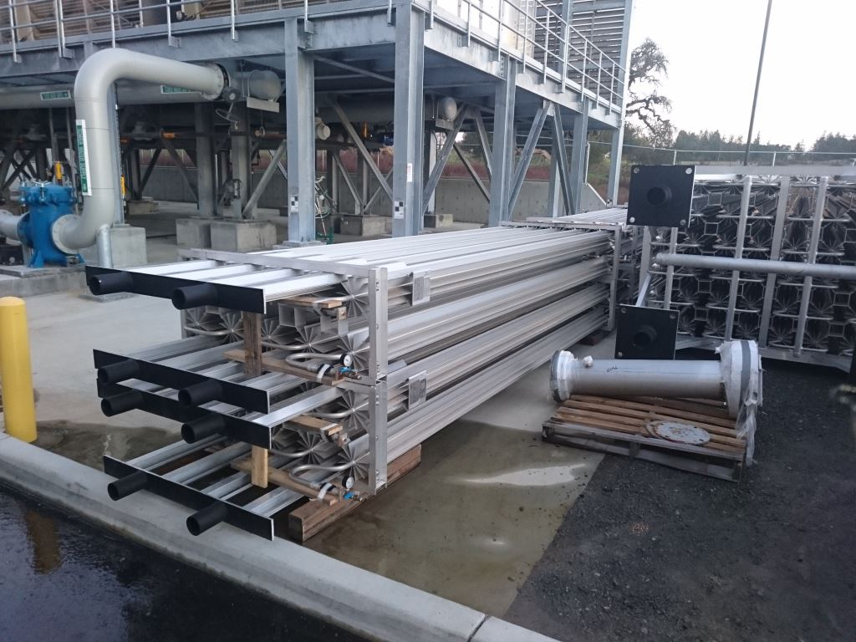

**QUALITY:**

* Site visit to Dewar-neck-can vendor to witness factory acceptance testing.

**Upcoming Travel/Deliveries/Reviews:**

* CP1 Dewar neck ship to SLAC 14-Mar-2019
* Weekly site visit to 4.5K cold box vendor 13-Mar-2019
* DOE OPA Project Review 19-21-Mar-2019
* Witness factory acceptance testing of 40-gallon oil vessels 21-Mar-2019
* Weekly site visit to 4.5K cold box vendor 21-Mar-2019
* 4.5K cold box monthly schedule status meeting @PHPK 28-Mar-2019