Weekly Reporting
WBS 1.01.07 JLAB Management
Week of March 28-April 3, 2019

Issues:

Accomplishments this week:

Contract Mod complete for IBX&MTL installation contract. PCR submitted.
LERF: High power measurements continue on CM12 and CM5.

Upcoming Reviews: None

Weekly Reporting
WBS 1.04.06 JLAB Cryomodules
Week of March 28-April 3, 2019

Issues: Delay in start of string 17 may impact CM test and delivery schedule. This was reflected in the March forecast file.

Accomplishments this week:

Forecast schedule includes moving pCM and J-03 retrofit activities to April/May 2019.

J1.3-13 has shipped to SLAC departing 30-MAR arriving 2-APR.

J1.3-14 is in the CMTF for testing. Project warm up by the end of the week.

J1.3-15 is nearly complete at WS5.

J1.3-16 is making good progress on the production lines.

J1.3-17 cavity string rolled out of the cleanroom on 01-APR.

J1.3-12 Q₀ testing is in progress; average value for the CM is ~3.0e10. Test plan was submitted for 8-cavity run later this week.

J1.3-5 Q₀ testing is in progress. There is a possibility of a 16-cavity run pending on the results from the J-12 8-cavity run.

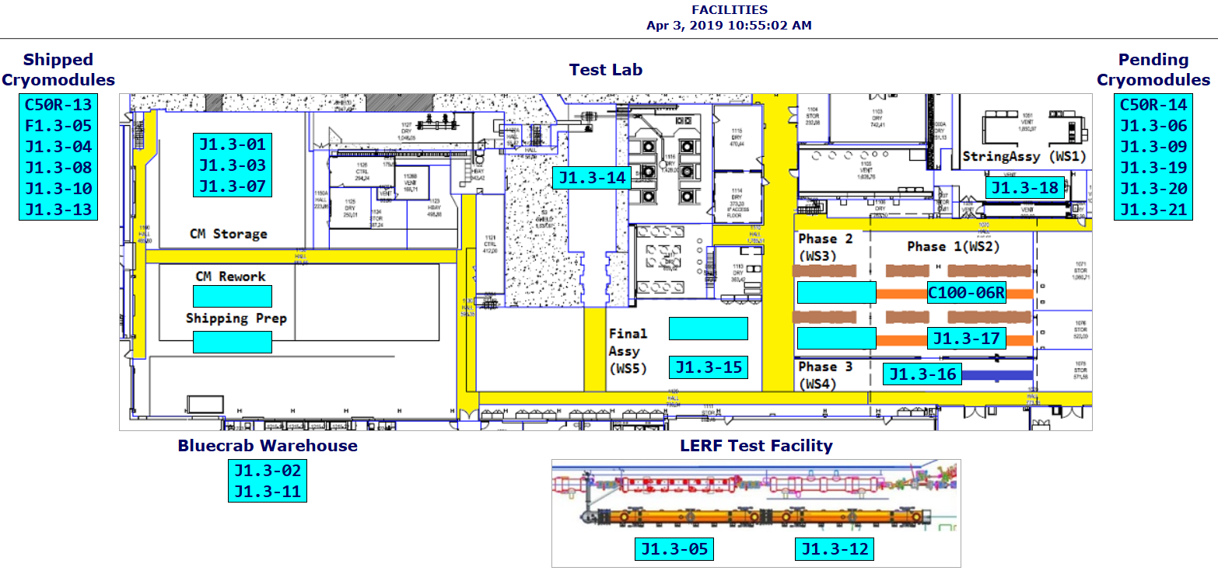

QUALITY: In process high and low pressure welding inspections and pressure testing on CM015 Saturday RT forCM015 (3-30-19).

Weekly Reporting
WBS 1.04.08 JLAB Cryoplant System
Week of March 28-April 3, 2019
Issues:
- Resolution of structural interferences created during the design of the cold box room platforms and cable trays support systems (identified in Nov 2017).
- Delays installing interconnecting piping systems in cryoplant is delaying startup of commissioning activities.
Accomplishments this week:
- Demaco IBX/MTL contract modified to include site installation scope.
- CP1 & CP2 vaporizer gauge panels received at SLAC.
- CP2 40-gallon oil tank with manifold scheduled to arrive at SLAC today.
- 4K cold box test u-tube heaters & electrical gear received at SLAC.
- Monthly 4.5K cold box scheduling meeting held at vendor on March 28th. Progress looks good and the schedule is holding.
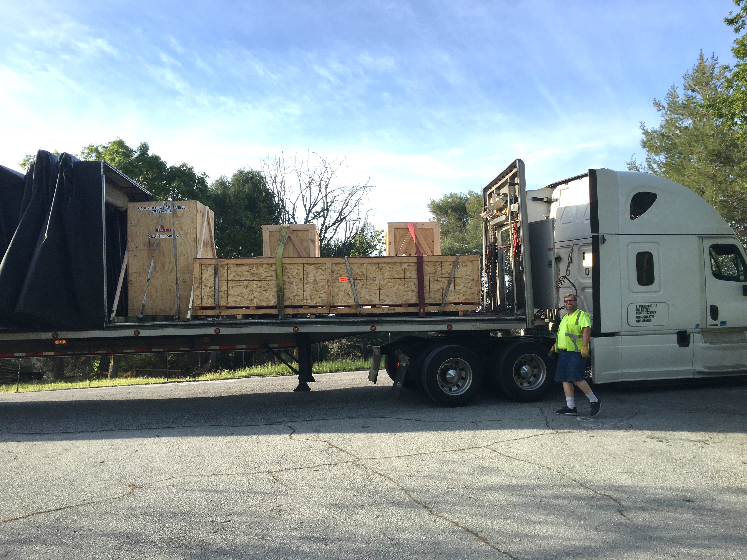
4K Cold Box Test U-Tube Heaters & Electrical Gear Arriving at SLAC.

QUALITY: Factory Acceptance Testing scheduled and confirmed at DEMACO for CP1 main transfer line. QA resource for CP document control in place and working.

Upcoming Travel/Deliveries/Reviews:
- 4.5K cold box and 2K cold box oversight vendor visit at PHPK 4 Apr
- 4.5K cold box and 2K cold box oversight vendor visit at PHPK 11 Apr
- Vendor Visit for IBX & MTL factory acceptance test 17-19 Apr
- 4.5K cold box and 2K cold box oversight vendor visit at PHPK 18 Apr
- 4.5K cold box and 2K cold box oversight vendor visit at PHPK 25 Apr

