Weekly Reporting

WBS 1.01.07 JLAB Management

Week of April 4-10, 2019

**Issues:**

**Accomplishments this week:**

Cryomodule production continues to run smoothly. Cavity String 18 assembly is going well and will keep the lines full.

LERF: High power 8 cavity run completed and plans are for a 16 cavity run.

CP procurements are progressing well. 4.5 K LCB 10-week notice for delivery has been issued by the vendor. 14 June is the planned arrival of the last of the 4.5 K cold boxes.

**Upcoming Reviews:** None

Weekly Reporting

WBS 1.04.06 JLAB Cryomodules

Week of April 4-10, 2019

**Issues**:

**Accomplishments this week:**

March forecast schedule includes moving pCM and J-03 retrofit activities to April/May 2019.

J1.3-14 completed testing in CMTF. Planning to ship to SLAC on 24-APR. Pre-ship review planned for 17-APR.

J1.3-15 installed in CMTF. Cooldown planned for 12-APR. Testing will start on 16-APR.

J1.3-16 at WS-5. Once completed, it is scheduled for LERF testing during the summer run.

J1.3-17 is at WS-2.

J1.3-18 string assembly is in progress with 6 of 8 cavities on the rail.

J1.3-19 has 5 of 8 cavities qualified.

J1.3-12 8-cavity testing completed on 8-APR. 16-cavity testing planned for Thursday using J1.3-5 in LERF.

J1.3-01 is at WS-4 for retro-fit.

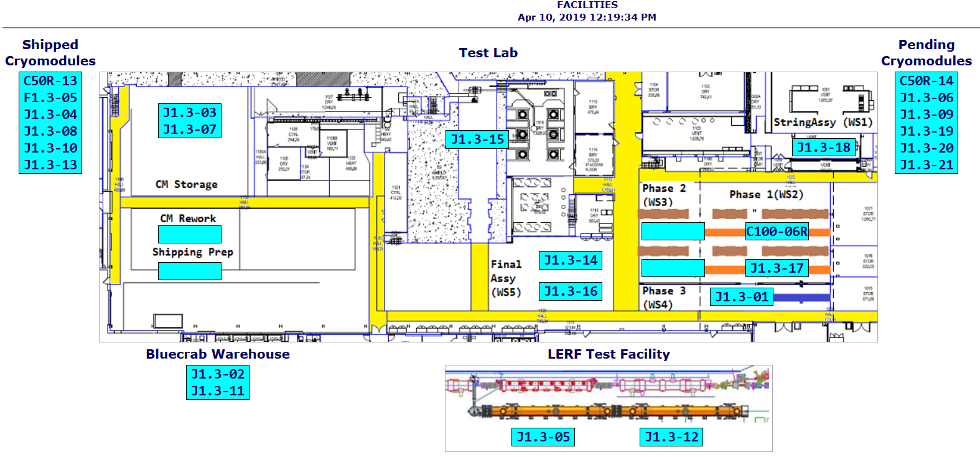

**QUALITY:** No report.

Weekly Reporting

WBS 1.04.08 JLAB Cryoplant System

Week of April 4-10, 2019

**Issues:**

1. Resolution of structural interferences created during the design of the cold box room platforms and cable trays support systems (*identified in Nov 2017*).
2. Delays installing interconnecting piping systems in cryoplant is delaying startup of commissioning activities.

**Accomplishments this week:**

* Demaco IBX/MTL contract modified to include site installation scope.
  + Plan to assign the installation scope to SLAC staff.
  + C1 MTL FAT scheduled for this month

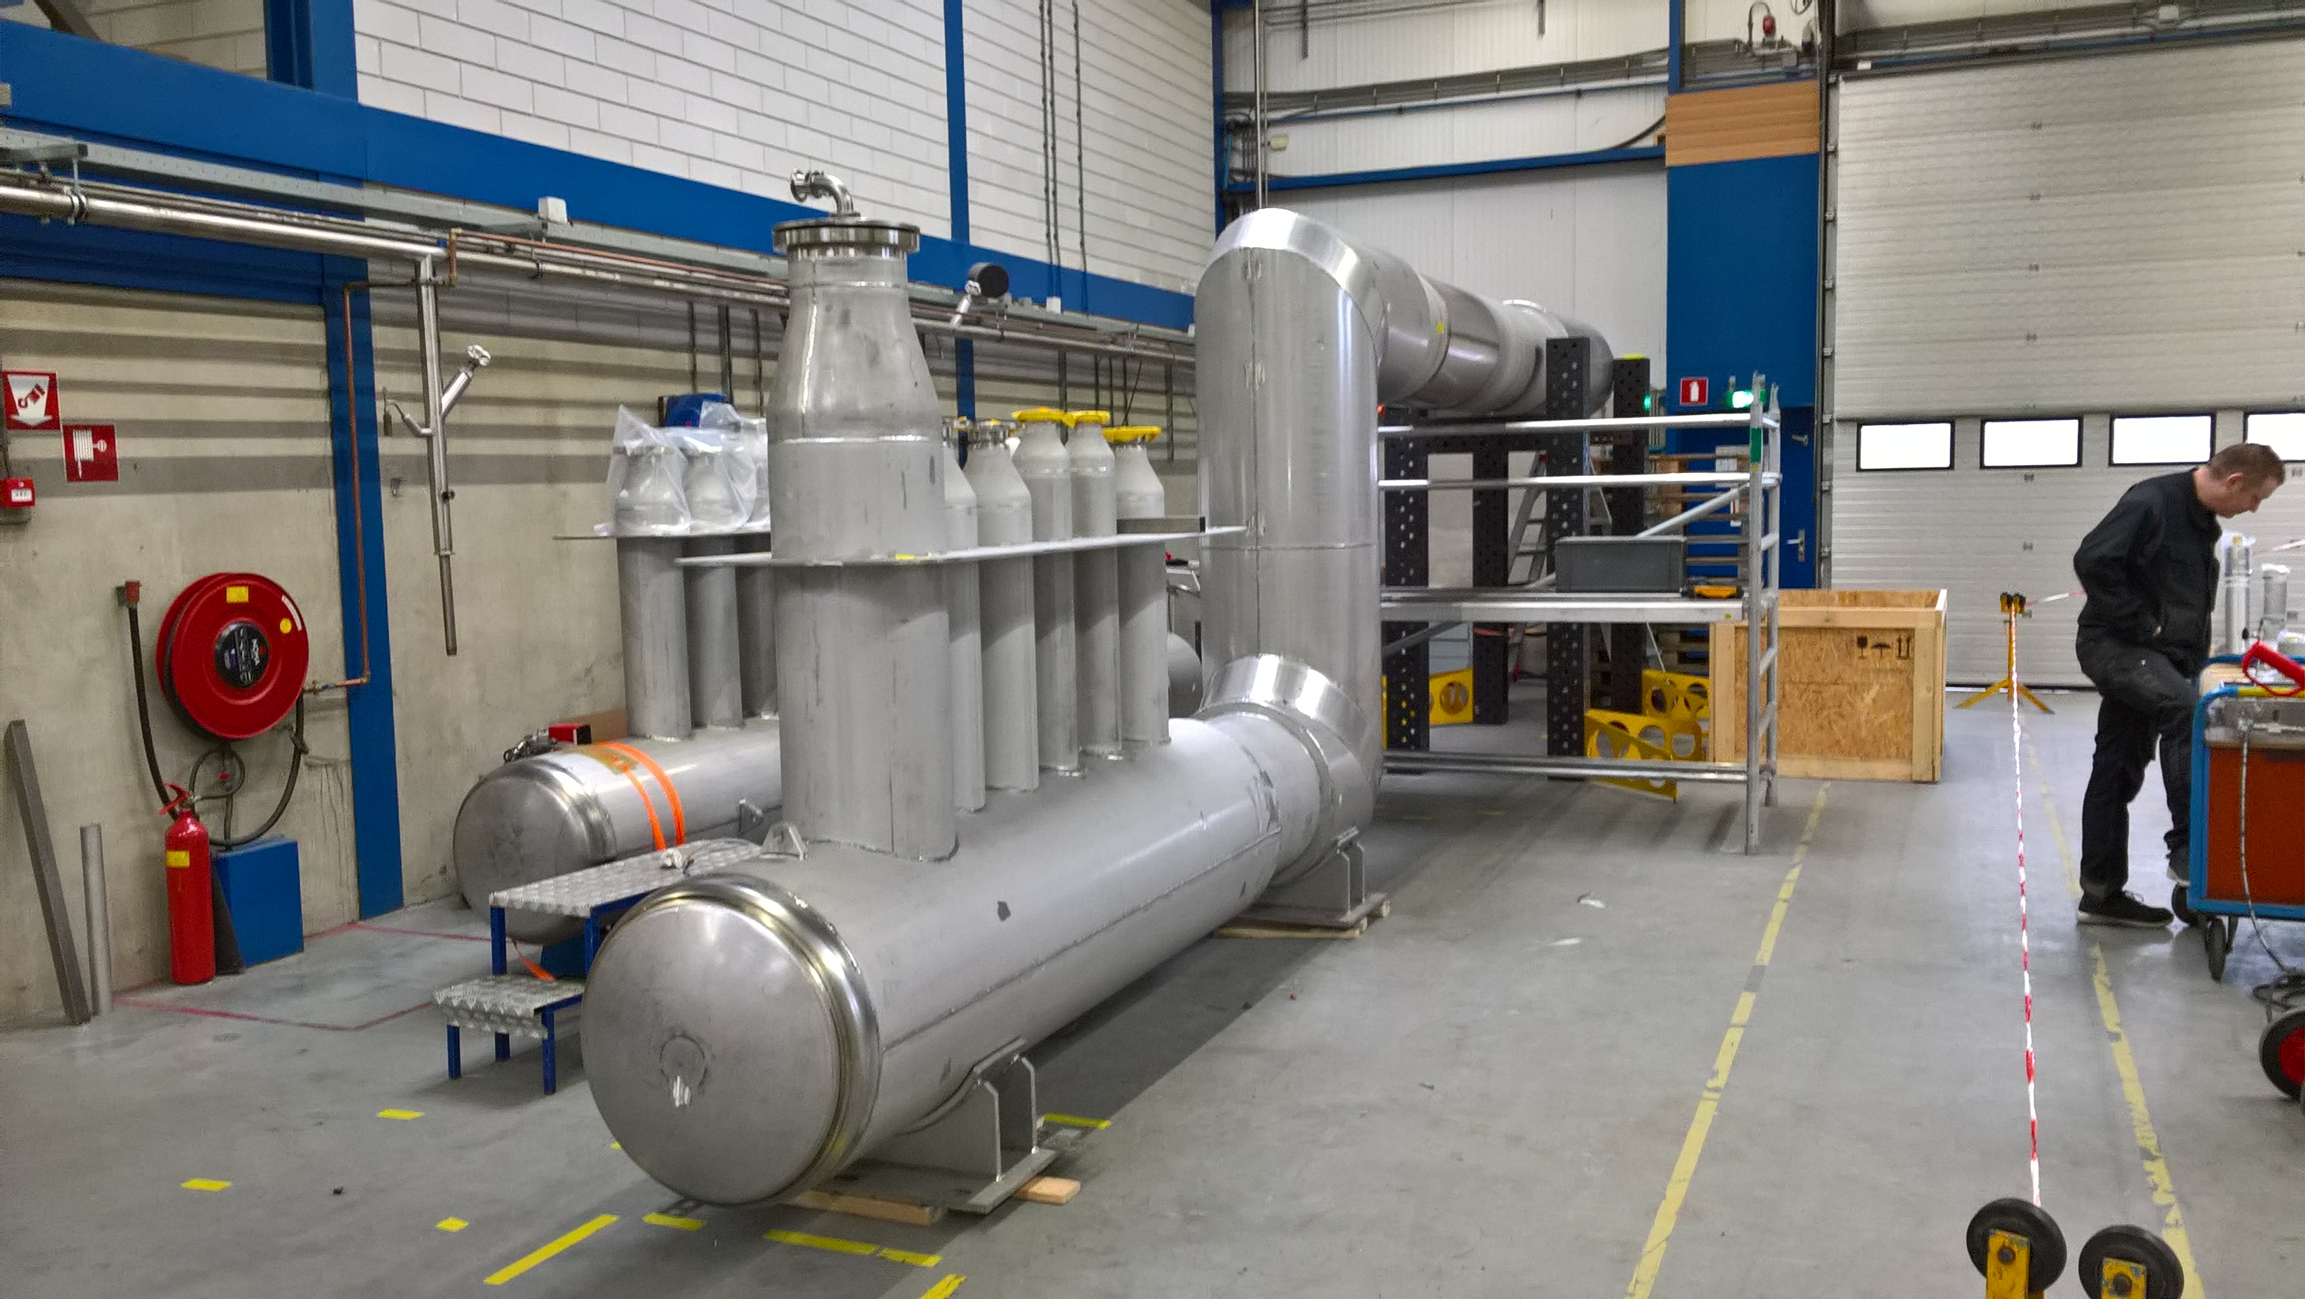

**C1 Multi-Transfer Line (MTL) in preparation for Factory Acceptance Test (FAT)**

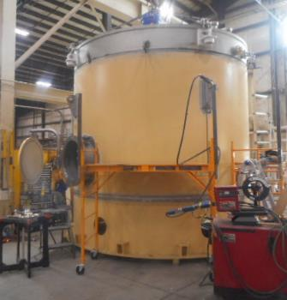

**C1 2K Cold Box @PHPK - Top plate integrated into shell in preparation for final welding**



**QUALITY:**

* JLAB & SLAC staff scheduled to be present for Factory Acceptance Testing
  + C1 MTL
  + C2 Dewar Neck Can
* QA resource for CP document control in place and working.

**Upcoming Travel/Deliveries/Reviews:**

* 4.5K & 2K cold boxes oversight vendor visit at PHPK 11 Apr 2019
* Vendor Visit for IBX & MTL factory acceptance test 17-19 Apr 2019
* 4.5K & 2K cold boxes oversight vendor visit at PHPK 18 Apr 2019
* 4.5K & 2K cold boxes oversight vendor visit at PHPK 25 Apr 2019
* Factory Acceptance Test for C2 Dewar Neck Can week of 25-Apr-2019
* 4.5K Cold box Monthly status update @PHPK 02-May-2019