Weekly Reporting

WBS 1.01.07 JLAB Management

Week of April 11-17, 2019

**Issues:**

**Accomplishments this week:**

Cryomodule production continues to run smoothly. Cavity String 18 is complete and rolled out of the clean room.

LERF: High power 16 cavity run completed.

CP procurements are progressing well. 4.5 K LCB insulating vacuum is being pumped.

**Upcoming Reviews:** None

Weekly Reporting

WBS 1.04.06 JLAB Cryomodules

Week of April 11-17, 2019

**Issues**:

**Accomplishments this week:**

J1.3-14 - Planning to ship to SLAC on 24-APR. Pre-ship review planned for 17-APR.

J1.3-15 installed in CMTF and cold. Testing started on 16-APR.

J1.3-16 at WS-5. Once completed, it is scheduled for LERF testing during the summer run.

J1.3-17 moved to WS-3 on 16-APR.

J1.3-18 string assembly completed and leak tight. Rolled out to WS-2 on 17-APR.

J1.3-19 has 5 of 8 cavities qualified.

J1.3-12 16-cavity testing with J1.3-5 completed on 12-APR. Planning to pull u tubes on 20-APR.

J1.3-01 is at WS-4 for retro-fit. Shields and MLI installed.

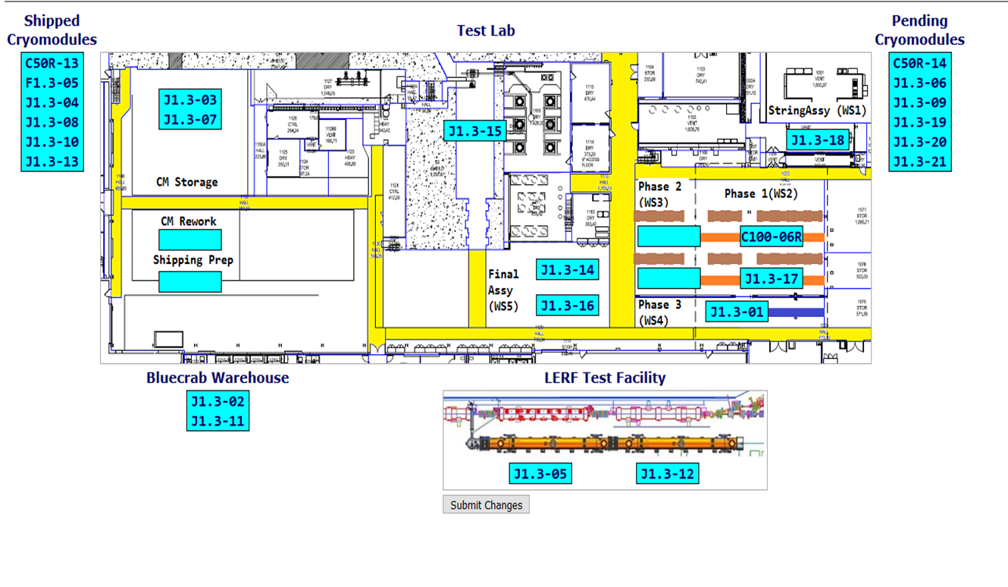

**QUALITY:** No report.

Weekly Reporting

WBS 1.04.08 JLAB Cryoplant System

Week of April 11-17, 2019

**Issues:**

1. Resolution of structural interferences created during the design of the cold box room platforms and cable trays support systems (*identified in Nov 2017*).
2. Delays installing interconnecting piping systems in cryoplant is delaying startup of commissioning activities.

**Accomplishments this week:**

* IBX/MTL subcontract (Demaco)
  + Successful FAT of C1 Multi-transfer Line (MTL)
  + This keeps the C1 MTL on schedule for delivery to SLAC late next month.

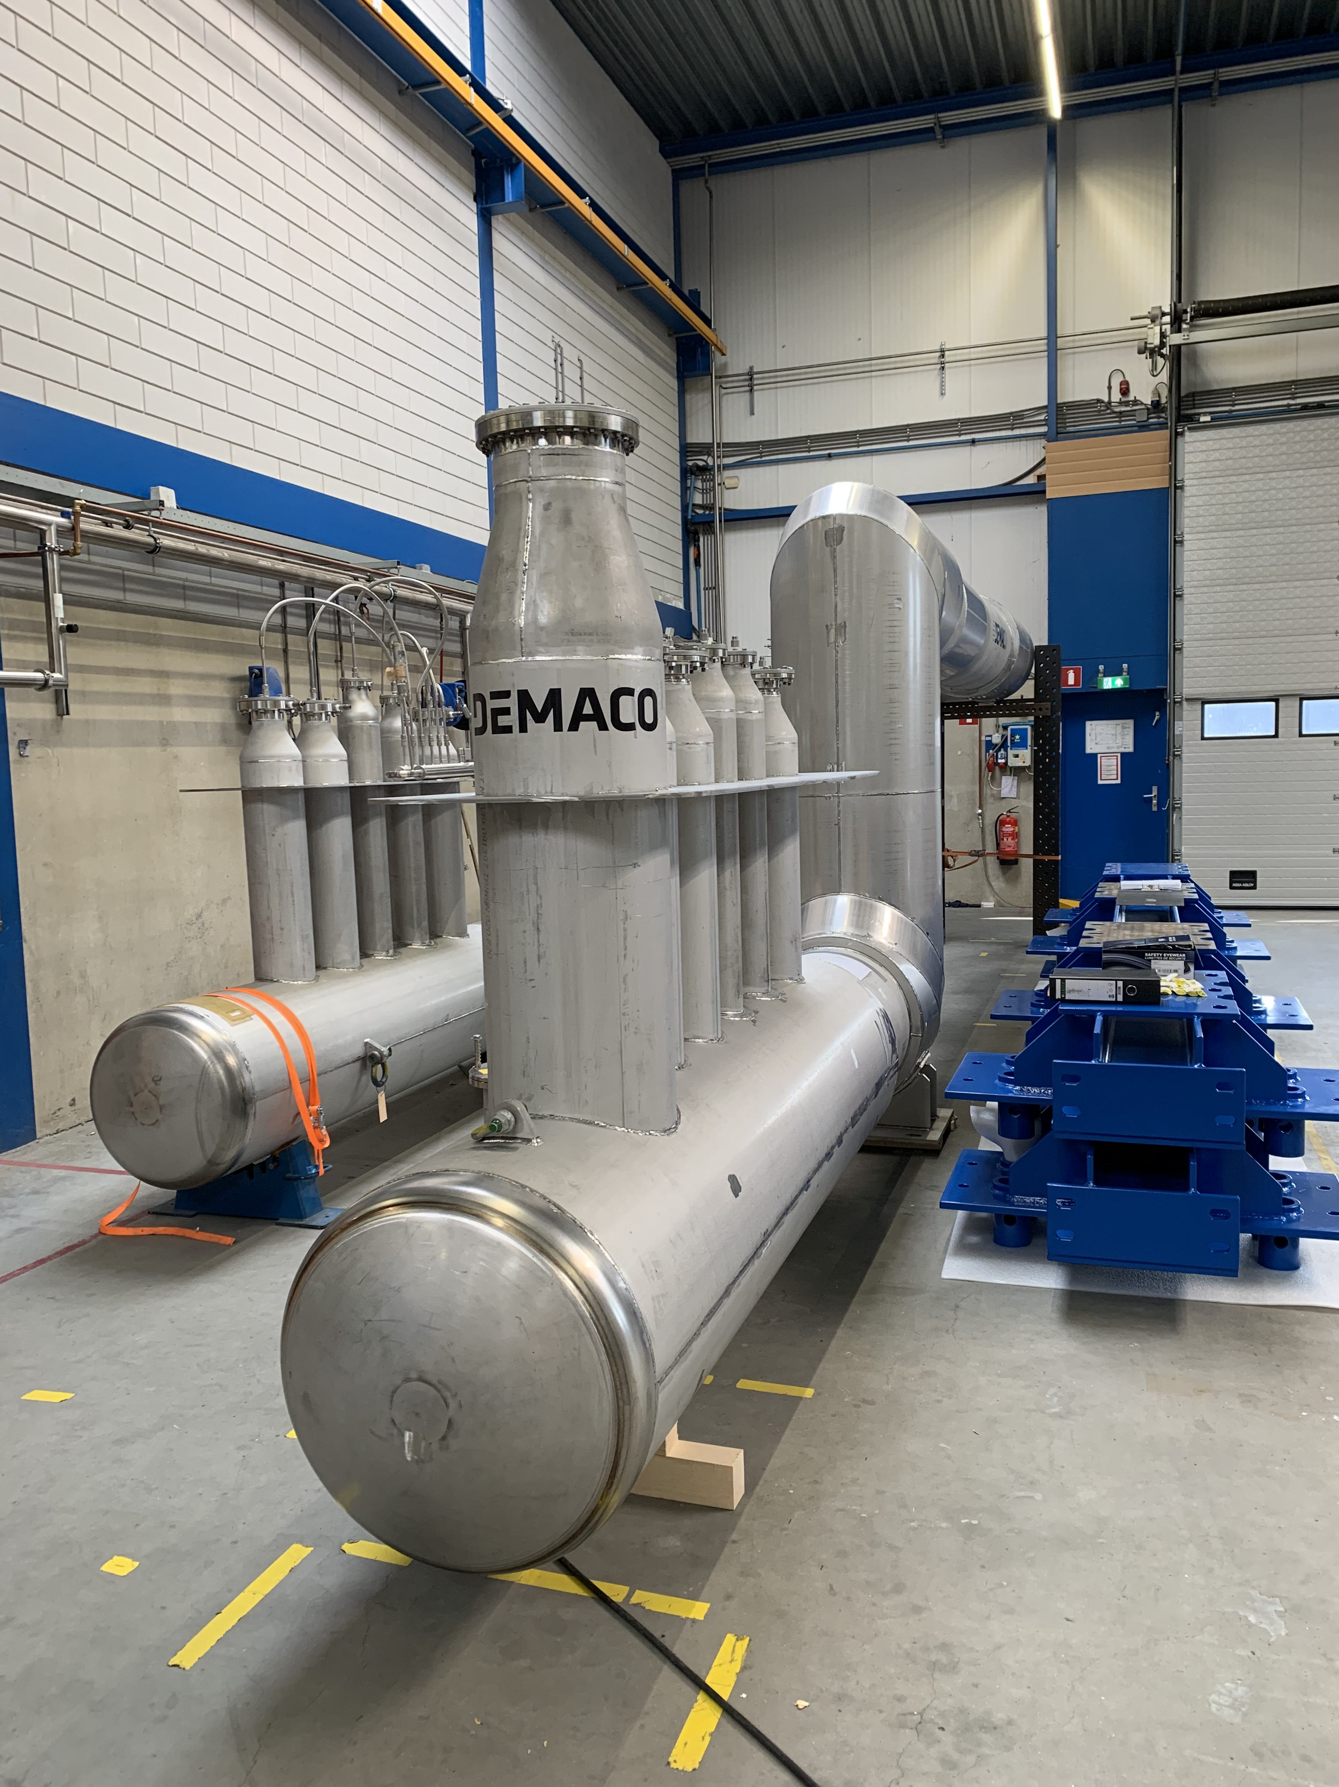 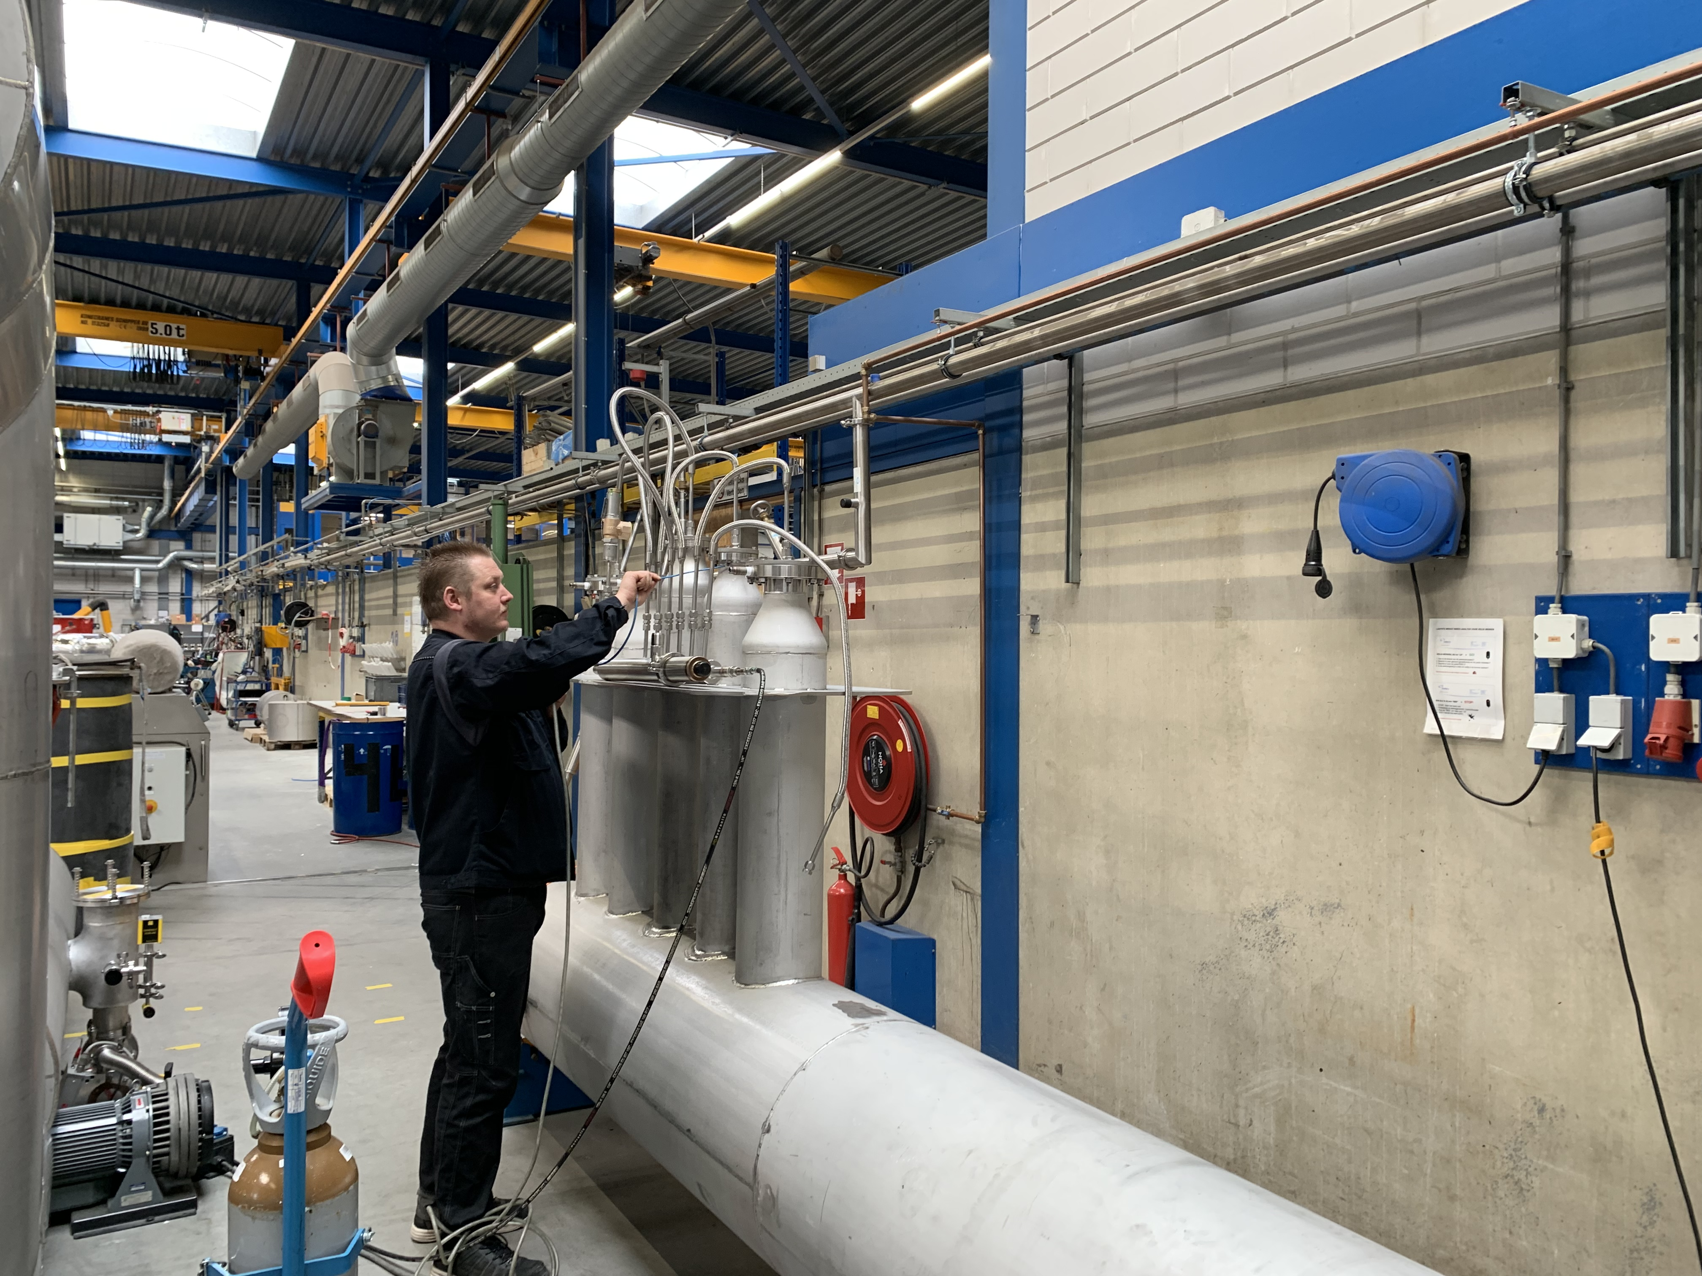

* 4.5K Cold Box – Final closure welding complete – Initial pump-down in progress

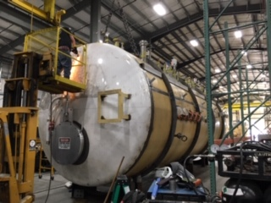



**QUALITY:**

* JLAB & SLAC staff scheduled to be present for Factory Acceptance Testing
  + C1 MTL
  + C2 Dewar Neck Can
* QA resource for CP document control in place and working.

**Upcoming Travel/Deliveries/Reviews:**

* Vendor Visit for IBX & MTL factory acceptance test 17-19 Apr 2019
* 4.5K & 2K cold boxes oversight vendor visit at PHPK 18 Apr 2019
* 4.5K & 2K cold boxes oversight vendor visit at PHPK 25 Apr 2019
* Factory Acceptance Test for C2 Dewar Neck Can Week of 25-Apr-2019
* 4.5K Cold box Monthly status update @PHPK 02-May-2019