Weekly Reporting

WBS 1.01.07 JLAB Management

Week of April 18-24, 2019

**Issues:**

**Accomplishments this week:**

Cryomodule production continues to run smoothly. Cavity String 19 preparations have started.

J1.3-14 shipped to SLAC on 24-APR and scheduled to arrive on 30-APR for unload on 01-MAY.

LERF: We are progressing with disassembly and on track to replace J-12 with J-16 on 29-30 APR.

CP procurements are progressing well. Four Gauge Panels fabricated at JLab shipped out to SLAC – ETA 29-APR.

**Upcoming Reviews:** None

Weekly Reporting

WBS 1.04.06 JLAB Cryomodules

Week of April 18-24, 2019

**Issues**:

**Accomplishments this week:**

J1.3-14 - Planning to ship to SLAC on 24-APR with arrival on Tue 30-APR for Wed 01-MAY unload. Pre-ship review completed 17-APR.

J1.3-15 installed in CMTF and cold. Emax’s completed – total ~152 MV. FCD was conducted on 23-APR. Qo’s are in progress.

J1.3-16 at WS-5. Once completed, it is scheduled for LERF testing during the summer run. Planned to move to LERF on 30-APR.

J1.3-17 at WS-3. Lollipops will be returned for J-19 later this week.

J1.3-18 at WS-2.

J1.3-19 has 7 of 8 cavities qualified.

J1.3-12 Pulled u tubes at LERF on 20-APR. Opened up interconnect and removed bellows. Setting up to remove beamline connection. Plan to remove CM from LERF on 29-APR. Plan to ship to SLAC on 21-JUN or earlier.

J1.3-01 moved to WS-5 on 23-APR. Plan to ship to SLAC on 17-MAY.

J1.3-03 installed on WS-4 on 23-APR.

HOM BLA assembly (1 unit) was completed on Monday.

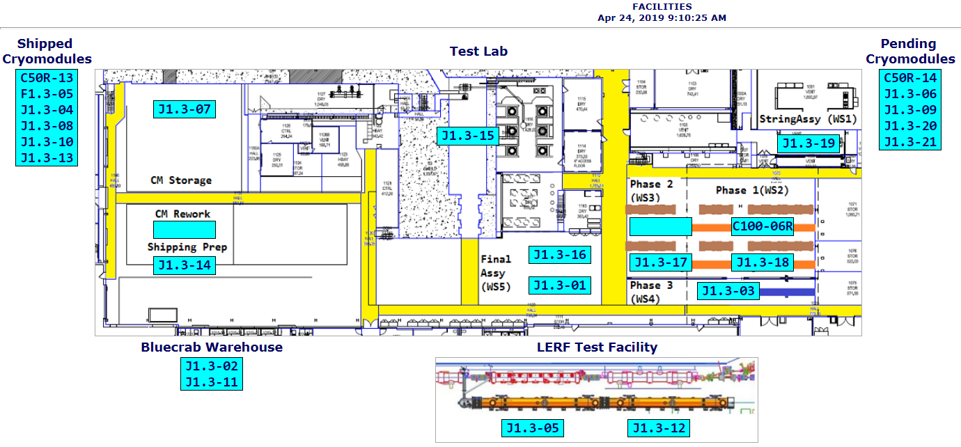

**QUALITY:** J1.3-16 was RT on Saturday 4-20; welding passed.

Weekly Reporting

WBS 1.04.08 JLAB Cryoplant System

Week of April 11-17, 2019

**Issues:**

1. Resolution of structural interferences created during the design of the cold box room platforms and cable trays support systems (*identified in NOV 2017*).
2. Delays installing interconnecting piping systems in cryoplant is delaying startup of commissioning activities.

**Accomplishments this week:**

* IBX/MTL subcontract (Demaco) installation scope kickoff meeting held 18-APR
* Four Gauge Panels fabricated at JLab shipped out to SLAC – ETA 29-APR
* Gas Analyzer Cabinets fabrication complete at JLab – crating underway for shipment to SLAC

|  |  |
| --- | --- |
| C:\Users\mbevins\Desktop\Gas analyzer cabinets.png | C:\Users\mbevins\Desktop\Gas analyzer cabinets _ Inside.png |

Gas Analyzer Cabinets.

**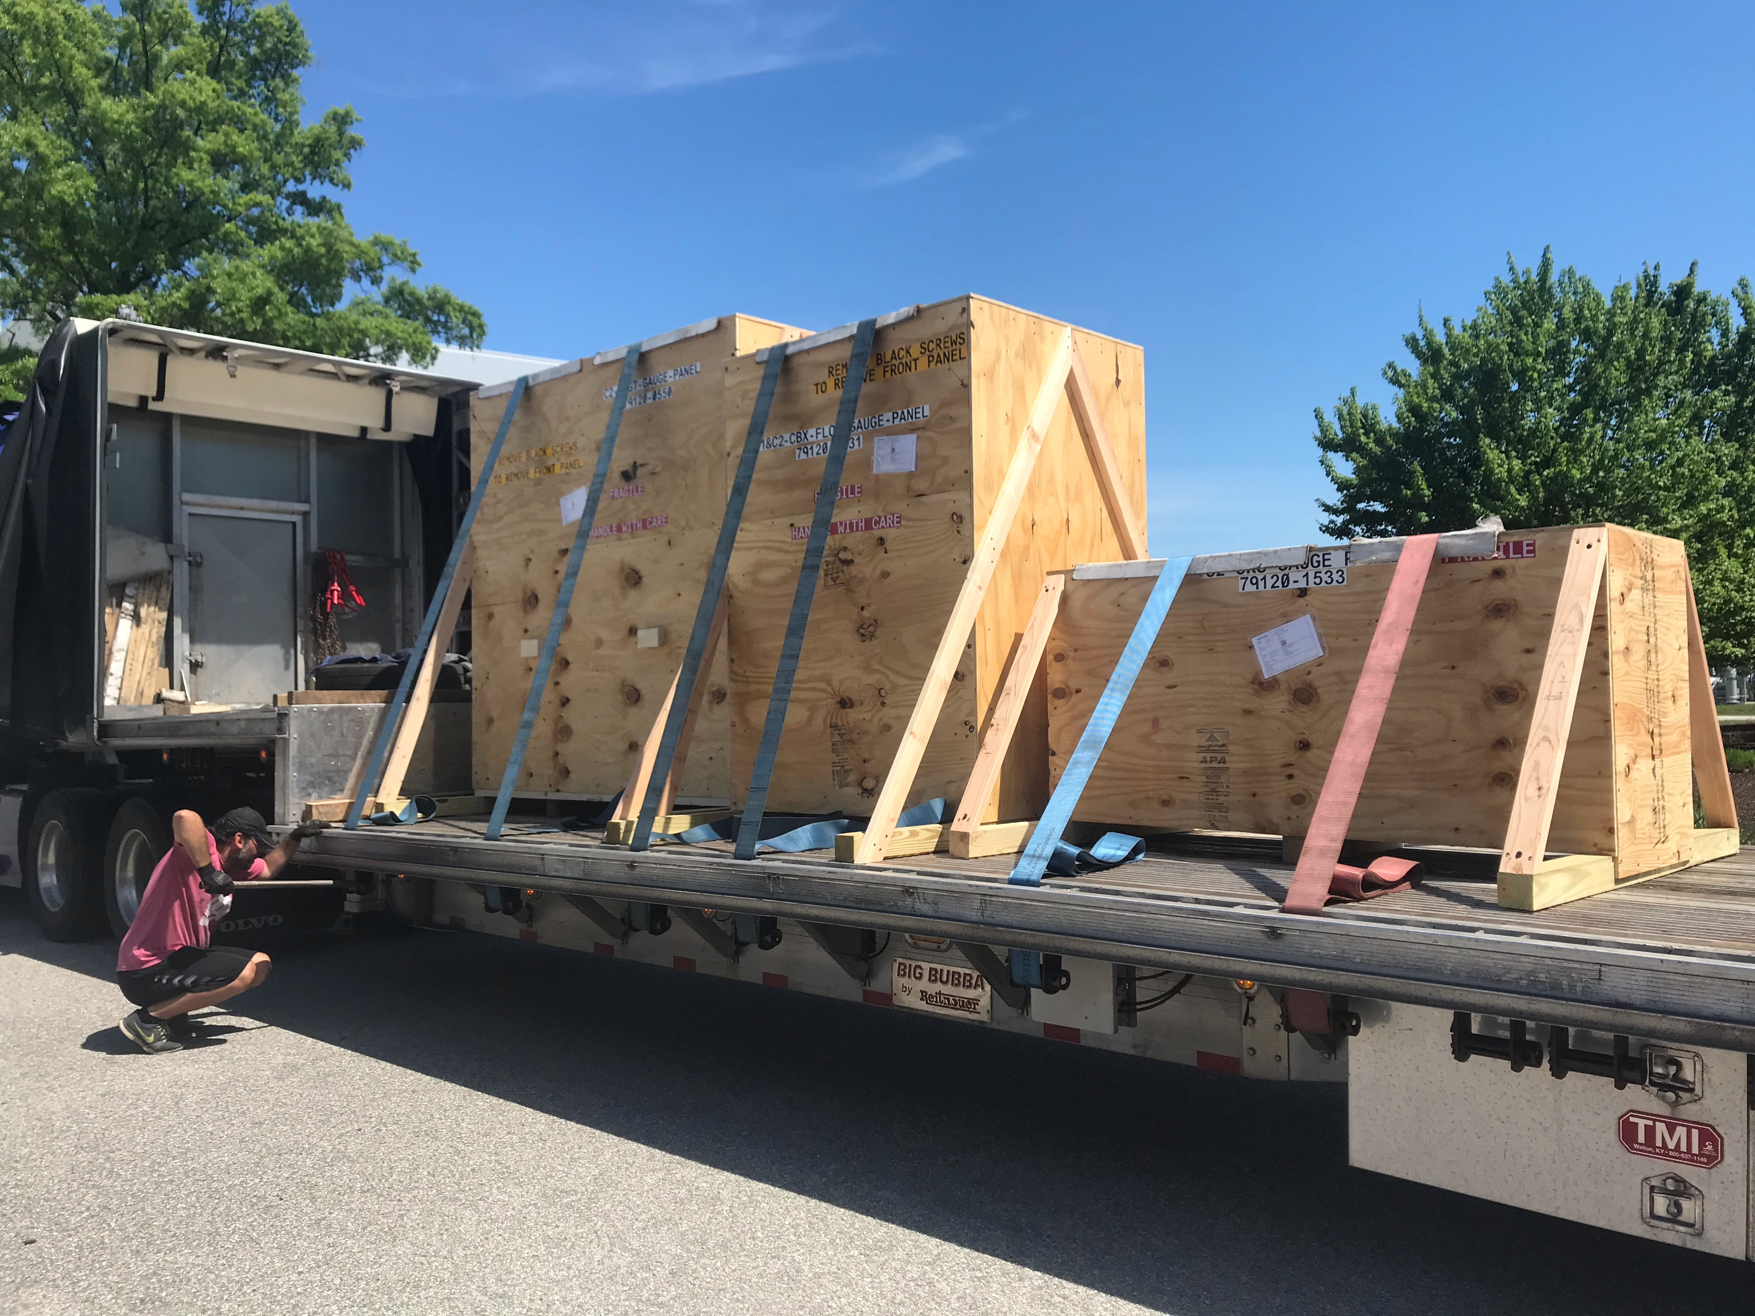**

Gauge Panels loaded at JLab for delivery to SLAC.

**QUALITY:**

* JLAB & SLAC staff present for CP1 MTL Factory Acceptance Testing at Demaco
* JLab staff scheduled to be present for C2 Dewar Neck Can Factory Acceptance Testing at Ability Engineering (AET)
* QA resource for CP document control in place and working.

**Upcoming Travel/Deliveries/Reviews:**

* 4.5K & 2K cold boxes oversight vendor visit at PHPK 25-Apr, 2019
* 4.5K Cold box Monthly status update @PHPK 02-May, 2019
* Factory Acceptance Test for C2 Dewar Neck Can Week of 6-May, 2019