Weekly Reporting

WBS 1.01.07 JLAB Management

Week of April 25 to May 1, 2019

**Issues:**

**Accomplishments this week:**

Cryomodule production continues to run smoothly. Cavity String 19 preparations have started.

J1.3-14 shipped to SLAC on 24-APR and scheduled to arrive on 30-APR for unload on 01-MAY.

LERF: We are progressing with assembly of J-16.

The project has issued a shipping hold for cryomodule.

**Upcoming Reviews:** None

Weekly Reporting

WBS 1.04.06 JLAB Cryomodules

Week of April 25 to May 1, 2019

**Issues**: Shipping hold instructions issued on 30-APR.

**Accomplishments this week:**

J1.3-01 at WS-5. Warm couplers in progress. Plan to ship to SLAC on 17-MAY.

J1.3-03 installed on WS-4 on 23-APR. Preparing for VV removal.

J1.3-12 at WS-5. Removed from LERF on 29-APR. Plan to ship to SLAC on 21-JUN or earlier pending shipping restart authorization.

J1.3-14 - Shipped to SLAC on 24-APR. Arrival planned for Wed 01-MAY unload.

J1.3-15 installed in CMTF and cold. Q0’s are complete. Multi-cavity runs complete. Pre-warm up review planned for Wednesday 1-MAY.

J1.3-16 at LERF. Moved to LERF on 30-APR, installed and aligned. Beamline work starting on 1-MAY.

J1.3-17 at WS-3. Alignment in progress.

J1.3-18 at WS-2.

J1.3-19 has 8 cavities qualified. String assembly started.

J1.3-20 has 1 of 8 cavities qualified.

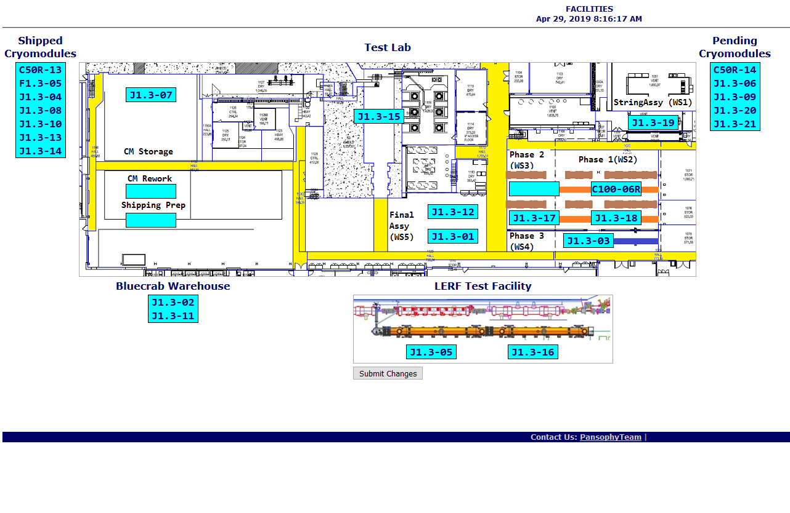

**QUALITY:** Pressure testing of CM 016 (# 30) low-pressure circuit prior to moving to LERF for testing. LCLS II Tooling receipt inspection and document review for LCLS-II Cryomodule Assembly Rail weldments PO 19-P0346 from Astro Machine.

Weekly Reporting

WBS 1.04.08 JLAB Cryoplant System

Week of April 25 to May 1, 2019

**Issues:**

1. Resolution of structural interferences created during the design of the cold box room platforms and cable trays support systems (*identified in NOV 2017*).
2. Delays installing interconnecting piping systems in cryoplant is delaying startup of commissioning activities.

**Accomplishments this week:**

* Final factory acceptance leak check of CP2 4.5K lower cold box
* Initial pump-down of 2KCB (@PHPK) in progress
* Gauge Panels (fabricated at JLab) en-route to SLAC
* Gas Analyzer Cabinets fabrication complete ready to ship to SLAC

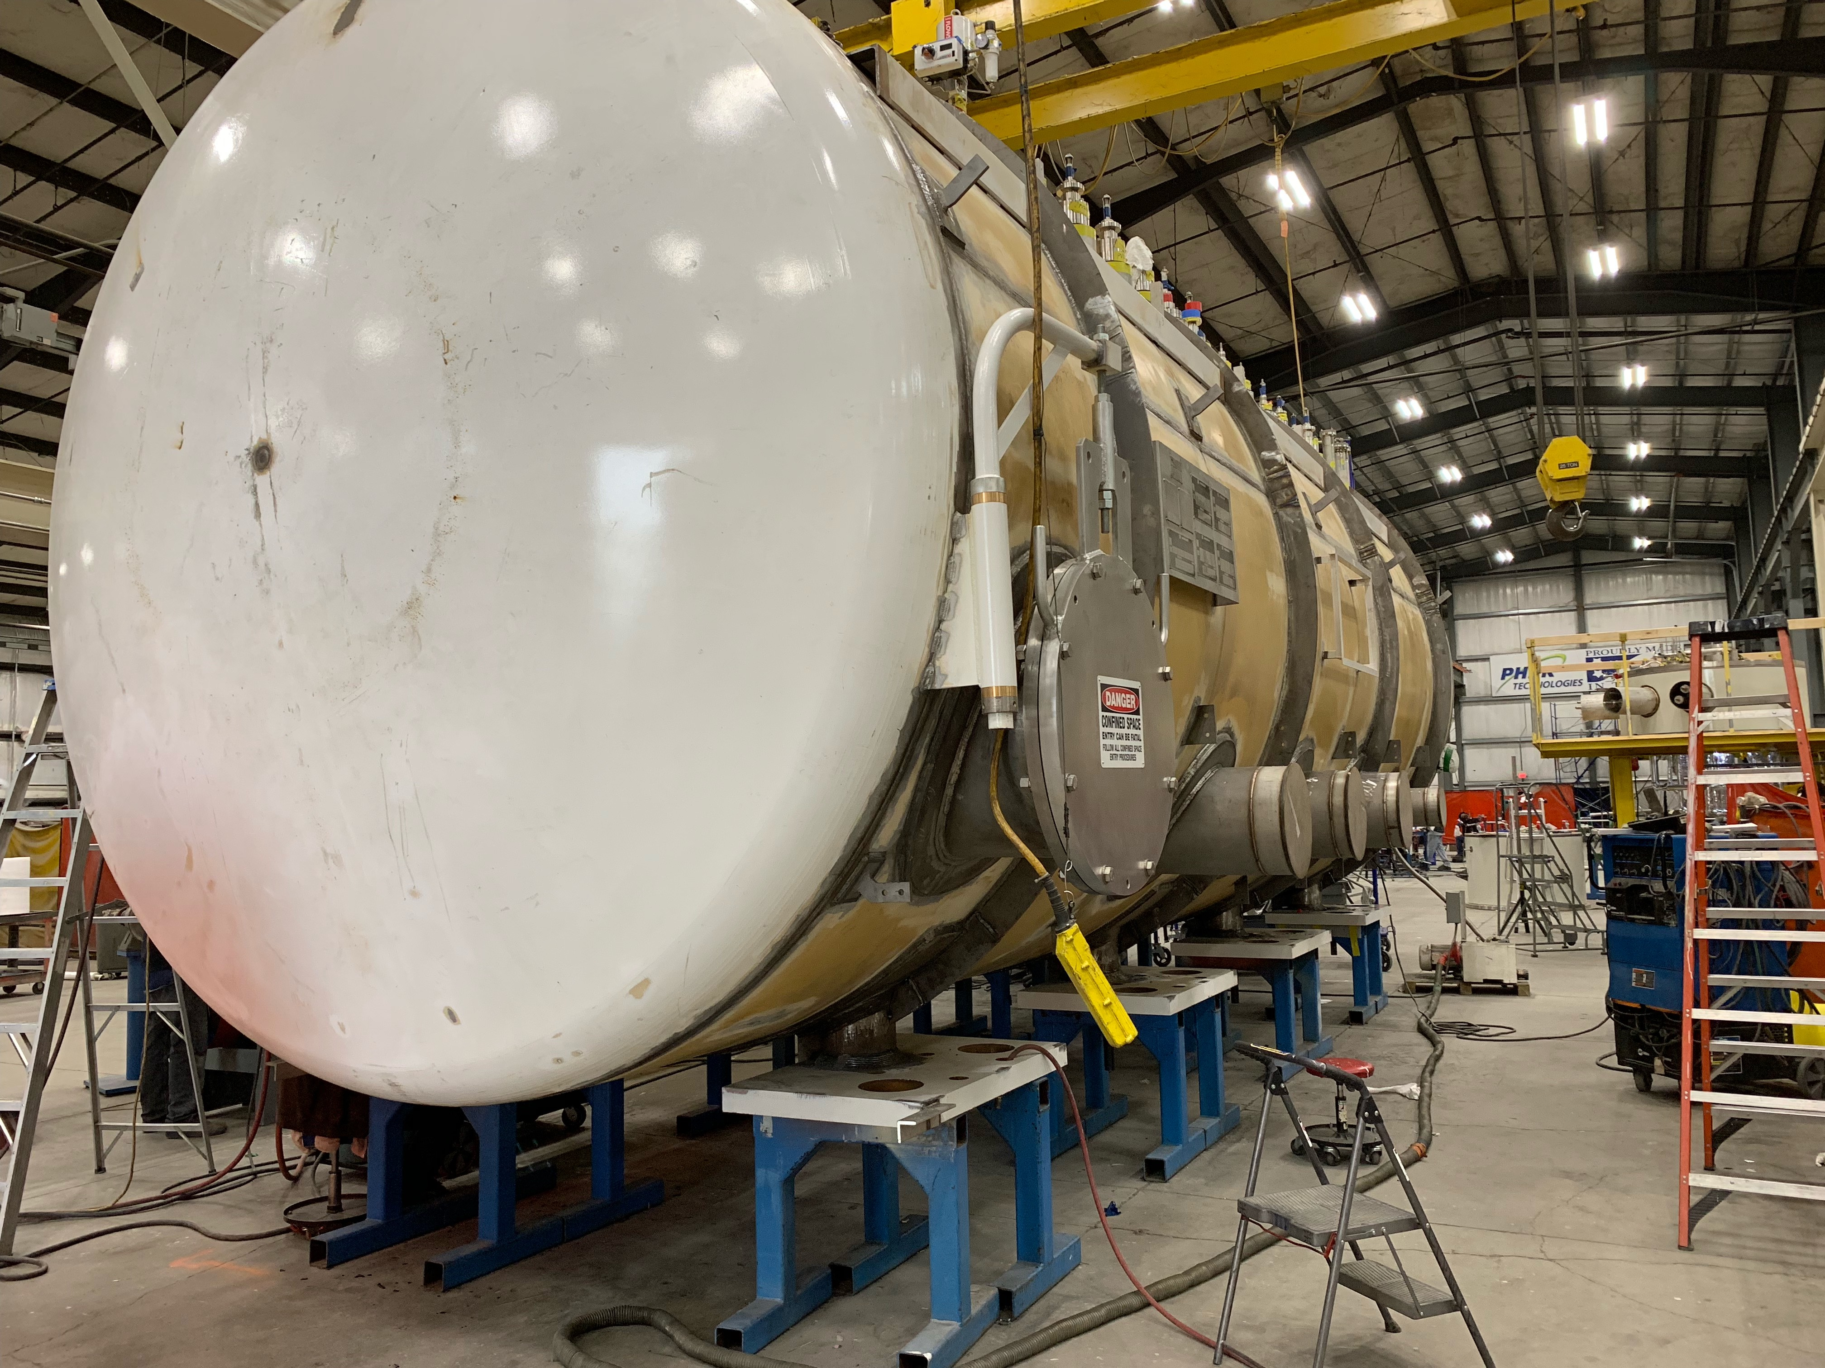 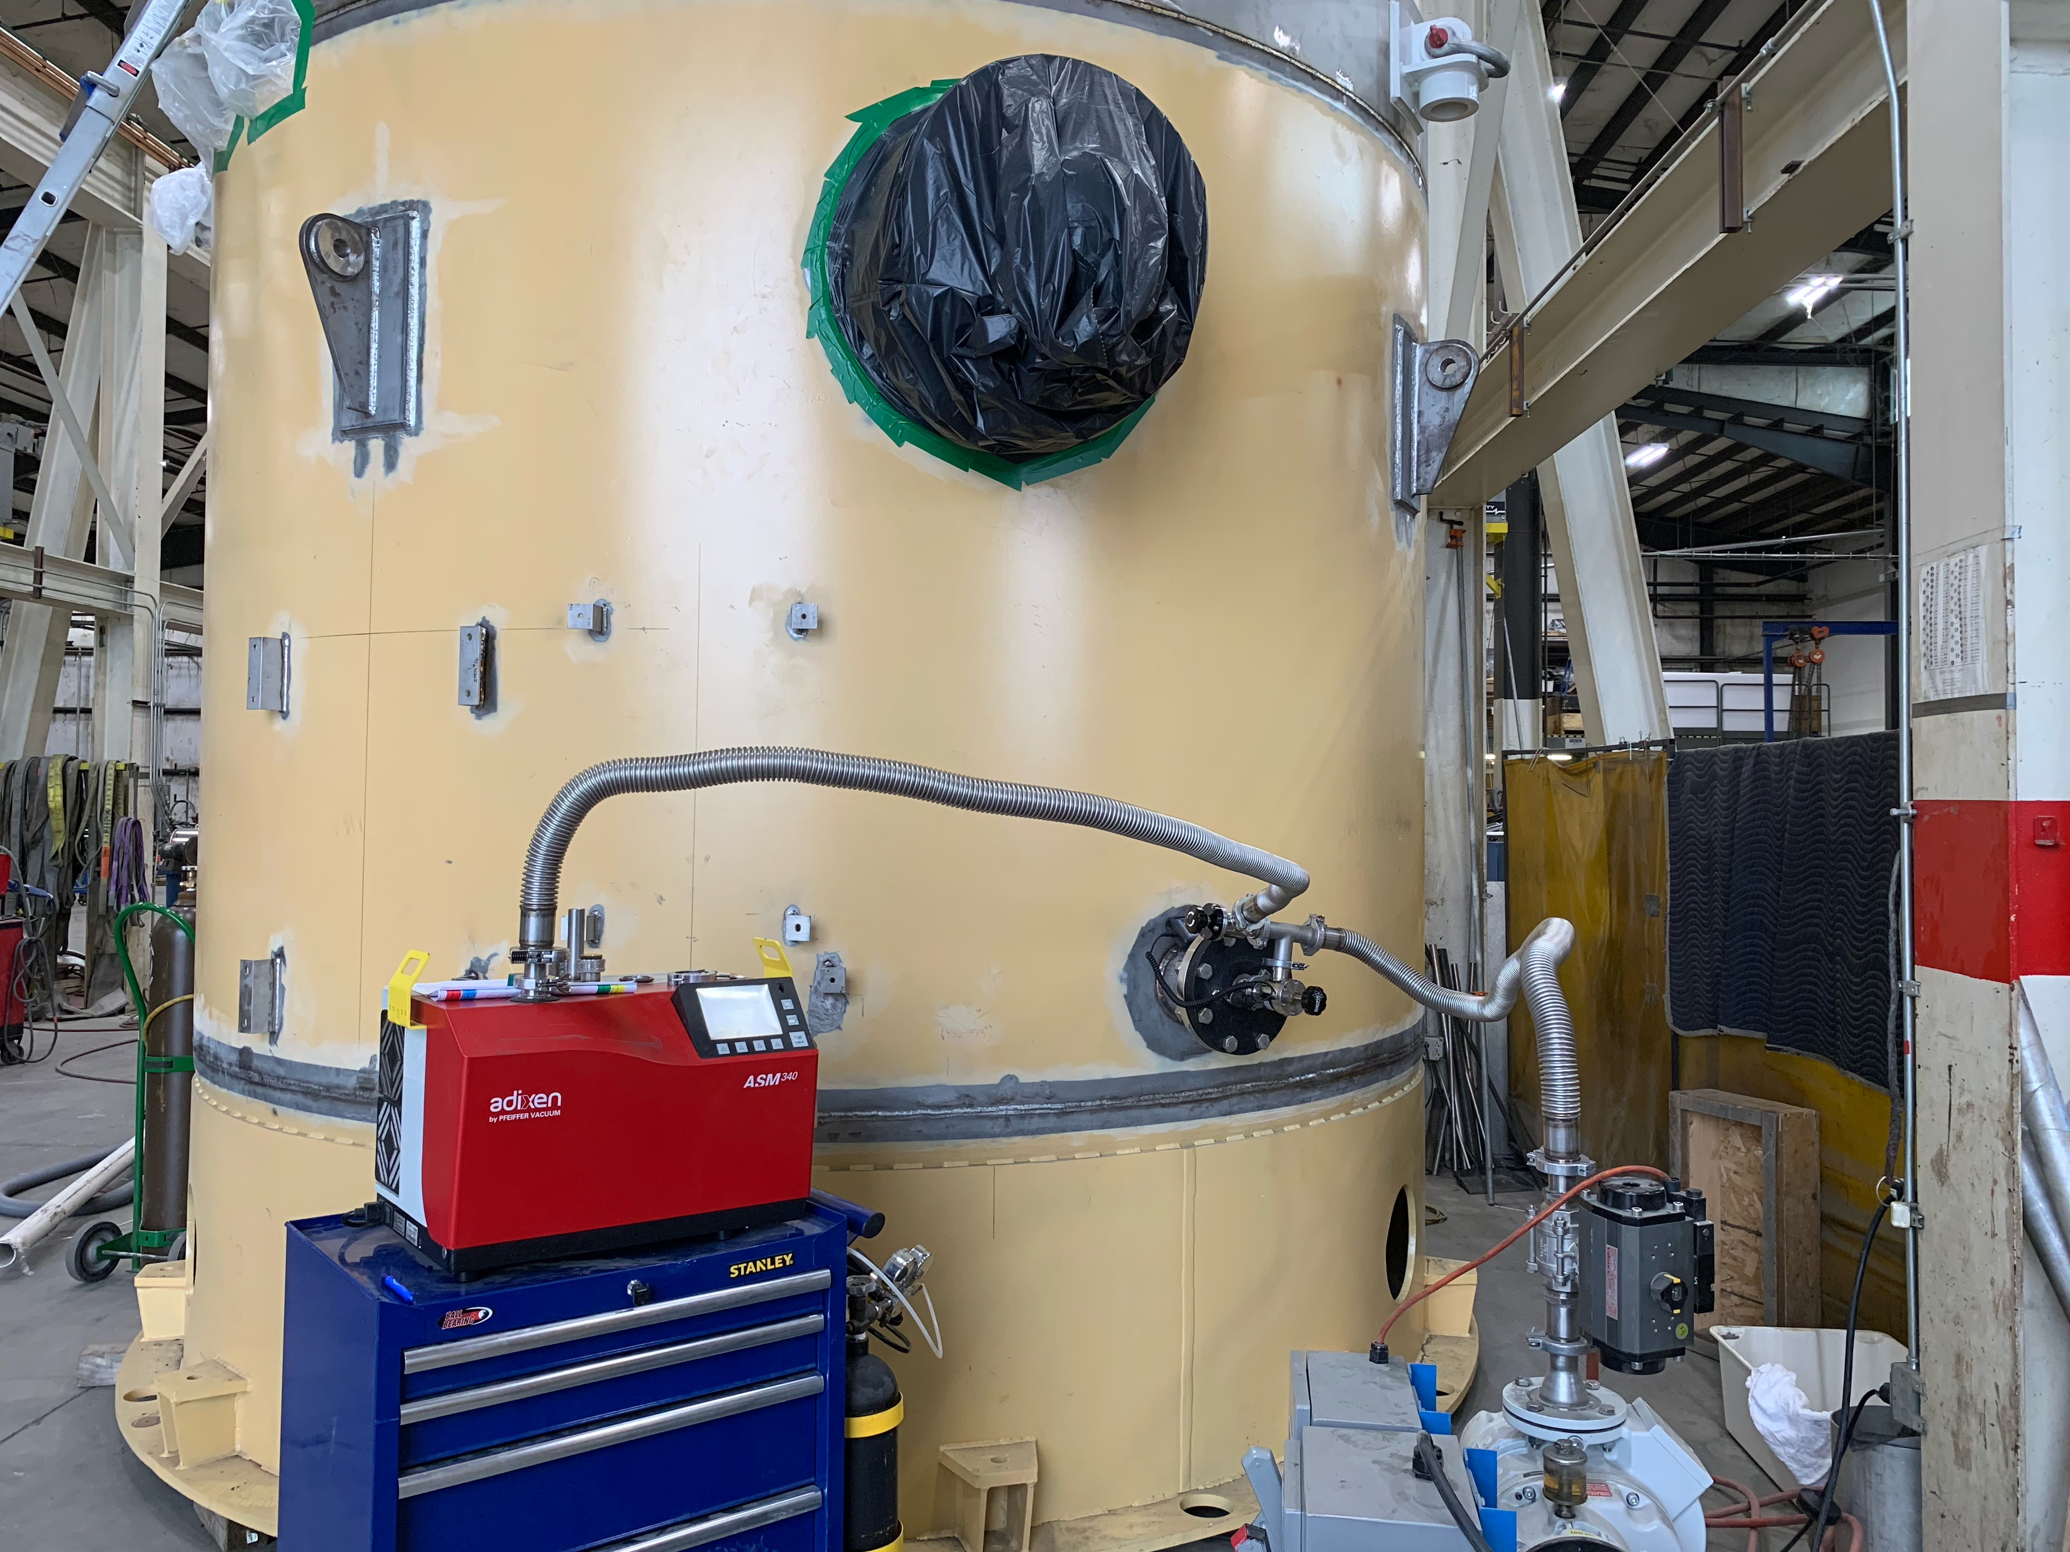

CP2 4.5K LCB in final leak-check ---- 2KCB initial pump-down in progress @PHPK

**QUALITY:**

* JLAB & SLAC staff present for CP1 MTL Factory Acceptance Testing at Demaco
* JLab staff scheduled to be present for C2 Dewar Neck Can Factory Acceptance Testing at Ability Engineering (AET)
* QA resource for CP document control in place and working.

**Upcoming Travel/Deliveries/Reviews:**

* Onsite visit to SLAC to witness/coordinate install/com 01-03-May-2019
* Final leak check of CP2 4.5K lower cold box 02-May-2019
* 4.5K Cold box Monthly status update @PHPK 02-May-2019
* Factory Acceptance Test for C2 Dewar Neck Can Week of 6-May, 2019