Weekly Reporting

WBS 1.01.07 JLAB Management

Week of May 2-8, 2019

**Issues:**

**Accomplishments this week:**

The last 4.5K (lower) cold box for the cryoplant has completed the final factory acceptance test; shipment to SLAC scheduled for 10-May-2019.

Cryomodule production continues to run smoothly. Cavity String 19 preparations have started. First cavity for cavity string 20 is qualified.

J1.3-14 shipped on 24-APR and has been received onsite @SLAC.

LERF: We are progressing with assembly of J-16. Cooldown scheduled in the next two weeks.

The project has issued a shipping hold for cryomodules.

**Upcoming Reviews:** None

Weekly Reporting

WBS 1.04.06 JLAB Cryomodules

Week of May 2-8, 2019

**Issues**: Shipping hold instructions issued on 30-APR.

**Accomplishments this week:**

J1.3-20 has 1 of 8 cavities qualified.

J1.3-19 has 8 cavities qualified. String assembly started.

J1.3-18- WS2, Leak check Process piping

J1.3-17 – WS3; Alignment

J1.3-16 – To LERF, Install Beam pipe

J1.3-15 – Warm in CMTF

J1.3-14 - Received @SLAC

J1.3-12 – WS5, Configure for shipping

J1.3-09 – Disassembled

J1.3-05 – LERF; Install Beam pipe

J1.3-03 - WS4, Shields removed, FSS

J1.3-01 - WS5, Warm couplers, MC Line, RT Done

J1.3-02, 07– Waiting for cantilever fixture for retrofit

J1.3-04, -08, -10, -13, -14 @ SLAC

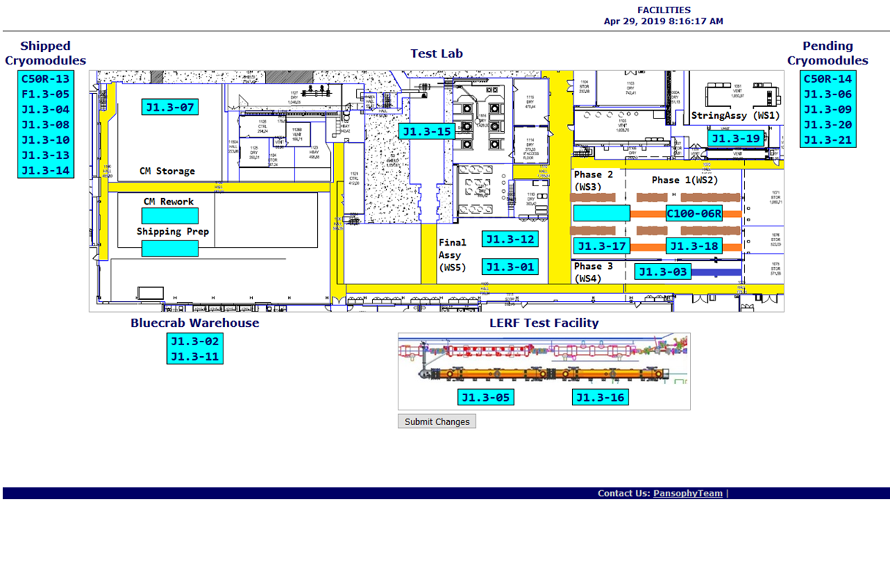

**QUALITY:** CM16 RT testing Saturday, May 4, all welding passed.

Weekly Reporting

WBS 1.04.08 JLAB Cryoplant System

Week of May 2-8, 2019

**Issues:**

1. Resolution of structural interferences created during the design of the cold box room platforms and cable trays support systems (*identified in NOV 2017*).
2. Delays installing interconnecting piping systems in cryoplant is delaying startup of commissioning activities.

**Accomplishments this week:**

* Shipment of CP2 4.5K lower cold box to SLAC.
* Initial pump-down of 2KCB (@PHPK) in progress.
* Final shipment of gauge panels delivered to SLAC.
* Gas Analyzer Cabinets fabrication complete & shipped to SLAC.

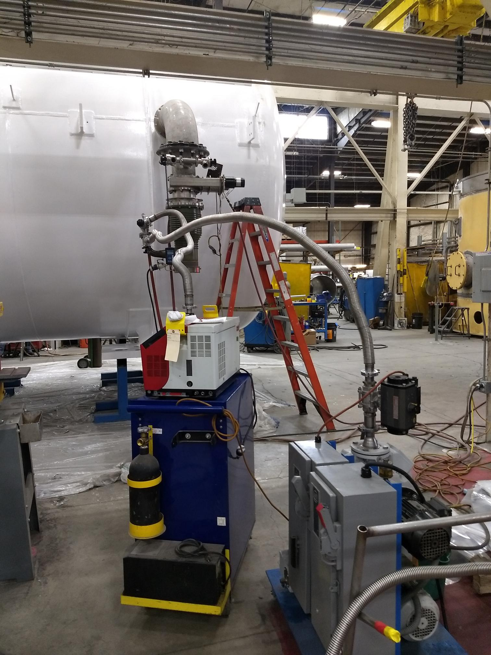 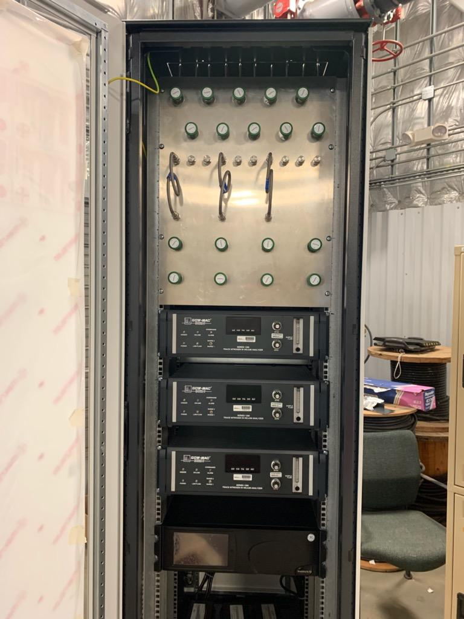 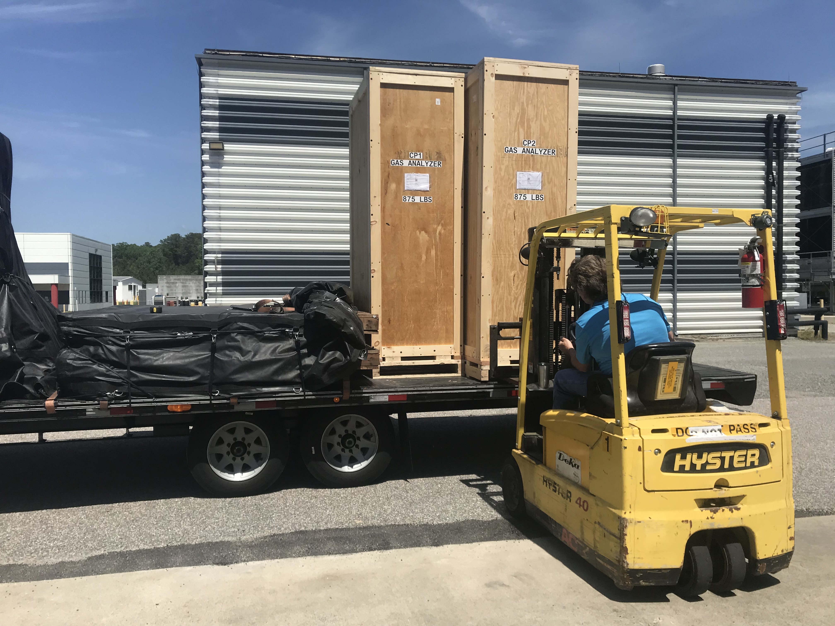

Gas Analyzer cabinets complete & shipped

Scheduled to arrive @SLAC this week

CP2 Lower Cold Box successfully completed final leak-check

Shipping to SLAC this week

**QUALITY:**

* Gas Analyzer cabinets successfully completed QA pressure testing requirements.
* JLAB & SLAC staff present for CP2 LCB final leak check at PHPK.
* JLab staff scheduled to be present for C2 Dewar Neck Can Factory Acceptance Testing at Ability Engineering (AET).
* QA resource for CP document control in place and working.

**Upcoming Travel/Deliveries/Reviews:**

* Site visit to witness loading & shipment of C2 4.5K LCB 9-May2019
* Delivery of Gas Analyzers to (JLab Fab) SLAC 9-May-2019
* Factory Acceptance Test for C2 Dewar Neck Can 16-May-2019
* Delivery of C2 4.5K Lower Cold Box 17-May-2019
* Delivery of C1 Multi-transfer Line (MTL) 07-Jun-2019