Weekly Reporting

WBS 1.01.07 JLAB Management

Week of May 9-15, 2019

**Issues:**

**Accomplishments this week:**

The last 4.5K (lower) cold box for the cryoplant has completed the final factory acceptance test; shipment to SLAC scheduled for 20-May-2019 arrival.

Cryomodule production continues to run smoothly. Cavity String 19 rolled out on 15-May. Two cavities for cavity string 20 are qualified.

J1.3-12 is planned for shipment from JLab on 18-May to arrive at SLAC on 21-May.

The project has issued a shipping hold for cryomodules, except for J-12 and J-01.

LERF: We are progressing with assembly of J-16. Cooldown is scheduled in the next week.

**Upcoming Reviews:** None

Weekly Reporting

WBS 1.04.06 JLAB Cryomodules

Week of May 9-15, 2019

**Issues**: Shipping hold instructions issued on 30-APR. J-12 and J-01 are not subject to this hold.

**Accomplishments this week:**

J. Martin traveled to SLAC to support M-mount removal procedure development. It was expected that J-14 M-mounts were to be removed. This was delayed until a later date.

LERF cooldown expected to start on 22-May. Beamline is leak tight. Interconnect piping and bellows are being installed and clean-up in advance of cooldown.

J1.3-20 has 2 of 8 cavities qualified.

J1.3-19 string is leak tight. Plan to roll out on 15-May.

J1.3-18 – WS3, Unite UCM to CS

J1.3-17 – WS4, RF cables / Tune HOMs

J1.3-16 – To LERF, Leak check ICR pp

J1.3-15 – Warm in CMTF, remove this week

J1.3-12 – WS5 Ship 5-18

J1.3-09 – Disassembled

J1.3-05 – LERF; ICR LC

J1.3-03 – WS3, FSS, Prep for BPM Hardware

J1.3-01 – WS5, MC Line lc, Flex line repair

J1.3-02, 07 – Waiting for cantilever fixture for retrofit

J1.3-04, -08, -10, -13, -14 @ SLAC

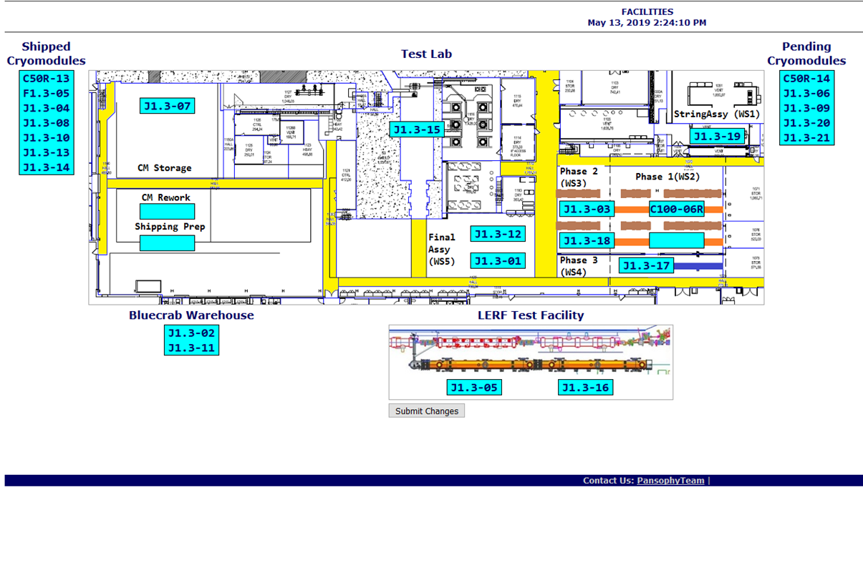

**QUALITY:** CM001 leak repair work in process. Document review for LCLS Cryo Module UCM037 and VV037 completed. UCM 037 welding review completed.

Weekly Reporting

WBS 1.04.08 JLAB Cryoplant System

Week of May 9-15, 2019

**Issues:**

1. Resolution of structural interferences created during the design of the cold box room platforms and cable trays support systems (*identified in NOV 2017*).
2. Delays installing interconnecting piping systems in cryoplant is delaying startup of commissioning activities.

**Accomplishments this week:**

* Completed assignment of IBX installation scope to SLAC.
* Shipment of CP2 4.5K lower cold box to SLAC (see picture below).
* First 2K CB factory acceptance test (@PHPK) scheduled this week.

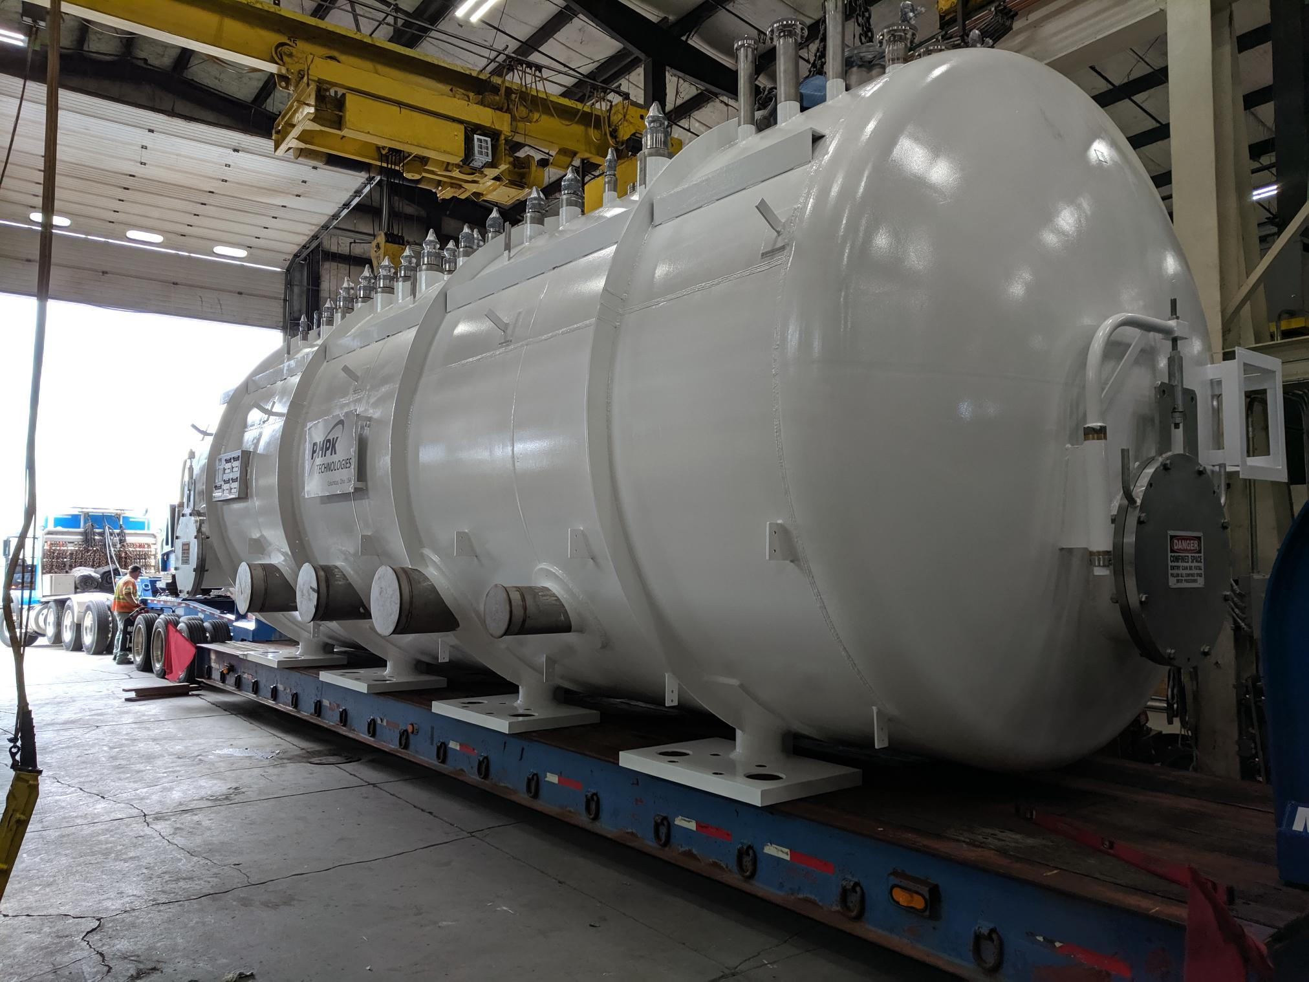

C2 Lower 4.5K Cold Box Loaded and shipped out to SLAC. Delivery expected for next.

**QUALITY:**

* First set of commissioning documentation delivered to SLAC.
* JLab staff scheduled for C2 Dewar Neck Can Factory Acceptance Testing at Ability Engineering (AET).
* QA resource for CP document control in place and working.

**Upcoming Travel/Deliveries/Reviews:**

* Factory Acceptance Test (FAT) for C2 Dewar Neck Can 17-May-2019
* Delivery of C2 4.5K Lower Cold Box 20-May-2019
* Delivery of C1 Multi-transfer Line (MTL) 07-Jun-2019