Weekly Reporting

WBS 1.01.07 JLAB Management

Week of May 16-29, 2019

**Issues:**

**Accomplishments this week:**

* The last 4.5K (lower) cold box for the cryoplant has made it to SLAC.
* Cryomodule production continues to run smoothly. We are on a shipping hold. We need a qualified alternative to the current M-Mount configuration.
* J1.3-12 is at SLAC.
* The project has rescinded the approval to ship J-01. We need to develop the p[lan for how to ship this CM.
* LERF: J-16 Cooldown has been completed.

**Upcoming Reviews:** None

Weekly Reporting

WBS 1.04.06 JLAB Cryomodules

Week of May 16-29, 2019

**Issues**: Shipping hold instructions issued on 30-APR. J-01 has been put on hold while SLAC reconsiders RoD on shipping configuration. Lack of qualified cavities due for string 20 due to lower than expected yield in testing.

**Accomplishments this week:**

LERF is at 2K as of 28-May.

J1.3-20 has 4 of 8 cavities qualified. String may be delayed at project’s direction.

J1.3-19 rolled out on 15-May.

J1.3-18 – WS3, WS3, Magnet leads, Welding 2 phase piping

J1.3-17 – WS4, Instrumentation, tune HOM’s

J1.3-16 – In LERF, Cooled down to 2K on 28-May.

J1.3-15 – Removed from CMTF; Configure for Shipping 8-Jun – delayed to arrive at SLAC on 17-Jun at project’s direction.

J1.3-12 – Received at SLAC on 5-21

J1.3-09 – Disassembled

J1.3-05 – In LERF, Cooled down to 2K on 28-May.

J1.3-03 – WS3, Installing shipping manifold.

J1.3-01 – WS5, Flex line repair on-going, SHIPPING HOLD

J1.3-02, 07 – Waiting for cantilever fixture for retrofit

J1.3-04, -08, -10, -13, -14, -12 @ SLAC

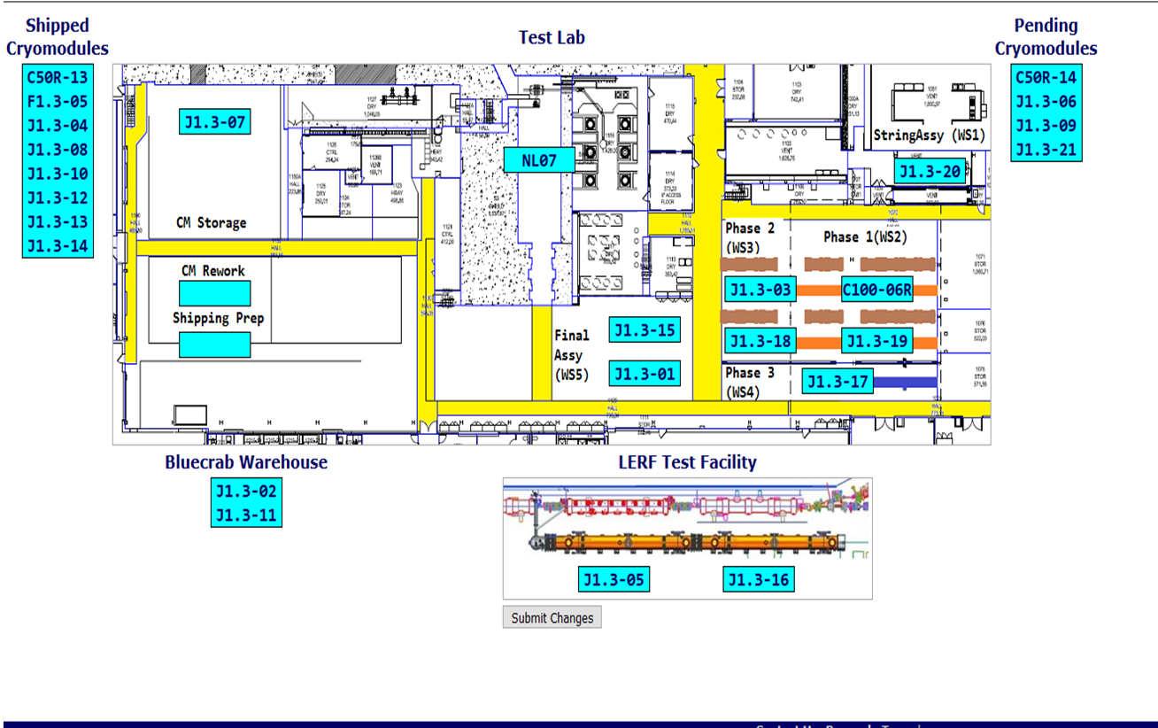

**QUALITY:** CM001 leak repair work in process for second repair attempt (welding is done). RT to be scheduled this week. Document review for LCLS Cryo Module UCM039 and VV039 completed.

**Upcoming Travel/Deliveries/Reviews:**

* J-15 arrival at SLAC 17-June-2019
* J-01 arrival at SLAC ON HOLD
* J-03 arrival at SLAC TBD

Weekly Reporting

WBS 1.04.08 JLAB Cryoplant System

Week of May 16-29, 2019

**Issues:**

1. Resolution of structural interferences created during the design of the cold box room platforms and cable trays support systems (*identified in NOV 2017*).
2. Delays installing interconnecting piping systems in cryoplant is delaying startup of commissioning activities.

**Accomplishments this week:**

* Bench testing of Utility software in progress.
* CP2 Dewar-neck-can delivered to SLAC.
* First 2K CB successfully completed factory acceptance test at PHPK, and was shipped to SLAC (see photo below).

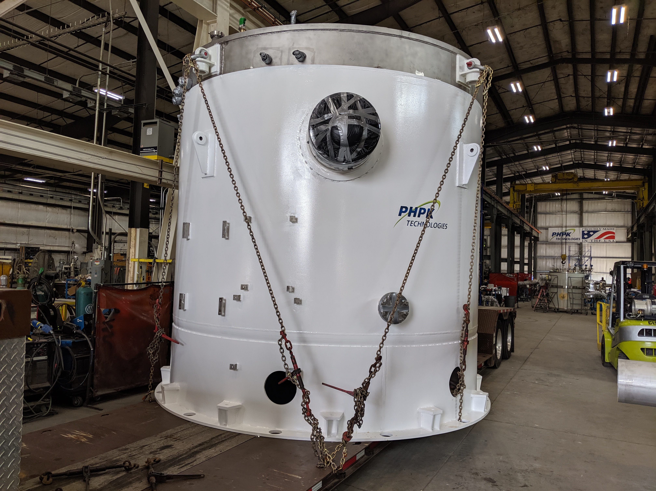

* CP2 4.5K LCB delivered and set in position at SLAC (see photo below).

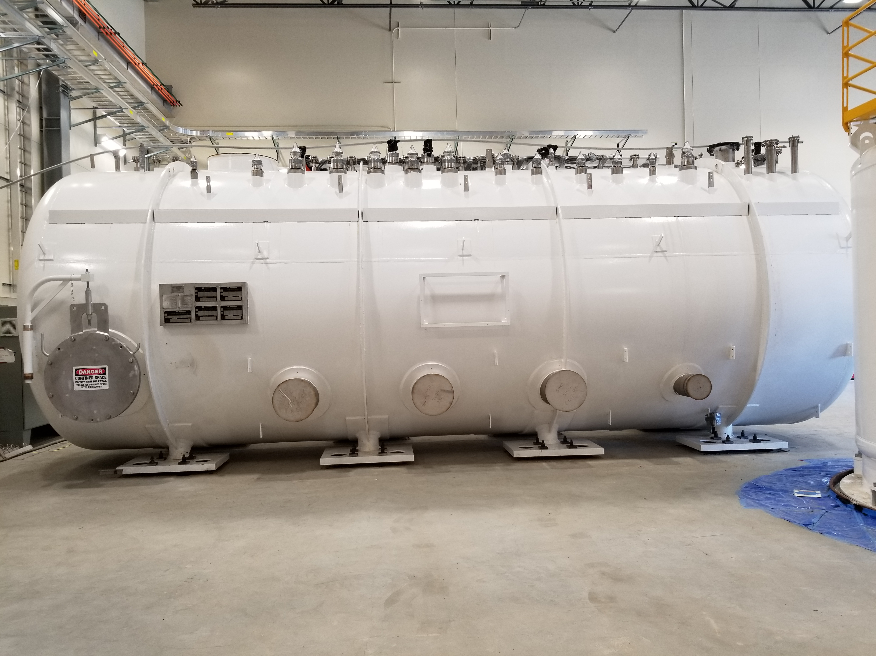

**QUALITY:**

* First set of commissioning documentation delivered to SLAC.
  + Routine in place for documentation review and submittal to SLAC.
* JLab witness first 2K cold box factory acceptance test on 20-May-2019.
* JLab staff onsite for C2 Dewar Neck Can Factory Acceptance Testing at Ability Engineering (AET).
* JLab staff onsite to witness progress on C2 LN2 Dewar at AES.

**Upcoming Travel/Deliveries/Reviews:**

* Delivery of C2 Dewar Neck Can 30-May-2019
* Delivery of first 2K CB to SLAC 05-Jun-2019
* Delivery of C1 Multi-transfer Line (MTL) 07-Jun-2019