Weekly Reporting

WBS 1.01.07 JLAB Management

Week of May 30-Jun 5, 2019

**Issues:**

**Accomplishments this week:**

* The last 4.5K (lower) cold box for the cryoplant piping was pressurized and is holding pressure.
* Cryomodule production continues to run smoothly. We are on a shipping hold. We need a qualified alternative to the current M-Mount configuration.
* J1.3-15 is shipping schedule has been modified to the project request date.
* The project has rescinded the approval to ship J-01. We need to develop the plan for how to ship this CM.

**Upcoming Reviews:** None

Weekly Reporting

WBS 1.04.06 JLAB Cryomodules

Week of May 30-Jun 5, 2019

**Issues**: Shipping hold instructions issued on 30-APR. J-01 has been put on hold while SLAC reconsiders RoD on shipping configuration.

**Accomplishments this week:**

LERF testing was on hold until CEBAF machine set up was completed. Testing is expected to begin

J1.3-20 has 8 cavities qualified. String delayed until next week due to issue with clean nitrogen supply.

J1.3-19 - WS2, Leak checking two-phase piping, MLI, Mag Shields

J1.3-18 - WS3, Soldered magnet leads, Welding 2 phase

J1.3-17 – WS4, MLI, installing into VV

J1.3-16 – Testing in LERF

J1.3-15 –WS5, Configure for Shipping 6/14

J1.3-09 – Disassembled

J1.3-05 –Testing in LERF

J1.3-03 - WS3, FSS, tune HOM’s

J1.3-01 - WS5, Inner RT passed, complete valve box welding

J1.3-02, 07– Waiting for cantilever fixture for retrofit

J1.3-04,08,10,12,13,14@SLAC

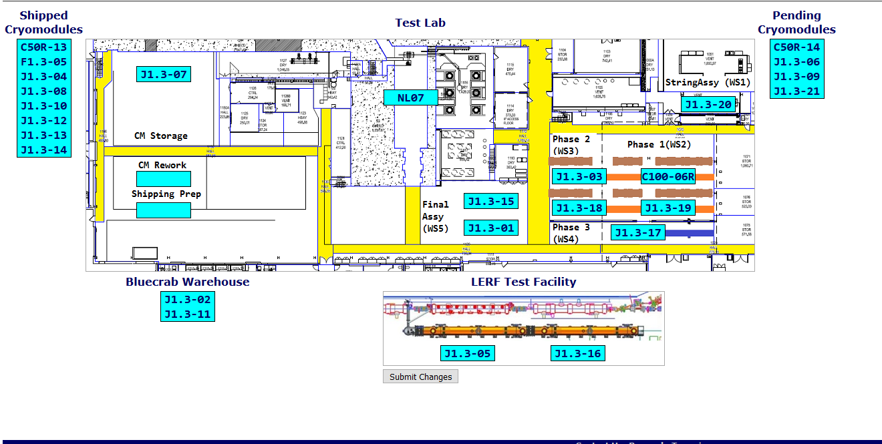

**QUALITY:** CRM001 flex hose leak repair work passed RT on 5-30-19. In process welding inspections on CRM001 to reconnect high press line (target RT 6-8-19). Document review for LCLS II Cryo Module UCM040 and VV040 completed. Completed vendor welding review for LCLS UCM 040.

**Upcoming Travel/Deliveries/Reviews:**

* J-15 arrival at SLAC 17-June-2019
* J-03 arrival at SLAC 21-July-2019
* J-01 arrival at SLAC ON HOLD

Weekly Reporting

WBS 1.04.08 JLAB Cryoplant System

Week of May 30-Jun 5, 2019

**Issues:**

1. Delays installing interconnecting piping systems in cryoplant is delaying startup of commissioning activities.
2. Getting a PO in place for the CP1 (interface box) multi-transfer line onsite installation scope of work.

**Accomplishments this week:**

* Bench testing of Gas Management & Utility software nearing completion.
* First 2K CB shipped to SLAC.
  + Delivery scheduled for 06-June-2019

**QUALITY:**

* First set of commissioning documentation delivered to SLAC.
  + Routine in place for documentation review and submittal to SLAC.
* JLab onsite to witness CP2 LN2 Dewar manufacturing (AES) and reviewed progress to complete.
* JLab staff onsite to witness final assembly stage of CP2 2K CB (Linde see photos below).
* Review completed for QA document package for LCLS II CP1 Main Transfer Line from Demaco.
* Review completed for document package for LCLS II CP1 second Dewar Neck Can from Ability.

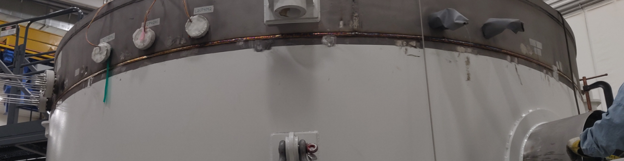

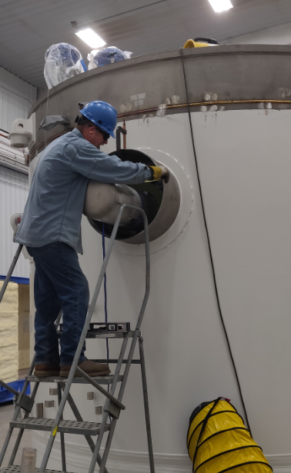

**Upcoming Travel/Deliveries/Reviews:**

* Delivery of first 2K CB to SLAC 06-Jun-2019
* Delivery of C1 Multi-transfer Line (MTL) 10-Jun-2019