Weekly Reporting

WBS 1.01.07 JLAB Management

Week of June 6-12, 2019

**Issues:**

**Accomplishments this week:**

* The last 4.5K (lower) cold box for the cryoplant has completed the receiving acceptance.
* The first 2K cold box is onsite in B905 @SLAC.
* Cryomodule production continues to run smoothly.
* J-15 has been approved by SLAC for shipment with removable zip ties.
* J-15 is shipping schedule has been modified to the project request date, arrives at SLAC on 17-June.
* The project has rescinded the approval to ship J-01. We need to develop the plan for how to ship this CM.

**Upcoming Reviews:** None

Weekly Reporting

WBS 1.04.06 JLAB Cryomodules

Week of June 6-12, 2019

**Issues**: Shipping hold instructions issued on 30-APR. J-01 has been put on hold while SLAC reconsiders RoD on shipping configuration.

**Accomplishments this week:**

LERF testing was on hold while LLRF issues were being resolved. Cavities were tuned to resonance and couplers were adjusted.

J1.3-21 Three cavities are qualified for the string.

J1.3-20 String assembly started on June 11, and will roll out by June 21.

J1.3-19- WS2- QC-Demag of UCM@WS3

J1.3-18- WS3- LC 2 phase piping, CS Alignment

J1.3-17 – WS5- Warm Couplers, Beam line config.

J1.3-16 – Testing in LERF

J1.3-15 –WS6- Shipping 6/14

J1.3-09 – Disassembled

J1.3-05 –Testing in LERF

J1.3-03- WS4, Shields install, verify HOM’s

J1.3-01- WS5, all RT’s passed, complete valve box, N-Mount installed on Cav1

J1.3-02, 07– Waiting for cantilever fixture for retrofit

J1.3-04,08,10,12,13,14@SLAC

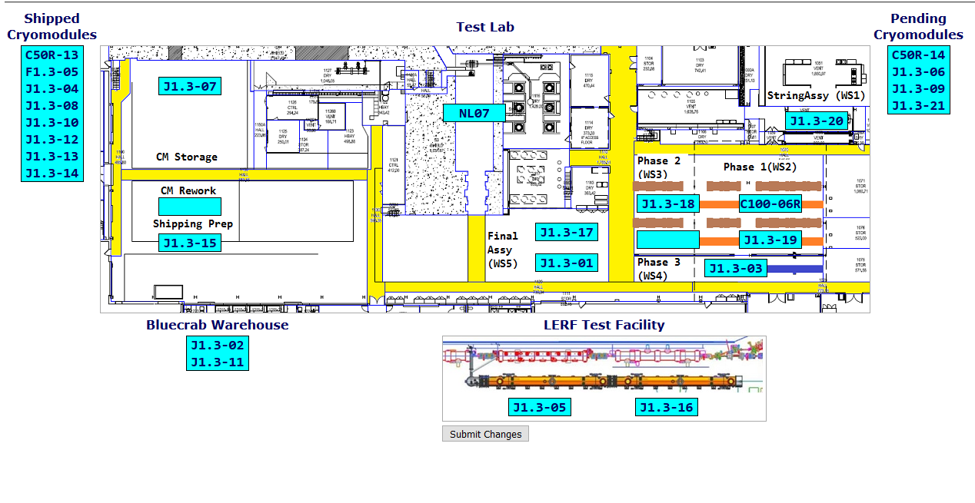

**QUALITY:** No report.

**Upcoming Travel/Deliveries/Reviews:**

* J-15 arrival at SLAC 17-June-2019
* J-03 arrival at SLAC 21-July-2019
* J-01 arrival at SLAC ON HOLD

Weekly Reporting

WBS 1.04.08 JLAB Cryoplant System

Week of June 6-12, 2019

**Issues:**

1. Delays installing interconnecting piping systems in cryoplant is delaying startup of commissioning activities.

**Accomplishments this week:**

* Bench testing of Gas Management & Utility software nearing completion.
* First 2K CB delivered to SLAC from vendor (PHPK).

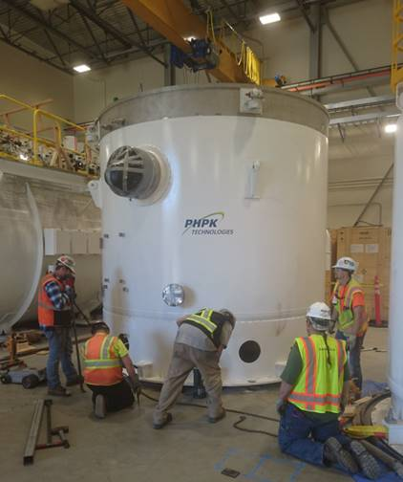

**QUALITY:**

* Commissioning documentation being reviewed by JLab QA group.
  + Routine in place for documentation review and submittal to SLAC.
* JLab SO, SOTR & QA staff onsite to witness CP2 LN2 Dewar manufacturing (AES).
* JLab staff onsite to witness final assembly stage of CP2 2K CB.

**Upcoming Travel/Deliveries/Reviews:**

* Delivery of C1 Multi-transfer Line (MTL) 13-Jun-2019