Weekly Reporting

WBS 1.01.07 JLAB Management

Week of June 13-19, 2019

**Issues:**

**Accomplishments this week:**

* The last cold box for the cryoplant FAT has a tentative schedule of 24 June.
* The final equipment FAT, IBX#1&2 and MTL#2, is scheduled for 29 July – 2 August.
* Cryomodule production continues to run smoothly.
* J-15 has arrived at SLAC
* JLab has sent a proposal for shipping configuration to SLAC and is waiting for a response. J-01.

**Upcoming Reviews:** None

Weekly Reporting

WBS 1.04.06 JLAB Cryomodules

Week of June 13-19, 2019

**Issues**: Shipping hold instructions issued on 30-APR. J-01 has been put on hold while SLAC reconsiders RoD on shipping configuration. JLab has proposed an alternative.

**Accomplishments this week:**

LERF testing is ongoing J16, working on Emaxs

J1.3-21 – Three cavities are qualified for the string.

J1.3-20 – String assembly started on June 11 has a leak and will need to be taken apart.

J1.3-19 – WS3-Unite with UCM

J1.3-18 – WS3- CS Alignment

J1.3-17 – WS5- Beam line config, HPT, MC Line

J1.3-16 – Testing in LERF

J1.3-09 – Disassembled

J1.3-05 –Testing in LERF

J1.3-03 – WS5, WC’s, JT welding

J1.3-01 – WS5, Project- N-Mount install

J1.3-02, 07– Waiting for cantilever fixture for retrofit

J1.3-04,08,10,12,13,14,15@SLAC

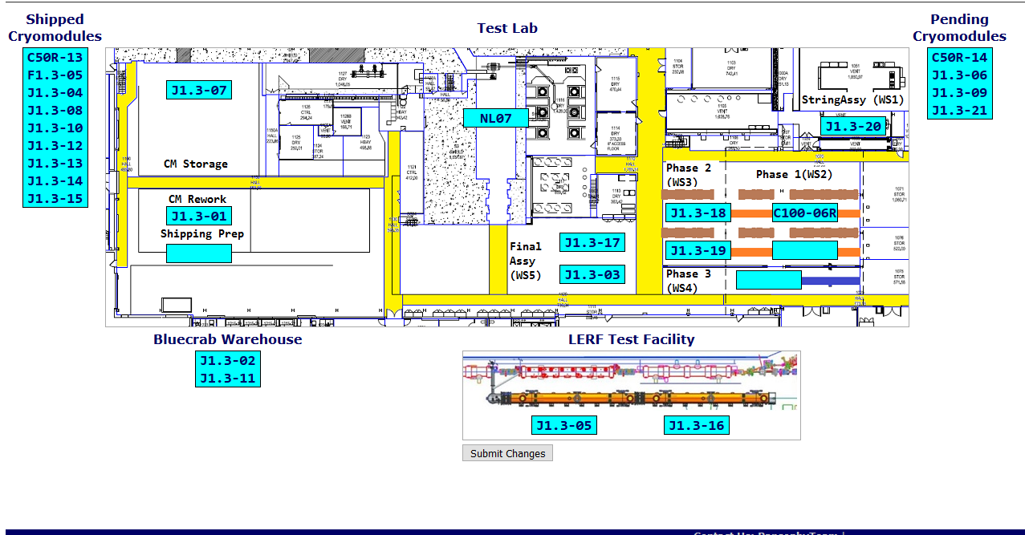

**QUALITY:** In process welding inspections on CRM017 high-pressure line (RT scheduled Saturday 6-22-19).

**Upcoming Travel/Deliveries/Reviews:**

* J-15 arrived at SLAC 17-June-2019
* J-01 arrival at SLAC Proposed 14 July
* J-03 arrival at SLAC 22-July-2019

Weekly Reporting

WBS 1.04.08 JLAB Cryoplant System

Week of June 13-19, 2019

**Issues:**

1. Delays installing interconnecting mechanical, electrical and controls infrastructure in cryoplant is delaying startup of commissioning activities.

**Accomplishments this week:**

* Bench testing of Gas Management, Utility and Vacuum skid software in progress.
* First 2K CB delivered to SLAC from vendor (PHPK).

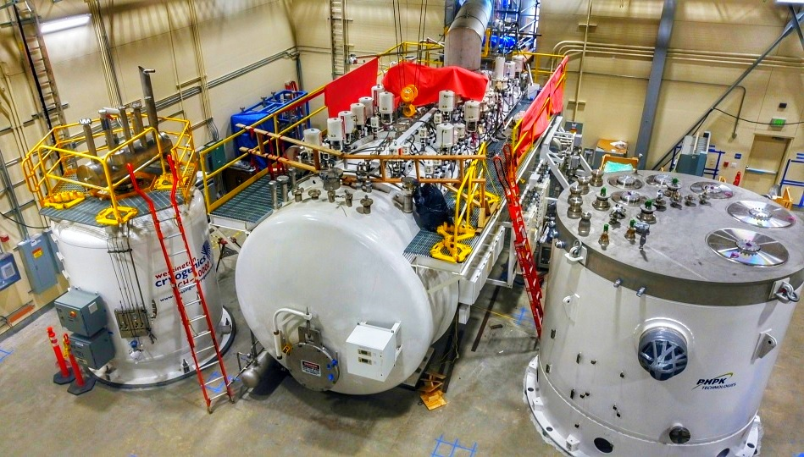

CryoPlant – 1: Liquid Helium Dewar, Lower 4.5K & 2K cold boxes in place @SLAC

  

CryoPlant – 1: Interface box – Multi-transfer line delivered to SLAC

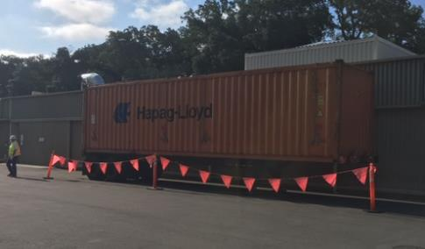

**QUALITY:**

* Commissioning documentation progressing by JLab QA group.
* Routine in place for documentation review and submittal to SLAC.
* JLab SO, SOTR & QA staff onsite to witness CP2 LN2 Dewar manufacturing (AES).
* JLab staff onsite to witness final assembly stage of CP2 2K CB.

**Upcoming Travel/Deliveries/Reviews:**

* Factory Acceptance Test of 2nd 2K cold box 24-Jun-2019
* Factory Acceptance Test 2 of IBX & MTL 29-Jul to 2-Aug 2019