Weekly Reporting

WBS 1.01.07 JLAB Management

Week of June 20-26, 2019

**Issues:**

**Accomplishments this week:**

* The last cold box for the cryoplant passed its FAT on 24 June.
* The final equipment FAT, IBX#1&2 and MTL#2, is scheduled for 29 July – 2 August.
* Cryomodule production continues to run smoothly.
* JLab has put J-01 in storage.

**Upcoming Reviews:** None

Weekly Reporting

WBS 1.04.06 JLAB Cryomodules

Week of June 20-26, 2019

**Issues**: Shipping hold instructions issued on 30-APR. J-01 has been put into storage.

**Accomplishments this week:**

LERF testing is ongoing J16, working on Emaxs

J1.3-21 – Seven cavities are qualified for the string.

J1.3-20 – String assembly started on June 11 has a leak and has need to been taken apart. Reassembly is scheduled to start on 11 July.

J1.3-19 – WS3-2 phase welding, magnet leads

J1.3-18 – WS3- Tuners

J1.3-17 – WS5- Instrumentation, 2 phase leak check

J1.3-16 – Testing in LERF

J1.3-11 – In storage

J1.3-09 – Disassembled

J1.3-05 –Testing in LERF

J1.3-03 – WS5, WC’s, Inst flanges

J1.3-02, 07– Waiting for cantilever fixture for retrofit

J1.3-01 – WS5, In storage

J1.3-04,08,10,12,13,14,15@SLAC

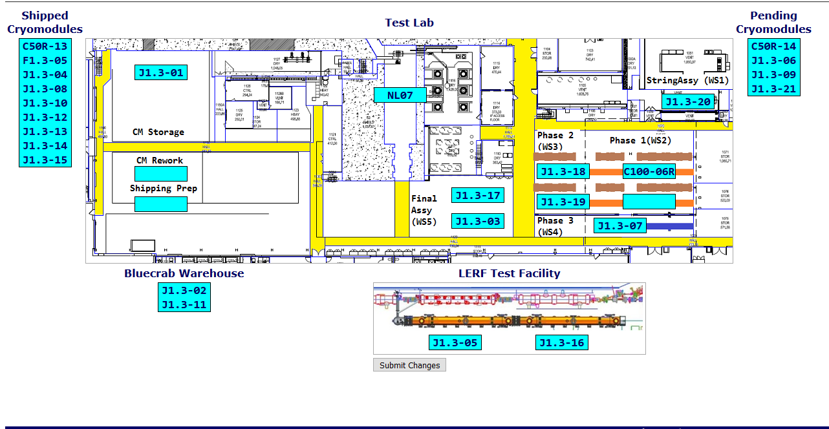

**QUALITY:** No report.

**Upcoming Travel/Deliveries/Reviews:**

* J-03 arrival at SLAC 30-July-2019

Weekly Reporting

WBS 1.04.08 JLAB Cryoplant System

Week of June 20-26, 2019

**Issues:**

1. Delays installing interconnecting mechanical, electrical and controls infrastructure in cryoplant is delaying startup of CP1 commissioning activities.

**Accomplishments this week:**

* Site visit to 2nd LN2 Dewar vendor
  + Inner and outer vessel nearing completion.
* Second 2K CB completed factory acceptance test (Linde).

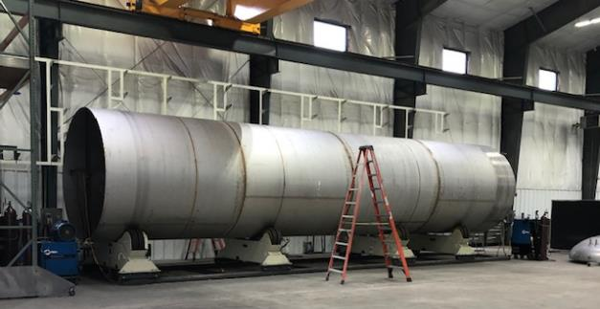 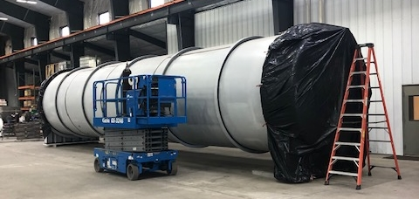

2nd LN2 Dewar – Site visit to witness progress and discuss delivery schedule.

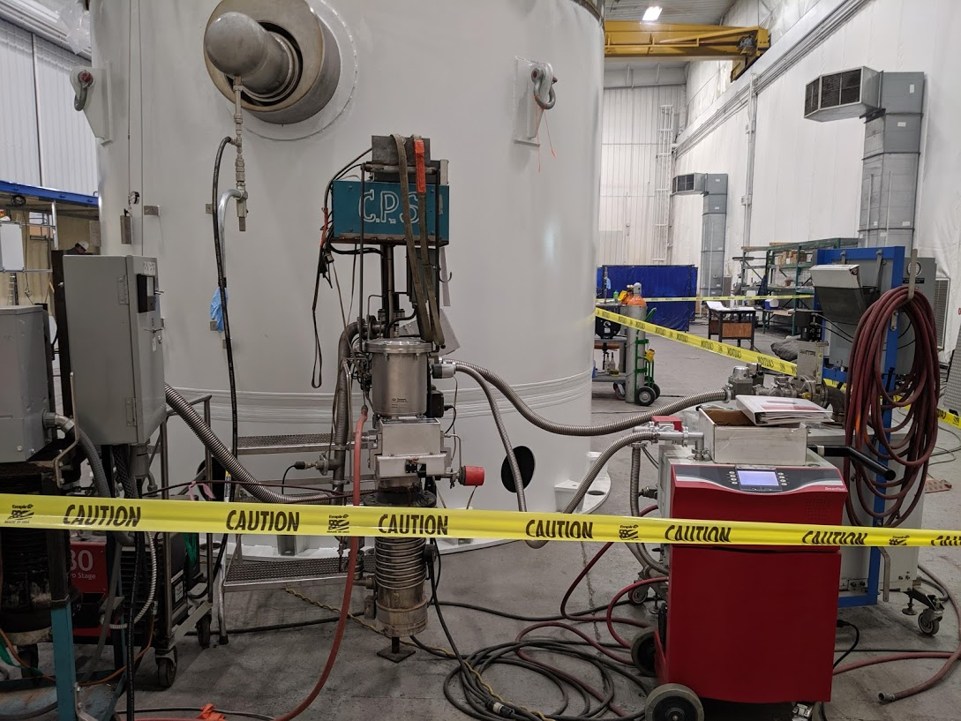 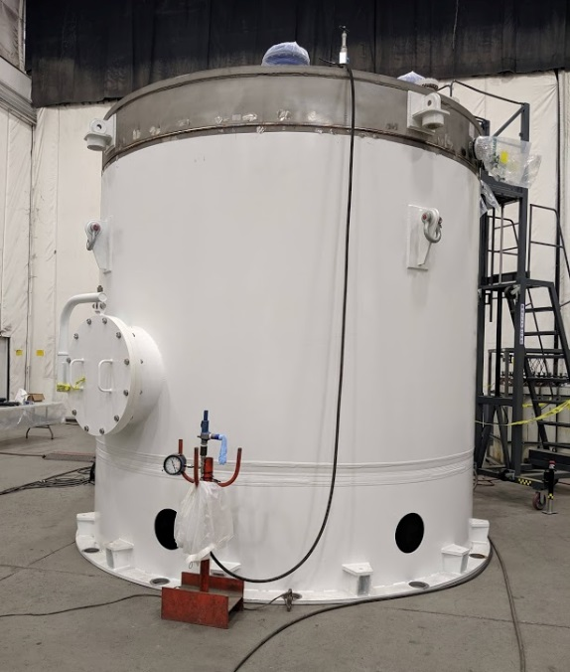

2nd 2K CB for CP2 completed factory acceptance testing - Monday (24-June).

**QUALITY:**

* Commissioning documentation progressing by JLab QA group.
  + Routine in place for documentation review and submittal to SLAC.
* JLab SO, SOTR & QA staff onsite to witness CP2 LN2 Dewar manufacturing (AES).
* JLab staff onsite to witness factory acceptance of CP2 2K CB.

**Upcoming Travel/Deliveries/Reviews:**

* Factory Acceptance Test of CP1 & CP2 IBX & MTL 29-Jul to 2-Aug 2019