**LCLS-II JUNE PROJECT STATUS REPORT**

**DATE:** July 3, 2019

**LOCATION OF PROJECT:** Jefferson Lab

**SENIOR TEAM LEAD:** Joe Preble

**MONTHLY PROGRESS**

Summary

JLab continues to make significant progress in all areas. Cost, schedule, and scope are being managed to the baseline. We received earned value and variance data, analyzed data and submitted VARs.

EV Performance as of May close.

Overall % complete = 91%, SPI = 0.96, CPI = 0.98

Management

The last 4.5K (lower) cold box for the cryoplant has completed receiving acceptance.

The first 2K cold box is onsite in B905 at SLAC. The second 2K cold box final acceptance test, held on June 24 at the vendor, was successful.

Cryomodule J-15 was approved by SLAC for shipment with removable zip ties; it arrived at SLAC on 17-June.

Cryoplant System:

EV Performance

Overall % complete = 89%, SPI = 0.95, CPI = 0.97

Interface box and multi-transfer line were delivered to SLAC for Cryoplant 1. See photos below.

  

Interface box and multi-transfer line.

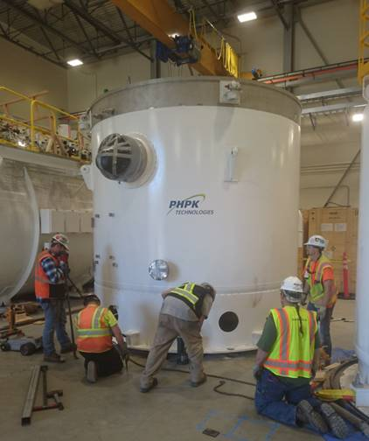

First 2K Coldbox delivered to SLAC.

Successful shipment of C2 4.5K lower cold box to SLAC.

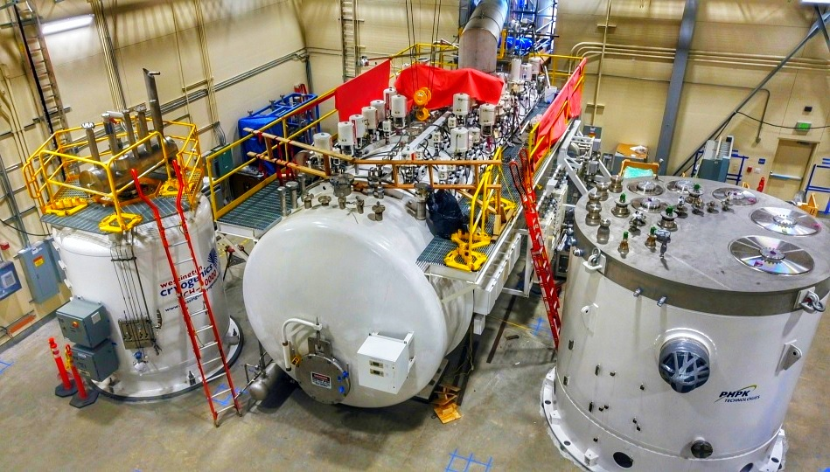

CryoPlant #1: Liquid Helium Dewar, Lower 4.5K & 2K cold boxes in place at SLAC.

First 2K coldbox delivered to SLAC from vendor (PHPK). Second 2K coldbox successfully completed the factory acceptance test at the vendor.

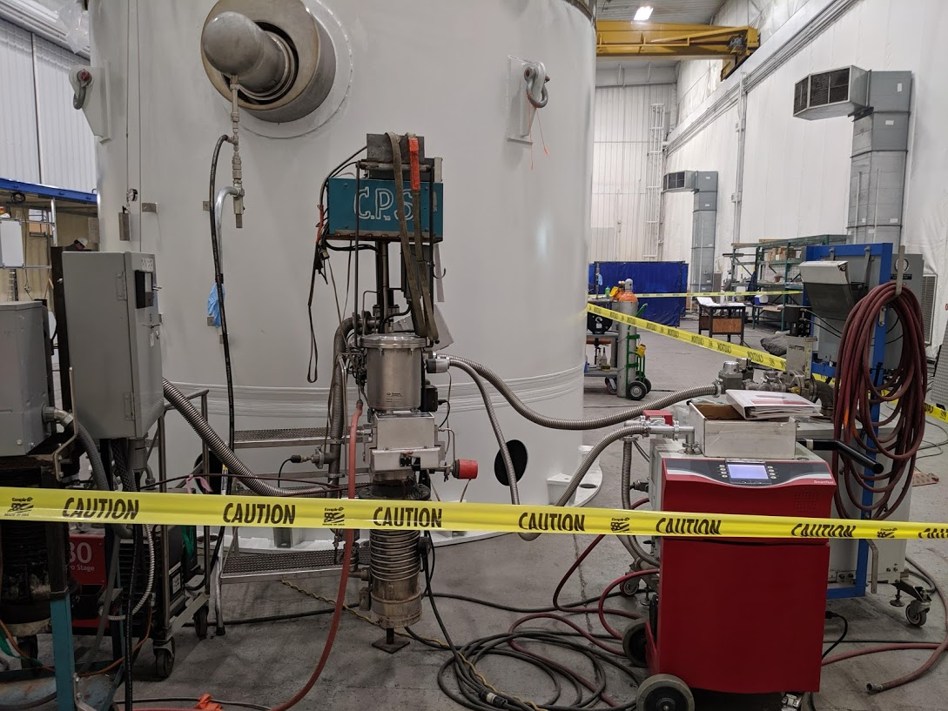 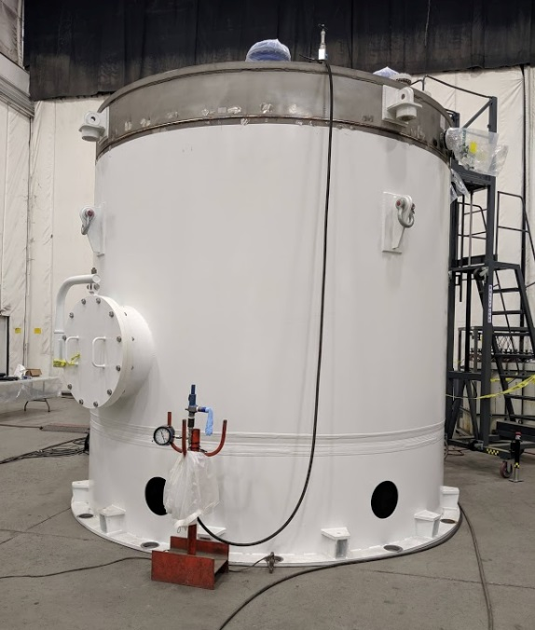

Second 2K CB for CP2 completed factory acceptance testing - Monday (24-June).

JLab onsite to witness CP2 LN2 Dewar manufacturing (AES) and reviewed progress of inner and outer vessel which are nearing completion.

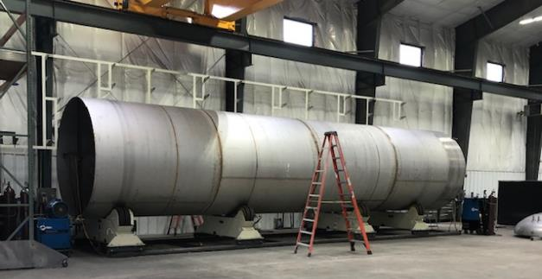 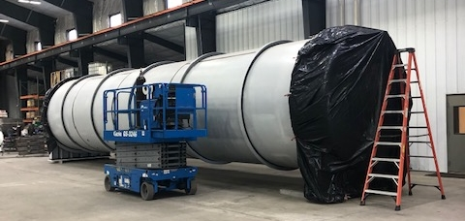

Second LN2 Dewar – Site visit to witness progress and discuss delivery schedule.

Review completed for QA document package for LCLS II CP1 Main Transfer Line from Demaco. Review completed for document package for LCLS II CP1 second Dewar Neck Can from Ability. First set of commissioning documentation were delivered to SLAC. Bench testing of Gas Management, Utility and Vacuum skid software in progress.

Major equipment continued to be shipped to SLAC.

Component Count = 94. Delivered = 90. In Fabrication = 3. Installed = 84. In storage = 6.



Upcoming CryoPlant Events:

Delivery of CP2 2K cold box is scheduled for 15 July.

Cryomodules:

EV performance

Overall % complete = 93%, SPI = 0.96, CPI = 0.98

LERF testing is ongoing J16, working on Emaxs.

Final cavities from vendors were received.

Three additional BLA assemblies were received.

J1.3-21 – Seven of eight cavities are qualified for the string.

J1.3-20 – String assembly started on 11 June has a leak and will need to be disassembled. Reassembly is scheduled to start on 11 July.

J1.3-19 – WS3-2 phase welding, magnet leads.

J1.3-18 – WS3- Tuners.

J1.3-17 – WS5- ready for testing; awaiting removal of CM currently in testing.

J1.3-16 – Testing in LERF.

J1.3-11 – In storage.

J1.3-09 – Disassembled.

J1.3-07 – WS3, disassembly and rework has started.

J1.3-05 – Testing in LERF.

J1.3-03 – WS5, preparing for shipment on 26-JUL; trailer to arrive back at JLab on 8-JUL.

J1.3-02 – Waiting for cantilever fixture for retrofit.

J1.3-01 – WS5, In storage.

J1.3-04,08,10,12,13,14,15 at SLAC.

