Weekly Reporting

WBS 1.01.07 JLAB Management

Week of June 26 to July 10, 2019

**Issues:**

**Accomplishments this week:**

* The last cold box for the cryoplant is in route to SLAC.
* The final equipment FAT, IBX#1&2 and MTL#2, is scheduled for 29 July – 2 August.
* Cryomodule production continues to run smoothly.
* J-17 is ready for installation into the CMTF
* Working BCRs for the CP commissioning change, aligning CP payment dates, and rework of J11.

**Upcoming Reviews:** None

Weekly Reporting

WBS 1.04.06 JLAB Cryomodules

Week of June 26 to July 10, 2019

**Issues**: Shipping hold instructions issued on 30-APR. J-01 was put into storage.

**Accomplishments this week:**

Received direction from project to begin rework on J11. BCR details in development.

LERF testing is ongoing – J16 & J5 Qo measurements began 8-JUL.

J1.3-21 – Seven of eight cavities are qualified for the string.

J1.3-20 – String assembly scheduled to start on 11-JUL.

J1.3-19 – WS3

J1.3-18 – WS4

J1.3-17 – installed in CMTF; cooldown planned for later this week

J1.3-16 – Testing in LERF

J1.3-11 – In storage

J1.3-09 – Disassembled

J1.3-07 – WS6, rework in progress; fastener spreadsheet

J1.3-05 –Testing in LERF

J1.3-03 – WS5, preparing for shipment on 26-JUL; trailer arrived back at JLab on 8-JUL.

J1.3-02 – Waiting for cantilever fixture for retrofit

J1.3-01 – In storage

J1.3-04,08,10,12,13,14,15@SLAC

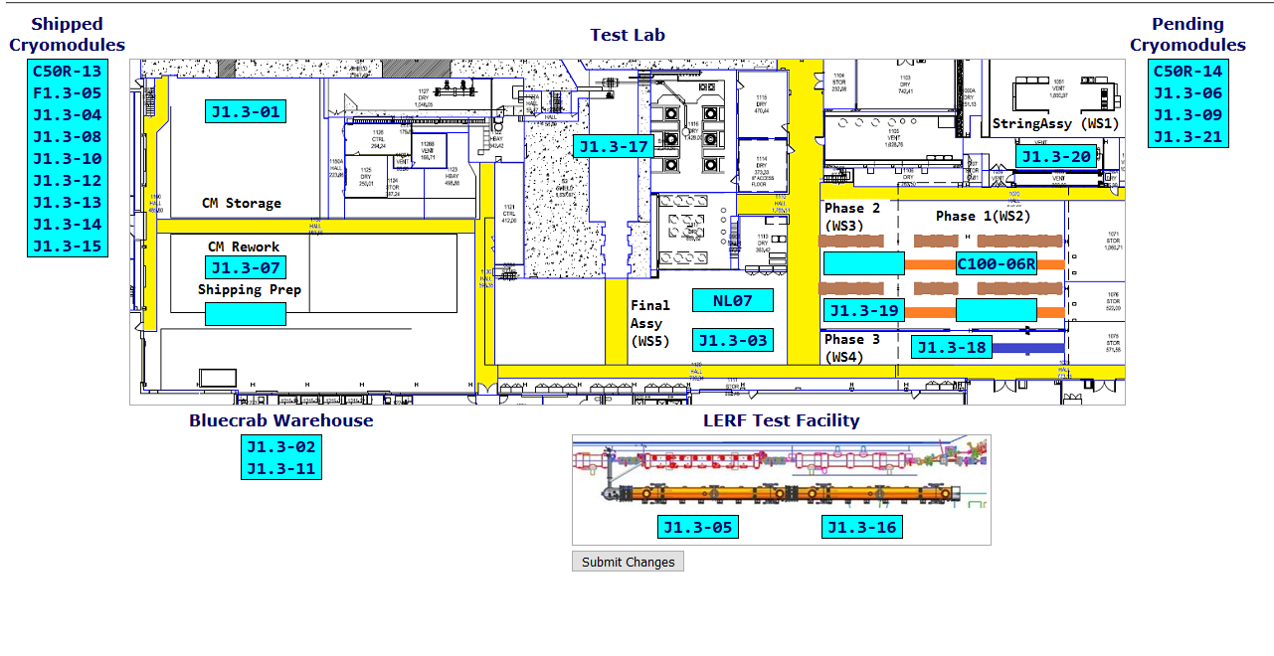

**QUALITY:** Low pressure testing on CRM003.

**Upcoming Travel/Deliveries/Reviews:**

* J-03 arrival at SLAC 30-July-2019

Weekly Reporting

WBS 1.04.08 JLAB Cryoplant System

Week of June 26 to July 10, 2019

**Issues:**

1. Delays installing interconnecting mechanical, electrical and controls infrastructure in cryoplant is delaying startup of CP1 commissioning activities.

**Accomplishments this week:**

* Site visit to 2nd LN2 Dewar vendor to witness progress.
* Second 2K cold box (Linde) is en route with live tracking to SLAC.

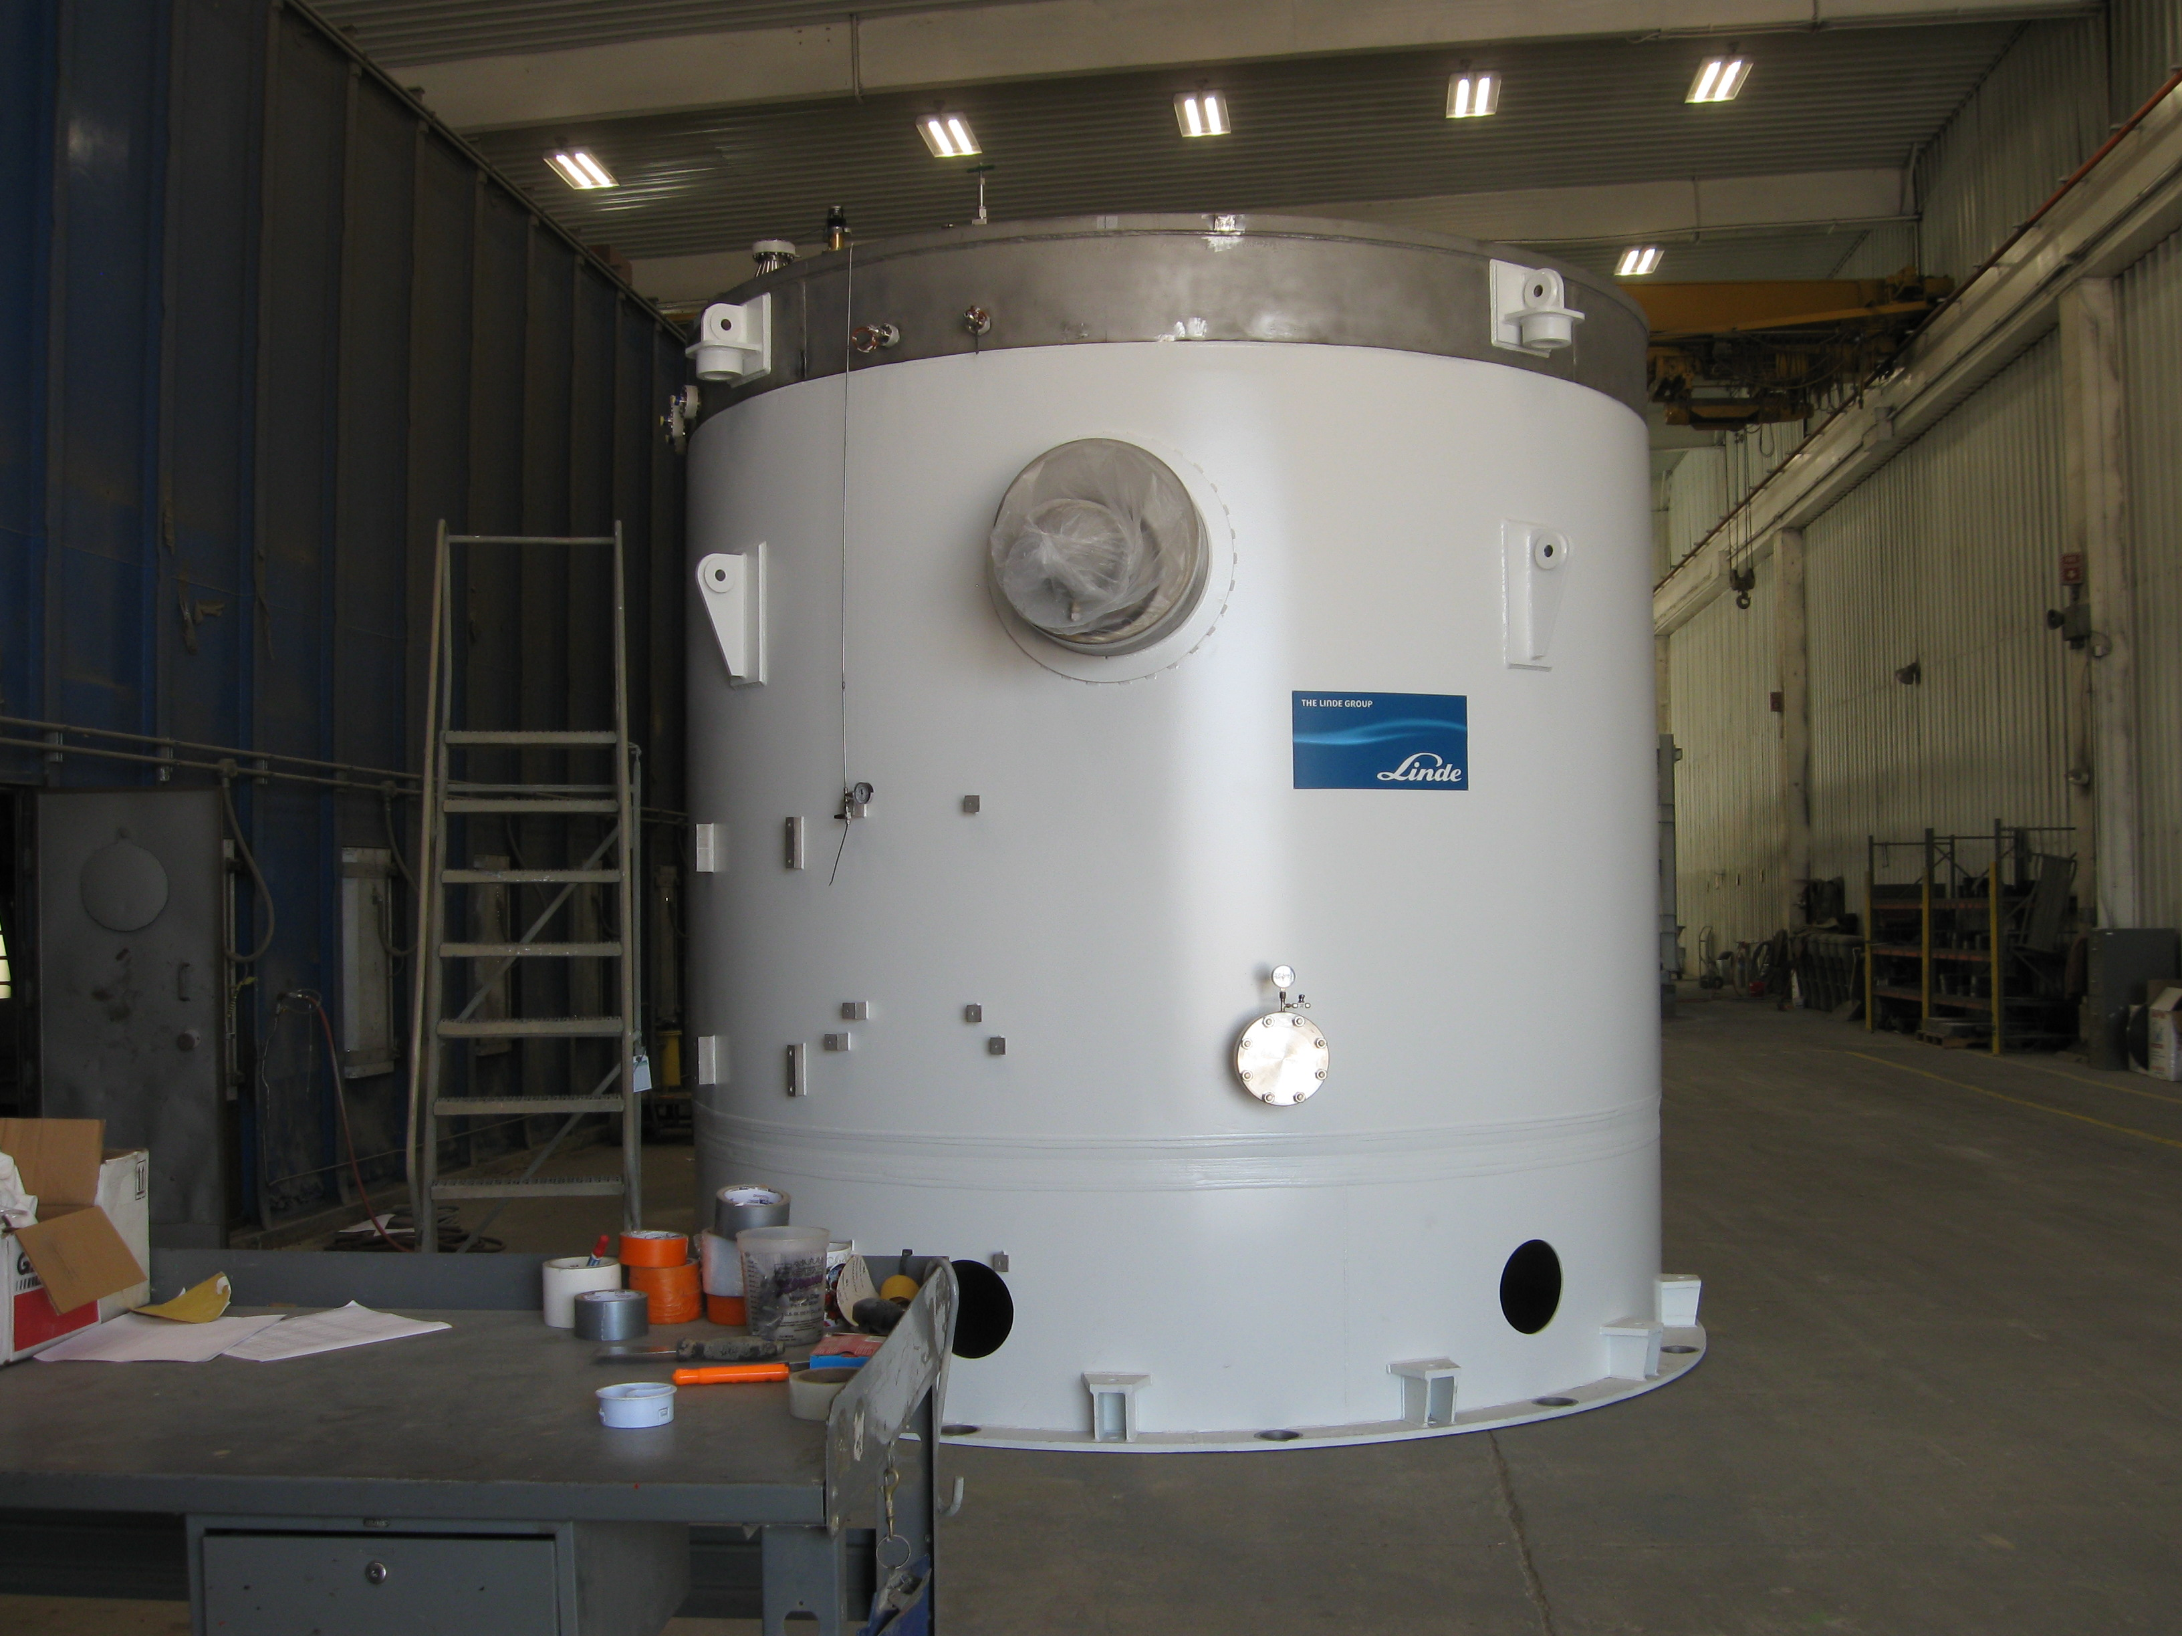 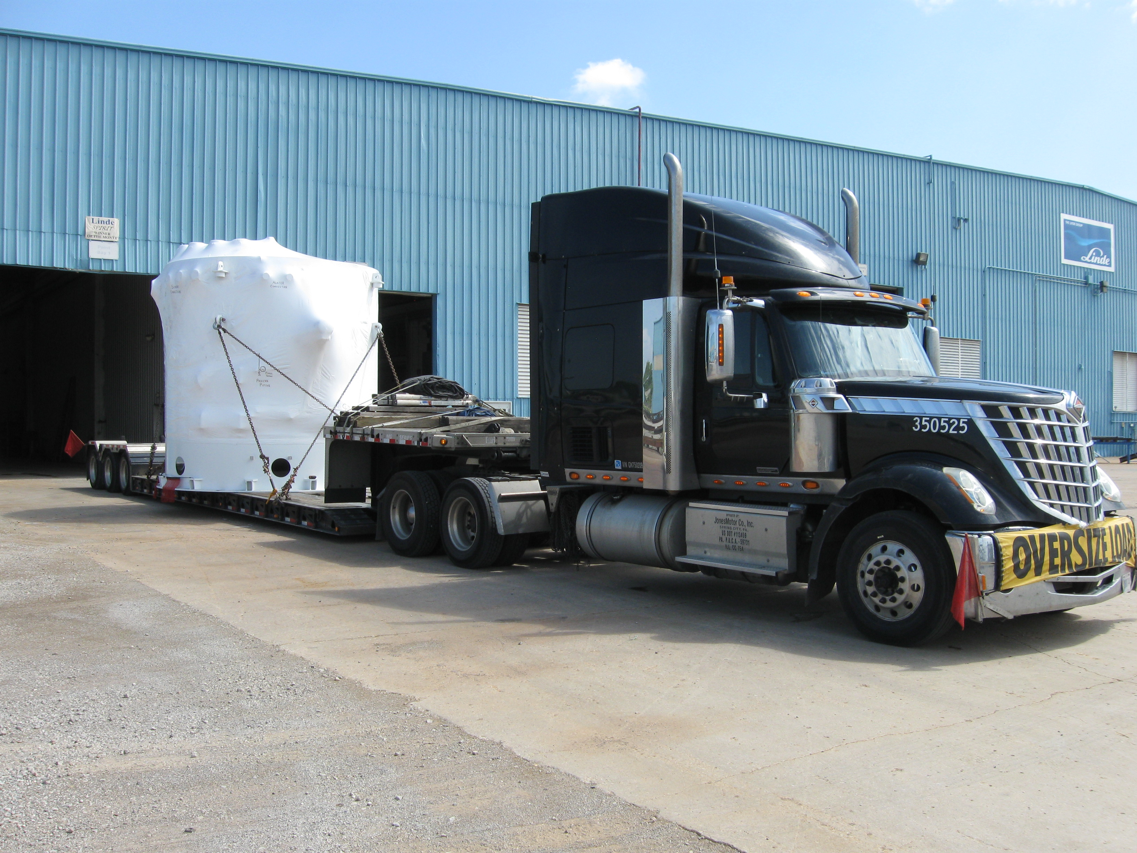 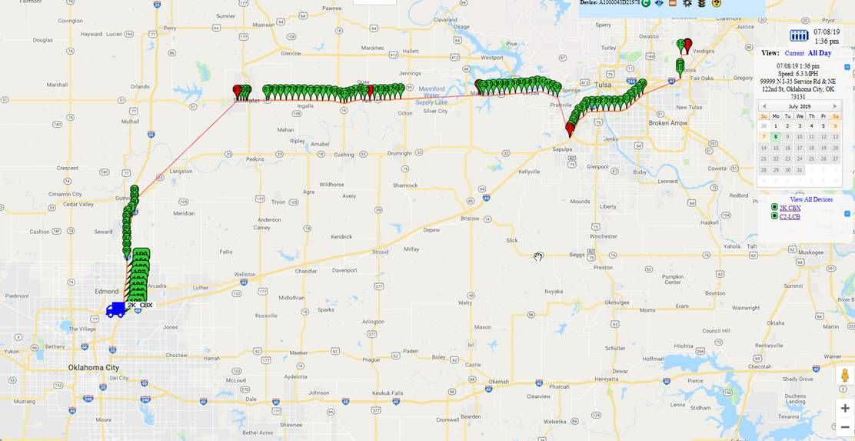

**QUALITY:**

* Commissioning documentation progressing by JLab QA group.
  + Routine in place for documentation review and submittal to SLAC.
* JLab SO onsite to witness CP2 LN2 Dewar manufacturing (AES).
* Software bench testing progressing well in advance of equipment readiness.

**Upcoming Travel/Deliveries/Reviews:**

* SME visit to LN2 Dewar vendor 10-July-2019
* Delivery of Second 2K cold box (week of) 12-July-2019
* Factory Acceptance Test of CP1 & CP2 IBX & MTL 29-July-2019