Weekly Reporting

WBS 1.01.07 JLAB Management

Week of July 18-24, 2019

**Issues:**

**Accomplishments this week:**

* Continue to work on finalizing the CP commissioning BCRs to transfer scope and responsibility to SLAC.
* Developing BCR to align 4.5K CB payments and P6 schedule.
* Provided SLAC with a SOW to use for procurement of 2K CB assembly.
* Cleaning up CP DCRs.
* Completed VARs.
* Reviewing June EAC.

**Upcoming Reviews:** None

Weekly Reporting

WBS 1.04.06 JLAB Cryomodules

Week of July 18-24, 2019

**Issues**: Shipping hold instructions issued on 30-APR. J-01 was put into storage.

**Accomplishments this week:**

Received direction from project to begin rework on J11. EAC details in development.

LERF testing is ongoing – J16 & J5; FPC High Qext studies ongoing; 8-cavity GDR run was completed.

J1.3-06 - One of eight cavities are qualified for the string.

J1.3-21 – Eight cavities are qualified for the string.

J1.3-20 – WS2; String rolled out on 17-JUL.

J1.3-19 – WS3; Tuner installation on-going

J1.3-18 – WS4; Shield welded; alignment on-going

J1.3-17 – installed in CMTF; Cooldown completed on 24-JUL; testing on-going

J1.3-16 – Testing in LERF

J1.3-11 – In storage

J1.3-09 – Disassembled

J1.3-07 – WS3, BPM hardware replacement – complete and leak tight

J1.3-06 - Disassembled

J1.3-05 –Testing in LERF

J1.3-03 – WS5, preparing for shipment on 26-JUL

J1.3-02 – Waiting for cantilever fixture for retrofit; In storage offsite

J1.3-01 – In storage

J1.3-04,08,10,12,13,14,15@SLAC

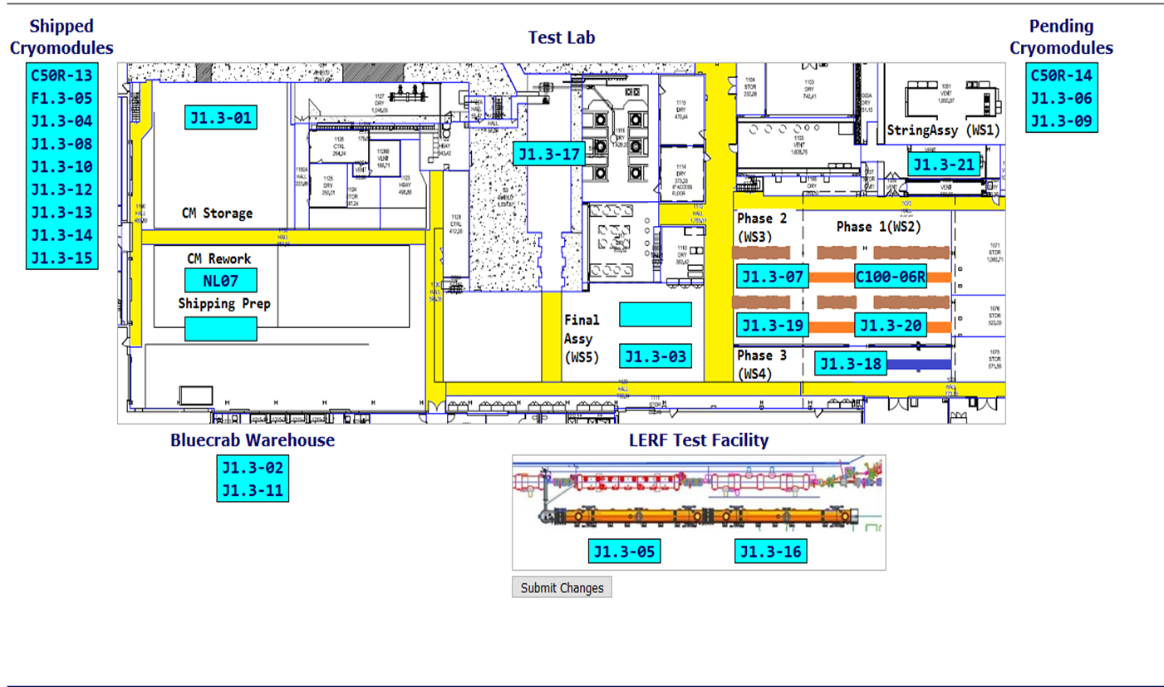

**QUALITY:** No report.

**Upcoming Travel/Deliveries/Reviews:**

* J-03 arrival at SLAC 30-July-2019

Weekly Reporting

WBS 1.04.08 JLAB Cryoplant System

Week of July 18-24, 2019

**Issues:** Delays installing interconnecting mechanical, electrical and controls infrastructure in cryoplant is delaying startup of CP1 commissioning activities.

**Accomplishments this week:**

* 2nd LN2 Dewar MLI completion. Stage for vessel integration.
* Complete preparations for CP1 & CP2 Interface box factory acceptance test.

**QUALITY:**

* Commissioning documentation progressing by JLab QA group.
  + Routine in place for documentation review and submittal to SLAC.
* Software bench testing progressing well in advance of equipment readiness.

**Upcoming Travel/Deliveries/Reviews:**

* Site visit to LN2 Dewar vendor 29-July-2019
* Factory Acceptance Test of CP1 & CP2 IBX & MTL 29-July-2019
* Factory Acceptance Test of 2nd LN2 Dewar (tentative) 7-August-2019