Weekly Reporting

WBS 1.01.07 JLAB Management

Week of July 25-31, 2019

**Issues:**

**Accomplishments this week:**

* Continue to work on finalizing the CP commissioning BCRs to transfer scope and responsibility to SLAC.
* Reviewing June EAC.

**Upcoming Reviews:** None

Weekly Reporting

WBS 1.04.06 JLAB Cryomodules

Week of July 25-31, 2019

**Issues**: Shipping hold instructions issued on 30-APR. J-01 is now in storage.

**Accomplishments this week:**

LERF testing is ongoing – J16 & J5; SLAC test plans ongoing

J1.3-20 – WS22 Phase piping and instrumentation

J1.3-19 – WS3; Tuner installation on-going

J1.3-18 – WS5; Warm couplers and beam pipes for testing

J1.3-17 – CMTF testing

J1.3-16 – Testing in LERF

J1.3-05 –Testing in LERF

J1.3-03 – Shipped to SLAC

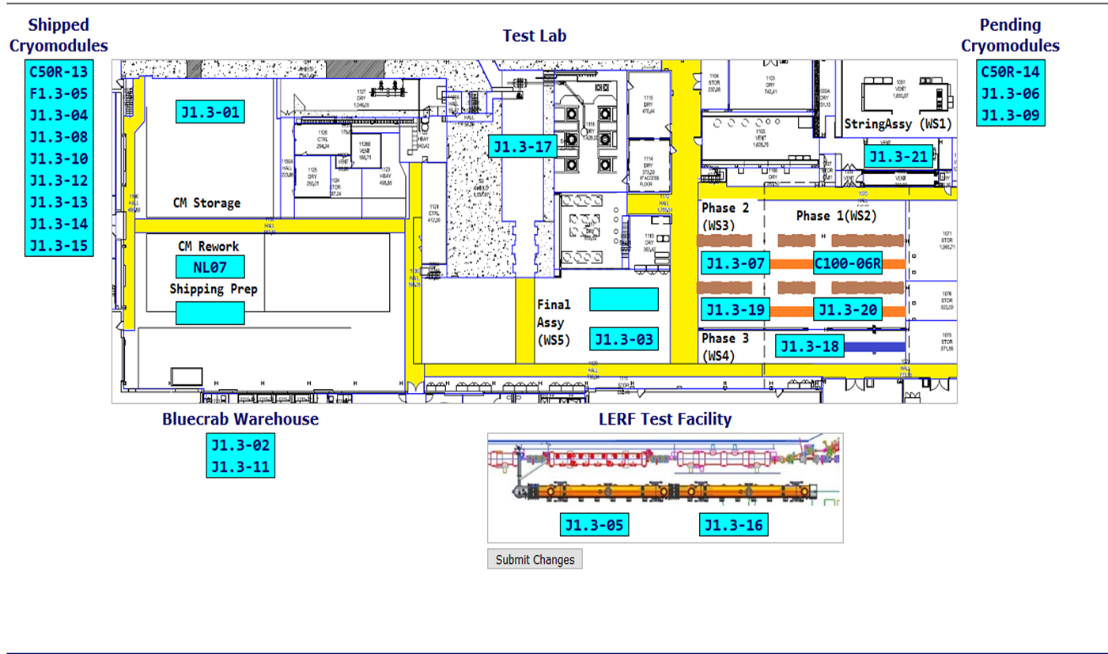

**QUALITY:** In Process welding inspections for CRM018 for RT inspection 8-3-19.

**Upcoming Travel/Deliveries/Reviews:**

Weekly Reporting

WBS 1.04.08 JLAB Cryoplant System

Week of July 25-31, 2019

**Issues:** Delays installing interconnecting mechanical, electrical and controls infrastructure in cryoplant is delaying startup of CP1 commissioning activities.

**Accomplishments this week:**

* Visited LN2 Dewar vendor to check welds.
* Successful Interface box factory acceptance test for CP1 & CP2.

|  |  |
| --- | --- |
| M:\LCLS-II\Project Photos & Videos\LN2 Dewar\LN2 Dewar 1.jpg | M:\LCLS-II\Project Photos & Videos\LN2 Dewar\LN2 Dewar 2.jpg |

LN2 Dewar weld check.

|  |  |
| --- | --- |
| https://lh3.googleusercontent.com/t6jVcFHqf3pF9DGzVAOHOINtkDOnqX35a7Y296rVMAAx0zJmlJ_nzqGt8Uy3rzhl-3fpmBvkwYe2ZDqYigBX-2w8DgZjHGe5-IMpcIQhG-Jna76UxSCn_eRuPL9vj3cHXqjqXGpf3g=w1245-h934-no | https://lh3.googleusercontent.com/mn6wPsdglTtUxjwgF56dyxEx1uGLDzSdhoC5s7EHBpsB2KutgC1v7xeyj7JCeah4OcOB-8NiCFlz0pUKOMs-Jrq6n7qeFF-IzLHNTwTmYyF-e6BKOu9c-vpD2Vsfz9ZQJy1J8z4w5Q=w1245-h934-no |
| https://lh3.googleusercontent.com/h1vYj2jvixCSkHdfLymspcIBLfW5d2W0mS9tCuJcjOo0PArzac7ugA4tZzyXV4LC2Z9kVGQ3IFPqYozwYuCriFQViupBoYu9dzGWNkGVK7vgBQrF4vVXPQzlLnjvKMN419xTddpR2A=w1245-h934-no | https://lh3.googleusercontent.com/CECrjiHB7kRv2RB0-I24TEIhGzCqIChANMB-4iqTu-DhRFxoy2NfJfZU6D1FDhCGFxkoR5j-tnOOFqkU7IHHB6o7E1juF-oqs_1B664j2zqSpsQkaL9JXVzhAFit98TM7aM4s-JzSQ=w1245-h934-no |

Second Interface Box and Multi-transfer line factory acceptance test successfully completed.

**QUALITY:**

* Travel Monday (7-29-19) for second LN2 Dewar welding review and doc pack review at AES.

**Upcoming Travel/Deliveries/Reviews:**

* Factory Acceptance Test of the 2K transfer line 7-August-2019
* Factory Acceptance Test of 2nd LN2 Dewar 14-August-2019