Weekly Reporting

WBS 1.01.07 JLAB Management

Week of August 1-7, 2019

**Issues:**

**Accomplishments this week:**

* Continue to work on finalizing the CP commissioning BCRs to transfer scope and responsibility to SLAC.
* Reviewing June EAC.

**Upcoming Reviews:** None

Weekly Reporting

WBS 1.04.06 JLAB Cryomodules

Week of August 1-7, 2019

**Issues**:

**Accomplishments this week:**

LERF testing is ongoing – J16 & J5; SLAC test plans ongoing. CEBAF run has been extended to 9-SEP. Need request from SLAC on additional proposed tests in LERF.

J1.3-20- WS2-LC 2 phase piping, MLI, Mag shields

J1.3-19- WS4- RF Cables, tune HOM’s

J1.3-18- WS5- MC Line, Configure for testing

J1.3-17- In CMTF, Testing

J1.3-16-Testing in LERF

J1.3-11- Disassemble, to TL mid August

J1.3-06/09 – Disassembled

J1.3-07- WS3-FSS, Waiting for Cantilever

J1.3-05 –Testing in LERF

J1.3-02– In storage offsite

J1.3-01- In storage

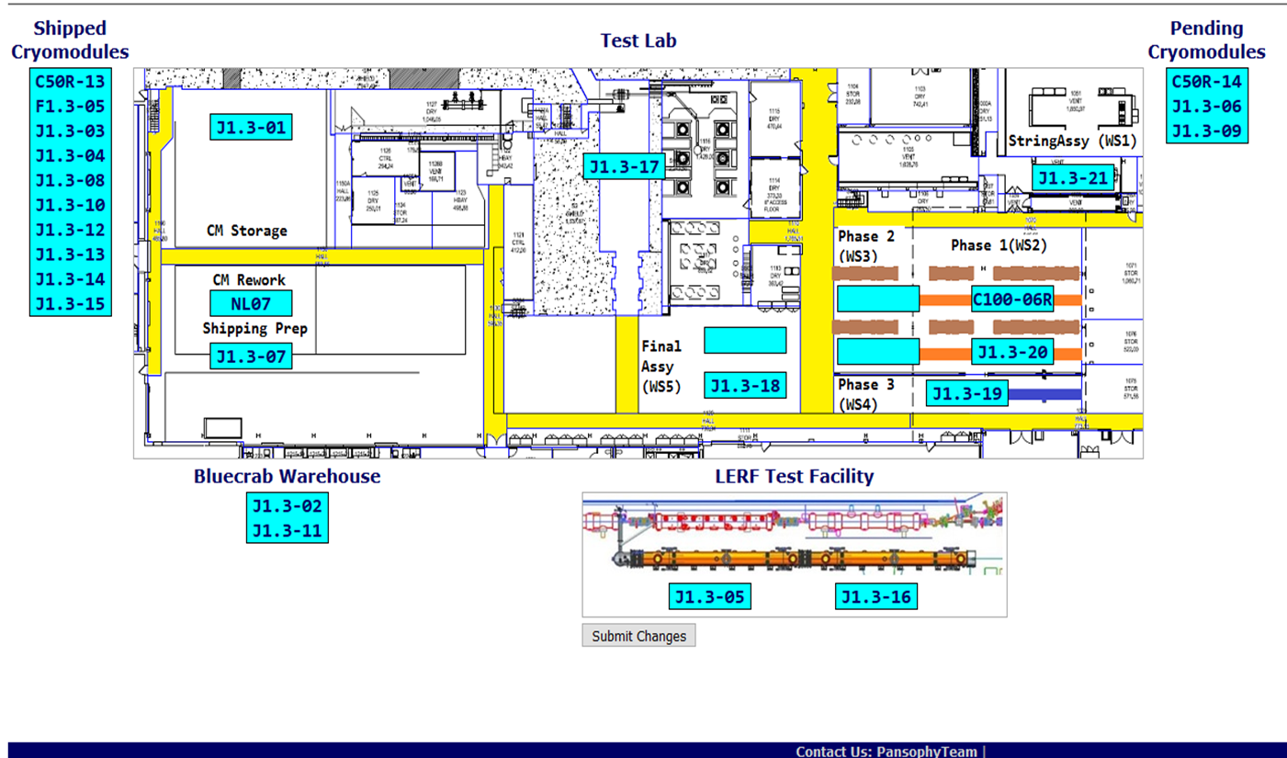

**QUALITY:**

* RT for CM018 passed Saturday 8-3-19.
* Welding review completed for UCM 039.

**Upcoming Travel/Deliveries/Reviews:**

Weekly Reporting

WBS 1.04.08 JLAB Cryoplant System

Week of August 1-7, 2019

**Issues:** Finalizing the EAC for planning purposes.

**Accomplishments this week:**

* Visited LN2 Dewar vendor to check welds.
  + JLab witness and consult on completion.
  + SLAC survey crew onsite to verify mounting locations for interface with foundations in the tank filed.

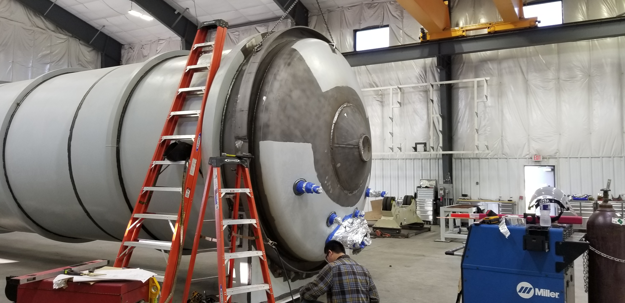

*Both ends (heads) welded onto the final LN2 Dewar in preparation for FAT next week.*

**QUALITY:** Traveled to AES for second LN2 Dewar welding review and doc pack review.

**Upcoming Travel/Deliveries/Reviews:**

* Factory Acceptance Test of the 2K transfer line 7-August-2019
* SLAC survey of LN2 Dewar foundation mounting 7-August-2019
* Factory Acceptance Test of 2nd LN2 Dewar 14-August-2019