Weekly Reporting

WBS 1.01.07 JLAB Management

Week of August 8-14, 2019

**Issues:**

* Need to finalize CP commissioning BCR
* Need to finalize J1.3-11 rework EAC

**Accomplishments this week:**

* Continue to work on finalizing the CP commissioning BCRs to transfer scope and responsibility to SLAC.
* Reviewing June EAC.

**Upcoming Reviews:** None

Weekly Reporting

WBS 1.04.06 JLAB Cryomodules

Week of August 8-14, 2019

**Issues**:

**Accomplishments this week:**

LERF testing is ongoing – J16 & J5; SLAC test plans ongoing. CEBAF run has been extended to 9-SEP. Received request from SLAC on additional proposed tests in LERF. Performing fast cooldown in LERF on J16 & J5. SLAC visitors (Fauve, Shrishrimal) observing.

J1.3-20- WS3- Unite to UCM

J1.3-19- WS4- Align CM in VV

J1.3-18- WS5- Configure for testing

J1.3-17- Removed from CMTF. Great test results reported at SRF weekly meeting. Currently at WS5 - Configure for Shipping 8/24

J1.3-16-Testing in LERF- Warm-up Sept

J1.3-11- Disassemble, to TL mid August

J1.3-06/09 – Disassembled

J1.3-07- WS3- Waiting for Cantilever

J1.3-05 –Testing in LERF

J1.3-02– In storage offsite

J1.3-01- In storage

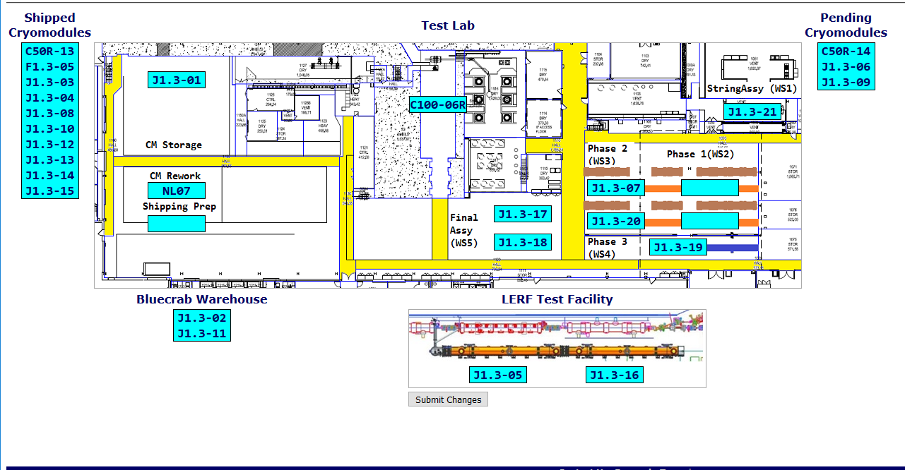

**QUALITY:** No report.

**Upcoming Travel/Deliveries/Reviews:**

Participate in LERF testing (Fauve, Shrishrimal)

Weekly Reporting

WBS 1.04.08 JLAB Cryoplant System

Week of August 8-14, 2019

**Issues:** Finalizing scope transfer & the EAC for planning purposes.

**Accomplishments this week:**

* Visited LN2 Dewar vendor to witness/consult on progress.
  + SLAC survey completed onsite to verification of mounting locations for interface with foundations in the tank farm.

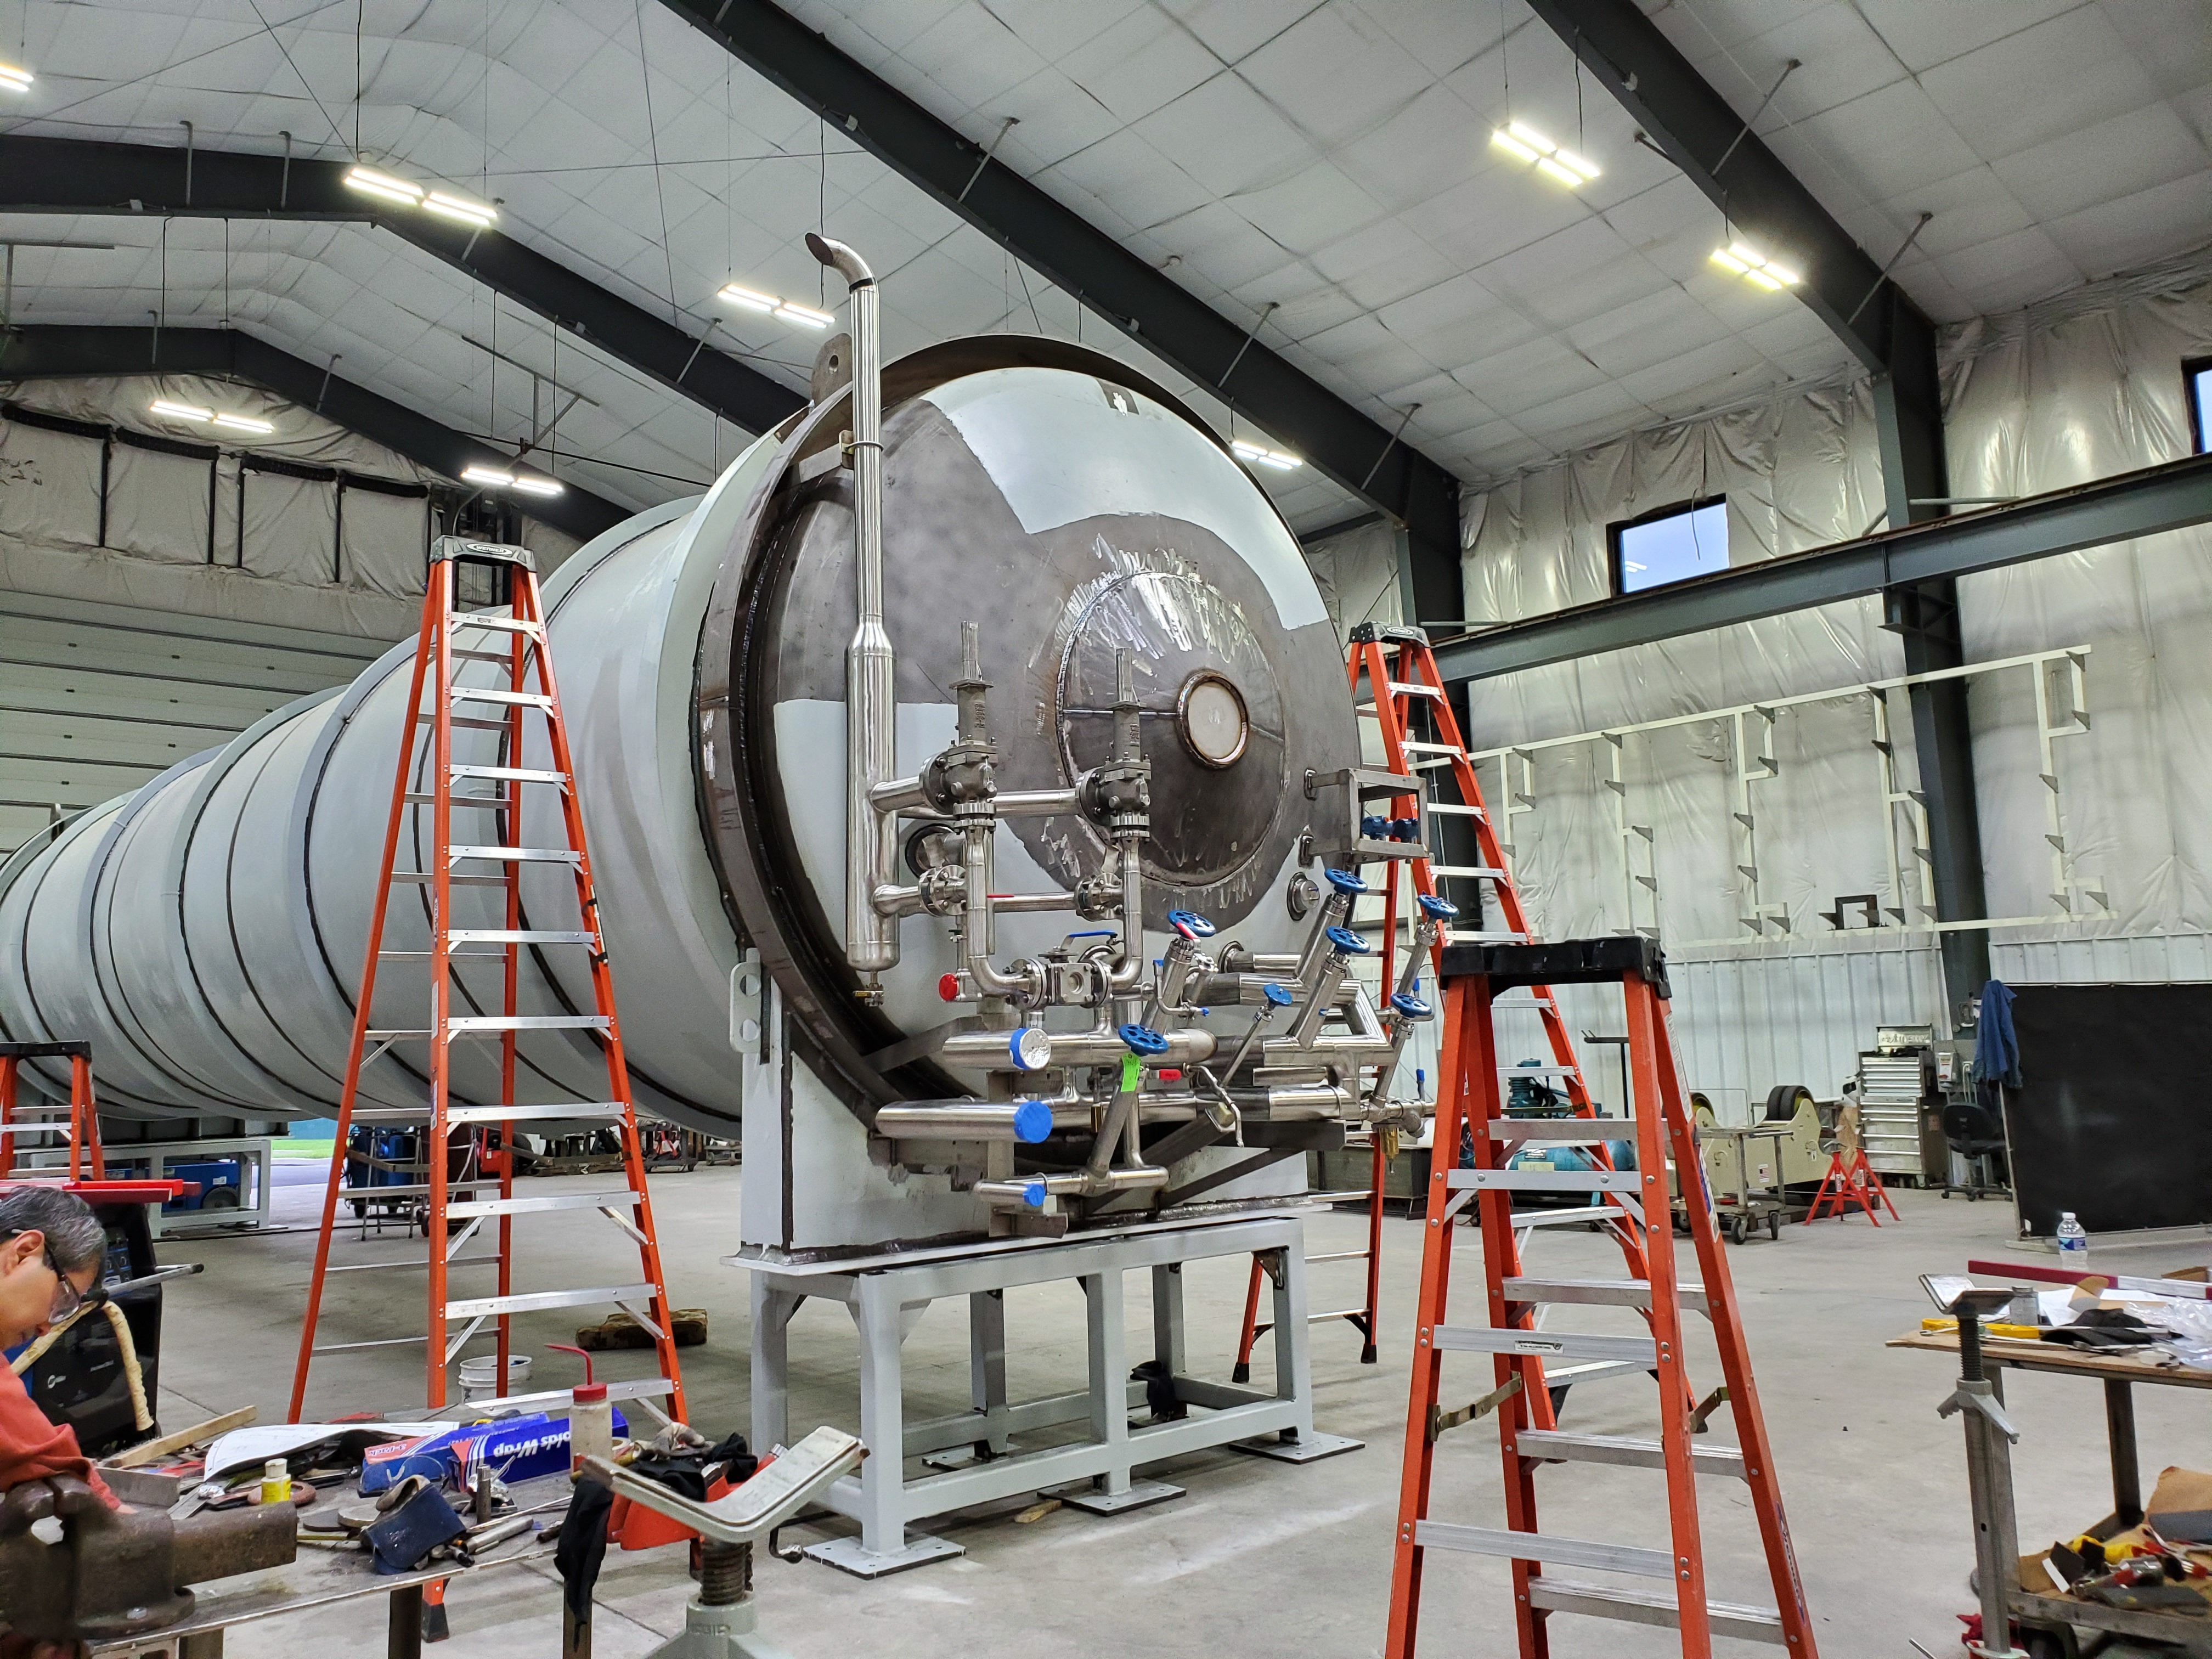

* C1&C2 IBXs and C2 MTL packaged for shipping

**QUALITY:**

Continuing with QA review of commissioning documentation package; prior to submittal in support of system readiness review.

**Upcoming Travel/Deliveries/Reviews:**

* LN2 Dewar manufacturer to witness/consult 7-August-2019
* Factory Acceptance Test of 2nd LN2 Dewar 28-August-2019