Weekly Reporting

WBS 1.01.07 JLAB Management

Week of August 15-21, 2019

**Issues:**

* Need to finalize J1.3-11 rework EAC.

**Accomplishments this week:**

* Finalized the CP commissioning BCRs to transfer scope and responsibility to SLAC.
* Completed review of June EAC and we are in agreement with the numbers.

**Upcoming Reviews:** None

Weekly Reporting

WBS 1.04.06 JLAB Cryomodules

Week of August 15-21, 2019

**Issues**:

**Accomplishments this week:**

LERF testing is ongoing – J16 & J5; SLAC test plans ongoing. CEBAF run has been extended to 9-SEP. Received request from SLAC on additional proposed tests in LERF. Conducting another fast cooldown in LERF on J16 & J5 based on proposal from SLAC visitors (Fauve, Shrishrimal).

J1.3-6- 2/8 cavities qualified for string. Four below-spec cavities identified.

J1.3-21- String will roll out on 21-AUG.

J1.3-20- WS3- Welding Process Piping, magnet leads prepped, need intercepts.

J1.3-19- WS5- Warm Couplers

J1.3-18- WS5- Ins Vac leak check, failed Magnet flange

J1.3-17- WS5- Configure for Shipping 8/24

J1.3-16-Testing in LERF- Warm-up Sept

J1.3-11- Disassemble, brought to Test Lab 8/20

J1.3-06/09 – Disassembled

J1.3-07- WS4- Weld lower shields

J1.3-05 –Testing in LERF

J1.3-02– In storage offsite

J1.3-01- In storage

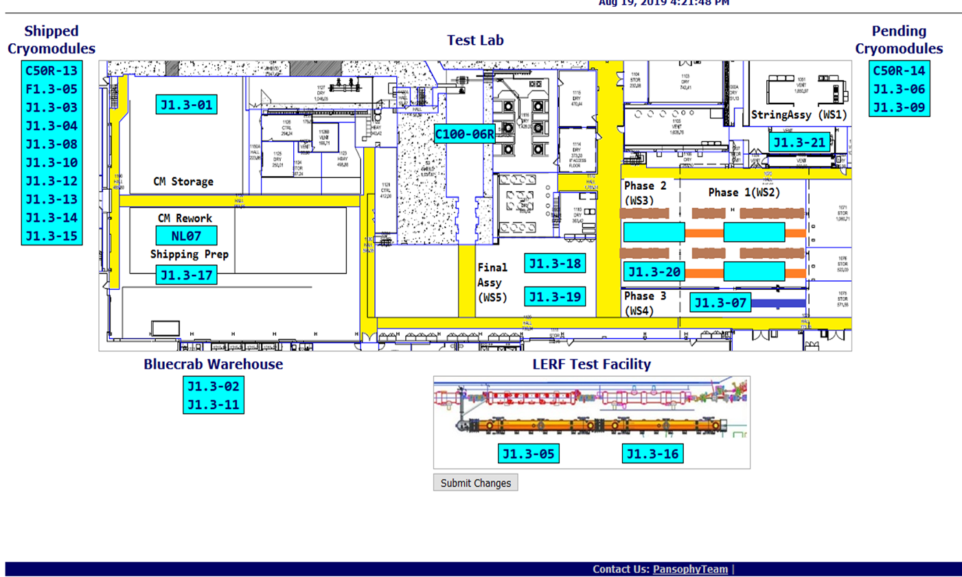

**QUALITY:** No report.

**Upcoming Travel/Deliveries/Reviews:**

Weekly Reporting

WBS 1.04.08 JLAB Cryoplant System

Week of August 15-21, 2019

**Issues:** Finalizing scope transfer & the EAC for planning purposes.

**Accomplishments this week:**

* SLAC survey verified LN2 Dewar tank saddle mounting locations are correct and within tolerance for interface with tank farm foundations.
* 2nd LN2 Dewar pumping down in prep for final leak check in progress.

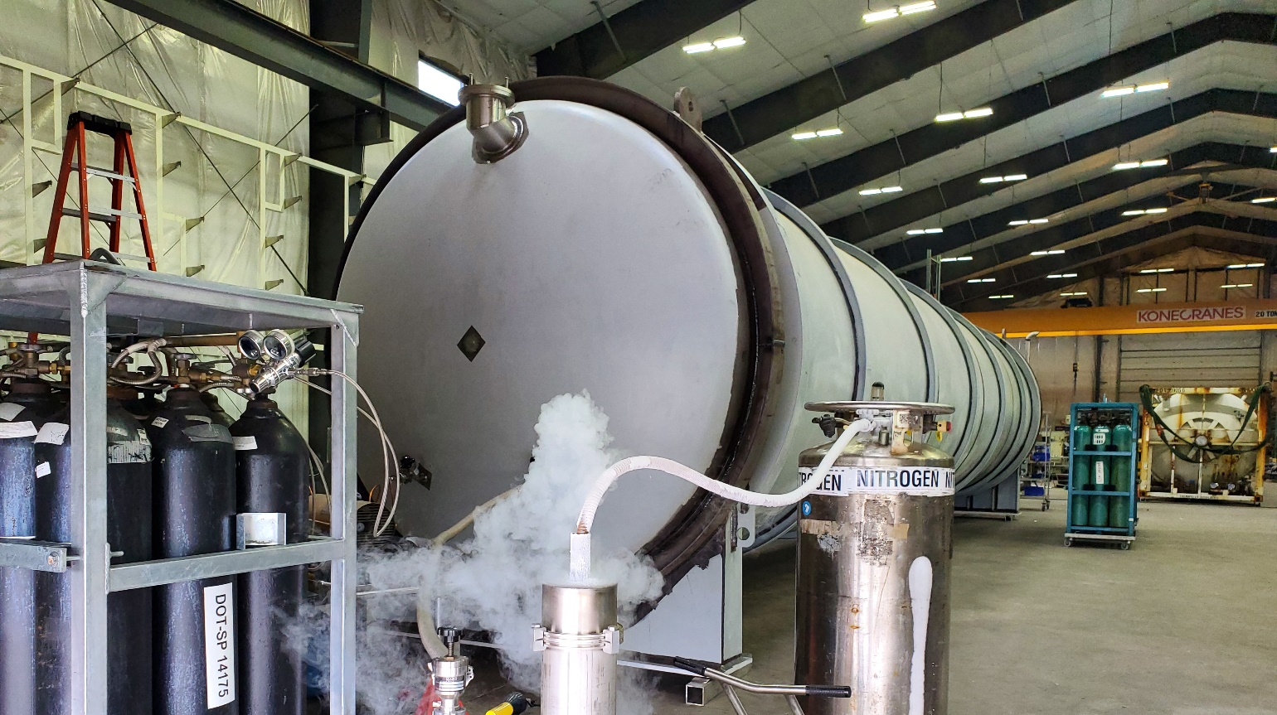

* C1&C2 IBXs and C2 MTL loaded onto Shipping container – Due to arrive in Oakland, CA mid-Sep.

**QUALITY:**

JLab QA group leading the review and submittal process of final cryoplant documentation packages for manufacturing and commissioning.

**Upcoming Travel/Deliveries/Reviews:**

* Factory Acceptance Test of 2nd LN2 Dewar 28-August-2019
* C1&C2 IBXs and C2 MTL delivery to SLAC 27-Sep-2019