Weekly Reporting

WBS 1.01.07 JLAB Management

Week of August 22-28, 2019

**Issues:**

* Need to finalize J1.3-11 rework EAC.

**Accomplishments this week:**

* Exchange rate documents are at EZ for signature.
* J1.3-7 arrived at SLAC.

**Upcoming Reviews:** None

Weekly Reporting

WBS 1.04.06 JLAB Cryomodules

Week of August 22-28, 2019

**Issues**: Lack of qualified cavities for string 6. Will need to use below-spec cavities to hold schedule.

**Accomplishments this week:**

LERF testing is ongoing – J16 & J5; SLAC test plans ongoing. CEBAF run was extended to 9-SEP. Received request from SLAC on additional proposed tests in LERF. Conducting LLRF development this week. LLRF experts from SLAC (S. Hoobler), LBNL (L. Doolittle, S. Ferreira Paiagua) and FNAL (B. Chase) are on site.

Plan to ship 5 BLAs to SLAC later this week.

J1.3-6- 2/8 cavities qualified for string. Four below-spec cavities identified.

J1.3-21- WS2- Process Piping, Berry Bolts

J1.3-20- WS3- Leak checked Piping, magnet leads prepped, need intercepts.

J1.3-19- WS5- Warm Couplers, MC line, Installing end cap

J1.3-18- WS6- Ready for CMTF

J1.3-17- Arrived at SLAC on 8/26

J1.3-16-Testing in LERF- Warm-up Sept

J1.3-11- WS4 – Removing vacuum vessel

J1.3-06/09 – Disassembled

J1.3-07- WS5- Warm couplers, instrumentation flanges

J1.3-05 –Testing in LERF

J1.3-02– In storage offsite

J1.3-01- In storage

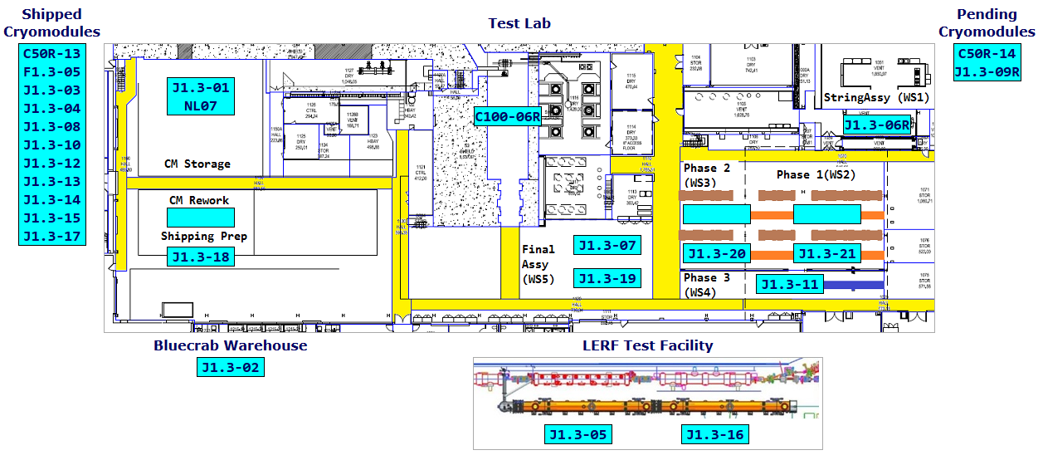

**QUALITY:** No report.

**Upcoming Travel/Deliveries/Reviews:**

Weekly Reporting

WBS 1.04.08 JLAB Cryoplant System

Week of August 22-28, 2019

**Issues:** None.

**Accomplishments this week:**

* Interface Boxes (IBX) & Main Transfer Lines (MTL) in transit to SLAC.
* Due to arrive in Oakland, CA mid-Sep.
* 2nd LN2 Dewar scheduled for final leak check.

**QUALITY:**

* JLab QA group leading the review and submittal process of final cryoplant documentation packages for manufacturing and commissioning.
  + Uploaded the following documents to SLACSpace: Warm He Tanks Modern 8/20/19; 50+ Engineering Analysis Notes 8/27/19

**Upcoming Travel/Deliveries/Reviews:**

* Factory Acceptance Test of 2nd LN2 Dewar 28-August-2019
* C1&C2 IBXs and C2 MTL delivery to SLAC 27-Sep-2019