**LCLS-II AUGUST PROJECT STATUS REPORT**

**DATE:** September 4, 2019

**LOCATION OF PROJECT:** Jefferson Lab

**SENIOR TEAM LEAD:** Joe Preble

**MONTHLY PROGRESS**

Summary

Report reflects July EV data. JLab continues to make significant progress in all areas. Cost, schedule, and scope are being managed to the baseline. We received earned value and variance data, analyzed data and submitted VARs.

EV Performance as of July close.

Overall % complete = 93%, SPI = 0.96, CPI = 0.99

Management

Finalized the CP commissioning BCRs to transfer scope and responsibility to SLAC.

Completed review of June EAC and we are in agreement with the numbers.

Cryomodule J1.3-07 was shipped and arrived at SLAC.

Cryoplant System:

EV Performance as of July close.

Overall % complete = 90%, SPI = 0.96, CPI = 0.97

* Interface Boxes (IBX) & Main Transfer Lines (MTL) in transit to SLAC. Scheduled to arrive in Oakland, CA mid-Sep.
* 2nd LN2 Dewar scheduled for final leak check 1st week of September.
* SLAC survey verified LN2 Dewar tank saddle mounting locations are correct and within tolerance for interface with tank farm foundations.
* JLab QA group leading the review and submittal process of final cryoplant documentation packages for manufacturing and commissioning.
  + Uploaded the following documents to SLACSpace: Warm He Tanks Modern and more than 50 Engineering Analysis Notes.

Upcoming CryoPlant Events:

* Delivery of 2nd LN2 dewar and the interface Boxes and last Multi Transfer Line are scheduled for September.

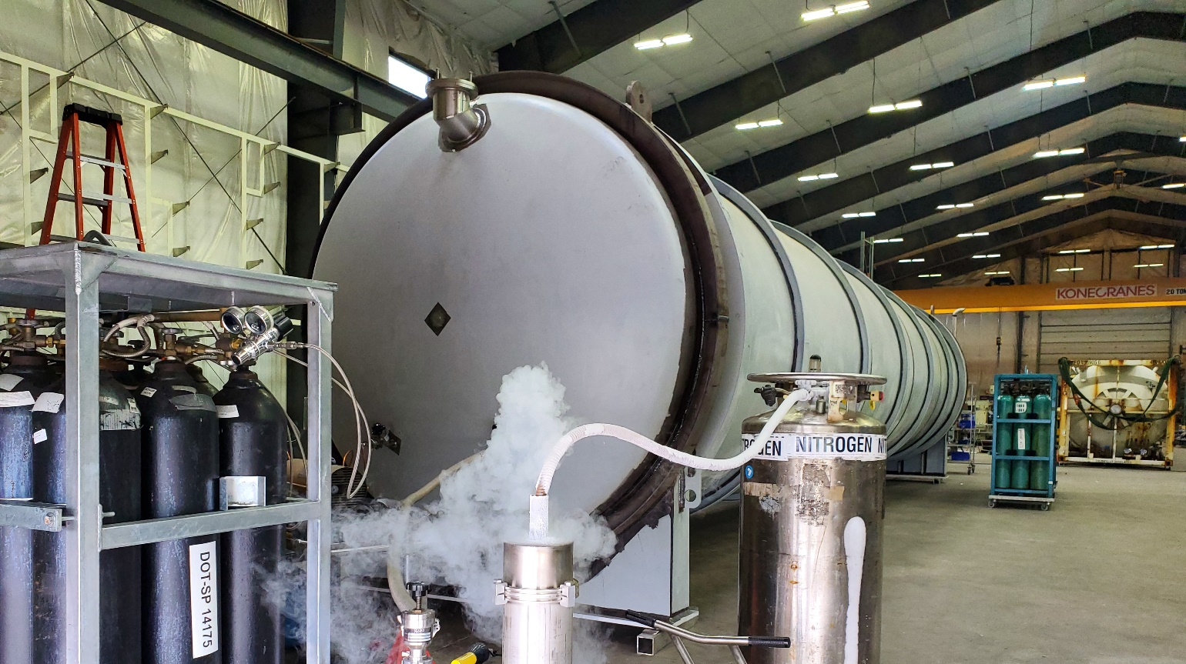

Second LN2 Dewar pumping down in prep for final leak check.

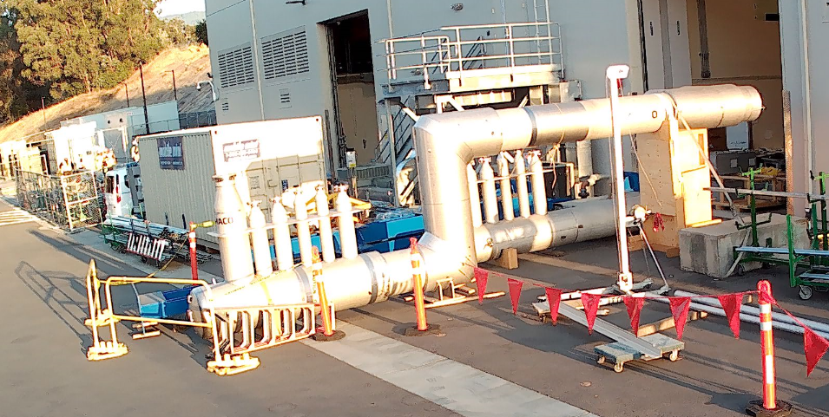

Interface Box first components delivered to SLAC.

Major equipment continued to be shipped to SLAC.

Component Count = 94. Delivered = 91. In Fabrication = 2. Installed = 89. In storage = 2.



Cryomodules:

EV Performance as of July close.

Overall % complete = 94%, SPI = 0.96, CPI = 0.99

LERF testing is ongoing – J16 & J5; CEBAF run was extended to 9-SEP. Received request from SLAC on additional proposed tests: 1) Conducted another fast cooldown in LERF on J16 & J5; and 2) Conducted LLRF development by experts from SLAC (S. Hoobler), LBNL (L. Doolittle, S. Ferreira Paiagua) and FNAL (B. Chase) who worked onsite in the LERF.

J1.3-6- 2/8 cavities qualified for string. Four below-spec cavities identified.

J1.3-21- WS2- Process Piping, Berry Bolts

J1.3-20- WS3- Leak checked Piping, magnet leads prepped, need intercepts.

J1.3-19- WS5- Warm Couplers, MC line, Installing end cap

J1.3-18- WS6- Ready for CMTF

J1.3-17- Arrived at SLAC on 8/26

J1.3-16-Testing in LERF- Warm-up Sept

J1.3-11- WS4 – Removing vacuum vessel

J1.3-06/09 – Disassembled

J1.3-07- WS5- Warm couplers, instrumentation flanges

J1.3-05 –Testing in LERF

J1.3-02– In storage offsite

J1.3-01- In storage

