Weekly Reporting

WBS 1.01.07 JLAB Management

Week of August 29-September 4, 2019

**Issues:**

* Need to finalize J1.3-11 rework EAC.
* Lack of Magnet Thermal anchor components is holding up CM20 and will have knock on effects for later CMs. This will result in a delay in the delivery of the CMs CM21, 6, 9, 11.

**Accomplishments this week:**

* Finished the last planned LERF test.
* Finalized pCM N-mount installation procedures in preparation for shipping the pCM. Plan to ship the pCM mid-September.

**Upcoming Reviews:** None

Weekly Reporting

WBS 1.04.06 JLAB Cryomodules

Week of August 29-September 4, 2019

**Issues**: Lack of qualified cavities for string 6. Will need to use below-spec cavities to hold schedule.

**Accomplishments this week:**

LERF testing is completed – J16 & J5; CEBAF run was extended to 9-SEP. Completed LLRF development with LLRF experts from SLAC (S. Hoobler), LBNL (L. Doolittle, S. Ferreira Paiagua) and FNAL (B. Chase). Completed Qo’s on selected CM-5 cavities.

Shipped 5 BLAs to SLAC last week.

J1.3-6- 8/8 cavities qualified for string. Five below-spec cavities identified.

J1.3-21- WS2- Process Piping, Berry Bolts

J1.3-20- WS3- Solder magnet leads to flags, install tuners

J1.3-19- WS5- MC line leak checking, Installing end cap, Low pressure testing

J1.3-18- Ready for testing, Installed in CMTF 9/03

J1.3-16-Testing in LERF- Warm-up Sept

J1.3-11- WS3N – Out of VV, Begin disassembly

J1.3-06/09 – Disassembled

J1.3-07- WS5- Warm couplers, instrumentation flanges

J1.3-05 –Testing in LERF

J1.3-02– In storage offsite

J1.3-01- Prep to Ship, 9/13 is the target

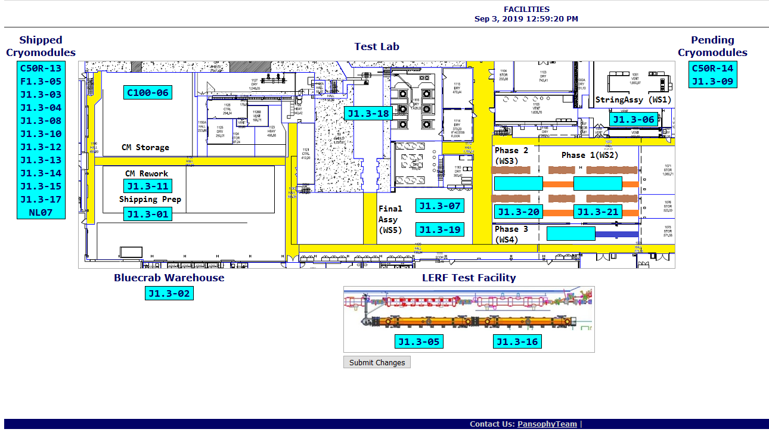

**QUALITY:** No report.

**Upcoming Travel/Deliveries/Reviews:**

Weekly Reporting

WBS 1.04.08 JLAB Cryoplant System

Week of August 29-September 4, 2019

**Issues:** None.

**Accomplishments this week:**

* Interface Boxes (IBX) & Main Transfer Lines (MTL) in transit to SLAC.
  + Due to arrive in Oakland, CA mid-Sep.
* 2nd LN2 Dewar & helium transfer line completed final leak check.

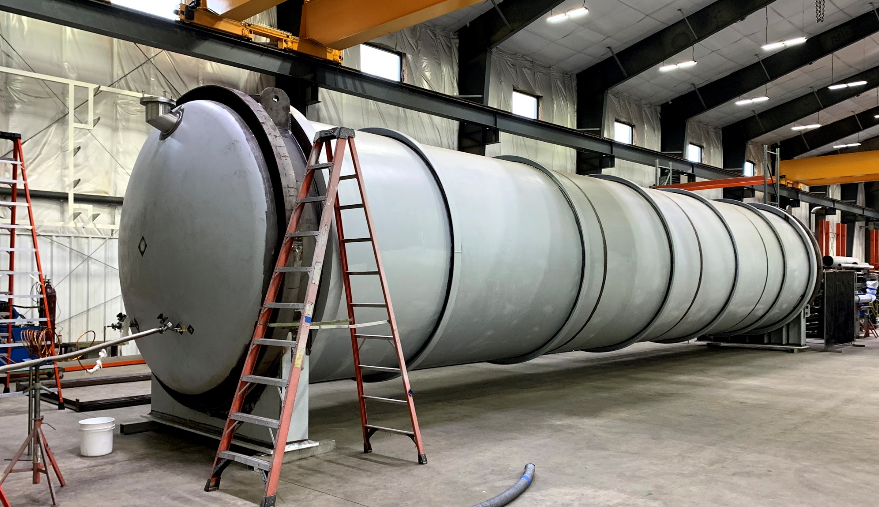 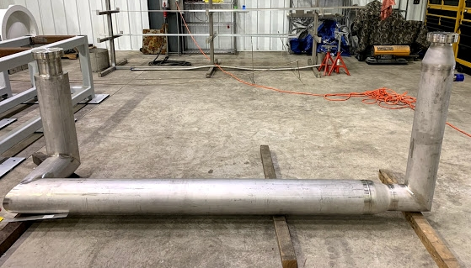

**QUALITY:**

* JLab SME witness successful factory acceptance testing of 2nd LN2 Dewar & LHe transfer line at Vendor site.

**Upcoming Travel/Deliveries/Reviews:**

* Shipment of 2nd LN2 Dewar 10-Sep-2019
* C1&C2 IBXs and C2 MTL delivery to SLAC 27-Sep-2019