Weekly Reporting

WBS 1.01.07 JLAB Management

Week of September 5-11, 2019

**Issues:**

* Need to finalize J1.3-11 rework EAC.
* Lack of Magnet Thermal anchor components is holding up CM20 and will have knock on effects for later CMs. This will result in a delay in the delivery of the CMs CM21, 6, 9, 11.

**Accomplishments this week:**

* Warming up CMs in LERF.
* Completed pCM N-mount installation in preparation for shipping the pCM. Plan to ship the pCM mid-September.

**Upcoming Reviews:** None

Weekly Reporting

WBS 1.04.06 JLAB Cryomodules

Week of September 5-11, 2019

**Issues**: Lack of qualified cavities for string 6. Will need to use below-spec cavities to hold schedule. Lack of magnet thermal intercepts from FNAL is delaying assembly schedule for remaining CMs. Shipping moratorium for 8 weeks.

**Accomplishments this week:**

LERF testing was completed – J16 & J5 are warming up. Conducted static heat load test for SLAC colleagues.

J1.3-9- 2/8 cavities identified for string; both are below-spec.

J1.3-6- String assembly in progress. Roll-out planned on 9/20.

J1.3-21- WS2- LC Process Piping, Berry Bolts

J1.3-20- WS3- Heat station magnet leads

J1.3-19- WS5- LC 2 phase & Bayonet box

J1.3-18- 2K @ CMTF; tuner tests completed; set FPC Qext; conducting Emax’s

J1.3-16- LERF warming up

J1.3-11- WS3N –Magnet heat stations used for CM20, begin disassembly

J1.3-07- WS5-MC Line, Instrumentation flanges

J1.3-05 –LERF warming up

J1.3-02– In storage offsite

J1.3-01- Prepping to Ship

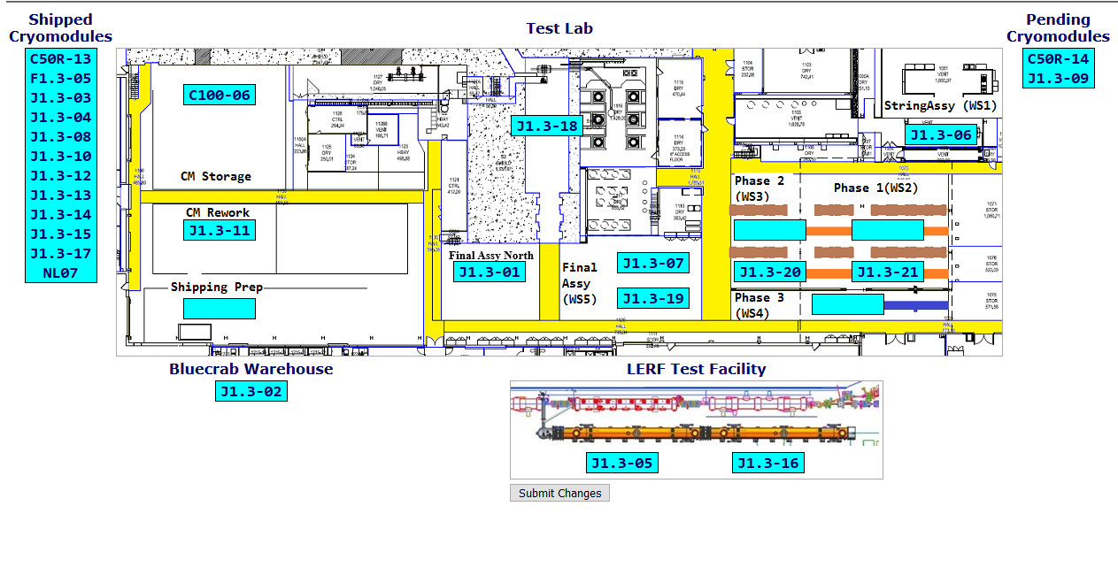

**QUALITY:** No report.

**Upcoming Travel/Deliveries/Reviews:**

Weekly Reporting

WBS 1.04.08 JLAB Cryoplant System

Week of September 5-11, 2019

**Issues:** None.

**Accomplishments this week:**

* Interface Boxes (IBX) & Main Transfer Lines (MTL) in transit to SLAC.
  + Due to arrive in Oakland, CA 16-Sep.
* 2nd LN2 Dewar in transit to SLAC.
  + Due to arrive at SLAC 16-Sept

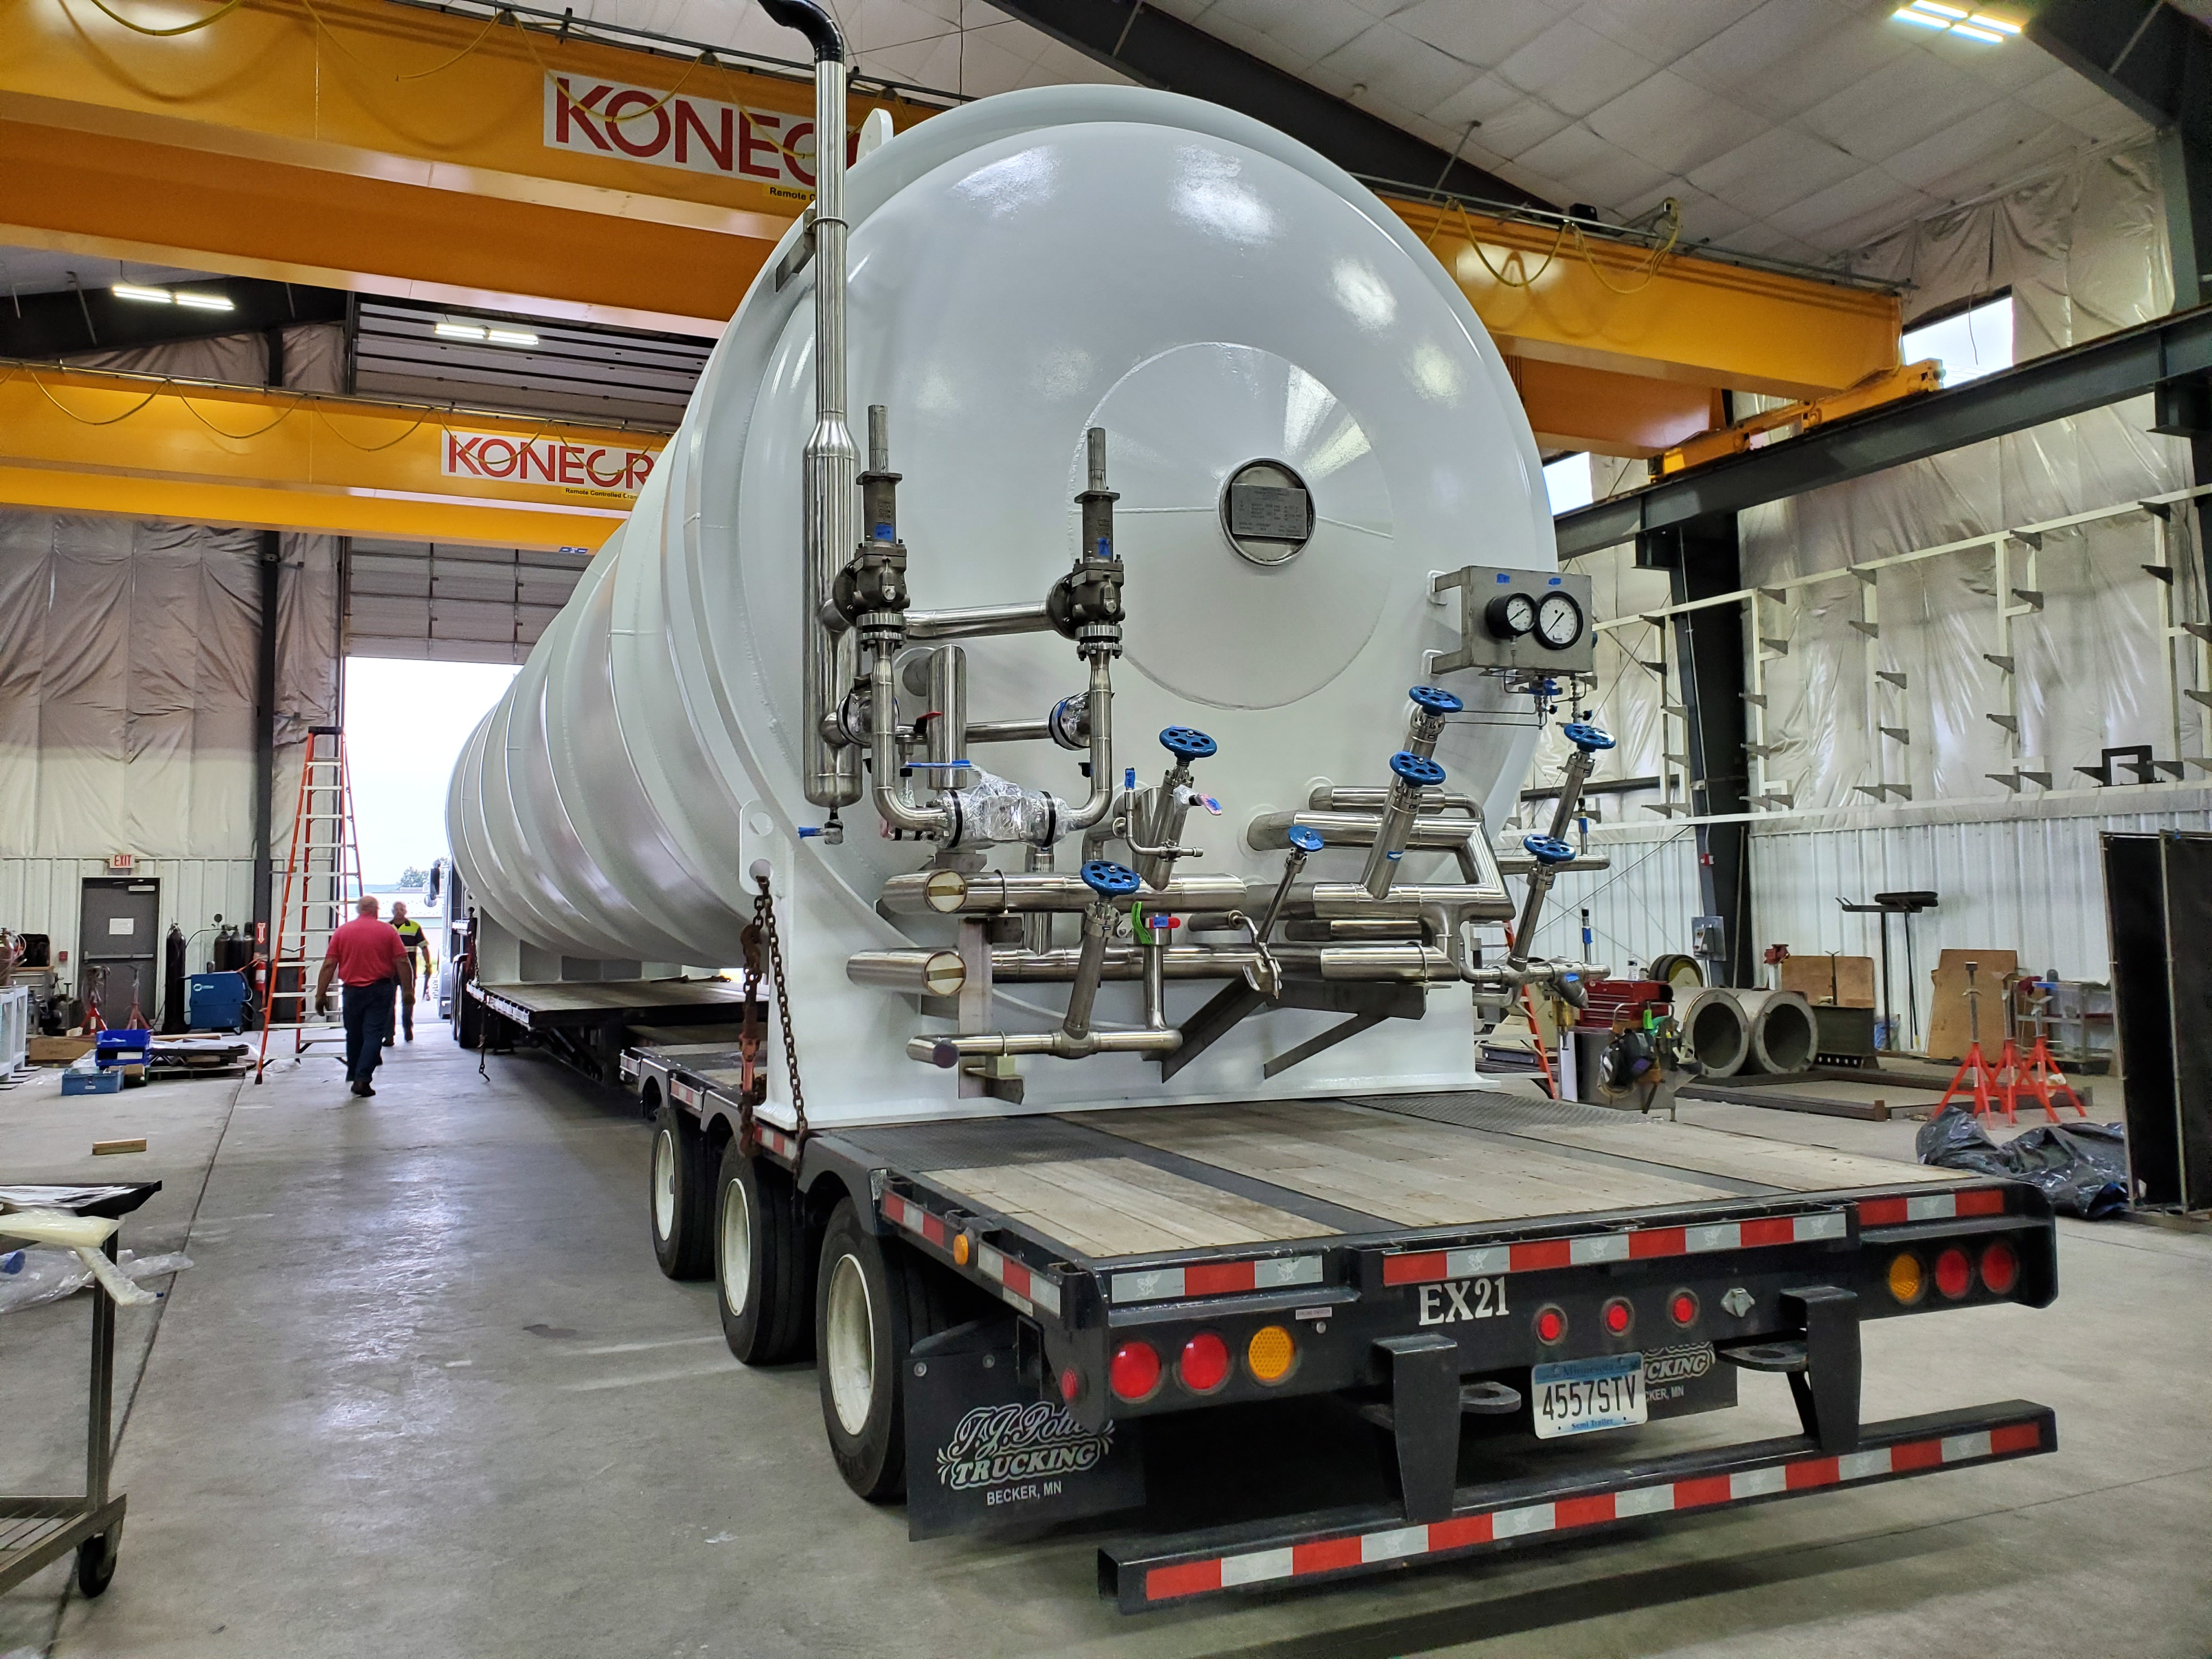

**Second LN2 Dewar Shipping from Vendor (AES)**

**QUALITY:**

* JLab Quality personnel supporting formal transfer of documentation to SLAC

**Upcoming Travel/Deliveries/Reviews:**

* 2nd LN2 Dewar delivery to SLAC 16-Sep-2019
* C1&C2 IBXs and C2 MTL delivery to SLAC 27-Sep-2019