Weekly Reporting

WBS 1.01.07 JLAB Management

Week of September 12-18, 2019

**Issues:**

* Need to finalize J1.3-11 rework EAC.
* Lack of Magnet Thermal anchor components has held up CM20 and is having a knock on effects for later CMs. This will result in a delay in the delivery of the CMs 20, 21, 6, 9, 11.

**Accomplishments this week:**

* CMs in LERF are warm. Received request from SLAC to conduct another CM test in LERF to enable more LLRF development.
* Completed pCM N-mount installation in preparation for shipping the pCM. Shipping moratorium for 8 weeks. Plan to ship the pCM 8-November.

**Upcoming Reviews:** None

Weekly Reporting

WBS 1.04.06 JLAB Cryomodules

Week of September 12-18, 2019

**Issues**: Lack of qualified cavities for string 6. Will need to use below-spec cavities to hold schedule. Lack of magnet thermal intercepts from FNAL is delaying assembly schedule for remaining CMs. Shipping moratorium for 8 weeks.

**Accomplishments this week:**

Received request from SLAC to conduct another CM test in LERF to enable more LLRF development.

Requested 3 cavities from FNAL to help with schedule for remaining two string assemblies.

J1.3-9- 2/8 cavities identified for string; both are below-spec.

J1.3-6- String is leak tight. Roll-out planned on 9/20.

J1.3-21- WS3W- Unite to UCM

J1.3-20- WS3E-Tuners, RF Cables

J1.3-19- WS5- LC Ins Vac

J1.3-18- 2K @ CMTF

J1.3-16- Out of LERF end Sept

J1.3-11- WS3N – Disassembly

J1.3-07- WS5- MC Line LC, Instrumentation flanges

J1.3-05 –Warm in LERF

J1.3-02– In storage offsite

J1.3-01- Prepping to Ship. Planned for 8-NOV departure from JLab.

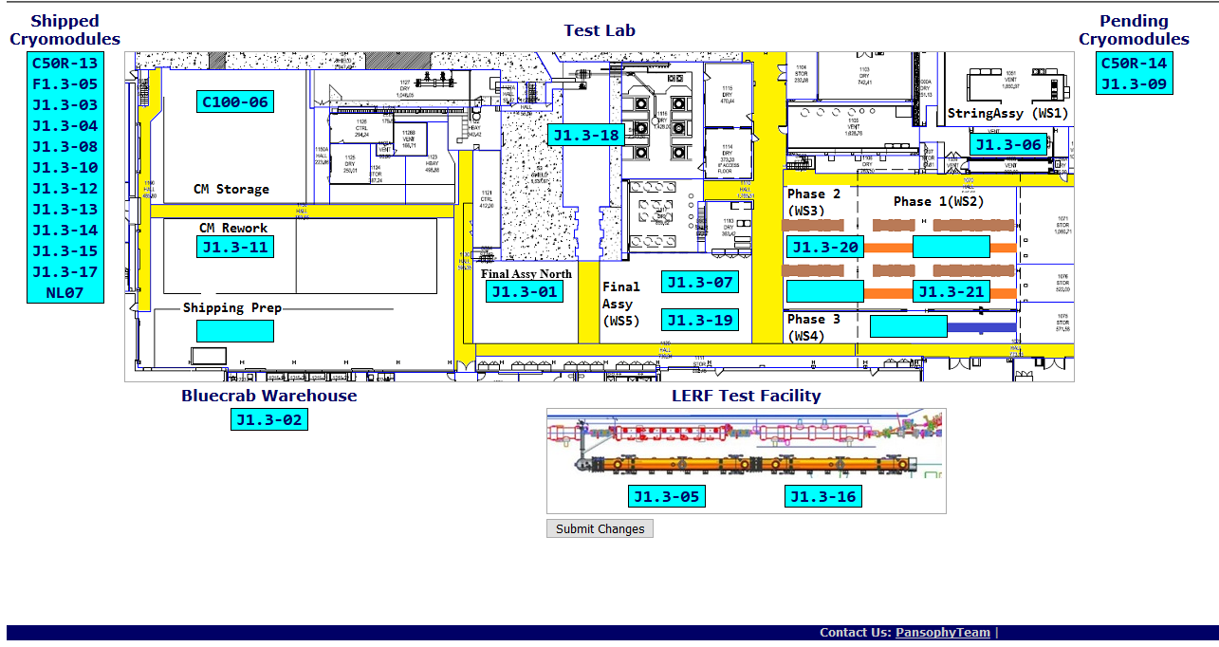

**Upcoming Travel/Deliveries/Reviews:** None

Weekly Reporting

WBS 1.04.08 JLAB Cryoplant System

Week of September 12-18, 2019

**Issues:** None.

**Accomplishments this week:**

* Interface Boxes (IBX) & Main Transfer Lines (MTL) received in port (Oakland).
  + Due to arrive @ SLAC 27-Sep.
* 2nd LN2 Dewar received @ SLAC 15-Sep-2019.
  + Off loaded and placed into position 17-Sep-2019.

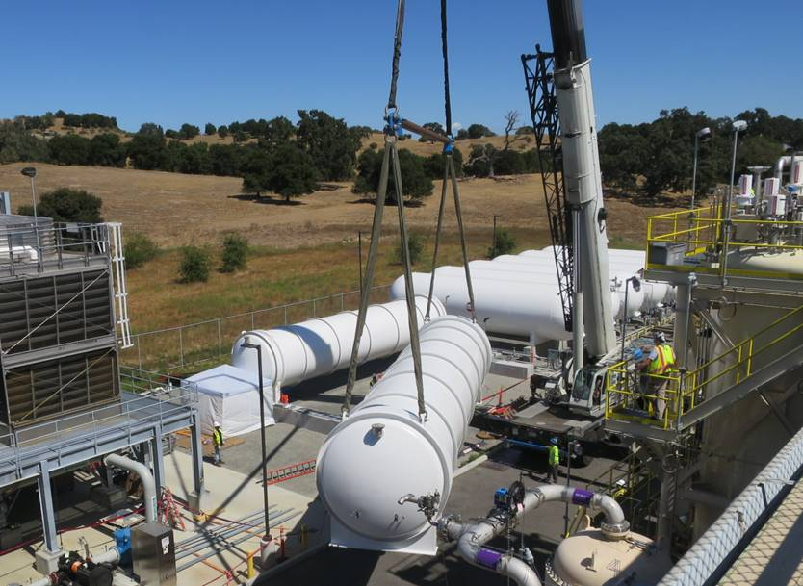 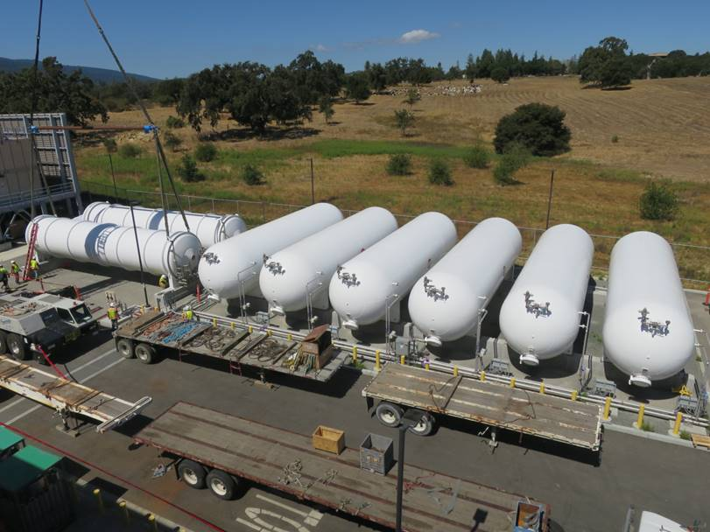

**QUALITY:**

* JLab Quality personnel supporting formal transfer of documentation to SLAC.

**Upcoming Travel/Deliveries/Reviews:**

* C1&C2 IBXs and C2 MTL delivery to SLAC 27-Sep-2019