Weekly Reporting

WBS 1.01.07 JLAB Management

Week of September 19-25, 2019

**Issues:**

* Need to finalize J1.3-11 rework EAC.
* Lack of Magnet Thermal anchor components for CM21 may result in a delay of CMs 21, 6, 9, 11.

**Accomplishments this week:**

* We developed a forecast for CM delivery with the required delay in shipping any CMs until November.
* CMs in LERF are warm. Received request for equipment return form the LERF and CMTF. We will develop the timing and cost for doing this.

**Upcoming Reviews:** None

Weekly Reporting

WBS 1.04.06 JLAB Cryomodules

Week of September 19-25, 2019

**Issues**: Lack of qualified cavities for string 9. Will need to use below-spec cavities to hold schedule. Lack of magnet thermal intercepts from FNAL is delaying assembly schedule for remaining CMs. Shipping moratorium for 8 weeks until 8-NOV.

**Accomplishments this week:**

Received request from SLAC to conduct another CM test in LERF to enable more LLRF development. Developing cost and schedule impacts.

Received 3 cavities from FNAL to help with schedule for remaining two string assemblies.

J1.3-9- 3/8 cavities identified for string; two are below-spec.

J1.3-6- String rolled out on 9/23.

J1.3-21- WS3W- Unite to UCM

J1.3-20- WS3E-Tuners, RF Cables

J1.3-19- WS5- Ready for CMTF

J1.3-18- 2K @ CMTF

J1.3-16- Out of LERF- Early Oct

J1.3-11- WS3N – Disassembly

J1.3-07- WS5- Instrumentation flanges

J1.3-05 – LERF, remove early Oct.

J1.3-02– In storage offsite

J1.3-01- Prepping to Ship J1.3-11- WS3N – Disassembly

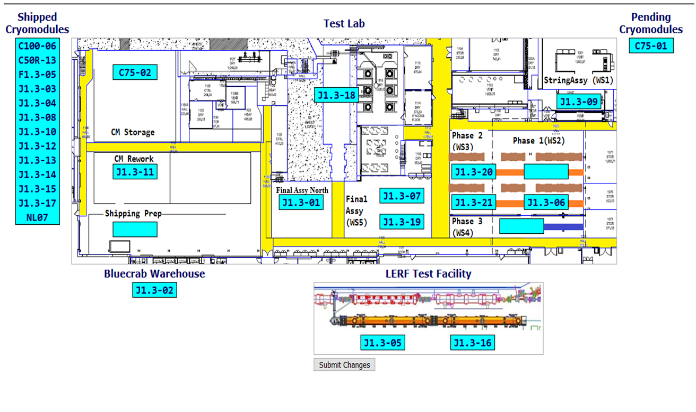

**Upcoming Travel/Deliveries/Reviews:** None

Weekly Reporting

WBS 1.04.08 JLAB Cryoplant System

Week of September 19-25, 2019

**Issues:** None.

**Accomplishments this week:**

* All major CryoPlant equipment has been received at SLAC.
  + C1 & C2 IBX Received at SLAC Cryoplant.

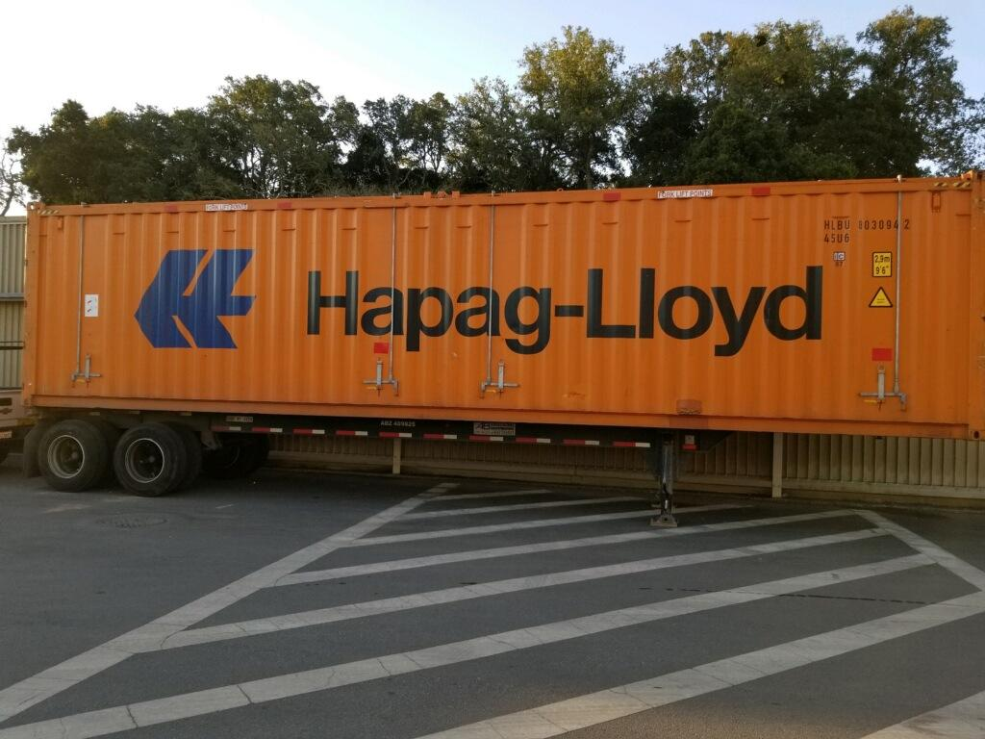 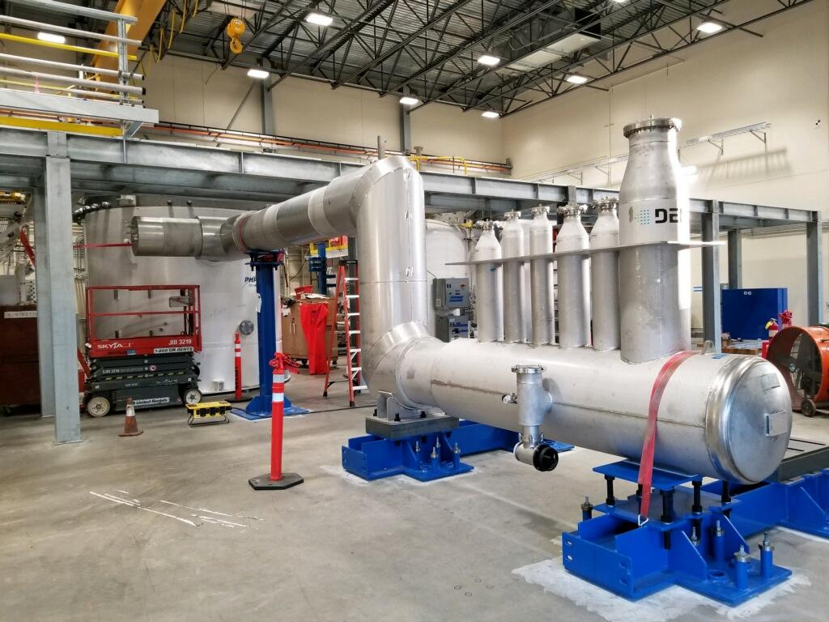

Interface Boxes (IBX) for the C1 & C2 Cryoplants received onsite at SLAC.

Multi-Transfer Line (MTL) for the C1 Cryoplant installed.

**QUALITY:** JLab Quality staff supporting formal review and transfer of LCLS-II commissioning documentation to SLAC.

**Upcoming Travel/Deliveries/Reviews:**

* JLab SME onsite @SLAC to review enclosure QA 26-28-Sep-2019