**LCLS-II SEPTEMBER PROJECT STATUS REPORT**

**DATE:** October 2, 2019

**LOCATION OF PROJECT:** Jefferson Lab

**SENIOR TEAM LEAD:** Joe Preble

**MONTHLY PROGRESS**

Summary

Report reflects August EV data. JLab continues to make significant progress in all areas. Cost, schedule, and scope are being managed to the baseline. We received earned value and variance data, analyzed data and submitted VARs.

EV Performance as of August close.

Overall % complete = 93.5%, SPI = 0.97, CPI = 0.99

Management

Completed LERF testing on cryomodules J1.3-05 and J1.3-16, as well as, LLRF development. Conducted static heat load test for SLAC colleagues.

Received request for equipment return for the LERF and CMTF.

Second LN2 Dewar was shipped and arrived at SLAC.

Interface Boxes (IBXs) and main transfer lines (MTLs) were shipped and arrived at SLAC.

Developed a forecast for cryomodule delivery with the required delay in shipping any cryomodule until November.

Completed pCM N-mount installation in preparation for shipping the pCM. Plan to ship the pCM 8-November.

Cryoplant System:

EV Performance as of August close.

Overall % complete = 90.5%, SPI = 0.96, CPI = 0.97

All major Cryoplant components received at SLAC!

The second LN2 dewar for CP2, the interface boxes (IBXs) and last multi transfer lines (MTLs) were shipped and arrived at SLAC. See photos below.

3 of 5 software programs complete and transferred to SLAC.

60% of the commissioning documentation has been uploaded to the SLAC ShareSpace.

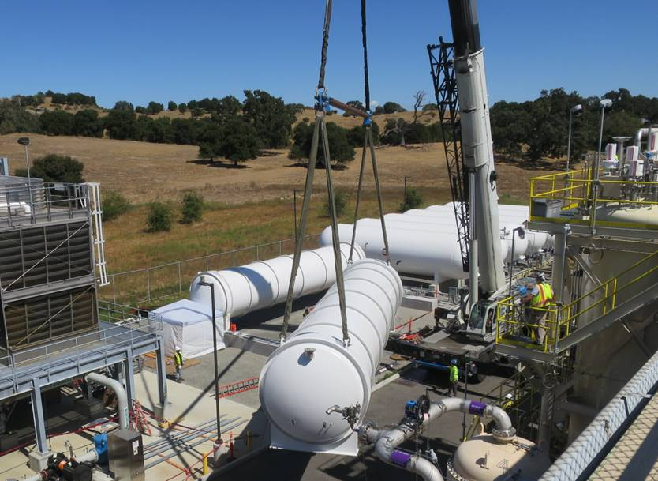 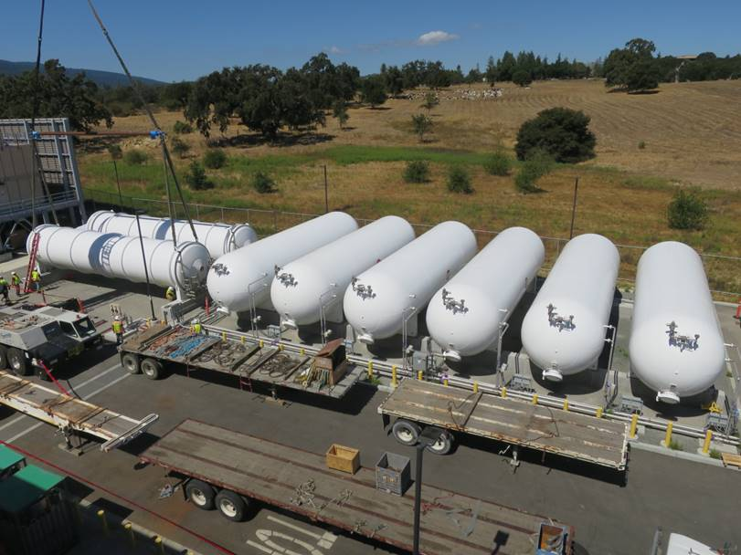

LN2 Dewar off loaded and placed into position at SLAC.

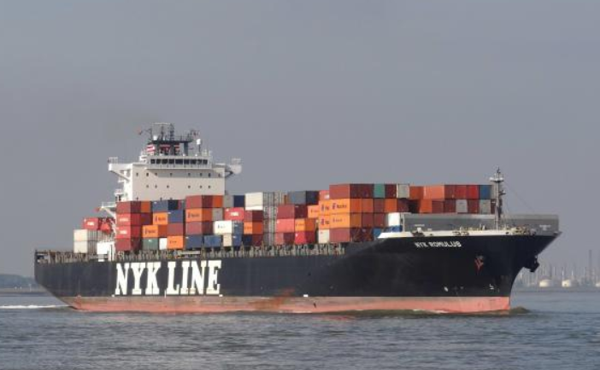 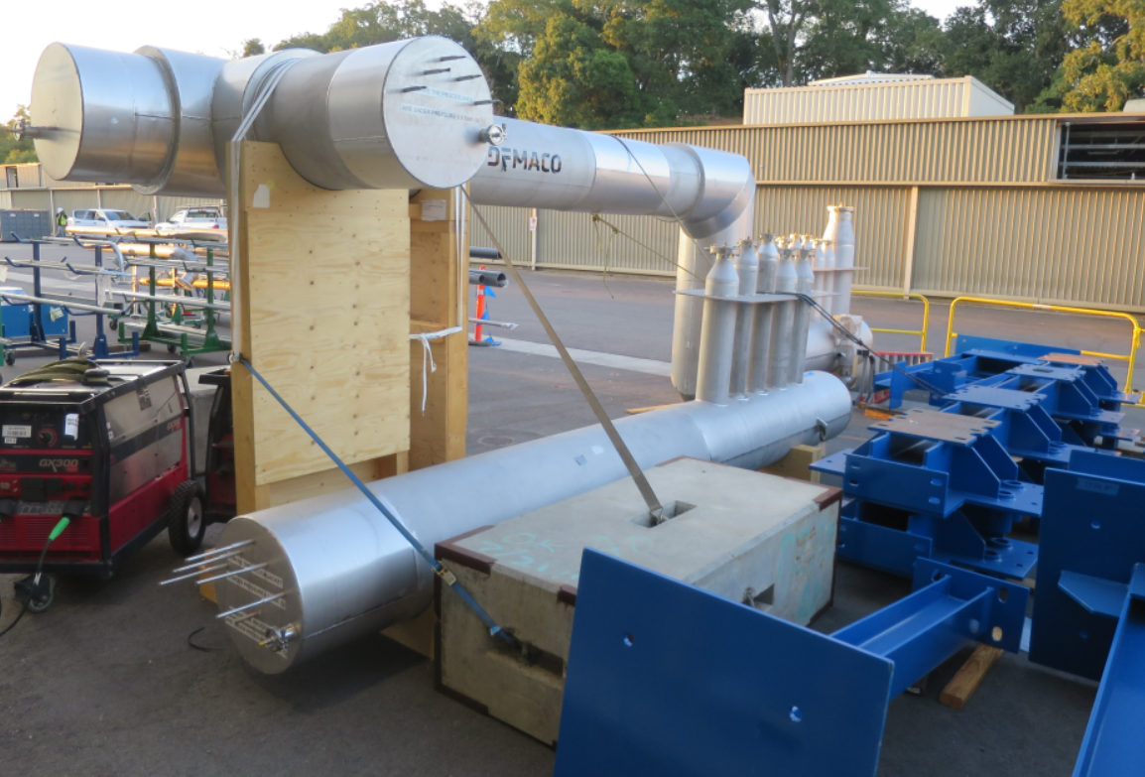

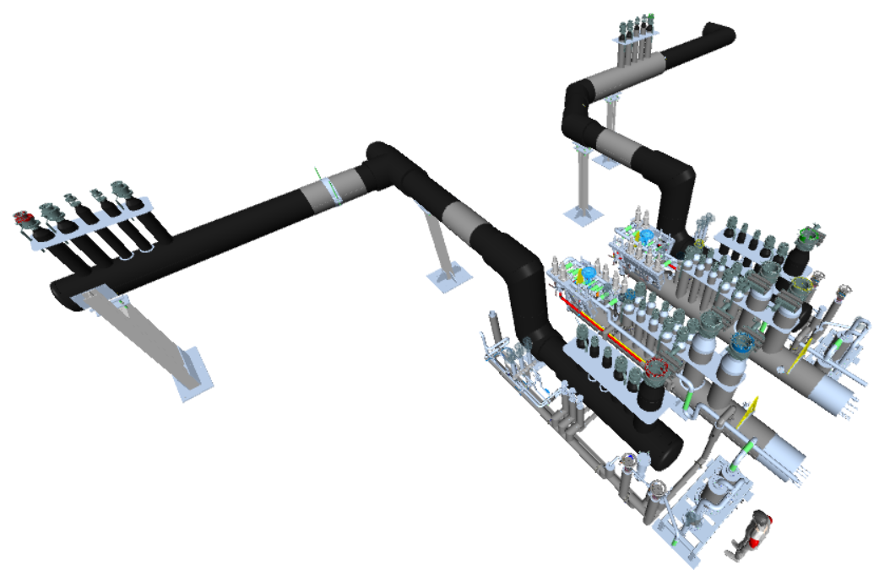

C1 MTL

C2 MTL

C2 IBX

C1 IBX

IBXs and MTL delivered to SLAC.

Component Count = 94. Delivered = 93. In Fabrication = 0. Installed = 91. In storage = 2

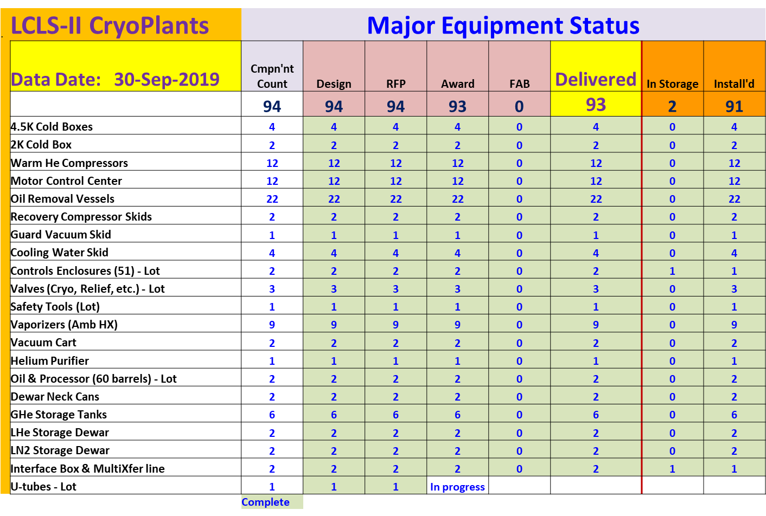

Cryomodules:

EV Performance as of August close.

Overall % complete = 95%, SPI = 0.97, CPI = 0.99

LERF testing is completed for J1.3-16 and J1.3-05.

Completed LLRF development with LLRF experts from SLAC (S. Hoobler), LBNL (L. Doolittle, S. Ferreira Paiagua) and FNAL (B. Chase). Conducted static heat load test. Completed Q0’s on selected J1.3-05 cavities.

Received three cavities from FNAL to help with schedule for remaining two string assemblies.

J1.3-9 – 3/8 cavities identified for string; two are below-spec.

J1.3-6 – String rolled out on 9/23.

J1.3-21 – WS3W- Unite to UCM.

J1.3-20 – WS3E-Tuners, RF Cables.

J1.3-19 – WS5- Ready for CMTF.

J1.3-18 – 2K @ CMTF.

J1.3-16 – LERF - Remove early Oct.

J1.3-11 – WS3N – Disassembly.

J1.3-07 – WS5- Instrumentation flanges.

J1.3-05 – LERF - Remove early Oct.

J1.3-02 – In storage offsite.

J1.3-01 – Prepping to Ship J1.3-11- WS3N – Disassembly.

