Weekly Reporting

WBS 1.01.07 JLAB Management

Week of October 3-9, 2019

**Issues:**

* Need to finalize J1.3-11 rework EAC.
* Lack of Magnet Thermal anchor components for CM21 has resulted in a delay of CMs 21, 6, 9, 11.

**Accomplishments this week:**

* We developed a forecast for CM delivery with the required delay in shipping any CMs until November.
* CMs have been removed from LERF. Received request for equipment return from the LERF and CMTF. We will develop the timing and cost for doing this.

**Upcoming Reviews:** None

Weekly Reporting

WBS 1.04.06 JLAB Cryomodules

Week of October 3-9, 2019

**Issues**: Lack of qualified cavities for string 9. Will need to use below-spec cavities to hold schedule. Lack of magnet thermal intercepts from FNAL is delaying assembly schedule for remaining CMs. Shipping moratorium (8 weeks) until 8-NOV.

**Accomplishments this week**:

Received request from SLAC to conduct another CM test in LERF to enable more LLRF development. Developing cost and schedule impacts.

J1.3-9- 4/8 cavities identified for string; two are below-spec.

J1.3-21- WS3W- Prep/Solder magnet leads

J1.3-20- WS4- Inst. Check, lower shields

J1.3-19- In CMTF, Cool down Oct 8th

J1.3-18- WS5- Post-test configuration, Beam line work

J1.3-16- Out of LERF- Oct 8th

J1.3-11- WS3E – Disassembly, lollipops installed

J1.3-07- WS5- Ins Vac LC

J1.3-06- 2 phase piping, waiting on parts

J1.3-05- LERF, remove Oct. 9th

J1.3-02- In storage offsite

J1.3-01- UTIF, Ready to ship

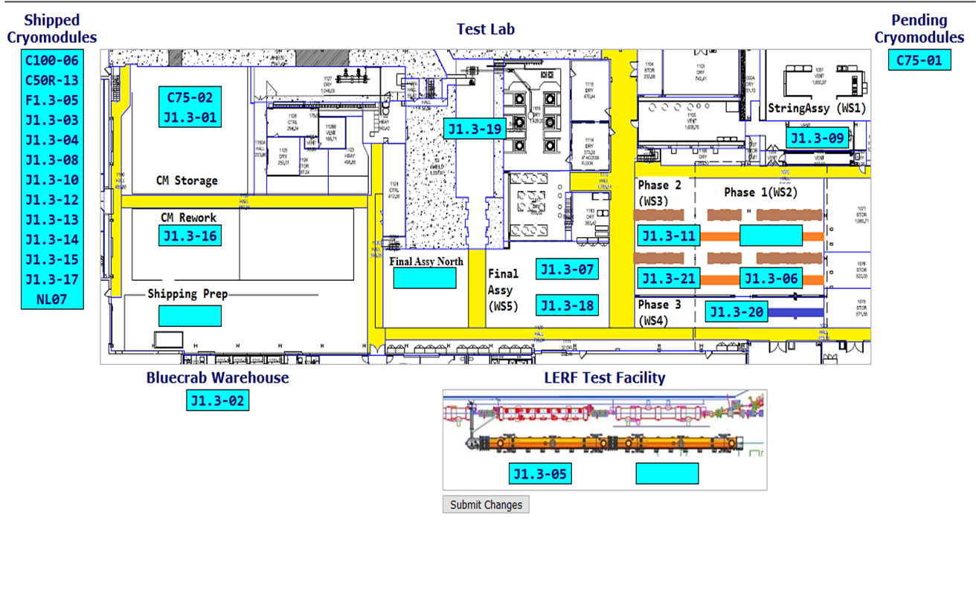

Upcoming Travel/Deliveries/Reviews: None

Weekly Reporting

WBS 1.04.08 JLAB Cryoplant System

Week of October 3-9, 2019

**Issues:** None.

**Accomplishments this week:**

* Complete Bench testing of 4.5K vacuum software.
* Complete review of Phase II commissioning documentation.
* Assembled 4K Cold Box fabrication documentation for transfer to SLAC.
* Updated HMI screens to suit final 4.5K vacuum software.
* Provided SLAC Draft Phase II commissioning documentation.

**QUALITY:**

* JLab Quality staff supporting formal review and transfer of LCLS-II commissioning documentation to SLAC.

**Upcoming Travel/Deliveries/Reviews:**

* C2 LHe dewar to 2K cold box transfer line (aka inverted u-tube) arriving at SLAC 15-Oct