Weekly Reporting

WBS 1.01.07 JLAB Management

Week of October 10-23, 2019

**Issues:**

* Need to finalize J1.3-11 rework EAC.
* Lack of Magnet Thermal anchor components for CM21 has resulted in a delay of CMs 21, 6, 9, 11.

**Accomplishments this week:**

* We to planning to restart CM delivery on 25 October.
* Still working on the plan for the request for equipment return from the LERF and CMTF. We will develop the timing and cost for doing this.

**Upcoming Reviews:** None

Weekly Reporting

WBS 1.04.06 JLAB Cryomodules

Week of October 10-23, 2019

**Issues:**

Cryomodule testing in the CMTF was delayed due to contamination in Cold Box 4. CB4 was restarted on 10/20/19.

Need to modify the remaining magnet thermal straps. Will get FNAL direction on the detailed requirements.

**Accomplishments this week:**

Cryomodule Status

**J1.3-21-** WS3W- Tuners; modify Magnet lead heat stationing parts.

**J1.3-20-** WS5- Configuring for LERF; Beam line & WCs

**J1.3-19-** In CMTF; testing

**J1.3-18-** WS6- Post-test configuration

**J1.3-16-** Test Lab storage

**J1.3-11**- Disassembly complete

**J1.3-07-** WS6- Shipping Alignment

**J1.3-06R-** WS3- Unite to UCM

**J1.3-05-** Disassembly; remove WCs

**J1.3-02-** In storage offsite

**J1.3-01 (pCM) -** Ship Oct 25th

* J1.3-19 in the CMTF has been pumped down to 2K and testing has been restarted. Cold Box 4 is functioning properly. Estimated warm-up date is 11/8/19. The delay will not affect the shipping schedule.
* Eight cavities are ready for J1.3-09R string. Six of the eight cavities do not meet spec. Awaiting SLAC approval to proceed with string build next week.
* J1.3-01 is currently at its last stages prior to shipping. It will be loaded on to the trailer on 10/23/19 and shipped to SLAC on 10/25/19.

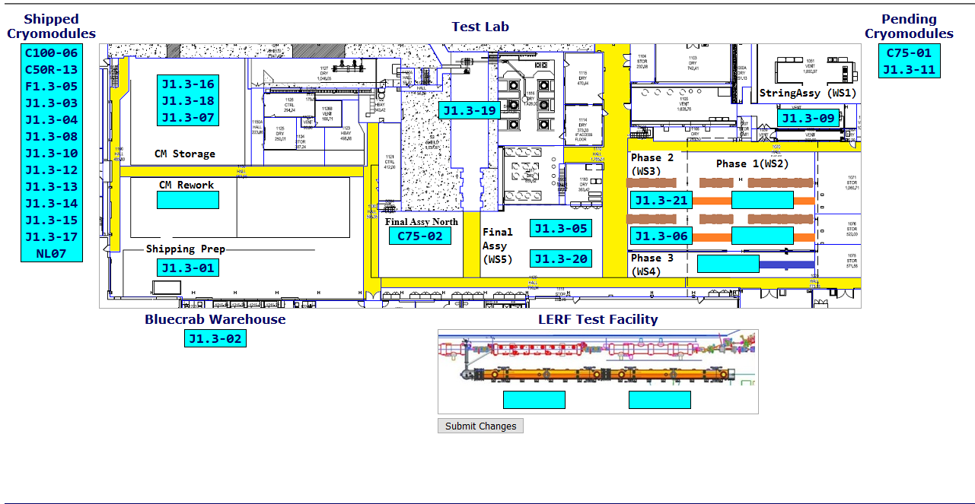

**Upcoming Reviews:** None

Weekly Reporting

WBS 1.04.08 JLAB Cryoplant System

Week of October 10-23, 2019

**Issues:** None

**Accomplishments this week:**

* Supporting cryoplant software checkout.
  + Updated HMI screens to accommodate changes in software @SLAC.
* Phase II commissioning documentation provided to SLAC CP engineering.

**QUALITY:**

* JLab Quality staff supporting formal review and transfer of LCLS-II commissioning documentation to SLAC.

**Upcoming Travel/Deliveries/Reviews:** None