LCLS-II DECEMBER PROJECT STATUS REPORT

DATE: January 8, 2019
LOCATION OF PROJECT: Jefferson Lab
SENIOR TEAM LEAD: Joe Preble

MONTHLY PROGRESS

Summary
Report reflects October EV data. JLab continues to make significant progress in all areas. Cost, schedule, and scope are being managed to the baseline. We received earned value and variance data, analyzed data and submitted VARs.
EV Performance as of November close.
Overall % complete = 95.4%, SPI = 0.97, CPI = 0.99

Management:
Started returning equipment from the LERF. Started testing CM20 in the LERF. This will be the last LCLS II CM tested in the LERF. Planning continues for the use of the LERF for testing LCLS II HE CMs in the future.
Cryoplant System:
EV Performance as of November close.
Overall % complete = 92.5%, SPI = 0.98, CPI = 0.97
2K CB gauge panels were shipped to SLAC.
4.5k CB software bench testing started at JLab.
Working with SLAC on commissioning planning and support.
Cryomodules:
EV Performance as of November close.
Overall % complete = 97.0%, SPI = 0.97, CPI = 1.00
J1.3-21 – WS5 – MC line LC; beamline work.
J1.3-20 –In LERF; conditioning circuits
J1.3-19 – Ready for shipping January 4th
J1.3-11 – Cavity prep and test completed
J1.3-09R – WS3; unite to UCM
J1.3-06R – WS4 – HOM tuning; lower shields
J1.3-05 – WS3 – LC BPM hardware replacement; FSS
J1.3-02– In Test Lab on UITF
J1.3-01,03,04,07,08,10,12,13,14,15,16,17,18 @ SLAC

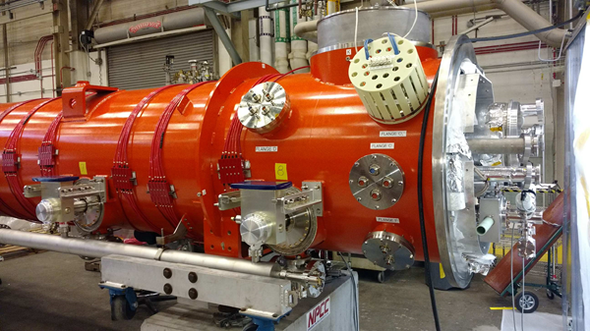  J1.3-19 @ WS6 | 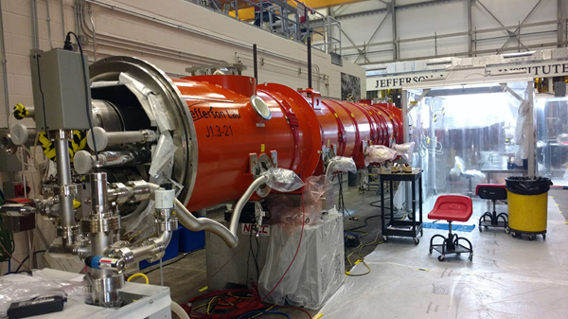  J1.3-21 at WS5
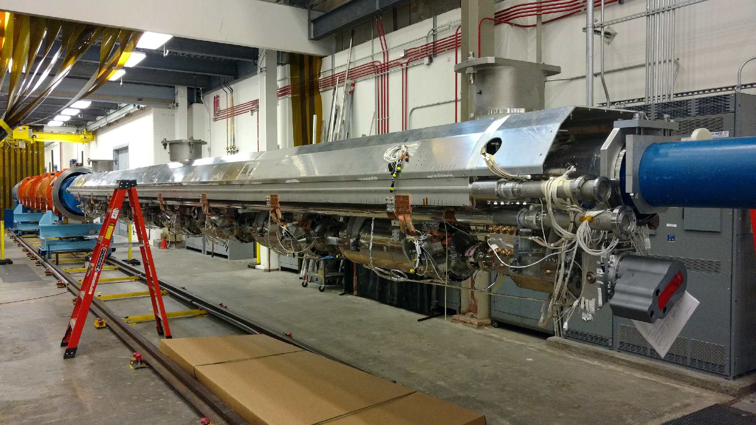  J1.3-06 | 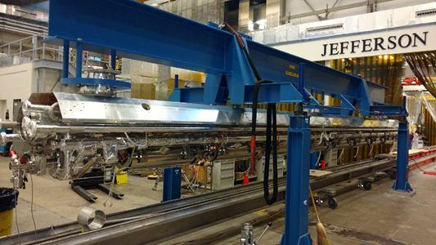  J1.3-05

