LCLS-II JANUARY PROJECT STATUS REPORT

DATE: February 4, 2020
LOCATION OF PROJECT: Jefferson Lab
SENIOR TEAM LEAD: Joe Preble

MONTHLY PROGRESS

Summary
Report reflects December EV data. JLab continues to make significant progress in all areas. Cost, schedule, and scope are being managed to the baseline. We received earned value and variance data, analyzed data and submitted VARs.
EV Performance as of December close.
Overall % complete = 96.0%, SPI = 0.98, CPI = 0.99

Management:
Testing CM20 in the LERF continues. We need a test plan form SLAC for the work they want to do on CM20 in the LERF.
Planning continues for the use of the LERF for testing LCLS II HE CMs in the future.
Cryoplant System:
EV Performance as of December close.
Overall % complete = 93.6%, SPI = 0.99, CPI = 0.97
U-tubes were awarded.
2K cold compressors and turbines arrived at SLAC. The plan is to transfer the remainder of the cold compressor contract to SLAC.
Male bayonets and gauge panels for CP2 were shipped to SLAC.
4.5k CB software bench testing was completed at JLab.
Working with SLAC on commissioning planning and support.
Cryomodules:
EV Performance as of December close.
Overall % complete = 97.3%, SPI = 0.97, CPI = 1.00
J1.3-11 – Completed the final cavity string, CM11.
J1.3-21- In CMTF, acceptance testing
J1.3-20- In LERF, acceptance testing. Plan to keep the CM cold to support SLAC LLRF testing.
J1.3-09- WS3
J1.3-06- WS5
J1.3-05- WS5, ships Feb 14 to SLAC
J1.3-02- WS3, leak in Cav 7 ~cold coupler 5e-6, working on the decision for the path forward.
J1.3-01,03,04,07,08,10,12,13,14,15,16,17,18,19@SLAC
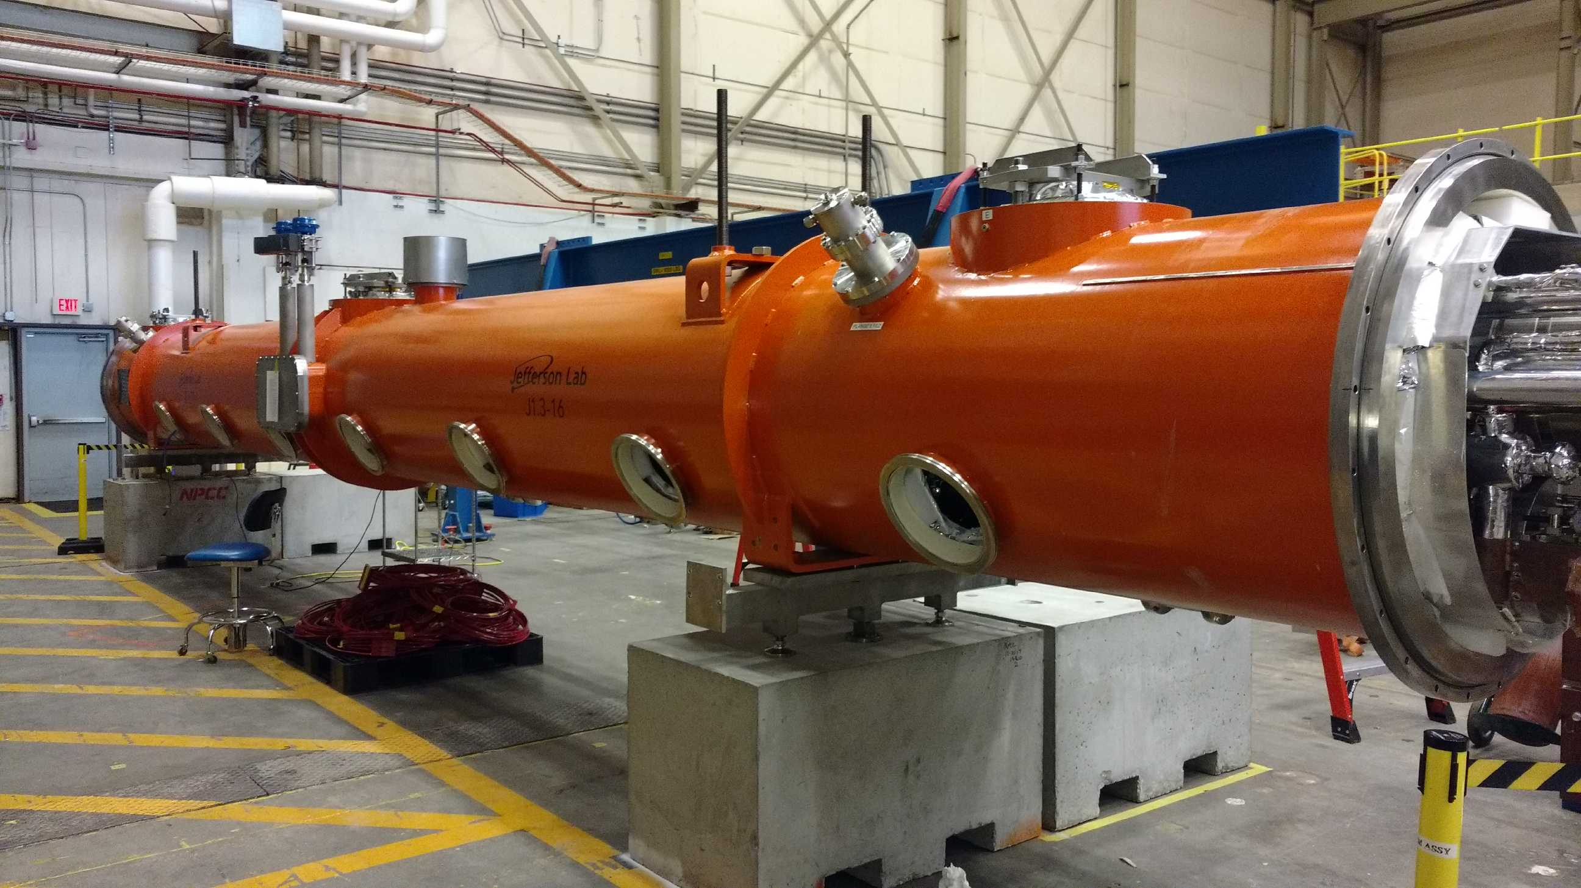  J1.3-05 Next to Ship in February | 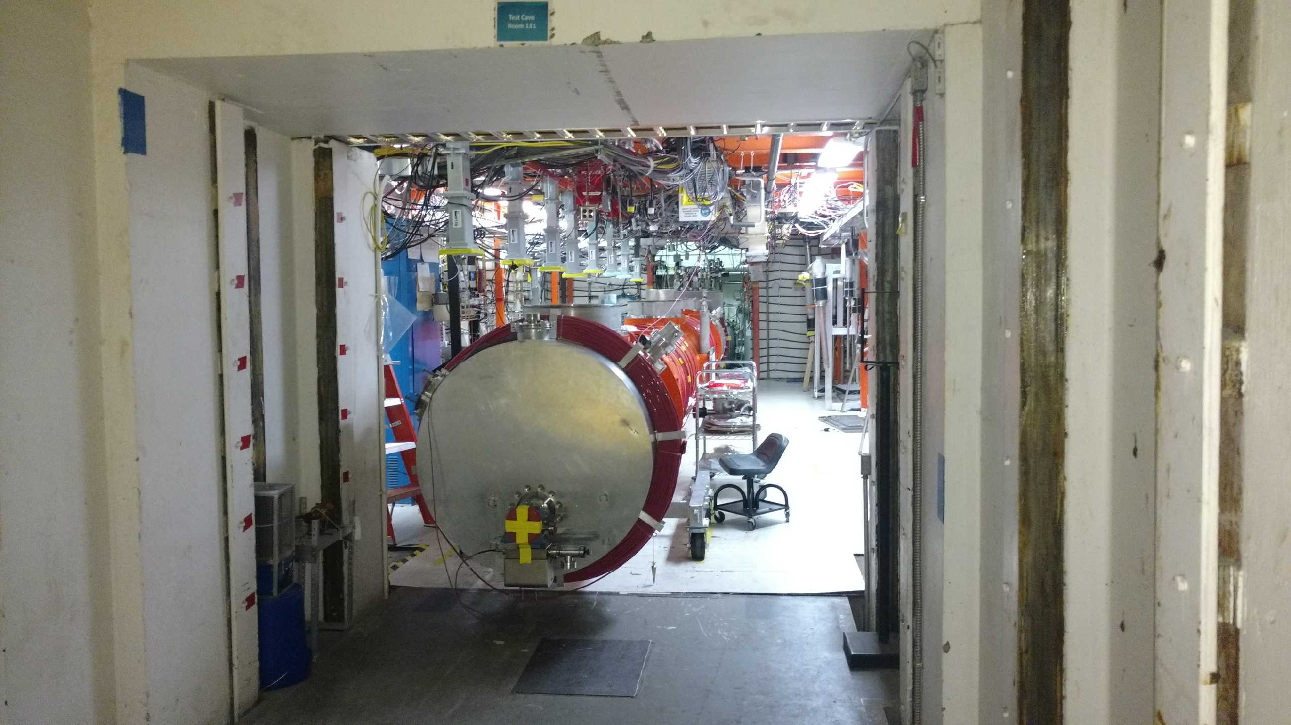  J1.3-21 entering CMTF
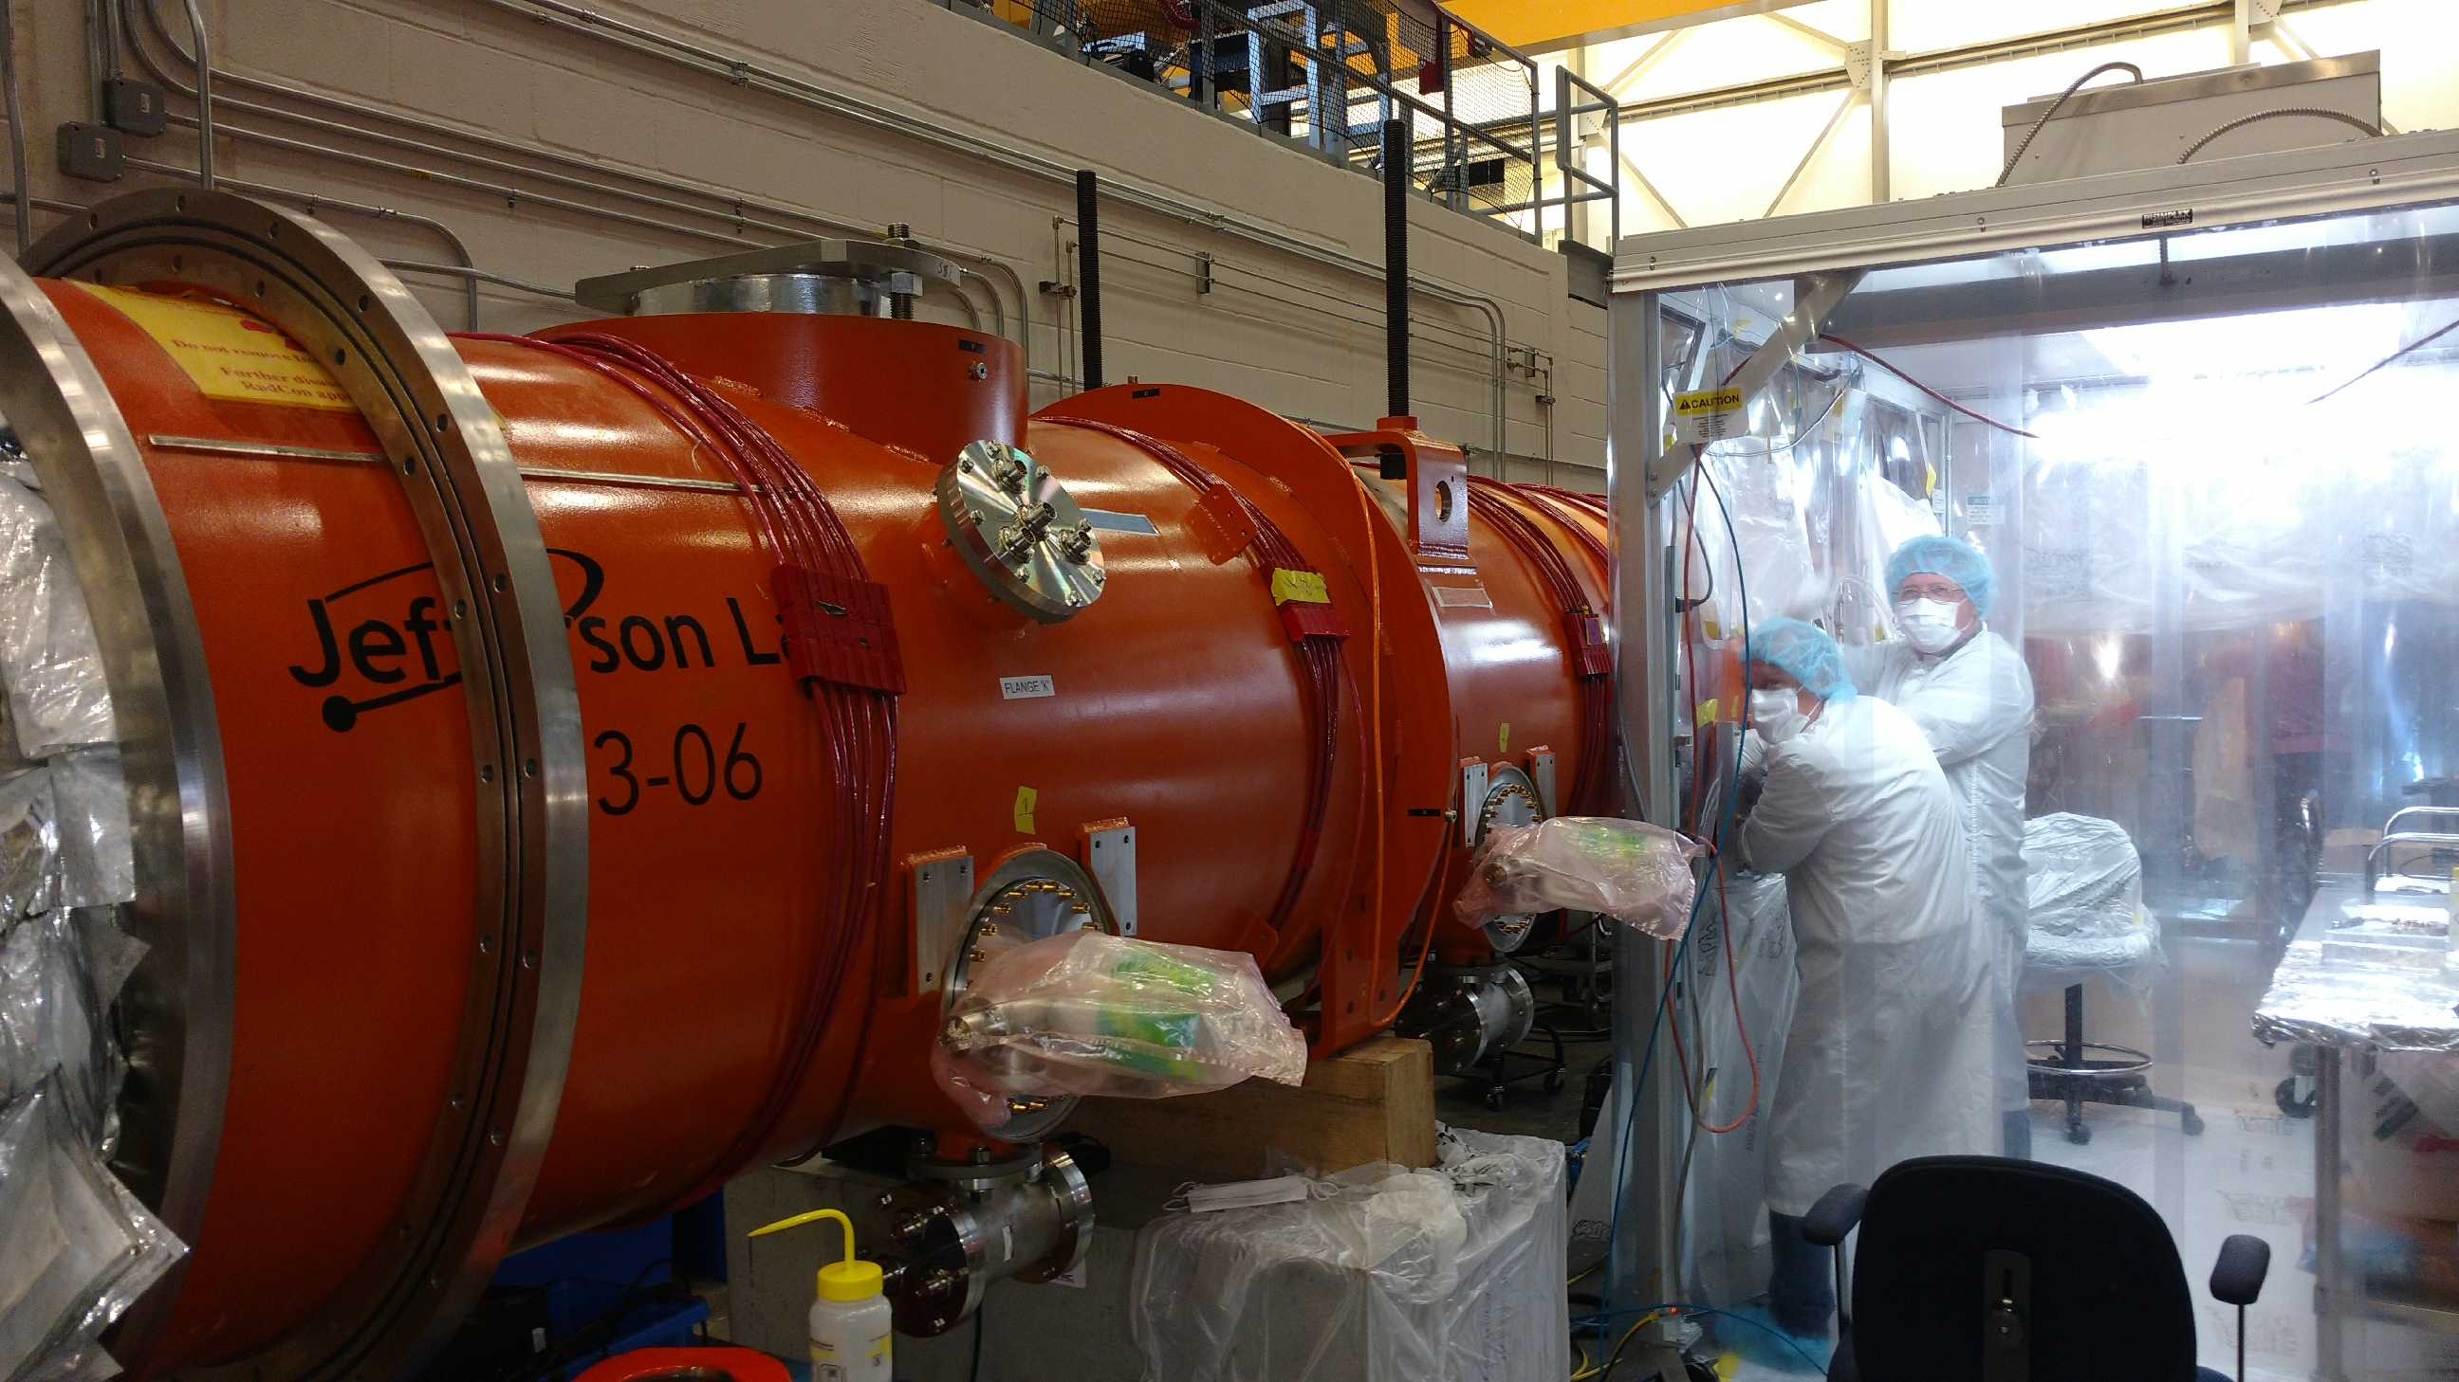  J1.3-06 | 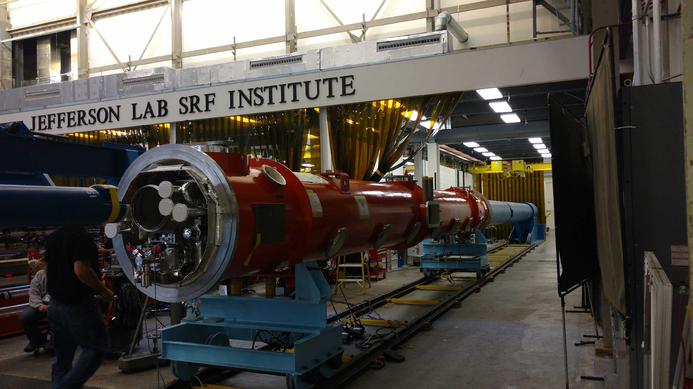  J1.3-02

