LCLS-II FEBUARY PROJECT STATUS REPORT

DATE: March 6, 2020
LOCATION OF PROJECT: Jefferson Lab
SENIOR TEAM LEAD: Joe Preble

MONTHLY PROGRESS

Summary
Report reflects January EV data. JLab continues to make significant progress in all areas. Cost, schedule, and scope are being managed to the baseline. We received earned value and variance data, analyzed data and submitted VARs.
EV Performance as of January close.
Overall % complete = 97.0%, SPI = 0.990, CPI = 0.99

Management:
Prepared for the 4.5k Cold Box Controls Software Review which is scheduled for March 3-4, 2020.
Participated in dry runs for the Director’s Review scheduled for March 10-12, 2020.
Cryoplant System:
EV Performance as of January close.
Overall % complete = 95.0%, SPI = 0.99, CPI = 0.97
Assisted with cryoplant assembly at SLAC.
Prepared for the 4.5k Cold Box Controls Software Review which is scheduled for March 3-4, 2020.
Procurement placed for final JLab provided hardware, u-tubes, was completed.
Working with SLAC on commissioning planning and support.
Supported troubleshooting efforts for the purifier installation at SLAC.
Completed checkout of the C1 4.5K Cold Box vacuum skid
Started the transfer of large equipment warranty packages to SLAC.
Cryomodules:
EV Performance as of January close.
Overall % complete = 98.0%, SPI = 0.98, CPI = 1.00
J1.3-11- WS2 – Leak in vendor supplied Helium Vessel bellows; developing plans for rework is ongoing
J1.3-21- WS6 - Ships March 6.
J1.3-20- In LERF, SLAC LLRF testing this week.
J1.3-09- WS5- Testing cap and bayonet box, prep for CMTF.
J1.3-06- In CTMF for testing; Out of CMTF 3-10.
J1.3-02- WS3 – UCM removed in preparation for replacing the Fundamental Power Coupler (FPC); The FPC has a leak in a braze joint.
J1.3-01,03,04,05,07,08,10,12,13,14,15,16,17,18,19@SLAC

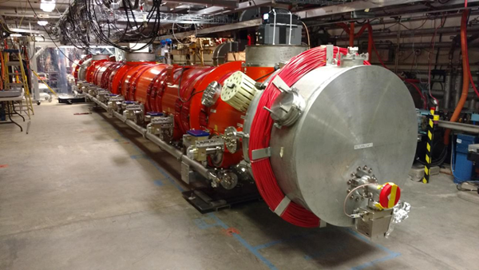  J1.3-20 LERF | 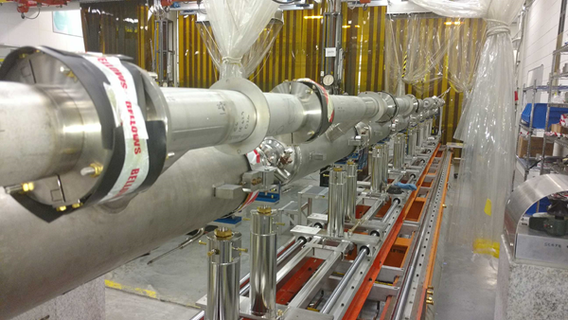  J1.2-11
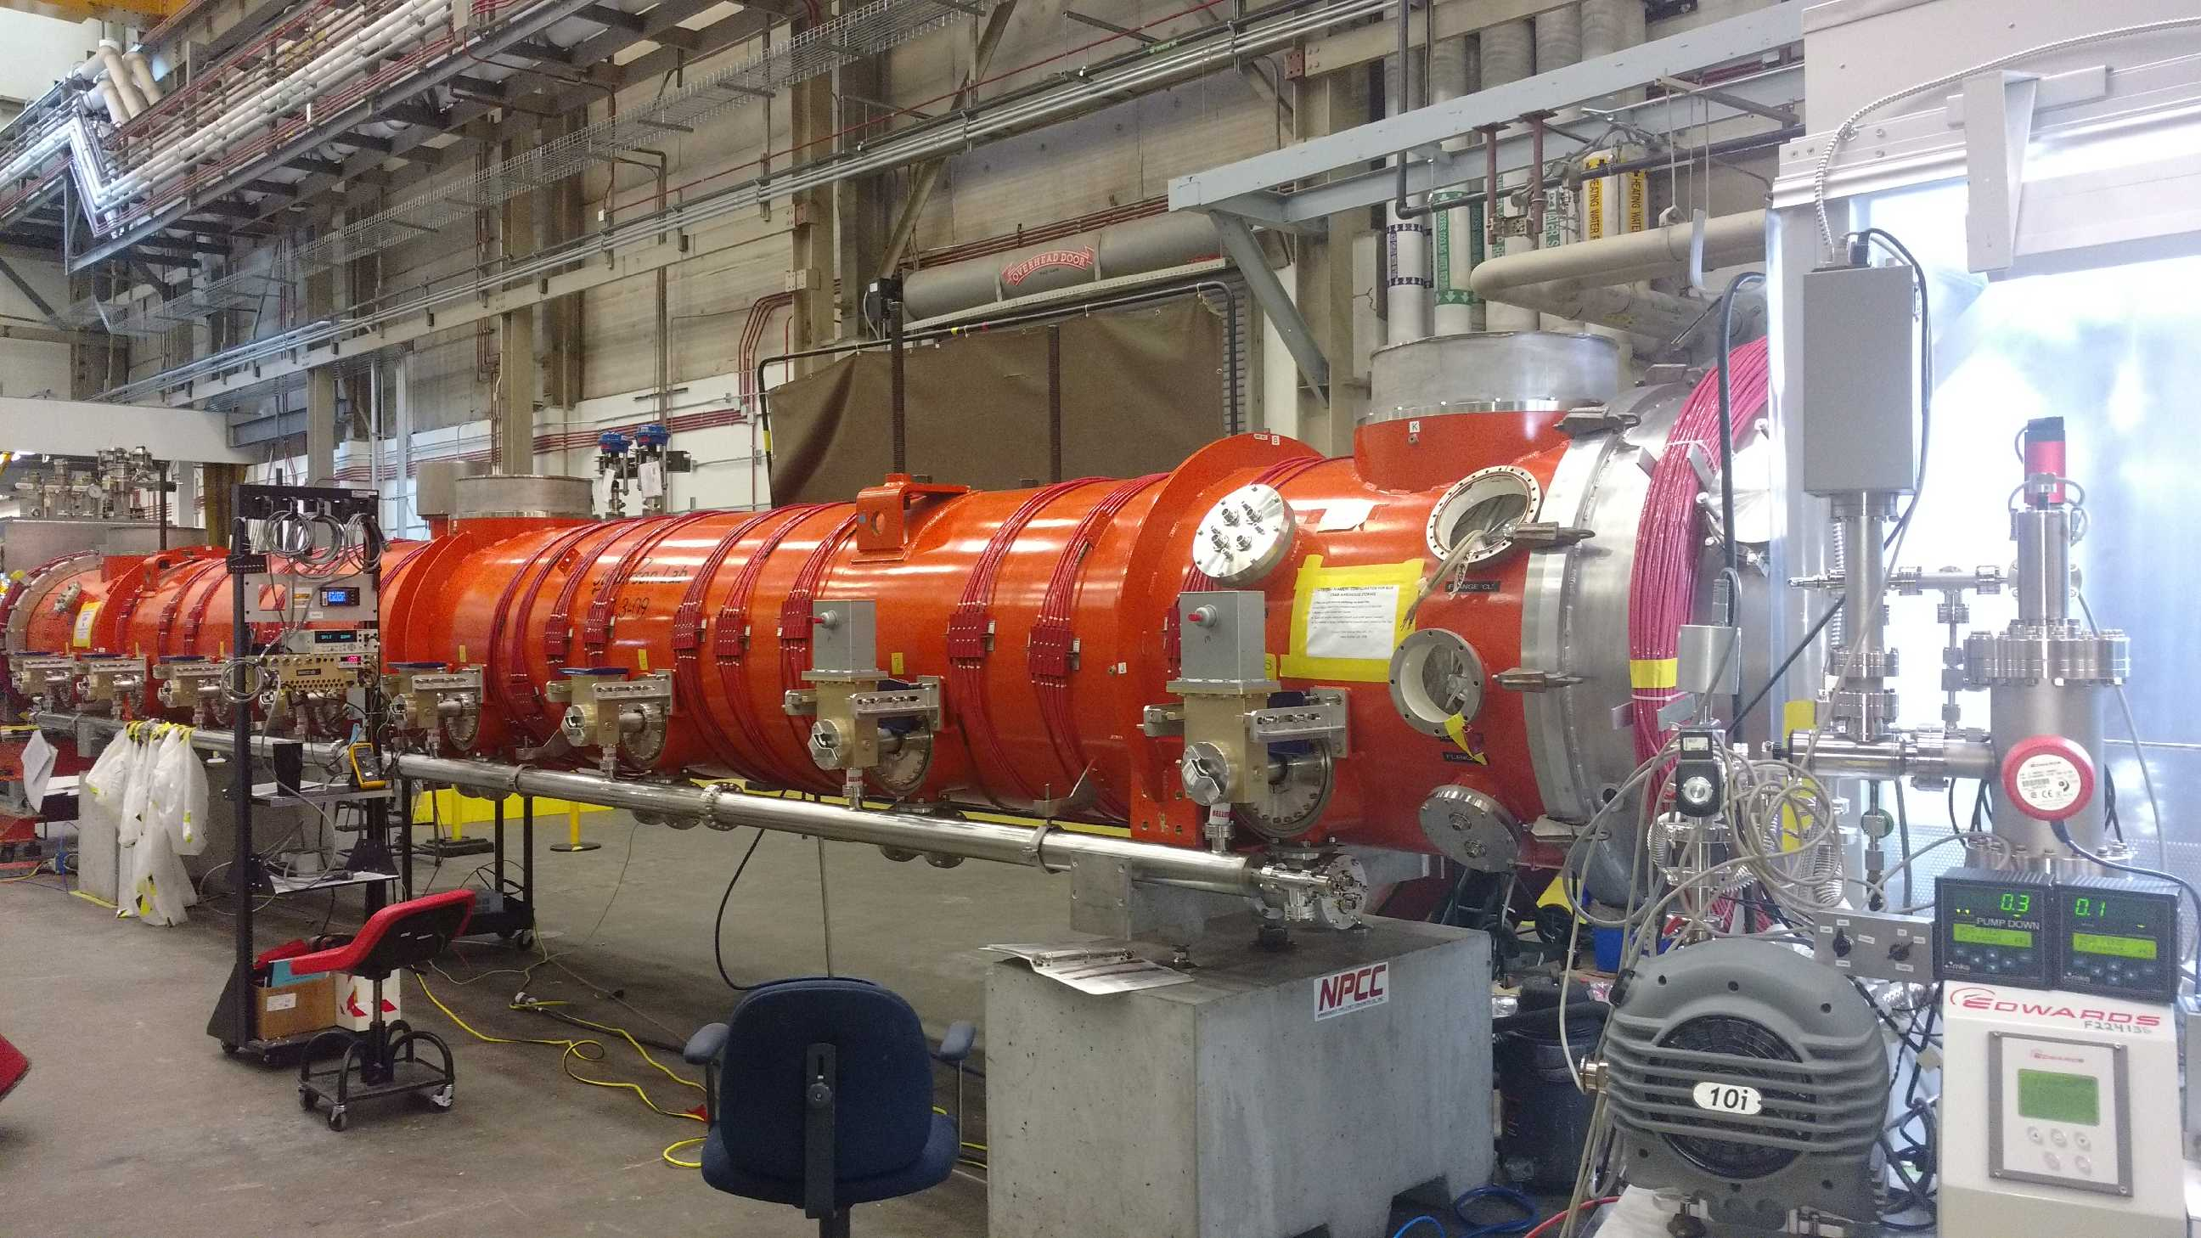  J1.3-09 | 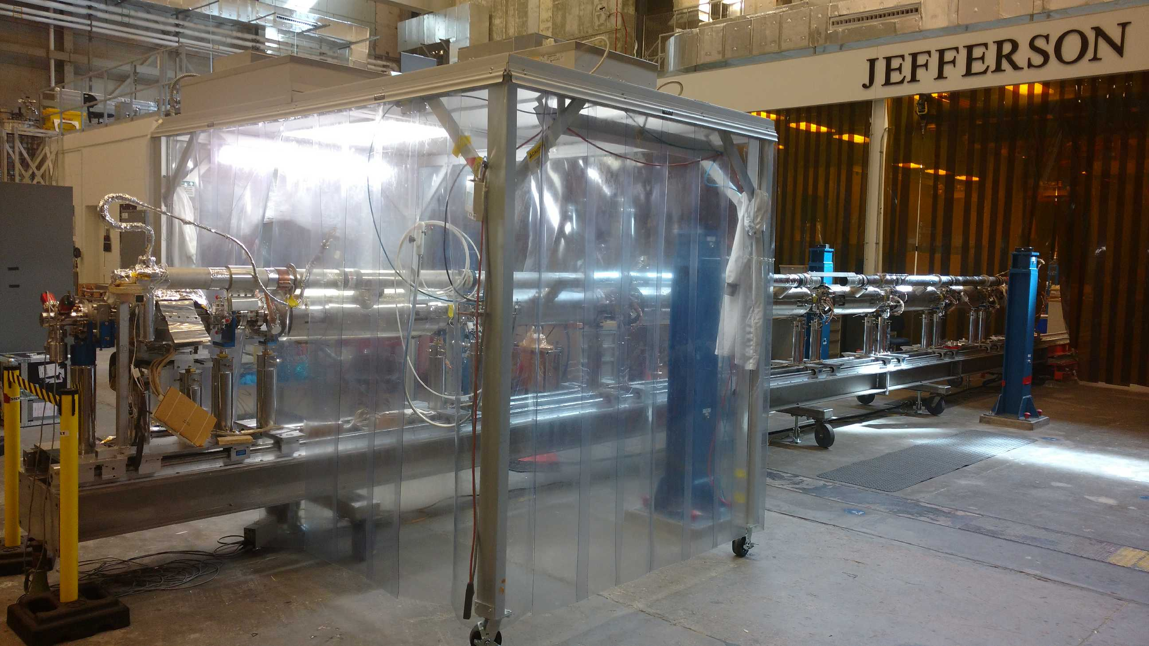  J1.3-02

