LCLS-II MARCH PROJECT STATUS REPORT

DATE: March 30, 2020
LOCATION OF PROJECT: Jefferson Lab
SENIOR TEAM LEAD: Joe Preble

MONTHLY PROGRESS

Summary
Due to the COVID19, on March 24 Jefferson Lab went to MEDCON6 until further notice. On site personnel are limited to site necessary personnel only. All LCLS II on site activities are on a hold.
Report reflects February EV data. JLab continues to make significant progress in all areas. Cost, schedule, and scope are being managed to the baseline. We received earned value and variance data, analyzed data and submitted VARs.
EV Performance as of February close.
Overall % complete = 97.0%, SPI = 0.99, CPI = 0.99

Management:
Participated in the 4.5k Cold Box Controls Software Review on March 3-4, 2020.
Participated in the Director’s Review on March 10-12, 2020.
Cryoplant System:
EV Performance as of February close.
Overall % complete = 95.0%, SPI = 0.99, CPI = 0.97
Assisted with cryoplant assembly at SLAC.
Hosted the 4.5k Cold Box Controls Software Review on March 3-4, 2020.
4.5K cold box software is complete. PLC code and interface document delivered to SLAC.
Warm helium compressor code is complete and ready for checkout at SLAC.
Working with SLAC on commissioning planning and support.
Continued the transfer of large equipment warranty packages to SLAC.
Cryomodules:
EV Performance as of February close.
Overall % complete = 98.0%, SPI = 0.99, CPI = 1.00
Six BLAs, currently stored in cleanroom, are ready to ship when SLAC reopens.
J1.3-02- WS5 – Ready for coupler replacement.
J1.3-06- WS6; shipping preparation ~90% complete.
J1.3-09- In CMTF for testing; warm-up for Public Health Emergency.
J1.3-11 – WS2 - Leaky cavity will be replaced; SPQA has been removed and areas prepped for R&R.
J1.3-20- In LERF, SLAC LLRF testing still needs to be completed; mid-April removal.
J1.3-01,03,04,05,07,08,10,12,13,14,15,16,17,18,19,21@SLAC

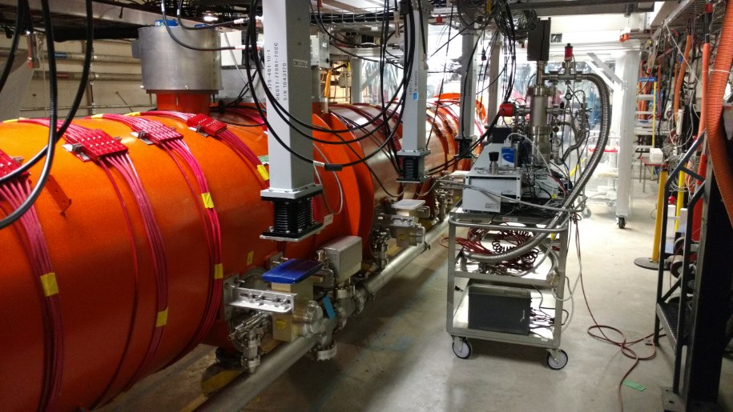  J1.3-20 in LERF | 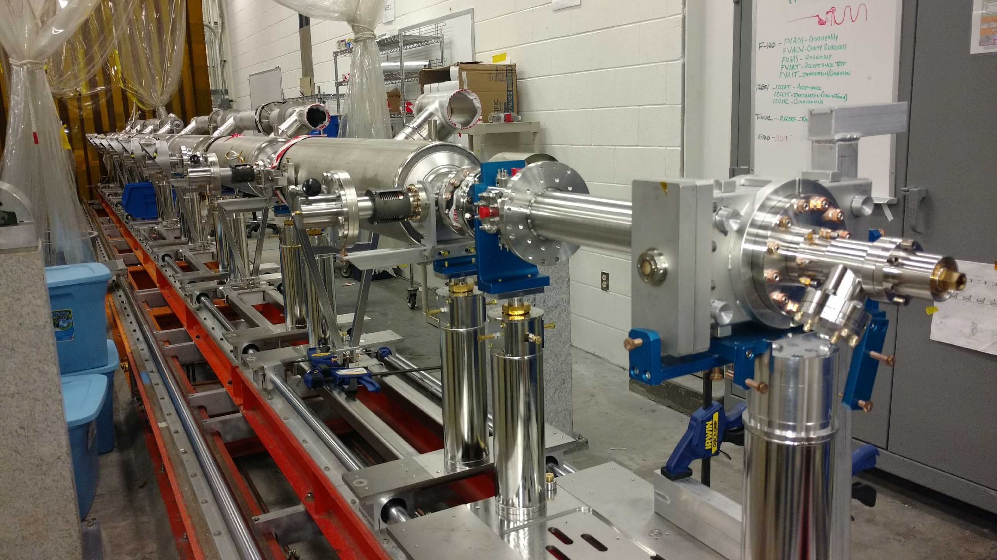  J1.3-11 at WS2
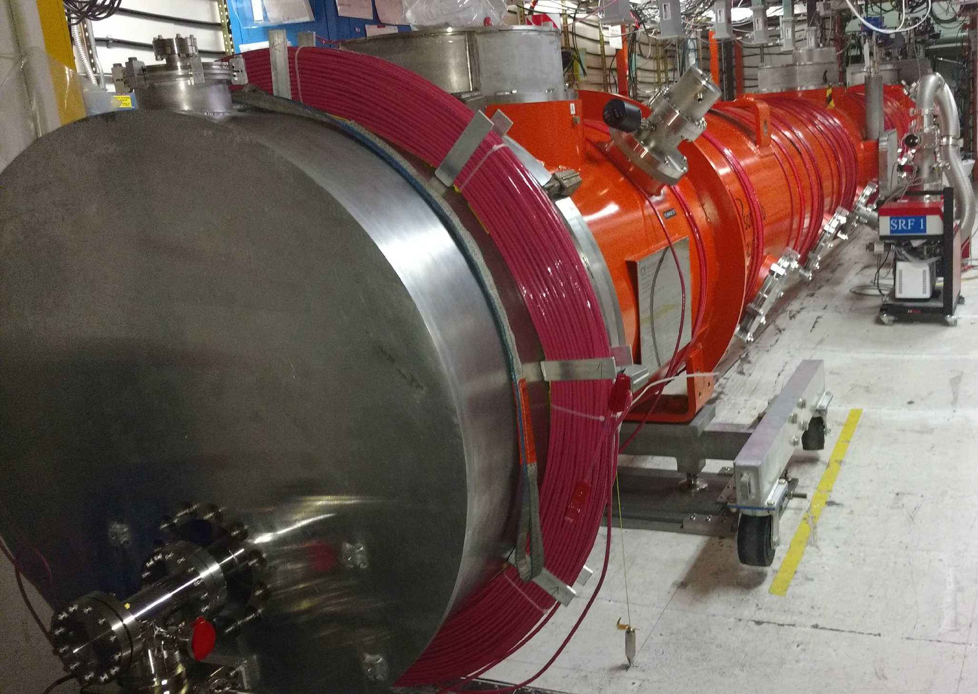  J1.3-09 in CMTF | 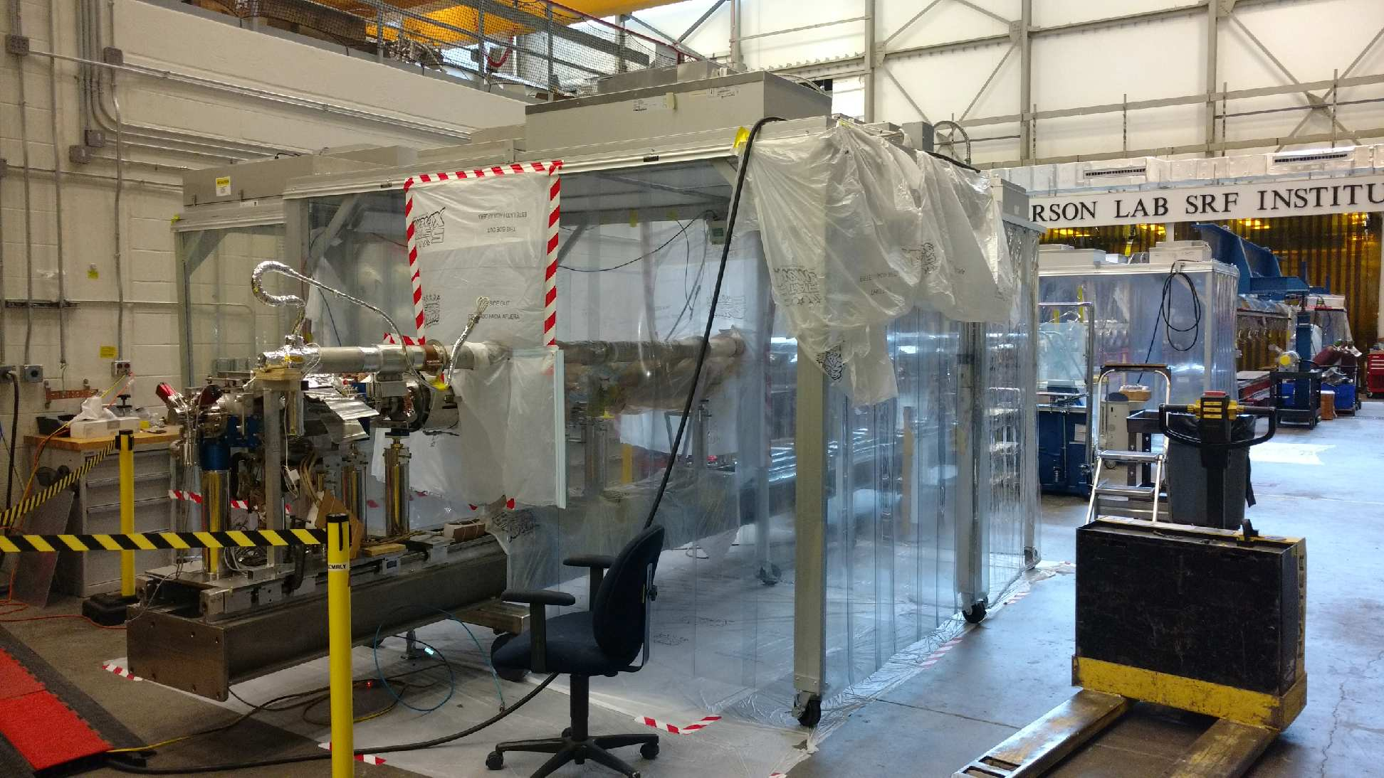  J1.3-02 at WS5

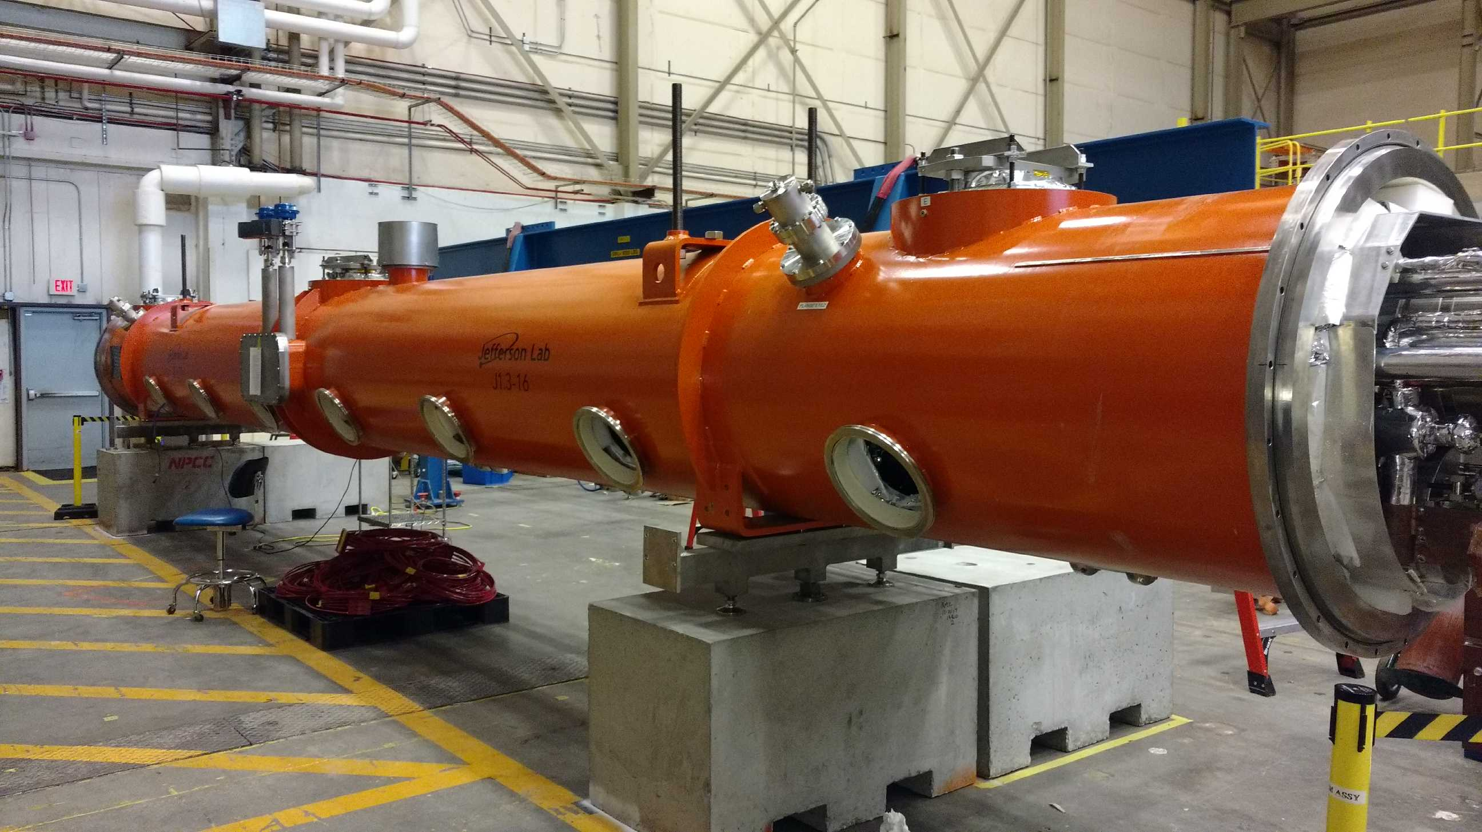
J1.3-06
J1.3-06 at WS6; next to ship.

