Weekly Reporting
LERF
Week of January 10, 2018

Issues:
none
Accomplishments this week:
The Zone 3 klystron rack is cleaned out and ready to be jacked up 2” for new waveguide layout, Zone 4 should be done in a day or so. The waveguide supports are installed on all 4 sets of waveguides.
The first shipment of waveguide components has arrived, 12 pieces of 12” bellows. Two more shipments are in transit, these will include long strait sections. The puzzle assembly will begin soon… The tunnel waveguide support structure drawings are complete, the installation crew will start drilling holes & mounting anchors in the ceiling.
The radiation shielding assessment for the accelerator vault continues.

The two PSS Interface boxes were mounted in the gallery this week Assembly & wiring of the internals is progressing and should complete them by the end of the January.

AC power for the racks in the gallery is also being worked. A new 42 slot panel is mounted in the gallery, this will supply all of the power for the new racks & equipment. The server rack is prepared for the power connection, once that is operational the UPS & servers will be mounted and powered up.

The C50 cryomodule has been re-surveyed into place.

Operational Safety Procedure (OSP) for LERF testing of the LCLS-II CMs is progressing well.
Continued work on WIKI site for documentation: wiki.jlab.org/lerf
Waveguide support structure
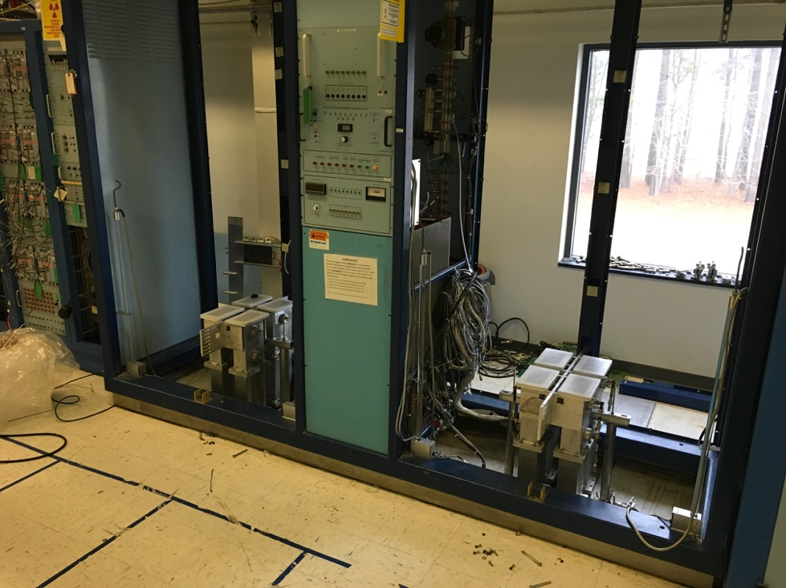
HPA racks cleaned out w/waveguide supports shown
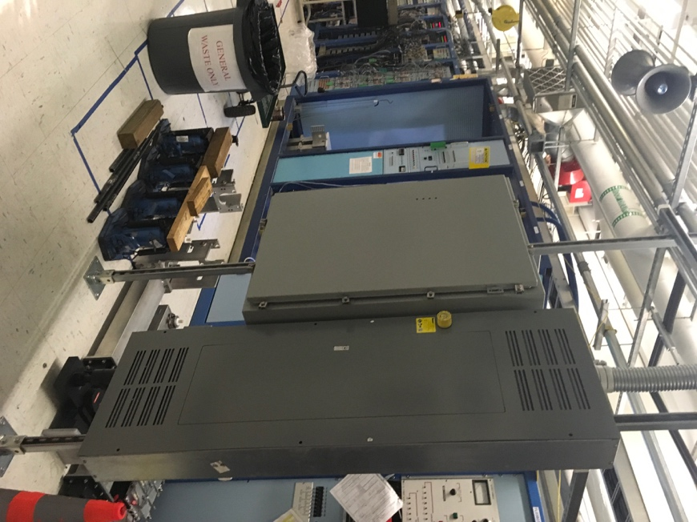
Safety system box mounted in gallery

