1. Infrastructure slide these tasks to be completed before CD-2

* Detail design of target and upstream torus shielding enclosures (60+% now)
* E&D of shielding wall and exit of drift tube (40+% now)
* E&D of LCW and electrical power to spectrometer magnets and power supplies
* Detector support structures and access platforms
  + preliminary design in place, on hold for structural detector design
* E&D of detector cables and power supply layouts including grounding.
* Pass final design reviews

What’s the labor breakdown for each task above (in units of hours)?

1. The labor profile looks like it is ramping down but there is a lot of work to be done:

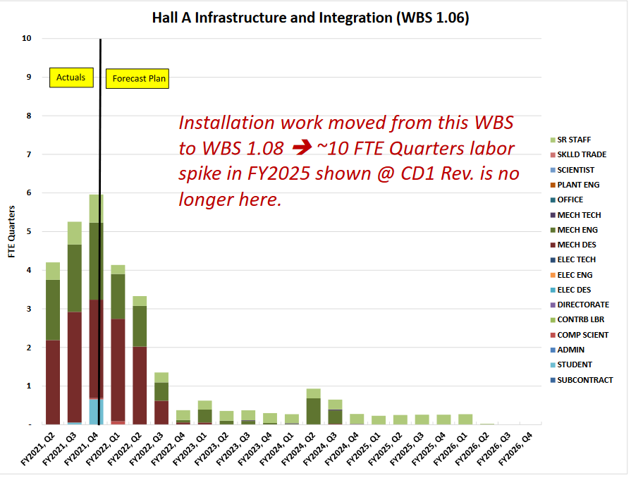

What’s the total planned infrastructure labor for FY22 (in units of hours)?

1. For BOM lead time surveys, which items were being tagged as one-year lead-time (or longer)?
2. Have you queried suppliers about lead-times on other key materials such as quartz for detectors, PMTs, and custom chemicals (e.g optical epoxies)?