**Mott Experiment Run II Beam Energy**

Joe Grames

March 4, 2016

JLab-TN-16-xx

**Introduction**

The single-atom Mott analyzing power, or Sherman function, depends upon the value of the elastically scattered electron energy. During Run II the physics asymmetry was systematically measured when the beam energy was set to 5 different values in ~200 keV increments (including the energy used for the target thickness extrapolation). For each case the electron momentum was measured using a conventional spectrometer to determine the corresponding kinetic energy.

**Measurements**

The beam energy was set to 5 values by changing the gradient set point (R028) of the second cryo-unit cavity. For each setting the beam orbit (see Fig. 1) was carefully measured when the spectrometer dipole magnet (MDL0L02) was set to 0.0 G-cm and again when the dipole was energized to deflect the beam about +25° into a diagnostic beam line. A pair of beam position monitors (IPM0L02, IPM0L03) measured the un-deflected orbit and another pair (IPM5D00, IPM5D01) measured the deflected orbit.

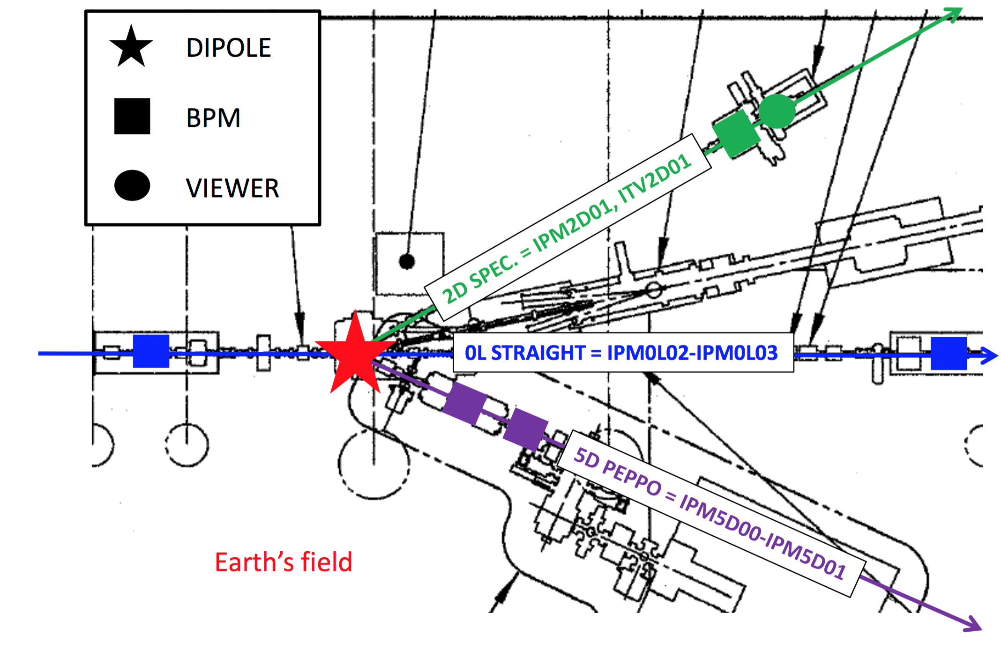

*Fig. 1. Place holder image for spectrometer layout.*

Additional horizontal steering coils were needed to address systematic effects. First, three steering coils (MHB0L02A, MHB0L02B, MBH0L03) were required to compensate the ~0.5 G vertical component of stray magnetic field spanning the injector area; these steering coils remained constant throughout all 5 measurements. Without the steering coils the beam would progressively deflect until reaching the beam pipe. Second, two steering coils (MBH0L01, MHB0L02) *upstream* of the spectrometer were used to correct for both the RF cavity dipole mode and stray field *between* the cryo-unit and spectrometer region. The steering coils took on different values for the five gradient settings because the size of the strength of the cavity dipole field and the beam momentum changed for each energy setting. The steering coils were set to null the horizontal beam position at the un-deflected monitors (IPM0L02, IPM0L03). The steering coils (MBH5D00H, MBH5D00AH) in the deflected beam line remained 0.0 G-cm for all measurements because this beam line is better shield from stray magnetic field and is shorter. It is worthwhile to mention that only the spectrometer dipole magnet changed value between each un-deflected and deflected measurement.

Recorded values of the cavity gradient, steering coils, spectrometer dipole, and beam position monitors for all 5 energies studied are summarized in Table 1.

*Table 1. The cavity gradient (MV/m), steering coil currents (mA), spectrometer dipole field integral (G-cm) and beam position monitor readings (mm) for the experiment are listed. Beam positions are reported in a left-handed system (x=right, y=up, z=forward).*

|  |  |  |  |  |  |  |  |  |  |  |  |
| --- | --- | --- | --- | --- | --- | --- | --- | --- | --- | --- | --- |
| *Constant* | | | | | | *Undeflected* | | | *Deflected* | | |
| *R028* | *MBH0L01* | *MHB0L02* | *MHB0L02A* | *MHB0L02B* | *MBH0L03* | *MDL0L02* | *IPM0L02.XPOS* | *IPM0L03.XPOS* | *MDL0L02* | *IPM5D00.XPOS* | *IPM5D01.XPOS* |
| *MV/m* | *mA* | *mA* | *mA* | *mA* | *mA* | *G-cm* | *mm* | *mm* | *G-cm* | *mm* | *mm* |
| 3.35 | -325.00 | -292.00 | -214.54 | -0.03 | -342.83 | 0.00 | 0.03 | 0.22 | 7109.57 | 0.00 | 3.50 |
| 3.74 | -327.00 | -293.00 | -214.54 | -0.03 | -342.83 | 0.00 | 0.08 | 0.17 | 7384.34 | 0.01 | 3.67 |
| 4.12 | -329.00 | -292.00 | -214.54 | -0.03 | -342.83 | 0.00 | 0.06 | 0.15 | 7646.01 | 0.00 | 4.06 |
| 4.50 | -332.00 | -286.00 | -214.54 | -0.03 | -342.83 | 0.00 | -0.02 | 0.00 | 7927.59 | 0.00 | 3.89 |
| 4.89 | -333.00 | -287.00 | -214.54 | -0.03 | -342.83 | 0.00 | 0.05 | 0.21 | 8185.00 | 0.03 | 3.85 |

**Uncorrected Electron Momenta : ideal orbit and TOSCA model**

The MDL0L02 spectrometer dipole magnet field measurements and corresponding TOSCA model is described in [4]. The model with default BH curve agrees with the straight-line on-axis magnetic field measurement within 0.1% level. The model was used to generate the straight-line magnetic field integral corresponding to a deflecting an electron beam of momentum *P* (MeV/c) by +25.0° into the ideal diagnostic beam line. A 5th order polynomial applied to the model with corresponding coefficients yields,

BL = M0 + M1 P + M2 P2 + M3 P3 + M4 P4 + M5 P5

M0 = +4.811

M1 = -1416.2

M2 = +1.2399

M3 = -0.1646

M4 = +0.009795

M5 = -0.00021257

A solution of this polynomial for the corresponding eneriges is given in Table 2 and a plot over the full range is shown in Fig. 2.

*Table 2. Table of momenta for 5 energies studied according to model of MDL0L02.*

|  |  |  |  |
| --- | --- | --- | --- |
| *R028* | *MDL0L02* | *P* | *dP* |
| *MV/m* | *G-cm* | *MeV/c* | *MeV/c* |
| 3.35 | 7109.57 | 5.035 | 0.005 |
| 3.74 | 7384.34 | 5.229 | 0.005 |
| 4.12 | 7646.01 | 5.415 | 0.005 |
| 4.50 | 7927.59 | 5.614 | 0.006 |
| 4.89 | 8185.00 | 5.797 | 0.006 |

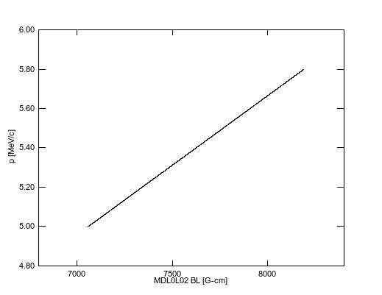

*Fig. 2. Plot of momenta vs. straight-line field integral determined by TOSCA model of dipole MDL0L02 to deflect an electron beam by +25.0°.*

**Corrected Beam Momenta: model orbit with stray field and steering coils**

The corrected beam momentum is determined by examining the effect of the stray magnetic field and steering coils on the beam orbit to improve the determination of the total bend angle, i.e. the angle between the beam just entering and just exiting the dipole magnet. This modeled beam angle is then used to make a simple correction to the ideal +25.0° deflection assumed in the previous section. Following this strategy one could also just determine the beam momentum from the un-deflected conditions, however the relative momentum error benefits from a large angular deflection. The method for correction is detailed in the following steps.

*Step 1: Model of Stray Field and Steering Coils*

A survey of vertical component of the stray magnetic field was made in December 2015 (see Appendix A) and is plotted in Fig. 3 over the span IPM0L02 to IPM0L03. To demonstrate the significance of the stray field the trajectories of beam momenta spanning 4.5-6.5 MeV/c in 0.5 MeV/c increments is overlaid on Fig. 3; the effect is that a beam centered at IPM0L02 will exit the beam pipe before reaching IPM0L03.

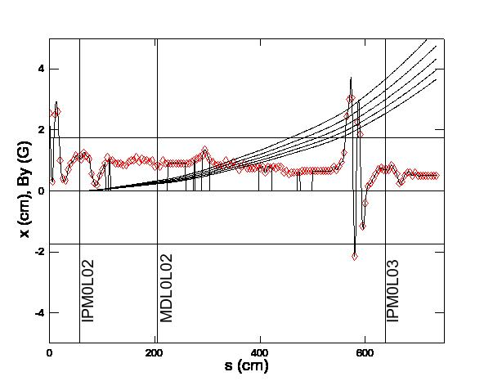

*Fig. 3. Stray magnetic field measurements (red diamonds) and spline fit are used to generate By(s) splanning IPM0L02 to IPM0L03. The horizontal trajectory is plotted vs. beam position over this length for momenta (4.5, 5.0, 5.5, 6.0, 6.5 MeV/c) with initial conditions IPM0L02(x=0 cm, x’=0 mrad).*

The effect of including the steering coils is meaningful (see Fig. 4); after converting the steering coils currents (see Table 1) into magnetic field (see Appendix B) a model of the beam trajectories for the same span is momenta is significantly better; a) the beam is transported from IPM0L02 to IPM0L03, b) the point-wise steering corrections compensate for the distributed stray field. Since both the effect of the steering coils and stray magnetic field scale linearly with beam momentum one finds that all of the orbits are similarly corrected.

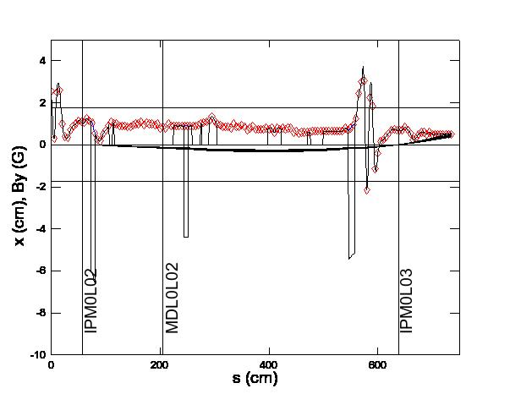

*Fig. 4. The addition of three fixed steering coils* (MHB0L02A, MHB0L02B, MBH0L03) *is added to the model. The horizontal trajectory is plotted vs. beam position over this length for momenta (4.5, 5.0, 5.5, 6.0, 6.5 MeV/c) with initial conditions IPM0L02(x=0 cm, x’=0 mrad).*

*Step 2: BPM Analysis*

The measured beam orbit needs to be computed before using the magnetic model to quantify the beam orbit. Prior to the experiment each beam position monitor center was calibrated (see Appendix A) to the magnetic center of the nearest downstream quadrupole magnet. Beam positions (*IPM.XPOS*) recorded during the energy measurements and reported in Table 1 consequently are relative to the magnetic centers. Corrected beam positions (*IPM.XCOR*) are then determined by accounting for the surveyed quadrupole positions (*QUAD.XOFF*) according to,

*IPM.XCOR = IPM.XPOS – QUAD.XOFF.*

*Table 3. Note that the quadrupole offsets reported in [1,2] are converted from right-handed survey system to left-handed beam position monitor system.*

|  |  |  |  |  |  |  |  |  |  |  |  |  |
| --- | --- | --- | --- | --- | --- | --- | --- | --- | --- | --- | --- | --- |
| *Constant* | *Undeflected* | | | | | | *Deflected* | | | | | |
| *R028* | *IPM0L02.XPOS* | *MQJ0L02.XOFF* | *IPM0L02.XCOR* | *IPM0L03.XPOS* | *MQJ0L03A.XOFF* | *IPM0L03.XCOR* | *IPM5D00.XPOS* | *MQD5D00.XOFF* | *IPM5D00.XCOR* | *IPM5D01.XPOS* | *MQD5D01.XOFF* | *IPM5D01.XCOR* |
| *MV/m* | *mm* | *mm* | *mm* | *mm* | *mm* | *mm* | *mm* | *mm* | *mm* | *mm* | *mm* | *mm* |
| 3.35 | 0.03 | -0.01 | 0.04 | 0.22 | -0.24 | 0.46 | 0.00 | -0.27 | 0.27 | 3.50 | -0.22 | 3.72 |
| 3.74 | 0.08 | -0.01 | 0.09 | 0.17 | -0.24 | 0.41 | 0.01 | -0.27 | 0.28 | 3.67 | -0.22 | 3.89 |
| 4.12 | 0.06 | -0.01 | 0.07 | 0.15 | -0.24 | 0.39 | 0.00 | -0.27 | 0.27 | 4.06 | -0.22 | 4.28 |
| 4.50 | -0.02 | -0.01 | -0.01 | 0.00 | -0.24 | 0.24 | 0.00 | -0.27 | 0.27 | 3.89 | -0.22 | 4.11 |
| 4.89 | 0.05 | -0.01 | 0.06 | 0.21 | -0.24 | 0.45 | 0.03 | -0.27 | 0.30 | 3.85 | -0.22 | 4.07 |

*Step 3: Application of model to determine size of correction*

The orbit for each of the 5 cases may be studied separately, uniquely; however, for the purpose of the Mott energy measurement one can take advantage of the systematically similar conditions and use averaging. Using Table 1 we find,

*<0L02_COR>meas = 0.067 +/- 0.025 mm*

*<0L03_COR>meas = 0.420 +/- 0.036 mm*

Using the tracking model one finds that over range of momenta 4.5-6.7 MeV/c the average beam position *<0L03_COR>meas* is satisfied when the beam passing through IPM0L02 satisfies the following conditions,

*X = +0.067 +/- 0.025 mm (defined by measurement)*

*X’ = +0.038 +/- 0.004 mrad (determined by model)*

A plot of the trajectories over range of momenta 4.5-6.7 MeV/c for these initial conditions is shown in Fig. 5. Because the point-wise steering coil corrections cancel the stray magnetic field and scale with momentum the beam position and angle are essentially constant at the dipole. Taking into account the uncertainty of position and angle at IPM0L02 the distribution of position and angle at MDL0L02 is calculated using the model to be,

*X = -1.20 +/- 0.21 mm*

*X’ = -0.916 +/- 0.145 mrad*

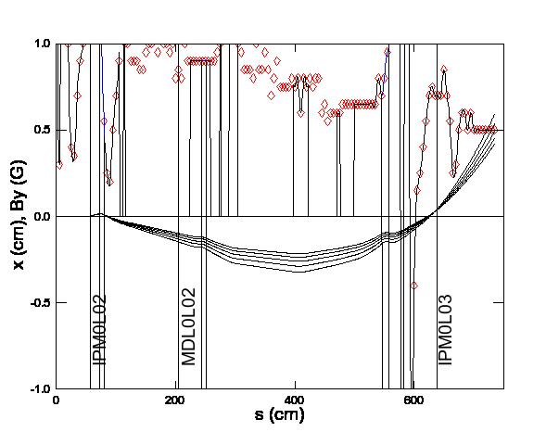

*Fig. 5. The trajectories for 5 different momenta (4.5, 5.0, 5.5, 6.0, 6.5 MeV/c) with initial conditions IPM0L02(x=0.067 mm, x’=0.038 mrad) is shown.*

A survey of stray magnetic fields was similarly measured (see Appendix D) and plotted in Fig. 5. Overlaid on this plot are the trajectories for the 5 momenta; the initial conditions (*X,X’*) are the values determined at MDL0L02 for the previous calculation.

The model predicts the beam positions to be,

*X5D00 = -1.003 +/- 0.061 mm (determined by model)*

*X5D01 = +1.262 +/- 0.276 mm (determined by model)*

Both predictions are systematically “beam left” of the measured values,

*<5D00_COR>meas = 0.273 +/- 0.006 mm*

*<5D01_COR>meas = 3.963 +/- 0.287 mm*

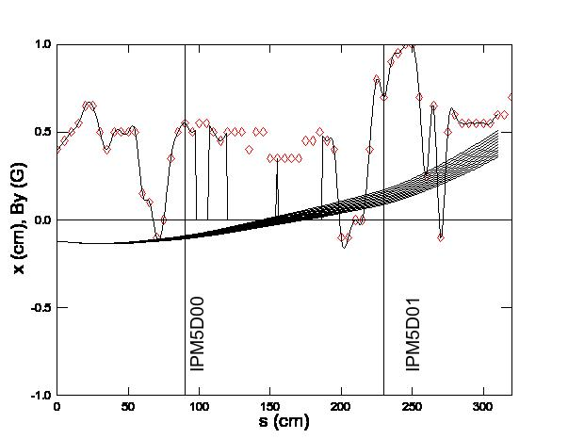

*Fig. 5. The trajectories for 5 different momenta (4.5, 5.0, 5.5, 6.0, 6.5 MeV/c) with initial conditions MDL0L02(x=-1.20 mm, x’=-0.916 mrad) is shown.*

The difference between model and measurement at each BPM is attributed to the dipole bending the beam by an amount larger than +25.0°. Consistent with this hypothesis the disparity in position (measured vs. modeled) of 2.18 is nearly proportional to the distance of each BPM to the dipole (229 cm / 89 cm = 2.57).

The corrected bend angle predicted by the model using each BPM as a boundary conditions yields,

*IPM5D00 =>  = 25.082*° *+/- 0.001*°

*IPM5D01 =>  = 25.068*° *+/- 0.007*°

Although the values agree at the 2 level the final value used is more conservative; the average is algebraic and the uncertainty is,

*<> = 25.075*° *+/- 0.014*°*.*

**Summary**

This note summarizes the Mott Run II beam energy measurements and discusses a method to calculate the beam momentum when including all of the magnetic fields (dipole, stray, steering coils). The method uses the TOSCA model to first calculate the beam momentum for an ideal 25° bend. A correction is applied to the bend angle spanning the dipole by a model that incorporates beam positions monitors, stray magnetic field and steering coils in the regions before and after the dipole. Applying this method to the average of 5 measurements an average corrected bend angle is determined, *<> = 25.075*° with a total error budget summarized in Table 4. Finally, a summary of the beam momenta and kinetic energies used is summarized in Table 5.

*Table 4. Error budget for beam momentum method is listed.*

|  |  |
| --- | --- |
| *Contribution* | *Value* |
| TOSCA Model (Ref [4]) | 0.100% |
| Magnet PS Calibration (10 mA / >1000 mA) | 0.001% |
| 0L Quad Survey (0.20 mm / 6430 mm) | 0.004% |
| 0L BPM Centering (0.50 mm / 5820 mm) | 0.012% |
| 5D Quad Survey (0.20 mm / 1400 mm) | 0.020% |
| 5D BPM Centering (0.50 mm / 1400 mm) | 0.005% |
| Stray Field Model (this TN) | 0.056% |
| Total | 0.117% |

*Table 5. Summary table.*

|  |  |  |  |  |  |  |
| --- | --- | --- | --- | --- | --- | --- |
| *R028* | *MDL0L02* | *P (TOSCA)* | *P (Corrected)* | *dP (Total)* | *T (KE)* | *dT (KE)* |
| *MV/m* | *G-cm* | *MeV/c* | *MeV/c* | *MeV/c* | *MeV* | MeV |
| 3.350 | 7109.570 | 5.035 | 5.020 | 0.006 | 4.535 | 0.006 |
| 3.740 | 7384.340 | 5.229 | 5.213 | 0.006 | 4.727 | 0.006 |
| 4.120 | 7646.010 | 5.415 | 5.399 | 0.006 | 4.912 | 0.006 |
| 4.500 | 7927.590 | 5.614 | 5.597 | 0.007 | 5.109 | 0.007 |
| 4.890 | 8185.000 | 5.797 | 5.780 | 0.007 | 5.291 | 0.007 |

**Reference**

[1] Jefferson Lab Alignment Group, *Data Transmittal #L1456*, May 25 2012 (note the information for magnets MQJ0L03 and MQJ0L03A appear reversed).

[2] Jefferson Lab Alignment Group, Data Transmittal *#L1462 Rev. 2*, Jan 22 2013.

[3] Magnet Measurement Facility, */u/group/MagTest/DataBase/DL*

[4] J. Benesh, *“A detailed examination of the MDL field map and the TOSCA model of this “5 MeV” dipole”*, JLab-TN-15-017.

**Appendix A**

The sequence of steps for each measurement is described here:

1. Setup beam to Faraday Cup #2
2. Quad center and update .SOF for IPM0L02, IPM0L03, IPM5D00, IPM5D01
3. Set MDL0L02 to zero and cycle
4. Set magnets on 2D and 3D lines to zero and cycle
5. Set skew and normal quads from IPM0L02 to IPM0L03 to zero and cycle
6. (Optional) Zero beam positions at IPM0L02 and IPM0L03
7. Record undeflected orbit conditions:
   1. MDL0L02
   2. beam positions IPM0L02/IPM0L03
   3. all corrector settings in 0L line
8. Set steering coils (stray fields) between MDL0L02 and IPM0L03 to zero
9. Set MDL0L02 to deflect beam to IPM5D00 and IPM5D01 so both within 5mm.
10. Cycle MDL0L02 and iterate with step #9 until satisfied
11. Record deflected orbit conditions:
    1. MDL0L02
    2. beam positions IPM5D00/IPM5D01
    3. all corrector settings in 5D line

**Appendix B – Stray Magnetic Field 0L Region**

The stray magnetic field between ITV0L02 and IFY0L03 was surveyed between Dec. 22, 2015 and Jan. 12, 2016. With magnets unpowered and degaussed the vertical component of stray magnetic field was measured every 5 cm both above and below the beam pipe and averaged. Additionally the upstream (US) and downstream (DS) location of beam line elements and regions of beam line that are covered in magnetic shielding were measured with an uncertainty of 0.5cm in a relative coordinate system.

The component and shielding positions are summarized first followed by magnetic field measurement results. The magnetic field measurement results are shown for Run II and following additional magnetic shielding added on January 12, 2016. The differences are noted in red.

|  |  |  |
| --- | --- | --- |
| ***Element*** | ***US (cm)*** | ***DS (cm)*** |
| ITV0L02/VIP0L02 | 1 | 1 |
| MQJ0L02 | 22 | 33 |
| IPM0L02 | 47 | 67 |
| MQS0L02 | 54 | 67 |
| MHB0L02 | 73 | 80 |
| MQJ0L02A | 83 | 94 |
| IBC0L02 | 130 | 145 |
| MDL0L02 | 199 | 209 |
| MHB0L02A | 244 | 251 |
| MQS0L02B | 398 | 410 |
| MHB0L02B | 413 | 419 |
| MHE0L03V | 513 | 525 |
| MHE0L03H | 527 | 540 |
| MBH0L03 | 547 | 557 |
| ITV0L03/VIP0L03 | 584 | 584 |
| MQJ0L03A | 602 | 613 |
| IPM0L03 | 629 | 649 |
| MQS0L03 | 636 | 649 |
| MQJ0L03 | 665 | 676 |
| IHA0L03 | 695 | 695 |
| IFY0L03 | 732 | 732 |

|  |  |  |
| --- | --- | --- |
| ***Mu-Metal*** | ***US (cm)*** | ***DS (cm)*** |
| 1 | 107 | 112 |
| 2 | 116 | 224 |
| 3 | 148 | 188 |
| 4 | 260 | 274 |
| 5 | 277 | 289 |
| 6 | 305 | 397 |
| 7 | 423 | 471 |
| 8 | 477 | 499 |

|  |  |  |  |  |  |  |
| --- | --- | --- | --- | --- | --- | --- |
| ***Z (cm)*** | ***Run II*** | | | ***After Jan 12, 2016*** | | |
| ***By_T (G)*** | ***By_B (G)*** | ***<By> (G)*** | ***By_T (G)*** | ***By_B (G)*** | ***<By> (G)*** |
| 0 | 1.1 | 4.0 | 2.6 | **1.0** | **0.9** | **1.0** |
| 5 | 1.1 | -0.5 | 0.3 | **1.0** | **0.8** | **0.9** |
| 10 | 2.0 | 3.0 | 2.5 | **0.9** | **0.9** | **0.9** |
| 15 | 2.2 | 3.0 | 2.6 | **0.7** | **0.7** | **0.7** |
| 20 | 1.0 | 1.0 | 1.0 | 1.0 | 1.0 | 1.0 |
| 25 | 0.5 | 0.3 | 0.4 | 0.5 | 0.3 | 0.4 |
| 30 | 0.2 | 0.5 | 0.4 | 0.2 | 0.5 | 0.4 |
| 35 | 0.7 | 0.7 | 0.7 | 0.7 | 0.7 | 0.7 |
| 40 | 0.9 | 0.9 | 0.9 | 0.9 | 0.9 | 0.9 |
| 45 | 0.9 | 1.1 | 1.0 | 0.9 | 1.1 | 1.0 |
| 50 | 1.1 | 1.2 | 1.2 | 1.1 | 1.2 | 1.2 |
| 55 | 1.1 | 1.1 | 1.1 | 1.1 | 1.1 | 1.1 |
| 60 | 1.0 | 1.1 | 1.1 | 1.0 | 1.1 | 1.1 |
| 65 | 1.3 | 1.2 | 1.3 | 1.3 | 1.2 | 1.3 |
| 70 | 1.1 | 1.2 | 1.2 | 1.1 | 1.2 | 1.2 |
| 75 | 1.1 | 1.0 | 1.1 | 1.1 | 1.0 | 1.1 |
| 80 | 0.5 | 0.6 | 0.6 | 0.5 | 0.6 | 0.6 |
| 85 | 0.2 | 0.3 | 0.3 | 0.2 | 0.3 | 0.3 |
| 90 | 0.2 | 0.2 | 0.2 | 0.2 | 0.2 | 0.2 |
| 95 | 0.5 | 0.5 | 0.5 | 0.5 | 0.5 | 0.5 |
| 100 | 0.7 | 0.7 | 0.7 | 0.7 | 0.7 | 0.7 |
| 105 | 0.9 | 0.9 | 0.9 | 0.9 | 0.9 | 0.9 |
| 110 | 1.1 | 1.1 | 1.1 | 1.1 | 1.1 | 1.1 |
| 115 | 1.0 | 1.0 | 1.0 | 1.0 | 1.0 | 1.0 |
| 120 | 0.9 | 1.1 | 1.0 | 0.9 | 1.1 | 1.0 |
| 125 | 0.9 | 0.9 | 0.9 | 0.9 | 0.9 | 0.9 |
| 130 | 0.9 | 0.9 | 0.9 | 0.9 | 0.9 | 0.9 |
| 135 | 0.9 | 0.9 | 0.9 | 0.9 | 0.9 | 0.9 |
| 140 | 0.9 | 0.8 | 0.9 | 0.9 | 0.8 | 0.9 |
| 145 | 0.9 | 0.8 | 0.9 | 0.9 | 0.8 | 0.9 |
| 150 | 1.0 | 0.9 | 1.0 | 1.0 | 0.9 | 1.0 |
| 155 | 1.1 | 0.9 | 1.0 | 1.1 | 0.9 | 1.0 |
| 160 | 1.0 | 1.0 | 1.0 | 1.0 | 1.0 | 1.0 |
| 165 | 1.1 | 1.1 | 1.1 | 1.1 | 1.1 | 1.1 |
| 170 | 1.0 | 0.9 | 1.0 | 1.0 | 0.9 | 1.0 |
| 175 | 1.0 | 1.1 | 1.1 | 1.0 | 1.1 | 1.1 |
| 180 | 1.0 | 1.0 | 1.0 | 1.0 | 1.0 | 1.0 |
| 185 | 1.0 | 1.0 | 1.0 | 1.0 | 1.0 | 1.0 |
| 190 | 0.9 | 1.0 | 1.0 | 0.9 | 1.0 | 1.0 |
| 195 | 1.0 | 1.0 | 1.0 | 1.0 | 1.0 | 1.0 |
| 200 | 0.7 | 0.9 | 0.8 | 0.7 | 0.9 | 0.8 |
| 205 | 0.8 | 0.9 | 0.9 | 0.8 | 0.9 | 0.9 |
| 210 | 0.8 | 0.8 | 0.8 | 0.8 | 0.8 | 0.8 |
| 215 | 1.0 | 1.0 | 1.0 | 1.0 | 1.0 | 1.0 |
| 220 | 0.9 | 0.9 | 0.9 | 0.9 | 0.9 | 0.9 |
| 225 | 0.9 | 0.9 | 0.9 | 0.9 | 0.9 | 0.9 |
| 230 | 0.9 | 0.9 | 0.9 | 0.9 | 0.9 | 0.9 |
| 235 | 0.9 | 0.9 | 0.9 | 0.9 | 0.9 | 0.9 |
| 240 | 0.9 | 0.9 | 0.9 | 0.9 | 0.9 | 0.9 |
| 245 | 0.9 | 0.9 | 0.9 | 0.9 | 0.9 | 0.9 |
| 250 | 0.9 | 0.9 | 0.9 | 0.9 | 0.9 | 0.9 |
| 255 | 0.9 | 0.9 | 0.9 | 0.9 | 0.9 | 0.9 |
| 260 | 0.9 | 0.9 | 0.9 | 0.9 | 0.9 | 0.9 |
| 265 | 0.9 | 0.9 | 0.9 | 0.9 | 0.9 | 0.9 |
| 270 | 0.9 | 1.0 | 1.0 | 0.9 | 1.0 | 1.0 |
| 275 | 0.9 | 1.1 | 1.0 | 0.9 | 1.1 | 1.0 |
| 280 | 1.0 | 1.1 | 1.1 | 1.0 | 1.1 | 1.1 |
| 285 | 1.0 | 1.2 | 1.1 | 1.0 | 1.2 | 1.1 |
| 290 | 1.2 | 1.1 | 1.2 | 1.2 | 1.1 | 1.2 |
| 295 | 1.7 | 1.0 | 1.4 | 1.7 | 1.0 | 1.4 |
| 300 | 1.2 | 1.1 | 1.2 | 1.2 | 1.1 | 1.2 |
| 305 | 1.0 | 1.0 | 1.0 | 1.0 | 1.0 | 1.0 |
| 310 | 0.9 | 1.0 | 1.0 | 0.9 | 1.0 | 1.0 |
| 315 | 0.8 | 0.9 | 0.9 | 0.8 | 0.9 | 0.9 |
| 320 | 0.9 | 0.8 | 0.9 | 0.9 | 0.8 | 0.9 |
| 325 | 0.9 | 0.8 | 0.9 | 0.9 | 0.8 | 0.9 |
| 330 | 0.9 | 0.7 | 0.8 | 0.9 | 0.7 | 0.8 |
| 335 | 1.0 | 1.0 | 1.0 | 1.0 | 1.0 | 1.0 |
| 340 | 0.9 | 0.8 | 0.9 | 0.9 | 0.8 | 0.9 |
| 345 | 0.8 | 0.9 | 0.9 | 0.8 | 0.9 | 0.9 |
| 350 | 0.9 | 1.0 | 1.0 | 0.9 | 1.0 | 1.0 |
| 355 | 0.8 | 0.9 | 0.9 | 0.8 | 0.9 | 0.9 |
| 360 | 0.6 | 0.8 | 0.7 | 0.6 | 0.8 | 0.7 |
| 365 | 0.8 | 0.8 | 0.8 | 0.8 | 0.8 | 0.8 |
| 370 | 0.9 | 0.9 | 0.9 | 0.9 | 0.9 | 0.9 |
| 375 | 0.7 | 0.8 | 0.8 | 0.7 | 0.8 | 0.8 |
| 380 | 0.7 | 0.8 | 0.8 | 0.7 | 0.8 | 0.8 |
| 385 | 0.7 | 0.8 | 0.8 | 0.7 | 0.8 | 0.8 |
| 390 | 0.8 | 0.7 | 0.8 | 0.8 | 0.7 | 0.8 |
| 395 | 0.9 | 0.7 | 0.8 | 0.9 | 0.7 | 0.8 |
| 400 | 0.9 | 0.6 | 0.8 | 0.9 | 0.6 | 0.8 |
| 405 | 0.9 | 0.7 | 0.8 | 0.9 | 0.7 | 0.8 |
| 410 | 0.7 | 0.5 | 0.6 | 0.7 | 0.5 | 0.6 |
| 415 | 0.9 | 0.7 | 0.8 | 0.9 | 0.7 | 0.8 |
| 420 | 0.8 | 0.7 | 0.8 | 0.8 | 0.7 | 0.8 |
| 425 | 0.9 | 0.7 | 0.8 | 0.9 | 0.7 | 0.8 |
| 430 | 0.8 | 0.7 | 0.8 | 0.8 | 0.7 | 0.8 |
| 435 | 0.9 | 0.7 | 0.8 | 0.9 | 0.7 | 0.8 |
| 440 | 0.9 | 0.7 | 0.8 | 0.9 | 0.7 | 0.8 |
| 445 | 0.7 | 0.5 | 0.6 | 0.7 | 0.5 | 0.6 |
| 450 | 0.7 | 0.6 | 0.7 | 0.7 | 0.6 | 0.7 |
| 455 | 0.6 | 0.5 | 0.6 | 0.6 | 0.5 | 0.6 |
| 460 | 0.7 | 0.5 | 0.6 | 0.7 | 0.5 | 0.6 |
| 465 | 0.6 | 0.6 | 0.6 | 0.6 | 0.6 | 0.6 |
| 470 | 0.6 | 0.6 | 0.6 | 0.6 | 0.6 | 0.6 |
| 475 | 0.6 | 0.6 | 0.6 | 0.6 | 0.6 | 0.6 |
| 480 | 0.7 | 0.6 | 0.7 | 0.7 | 0.6 | 0.7 |
| 485 | 0.7 | 0.6 | 0.7 | 0.7 | 0.6 | 0.7 |
| 490 | 0.7 | 0.6 | 0.7 | 0.7 | 0.6 | 0.7 |
| 495 | 0.7 | 0.6 | 0.7 | 0.7 | 0.6 | 0.7 |
| 500 | 0.7 | 0.6 | 0.7 | 0.7 | 0.6 | 0.7 |
| 505 | 0.7 | 0.6 | 0.7 | 0.7 | 0.6 | 0.7 |
| 510 | 0.7 | 0.6 | 0.7 | 0.7 | 0.6 | 0.7 |
| 515 | 0.7 | 0.6 | 0.7 | 0.7 | 0.6 | 0.7 |
| 520 | 0.7 | 0.6 | 0.7 | 0.7 | 0.6 | 0.7 |
| 525 | 0.7 | 0.6 | 0.7 | 0.7 | 0.6 | 0.7 |
| 530 | 0.7 | 0.6 | 0.7 | 0.7 | 0.6 | 0.7 |
| 535 | 0.7 | 0.6 | 0.7 | 0.7 | 0.6 | 0.7 |
| 540 | 0.9 | 0.7 | 0.8 | 0.9 | 0.7 | 0.8 |
| 545 | 0.8 | 0.6 | 0.7 | 0.8 | 0.6 | 0.7 |
| 550 | 0.9 | 0.7 | 0.8 | 0.9 | 0.7 | 0.8 |
| 555 | 1.0 | 0.9 | 1.0 | **0.8** | **0.6** | **0.7** |
| 560 | 1.3 | 1.2 | 1.3 | **0.8** | **0.6** | **0.7** |
| 565 | 1.7 | 3.2 | 2.5 | **0.5** | **0.5** | **0.5** |
| 570 | 1.8 | 4.2 | 3.0 | **0.5** | **0.5** | **0.5** |
| 575 | 1.5 | 4.6 | 3.1 | **0.5** | **0.7** | **0.6** |
| 580 | 1.0 | -5.3 | -2.2 | **0.5** | **0.5** | **0.5** |
| 585 | 0.6 | 3.9 | 2.3 | **0.5** | **0.6** | **0.6** |
| 590 | 0.1 | 3.6 | 1.9 | **0.6** | **0.9** | **0.8** |
| 595 | -0.3 | -2.0 | -1.2 | **0.5** | **0.6** | **0.6** |
| 600 | -0.2 | -0.6 | -0.4 | **0.4** | **0.4** | **0.4** |
| 605 | 0.0 | 0.3 | 0.2 | 0.0 | 0.3 | 0.2 |
| 610 | 0.3 | 0.2 | 0.3 | 0.3 | 0.2 | 0.3 |
| 615 | 0.3 | 0.5 | 0.4 | 0.3 | 0.5 | 0.4 |
| 620 | 0.6 | 0.5 | 0.6 | 0.6 | 0.5 | 0.6 |
| 625 | 0.7 | 0.7 | 0.7 | 0.7 | 0.7 | 0.7 |
| 630 | 0.8 | 0.7 | 0.8 | 0.8 | 0.7 | 0.8 |
| 635 | 0.7 | 0.7 | 0.7 | 0.7 | 0.7 | 0.7 |
| 640 | 0.7 | 0.7 | 0.7 | 0.7 | 0.7 | 0.7 |
| 645 | 0.7 | 0.7 | 0.7 | 0.7 | 0.7 | 0.7 |
| 650 | 0.8 | 0.9 | 0.9 | 0.8 | 0.9 | 0.9 |
| 655 | 0.7 | 0.7 | 0.7 | 0.7 | 0.7 | 0.7 |
| 660 | 0.6 | 0.5 | 0.6 | 0.6 | 0.5 | 0.6 |
| 665 | 0.3 | 0.2 | 0.3 | 0.3 | 0.2 | 0.3 |
| 670 | 0.3 | 0.3 | 0.3 | 0.3 | 0.3 | 0.3 |
| 675 | 0.5 | 0.5 | 0.5 | 0.5 | 0.5 | 0.5 |
| 680 | 0.6 | 0.6 | 0.6 | 0.6 | 0.6 | 0.6 |
| 685 | 0.6 | 0.6 | 0.6 | 0.6 | 0.6 | 0.6 |
| 690 | 0.5 | 0.5 | 0.5 | 0.5 | 0.5 | 0.5 |
| 695 | 0.7 | 0.5 | 0.6 | 0.7 | 0.5 | 0.6 |
| 700 | 0.5 | 0.5 | 0.5 | 0.5 | 0.5 | 0.5 |
| 705 | 0.5 | 0.5 | 0.5 | 0.5 | 0.5 | 0.5 |
| 710 | 0.5 | 0.5 | 0.5 | 0.5 | 0.5 | 0.5 |
| 715 | 0.5 | 0.5 | 0.5 | 0.5 | 0.5 | 0.5 |
| 720 | 0.5 | 0.5 | 0.5 | 0.5 | 0.5 | 0.5 |
| 725 | 0.5 | 0.5 | 0.5 | 0.5 | 0.5 | 0.5 |
| 730 | 0.5 | 0.5 | 0.5 | 0.5 | 0.5 | 0.5 |
| 735 | 0.5 | 0.5 | 0.5 | 0.5 | 0.5 | 0.5 |

**Appendix C – Haimson Steering Magnet Calibration**

In addition to the spectrometer dipole magnet two sizes (BH and HB) of Haimson-style steering coils were used to make point-wise corrections to compensate for the extended stray magnetic fields. The magnetic field profiles for both styles and both planes (horizontal or vertical) were measured at the Magnet Measurement Facility. Results for the four profiles are summarized in Table 2. A probe uncertainty of 0.05 Gauss for the 100-point profile results in an uncertainty of 2 G-m.

Table 2. The standard configuration at CEBAF is the inner coils produce horizontal (H) deflection and outer coils produce vertical (V) deflection.

|  |  |  |  |
| --- | --- | --- | --- |
| Haimson Part No. | *JLab Type* | *Integrated*  *Dipole Field*  *(G-cm/A)* | *Integrated Dipole*  *Field Uncertainty*  *(G-cm)* |
| 334 | BH-Horizontal | 179 | 2 |
| 335 | BH-Vertical | 143 | 2 |
| 825 | HB-Horizontal | 173 | 2 |
| 826 | HB-Vertical | 148 | 2 |

**Appendix D– Stray Magnetic Field 5D Region**

The stray magnetic field between MDL0L02 and IDL5D01 was surveyed between Dec. 21-23, 2015. With magnets unpowered and degaussed the vertical component of stray magnetic field was measured every 5 cm both above and below the beam pipe and averaged. Additionally the upstream (US) and downstream (DS) location of beam line elements and regions of beam line that are covered in magnetic shielding were measured with an uncertainty of 0.5cm in a relative coordinate system.

The component and shielding positions are summarized first followed by magnetic field measurement results. The magnetic field measurement results are shown for both Run II.

|  |  |  |
| --- | --- | --- |
| *Element Name* | *US (cm)* | *DS (cm)* |
| MDL0L02 | 20 | 20 |
| MBH5D00 | 37 | 47 |
| ITV5D00 | 62 | 62 |
| MQD5D00 | 77.5 | 99.5 |
| IPM5D00 | 102 | 116 |
| MBH5D00A | 104 | 115 |
| MQD5D01 | 217.5 | 239.5 |
| IPM5D01 | 242 | 256 |
| MBH5D01 | 244 | 254 |
| IFY5D01/ITV5D01 | 281 | 281 |
| MBH5D01A | 304 | 314 |
| IDL5D01 | 340 | 349 |

|  |  |  |
| --- | --- | --- |
| *Mu-Metal* | *US (cm)* | *DS (cm)* |
| 1 | 118 | 126 |
| 2 | 140 | 174 |
| 3 | 175.5 | 206.5 |

|  |  |  |  |
| --- | --- | --- | --- |
| ***Z (cm)*** | ***Run II*** | | |
| ***By_T (G)*** | ***By_B (G)*** | ***<By> (G)*** |
| 0 | 0.40 | 0.40 | 0.40 |
| 5 | 0.50 | 0.40 | 0.45 |
| 10 | 0.50 | 0.50 | 0.50 |
| 15 | 0.60 | 0.50 | 0.55 |
| 20 | 0.70 | 0.60 | 0.65 |
| 25 | 0.70 | 0.60 | 0.65 |
| 30 | 0.50 | 0.50 | 0.50 |
| 35 | 0.40 | 0.40 | 0.40 |
| 40 | 0.50 | 0.50 | 0.50 |
| 45 | 0.50 | 0.50 | 0.50 |
| 50 | 0.50 | 0.50 | 0.50 |
| 55 | 0.50 | 0.50 | 0.50 |
| 60 | 0.10 | 0.20 | 0.15 |
| 65 | 0.10 | 0.10 | 0.10 |
| 70 | -0.10 | -0.10 | -0.10 |
| 75 | 0.00 | 0.00 | 0.00 |
| 80 | 0.30 | 0.40 | 0.35 |
| 85 | 0.50 | 0.50 | 0.50 |
| 90 | 0.60 | 0.50 | 0.55 |
| 95 | 0.50 | 0.50 | 0.50 |
| 100 | 0.50 | 0.60 | 0.55 |
| 105 | 0.50 | 0.60 | 0.55 |
| 110 | 0.50 | 0.50 | 0.50 |
| 115 | 0.50 | 0.40 | 0.45 |
| 120 | 0.40 | 0.60 | 0.50 |
| 125 | 0.50 | 0.50 | 0.50 |
| 130 | 0.50 | 0.50 | 0.50 |
| 135 | 0.40 | 0.40 | 0.40 |
| 140 | 0.50 | 0.50 | 0.50 |
| 145 | 0.50 | 0.50 | 0.50 |
| 150 | 0.50 | 0.20 | 0.35 |
| 155 | 0.50 | 0.20 | 0.35 |
| 160 | 0.50 | 0.20 | 0.35 |
| 165 | 0.50 | 0.20 | 0.35 |
| 170 | 0.50 | 0.20 | 0.35 |
| 175 | 0.50 | 0.40 | 0.45 |
| 180 | 0.50 | 0.40 | 0.45 |
| 185 | 0.40 | 0.60 | 0.50 |
| 190 | 0.50 | 0.40 | 0.45 |
| 195 | 0.40 | 0.40 | 0.40 |
| 200 | -0.20 | 0.00 | -0.10 |
| 205 | -0.10 | -0.10 | -0.10 |
| 210 | 0.00 | 0.00 | 0.00 |
| 215 | 0.00 | 0.00 | 0.00 |
| 220 | 0.40 | 0.40 | 0.40 |
| 225 | 0.80 | 0.80 | 0.80 |
| 230 | 0.80 | 0.60 | 0.70 |
| 235 | 0.90 | 0.90 | 0.90 |
| 240 | 0.90 | 1.00 | 0.95 |
| 245 | 1.00 | 1.00 | 1.00 |
| 250 | 1.00 | 1.00 | 1.00 |
| 255 | 0.70 | 0.70 | 0.70 |
| 260 | 0.00 | 0.50 | 0.25 |
| 265 | -0.40 | 1.70 | 0.65 |
| 270 | -0.40 | 0.20 | -0.10 |
| 275 | 0.50 | 0.50 | 0.50 |
| 280 | 0.60 | 0.60 | 0.60 |
| 285 | 0.60 | 0.50 | 0.55 |
| 290 | 0.60 | 0.50 | 0.55 |
| 295 | 0.60 | 0.50 | 0.55 |
| 300 | 0.60 | 0.50 | 0.55 |
| 305 | 0.60 | 0.50 | 0.55 |
| 310 | 0.60 | 0.60 | 0.60 |
| 315 | 0.60 | 0.60 | 0.60 |
| 320 | 0.70 | 0.70 | 0.70 |
| 325 | 0.70 | 0.70 | 0.70 |
| 330 | 0.70 | 0.70 | 0.70 |