Traveler Title | L2PRD LCLS-II Cavity Receiving Inspection
Traveler Abstract | Incoming Inspection of Dressed LCLS-II Production Cavities.
Traveler ID | L2PRD-CAV-INSP-CAV
Traveler Revision | R3
Traveler Author | Katherine Wilson
Traveler Date | 06-Dec-2016
NCR Emails | kwilson,edaly,carpente,kdavis
Approval Names | Katherine Wilson | Brian Carpenter | Tony Reilly
Approval Signatures
Approval Date | 4 Jan 2017 | 4 Jan 2017 | 4 Jan 2017
Approval Title | Author | Reviewer | Project Manager

References | List and Hyperlink all documents related to this traveler. This includes, but is not limited to: safety (THAs, SOPs, etc.), drawings, procedures, and facility related documents.

Revision Note
R1 | Consolidated steps, removed bolt torque check, added reminate field check.
R2 | Consolidated steps
R3 | Fixed variable types in step 5

Receiving Inspection Goals:

This traveler covers all steps required to visually and dimensionally (CMM measurements) accept incoming LCLS-II dressed cavities.
Careful handling of the cavity is mandatory at all times. This includes transferring the cavity to another work station during or after the inspections. The goals of this inspection covers:

- Visual inspections of the dressed LCLS-II cavity (some checks require torque wrench and caliper)
- CMM inspections (restricted to accessible components on the exterior)

Nomenclature: The sketch below defines the nomenclature for the cavity coupler ports.
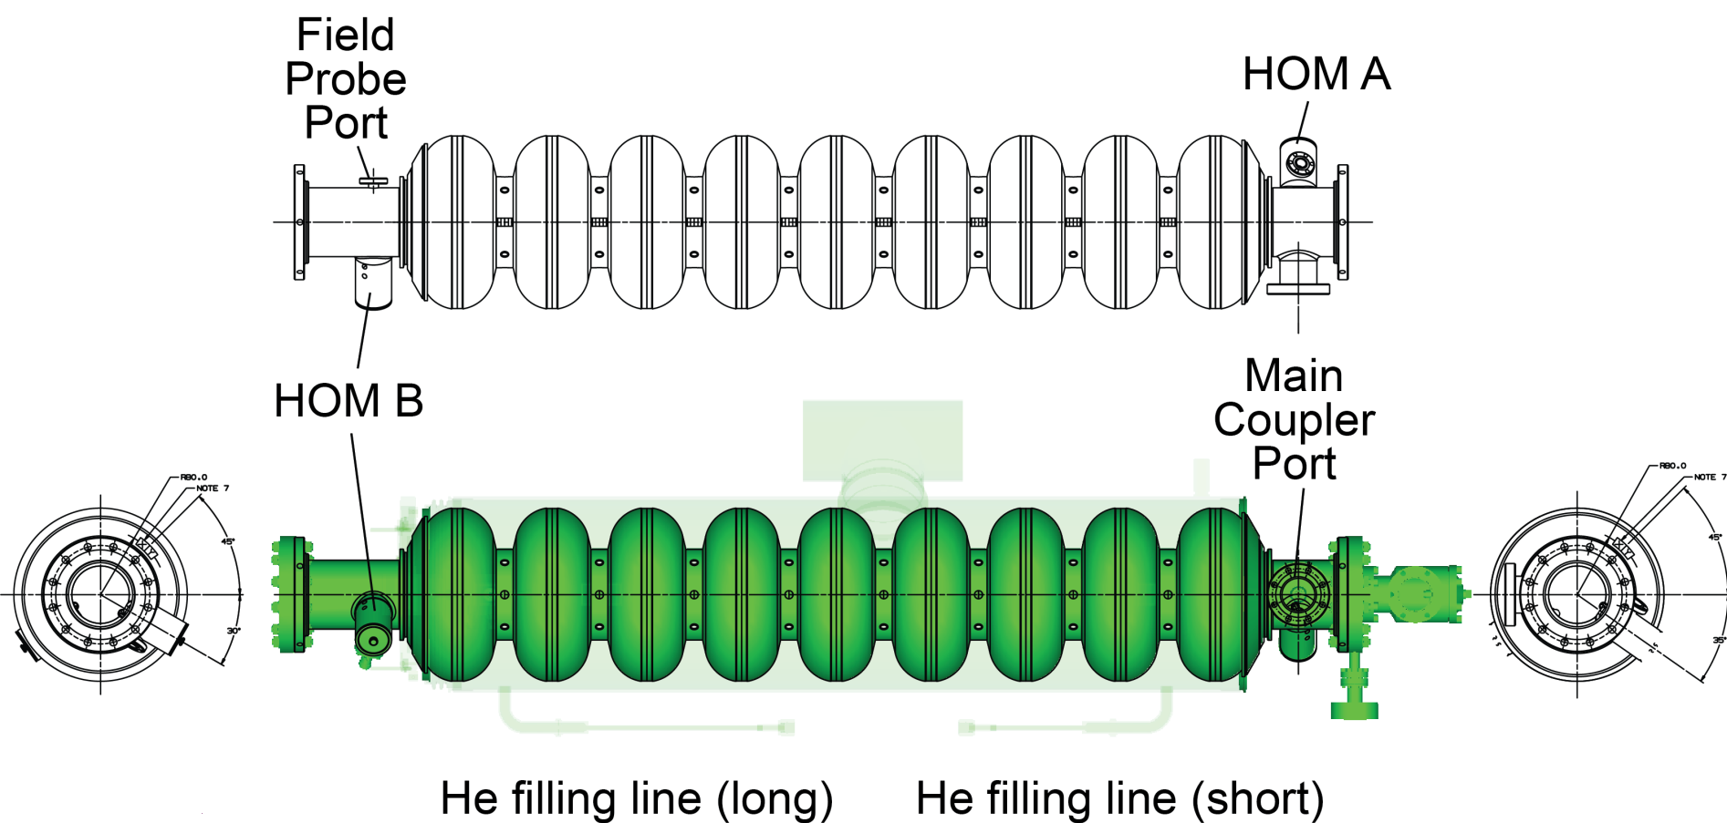

LCLS-II cavities are produced and delivered concurrently by Ettore Zanon, S.p.A. (short: EZ) and RI Research Instruments, GmbH (short: RI). Each LCLS-II production cavity is delivered with a helium vessel under vacuum and at this point has passed 3 acceptance levels (hold points) at the vendor site permitting shipment to JLab (or our partner institute at FNAL). At JLab the cavity must have passed receipt inspection and RF inspection to allow visual and CMM inspection. Vendor drawings of the dressed cavity assembly reflecting the condition at delivery are shown below
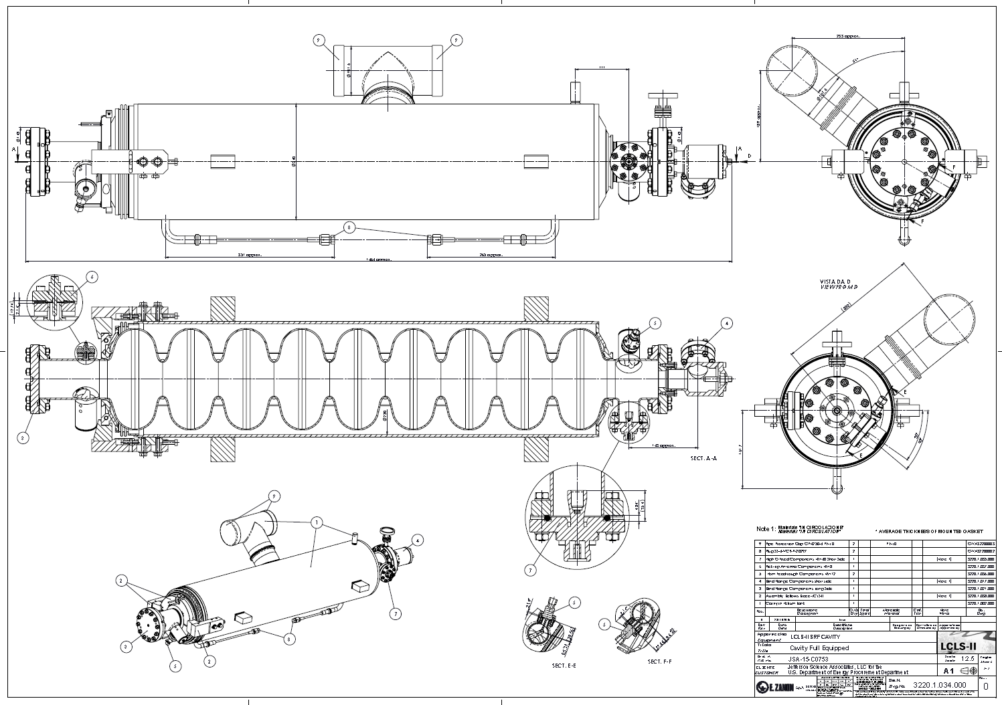
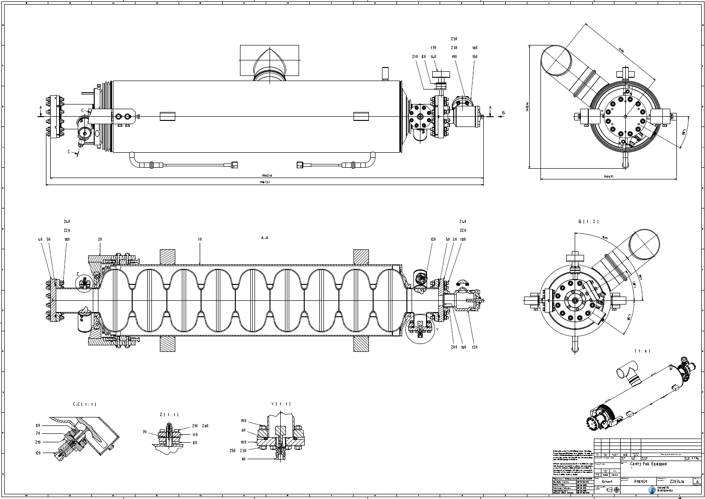

The cavity is mechanically restrained to the helium tank with bellows brackets (two arms) mounted between the tank and the cavity connection flange via the tuner split ring (figure below) on the long beam tube side (bellows side). These brackets are required for pressure testing and whenever the cavity and helium vessel are not under atmospheric pressure (e.g. vacuum leak check, VTA testing), The bellows bracket arms shall not be removed and remain with the cavity until string assembly.

The cavity has been welded to its helium vessel such that the bare cavity cells are not accessible for dimensional control. The cavity and helium vessel were dimensionally and optically inspected by the vendor before shipment to JLab. Upon arrival obvious damages of the shipping box and the cavity are to be checked visually and recorded. The dimensional inspections foreseen as part of this traveler serve as a verification of the vendor data restricted to externally accessible parts.

Note that temporary protection brackets – when installed by vendors - for both the rather thin bellows convolutions as well as both He filling lines may be removed to check the integrity of the components. The He fill line bracket might be attached to the Helium tank by plastic binders or other means, while the protection for the bellow convolutions might be attached to the two bellow restraint arms with screws. See below sketch (from vendor RI) showing a single protection bracket that covers both He filling lines along the Helium tank.

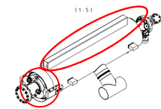

The photo below also shows the protection caps on the 2-phase Helium pipe of the first fully dressed LCLS-II cavities completed by RI and placed in the shipping box.

Step No | Instructions | Data Inputs
1 | Record serial numbers  Inspector Name  Cavity Serial Number  Date of Inspection | [[InspTech]] <<SRFCVP>>  [[InspDateTime]] <<TIMESTAMP>>  [[SerialNumComment]] <<COMMENT>>  [[SNfileupload]] <<FILEUPLOAD>>
 | Cavity | [[CAVSN]] <<CAVSN>>
 | Helium Vessel | [[HELVSN]] <<HELVSN>>
 | Valve | [[AV15SN]] <<AV15SN>>
 | Beam tube flange adapter – short | [[FlangeShortSN]] <<SN>>
 | Beam tube flange adapter - long | [[FlangeLongSN]] <<SN>>
 | Burst Disk | [[PBDSN]] <<PBDSN>>
 | Field Probe | [[FPFTSN]] <<FPFTSN>>
 | HOM Probe – short | [[HMFTASN]] <<HMFTASN>>
 | HOM Probe - long | [[HMFTBSN]] <<HMFTBSN>>
 | Input Coupler | [[NTFTSN]] <<NTFTSN>>

Step No | Instructions | Data Inputs
2 | Configuration Check. Are the following components installed? | [[CMMTechInstall]] <<SRFCVP>>  [[CMMDateTimeInstall]] <<TIMESTAMP>>  [[CMMCommentInstall]] <<COMMENT>>  [[CMMUploadInstall]] <<FILEUPLOAD>>
 | Protective caps on TEE | [[ProtectCapsTEE]] <<YESNO>>
 | Protective caps on helium fill lines | [[ProtectCapsHelFill]] <<YESNO>>
 | Covers on helium lines | [[HeliumLineCovers]] <<YESNO>>
 | Tuner ring | [[TunerRing]] <<YESNO>>
 | Support blocks (4) | [[SupportBlocks]] <<YESNO>>
 | Clamp Pin | [[ClampPin]] <<YESNO>>
 | Bellows restraint brackets | [[BellowRestraintBracket]] <<YESNO>>
 | Bellows covers. | [[BellowCovers]] <<YESNO>>
 | Right Angle Valve in closed position, exposed stem length is approximately 8mm. Measure and record length. | [[RightAngleValve]] <<YESNO>>  [[ValveBoltLength]] <<FLOAT>>

Step No | Instructions | Data Inputs
3 | Damage Check. Are the following components damaged? | [[CMMTechDammage]] <<SRFCVP>>  [[CMMDateTimeDammage]] <<TIMESTAMP>>  [[CMMCommentDammage]] <<COMMENT>>  [[CMMUploadDammage]] <<FILEUPLOAD>>
 | Helium Vessel shell and Tee | [[HELVShell]] <<YESNO>>
 | Helium Vessel Bellows | [[HELVBellows]] <<YESNO>>
 | Helium Vessel Fill line - short | [[HELVFillShort]] <<YESNO>>
 | Helium Vessel Fill line - long | [[HELVFillLong]] <<YESNO>>
 | Support blocks (4) No scratches allowed on top, bottom, or outboard side. | [[SupportBlocks]] <<YESNO>>
 | Field Probe Pin | [[FieldProbePin]] <<YESNO>>
 | HOM Probe Pin and Can - short | [[HOMPinShort]] <<YESNO>>
 | HOM Probe Pin and Can - long | [[HOMPinLong]] <<YESNO>>
 | Burst Disc | [[BurstDisc]] <<YESNO>>
 | Any other damage | [[OtherDamages]] <<YESNO>>

Step No | Instructions |  | Data Inputs
4 | CMM Inspections  Perform dimensional inspections on CMM. Fill out NCR for any out of tolerance measurements. |  | [[CMMTech]] <<SRFCVP>>  [[CMMDateTime]] <<TIMESTAMP>>  [[CMMComment]] <<COMMENT>>
Drawing number | Description | Drawing Value (mm or as noted) | Measured Value | Within Tolerance
F10015802 Rev. C  Sheet 3 of 3 (Weldment, Helium Vessel) | Distance of cavity center line to center line of 2-phase header pipe | 300.0 +0.5 – 1.5 | [[DIM1]] <<FLOAT>> | [[DIMTOL1]] <<YESNO>>
F10015802 Rev. C  Sheet 3 of 3 (Weldment, Helium Vessel) | Parallelism of 2-phase TEE | 1.0 | [[DIM2]] <<FLOAT>> | [[DIMTOL2]] <<YESNO>>
F10023864 Rev. D  Sheet 2 of 3 (Assembly, LCLS-II Production Cavity) | Perpendicularity of main coupler port to helium vessel lugs (support face C) (ref. to F10018181, “PAD, ROLLING”) | 0.5 degrees | [[DIM3]] <<FLOAT>> | [[DIMTOL3]] <<YESNO>>
F10015802 Rev. C  Sheet 3 of 3 (Weldment, Helium Vessel) | Distance between helium vessel lugs (ref. to F10018181, “PAD, ROLLING”), face to face, axially (2x) | 650 ± 1.0 | [[DIM4]] <<FLOAT>> | [[DIMTOL4]] <<YESNO>>
F10015802 Rev. C  Sheet 3 of 3 (Weldment, Helium Vessel) |  | 650 ± 1.0 | [[DIM5]] <<FLOAT>> | [[DIMTOL5]] <<YESNO>>
F10015802 Rev. C  Sheet 3 of 3 (Weldment, Helium Vessel) | Distance between Helium lugs (ref. to F10018181, “PAD, ROLLING”), face to face, radially (2x) | 342 +0.35 – 0.65 | [[DIM6]] <<FLOAT>> | [[DIMTOL6]] <<YESNO>>
F10015802 Rev. C  Sheet 3 of 3 (Weldment, Helium Vessel) |  | 342 +0.35 – 0.65 | [[DIM7]] <<FLOAT>> | [[DIMTOL7]] <<YESNO>>
F10015802 Rev. C  Sheet 3 of 3 (Weldment, Helium Vessel) | Angle of helium vessel lug #1 surface to center plane of 2-phase header pipe | 39 ± 1.0 degrees | [[DIM8]] <<FLOAT>> | [[DIMTOL8]] <<YESNO>>
F10015802 Rev. C  Sheet 3 of 3 (Weldment, Helium Vessel) | Angle of helium vessel lug #2 surface to center plane of 2-phase header pipe | 39 ± 1.0  degrees | [[DIM9]] <<FLOAT>> | [[DIMTOL9]] <<YESNO>>
F10015802 Rev. C  Sheet 3 of 3 (Weldment, Helium Vessel) | Angle of helium vessel lug #3 surface to center plane of 2-phase header pipe | 39 ± 1.0  degrees | [[DIM10]] <<FLOAT>> | [[DIMTOL10]] <<YESNO>>
F10015802 Rev. C  Sheet 3 of 3 (Weldment, Helium Vessel) | Angle of helium vessel lug #4 surface to center plane of 2-phase header pipe | 39 ± 1.0  degrees | [[DIM11]] <<FLOAT>> | [[DIMTOL11]] <<YESNO>>
F10023864 Rev. D  Sheet 2 of 3 (Assembly, LCLS-II Production Cavity) | Location of tuner ring circle | 5 ± 1.0  degrees | [[DIM12]] <<FLOAT>> | [[DIMTOL12]] <<YESNO>>
F10015802 Rev. C  Sheet 2 of 3 (Weldment, Helium Vessel) | Distance between tuner blocks | 272 +0.35 – 0.65 | [[DIM13]] <<FLOAT>> | [[DIMTOL13]] <<YESNO>>

Step No | Instructions | Data Inputs
5 | Magnetic Hygiene Control  Magnetic hygiene check of the helium vessel tee welds shall be conducted in a region with relatively stable ambient field. TLA high bay and rm 1012 are the expected locations to do this. This nominal field is 0.5G in those areas. Follow the following steps:  - Turn on the magnetometer.  - Move probe over Helium vessel Tee and fill line welds/EB joints and note readings.  - If any readings on the welds are greater than 1G (this includes background), the part is magnetic.  - Locations that are magnetic shall be demagnetized.  - Re-measure the demagnetized parts per steps 1-5. | [[MagCheckTech]] <<SRF>>  [[MagCheckDate]] <<TIMESTAMP>>  [[MagNotes]] <<COMMENT>>
 | Record highest reading as found. | [[MagReading1]] <<FLOAT>>
 | Was area de-magnetized? | [[MagYesNo]] <<YESNO>>
 | Final reading if de-magnetized. If final readings are 1G , generate an NCR. | [[MagFinal]] <<FLOAT>>

