|  |  |  |  |
| --- | --- | --- | --- |
| **Procedure Title** | ***SNS-HB Cavity Testing Using VTA RF Test Stand*** | | |
| **Procedure ID** | CP-STP-CAV-VTA-OPS | | |
| **Procedure Description** | Procedure to describe the SNS HB cavity test in the VTA | | |
| **Revision** | R1 | | |
| **Author** | **Sign**: | | **Date**: |
| **Name**: Christiana Wilson | |
| **Reviewer** | **Sign**: | | **Date**: |
| **Name:** Peter Owen | |
| **Approver** | **Sign**: | | **Date**: |
| **Name**: Kirk Davis | |
| **Revision Notes** | *Describe any changes between revisions here.* | | |
| R1: Initial Release converting Procedure  ***SNS-HB Cavity Testing Using VTA RF Test Stand –V1 ( C. Wilson)***  to a numbered STP Procedure | | |
|  | | |
|  | | |
|  | | |
| **References** | *List and Hyperlink all documents related to this procedure.* | | |
| [VTA RWP](https://misportal.jlab.org/railsForms/rad_work_permits/96060/briefing) |  |  | |
| [VTA OSP](https://mis.jlab.org/mis/apps/mis_forms/operational_safety_procedure_form.cfm?entry_id=84078) |  |  | |
|  |  |  | |

SAFETY:

Individual must keep safety as the first priority in the process; before beginning any job, the user must assure they have the correct PPE for the individual job. Maintaining the level of safety and secure nature of the work area is paramount. Assure personal safety by using caution in movement and taking necessary steps to avoid unnecessary personnel in the immediate area. Refer to the work-center OSP for specifics.

**VTA Cavity Testing Using RF Test Stand**

The RF test consists of four parts: Training Related Documentation Overview, Initial Tasks, Cable Calibrations and the High Power RF Test of the Cavity.

**I. Training Related Documentation Overview**

1. Required training: Radiation Worker I.

2. Read the VTA Standard Operating Procedure.

3. Read and sign the Radiation Work Permit.

IF AT ANY TIME THE RF TEST GOES BEYOND THE SCOPE OF THIS DOCUMENT

CONTACT THE VTA FACILITY MANAGER FOR GUIDENCE.

**II. Initial tasks**

Initial tasks are performed next to the Dewar using a network analyzer and a calibrated power meter on a cart.

1. Zero and calibrate the power meter located by the network analyzer.
2. Perform HOM Survey and find cavity passbands.
3. Turn on the Helium flow on the FPC cable.

# **III. Cable Calibrations**

1. Record the following information in the logbook:

* Operator name and date.
* Dewar number and top plate id number (found etched in the metal on top hat or as a sticker on the Dewar top plate.
* Cavity vacuum pressure measured at Dewar in mbarr.(found on vacuum gauge controller on top plate of Dewar)
* He pressure in Torr (at Dewar cryo control system Baratron indicator)
* He liquid level in centimeters . (found on touch screen at Dewar cryo control)
* Dewar temperature in Kelvin (convert using table below), the cavity should be at 2K.

|  |  |
| --- | --- |
| **Dewar Helium Pressure (TORR)** | **Dewar Temperature (K)** |
| 23.08 | 1.99 |
| 23.77 | 2.00 |
| 24.47 | 2.01 |
| 25.19 | 2.02 |
| 25.92 | 2.03 |
| 26.66 | 2.04 |
| 27.42 | 2.052 |
| 28.20 | 2.06 |
| 28.98 | 2.07 |
| 29.78 | 2.08 |
| 30.60 | 2.09 |
| 31.43 | 2.10 |
| 32.27 | 2.11 |
| 33.13 | 2.12 |
| 34.00 | 2.13 |
| 34.88 | 2.14 |
| 35.78 | 2.15 |
| 36.69 | 2.16 |
| 37.61 | 2.17 |
| 38.55 | 2.18 |
| 39.50 | 2.19 |
| 40.46 | 2.2 |

1. Verify the RF ENABLE ON/OFF switch is OFF.
2. Run the LabVIEW program named **VTA_main.vi**.
3. A window will appear as shown in figure 1:

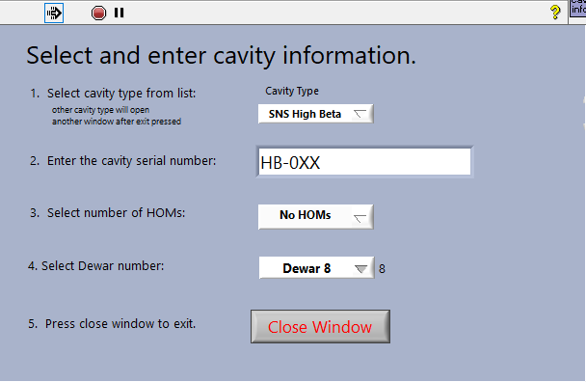

**Figure 1.**

* Select the cavity type from the list matches and displays the square root (R/Q)/L of the cavity under test.
* The cavity serial number can be determined from the white board just outside the VTA. The data file name will be determined by the cavity serial number. If more than one test has been conducted, the data file name will be the cavity serial number with an uppercase letter appended to the end of it.
* No HOM probes are installed on SNS cavities.
* Select Dewar number where the cavity under test is inserted.
* When all the information is filled in, press the CLOSE button to continue to the main RF testing screen.

1. Zero the power meters by clicking the red button labeled Zero Pwr Meters.
2. Verify RF off cavity resonance before continuing.
3. Run the cable calibration program by clicking the red button labeled Calibrate Cables.
4. Refer to Appendix A for complete cable calibration instruction.

**IV. High Power RF test of Cavity**

1. Preparations for High Power Cavity Testing
   1. Verify Dewar shield is closed.
   2. Notify all personnel working in test area that a high power RF test is about to begin. Verify they are wearing dosimetry and have been trained on the current VTA RWP.
   3. In the VTA Operational Safety Log Book enter: date, cavity name, operator name and Dewar number.
   4. Post VTA as a Radiation Area and the VTA Control Room as an Radiation Area per instructions in Radiation Worker Permit (RWP) document.
   5. At the PSS system panel, move the key from disable to enable position and press Dewar under test square grey icon so it is red.
   6. In the software, set Attn slide switch to 40db.
   7. Turn on high power amplifier located in test area.
   8. Turn high power RF on by moving the RF switch on the RF Monitor chassis from OFF to ON.
   9. Verify the cavity is not locked, by check transmitted power meter is reading in the picowatt range.
2. Dissipated Power Measurement (may be repeated at any time)
   1. In software, set Qext2 > 100. (There are two modes for measuring Qext2: CW mode is selected whenever the entered value for Qext2 > 100; decay mode is selected whenever the entered value for Qext2 <= 100)
   2. Set the attenuation slider switch such that the cavity incident power level is between ~ 1-3W.
   3. Click ‘Measure and Log’ button in the software.
   4. Verify the ­Ploss/Pincident ratio is less than 0.003.
      1. If it is not, redo the Forward Power Into Detuned Cavity Step in the cable calibration routine, using the high power amplifier set between ~1-3W.
      2. Repeat the Dissipated Power Measurement.
      3. If the ratio is not less than 0.003,turn high power off. Check cable connections at the Dewar. and repeat steps b – d. Changing cables or tightening connectors may require at least a partial cable calibration.
   5. Once Ploss/Pincident ratio is less than 0.003, the dissipated power measurement is complete.
3. Initial Cavity Tuning
   1. Verify transmitted power crystal signal and reflected power crystal signal are connected to the oscilloscope.
   2. In the software, switch to the ‘live numbers’ read back tab. The software will report the most recent power levels.
   3. Click on the software button labeled ‘Set Mixer Level’.

Set Mixer Level adjusts the variable attenuator control voltage so the transmitted power crystal detector voltage is within the crystal voltage range.

* 1. Using the phase knob on the LabView screen to tune the cavity to the center frequency.
  2. Press Optimize Phase button to get finer phasing using the FCC.
  3. Write the cavity frequency and the Baratron Dewar pressure in the log book.

1. Measure Cavity Coupling
   1. On the scope, decrease the volts/division for the reflected power signal until the trace reads above zero.
   2. Set the horizontal time scale for 2 seconds.
   3. Tune the cavity and set attenuator slide switch to provide enough power to measure transmitted power on the crystal detector connected to the oscilloscope. Power level should be less than 10W.
   4. Using the RF ON/OFF switch on the chassis, turn RF OFF and watch the Pt power decay on the scope. When it is decayed, turn RF ON. The scope will display a decay shape on reflected power, press the stop/run button on the scope to stop scrolling and freeze the screen.
   5. The shape of the reflected power signal during the decay indicates the cavity coupling. An example of the overcoupled, undercoupled and critically coupled cavity pulse shape can be found below. Note the relative amplitude of reflected power peaks when RF power on vs. RF power off.
   6. If the cavity appears to be critically coupled, watch the Pref  power meter during the RF power off transition. If the reflected power dips below average minimum power and returns to minimum power, the cavity is overcoupled. Refer to Figure 2 Cavity Overcoupled B>1 as an example. This phenomenon is exaggerated in Figure 2 and can only be seen by watching the Pref power meter.

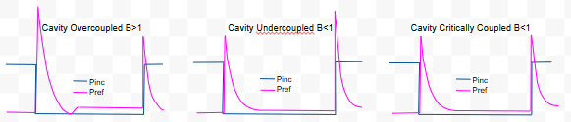

**Figure 2.** Examples of oscilloscope traces for overcoupled, undercoupled and critically coupled cavities. Note the relative amplitude of reflected power peaks when RF power on vs. RF power off.

* 1. Write down the coupling in the log book.
  2. In software, set B switch to B > 1 or B < 1 based on the results of this measurement.

1. Qext2 Measurement

If field emission is greater than 0.01mR/hr, do not measure Qext2. It will not be accurate.

* 1. In software, click the button labeled Set Mixer Level and then Optimize Phase.
  2. In software, set Qext2 <= 100. “Decay measurement” will appear on the screen.
  3. Detune the cavity by setting SEL to OPEN, press ‘Decay 100% to 95%’ button.
  4. Tune the cavity and set attenuator slide switch to 1W.
  5. Press ‘Decay 100% to 95%’. The RF system will perform a decay measurement.

A window will appear which displays the decay curve. Close the window to return to the main VI.

* 1. Perform three or more decay measurements and verify that three of the measurements have similar values.
  2. Press the button labeled Click to Update Qext2. Scroll through the decay measurements and select one which represents the average values measured. This is the Qext2 that will be used in the main VI to calculate gradient.
  3. In the logbook, write down in table format:

Eacc, Q0, Qext1, Qext2, Qext2 % error, Tau and radiation.

1. Qo versus Eacc Cavity Performance Measurement

The test will capture data for Qo versus Eacc, Radiation versus Eacc and frequency versus Eacc^2 curves.

1. Starting at 1.5MV/m, press the button labeled Optimize Phase.
2. Press the button labeled Click to Update Lorentz on the main VI.
3. In the left tab labeled Autostep, press the button labeled Click to Run Auto Step.
4. The Autostep algorithm will decrement the attenuation slider control such that gradient changes by the value entered in the Step Size control.
5. Multipacting Processing

The SNS cavities have a multipacting barrier that is theoretically between 8 – 14MV/m.

When the barrier is reached, field emission will increase dramatically and multipacting induced quenching will occur.

* To process through the barrier, increase the incident power until the multipacting induced quenching occurs.
* Sit at the gradient until the current portion of the barrier is processed. As each portion of the barrier is processed, increase the power to continue processing through the barrier.
* While processing, keep the field emission below 10R/hr and the incident power below 100W. It should be noted that the multipacting barrier can return after processing through the first time.
* After processing through the first time, incrementally reduce power to verify the cavity no longer has the barrier.

1. Check the following conditions:
   * + - the CW measurement of incident power is below 100W to avoid overheating cables
       - the CW measurement of Dewar radiation is below 20mR/hr
       - the cavity is not quenching

Turn off high power using the manual switch and turn off Autostep if any of the above conditions are not met.

1. Record gradient when onset of field emission occurs.
2. The test is completed when the cavity becomes limited, and RF processing is ineffective.

Limits include: quench, radiation, multipacting.

1. If required, perform Qo versus Eacc in all other modes or temperatures.
2. When the cavity performance measurements are complete:
   1. In the control room, turn off high power.
   2. In the high bay turn off the high power amplifier.
3. In the software, press ‘backup files’. A copy of the log file will be placed on the network at:

O:\srfee\LabVIEWData\VTACavityTest.

The subfolder is dependent on the frequency of the cavity.

1. At the PSS System panel. Press the red icon for the Dewar used in the test so it turns grey.
2. If no other Dewar is being used for high power testing, switch the PSS system to the disabled state with the key.
3. Open the Dewar lid.
4. If no other testing is taking place, flip down the radiation warning signs posted in Step 1.
5. Fill out the cavity performance traveler.

**Appendix A**

**Step 1 Reflected Power from VTA**

A. Verify RF Power off in control room.

B. Measure network analyzer power out (cable GH ) using power meter.

(for S21 configuration measure network analyzer power out at port 1)

Write down the measured network analyzer power out in logbook.

C. At Dewar, connect cable GH to cable AB as shown in figure 1a.

D. In cable calibration VI, click button labeled 'Reflected Power From VTA'

E. A pop-up will appear, enter the network power out (from Step 1.B, above) in the yellow highlighted field.

Click Done button when finished.

F. Disconnect cable GH from cable AB.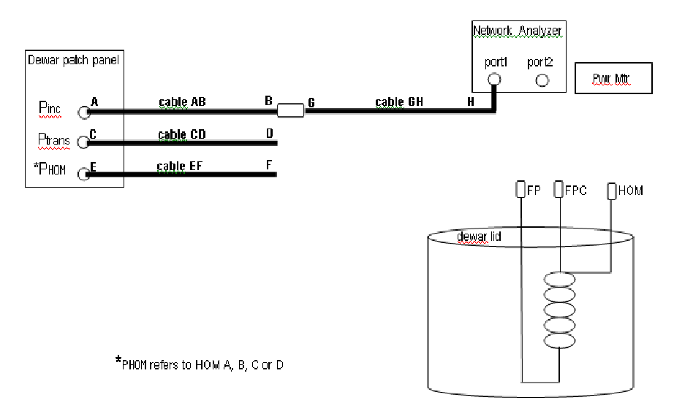

**Figure 1a.** Connect cable AB to cable GH to measure the reflected power from VTA.

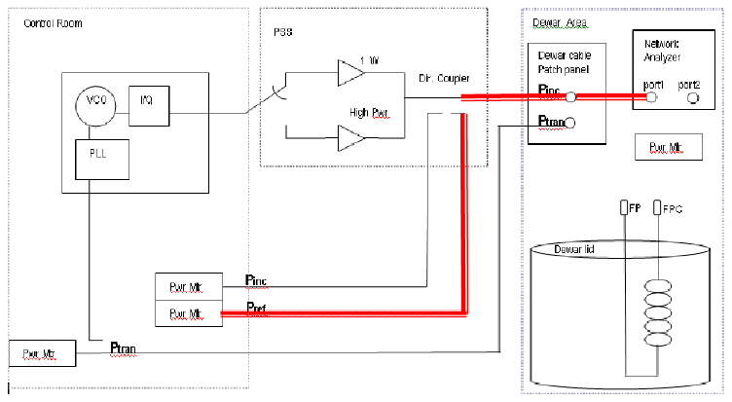

**Figure 1b.** Block diagram representation of ‘reflected power from VTA’ cable calibration step.

**Step 2 Incident power measured at Dewar.**

A. Connect cable AB to power meter cable as shown in Figure 2a.

B. Turn low power RF on in control room. RF ENABLE ON, RF ON and AMP set to LO.

C. In cable calibration VI, set Atten to 20dB using slide control.

Set frequency = Pi mode frequency + 50KHz using corse/fine knobs on transmit phase detector module.

D. At Dewar, write down measured power on cable AB.

E. In cable calibration VI, click button labeled 'Pi @ Dewar'.

F. A pop-up screen will appear, enter the Pi measured at the Dewar from Step 2D, above. Click Done button when finished.

G. Turn RF Power off in control room. RF ENABLE OFF and RF OFF.

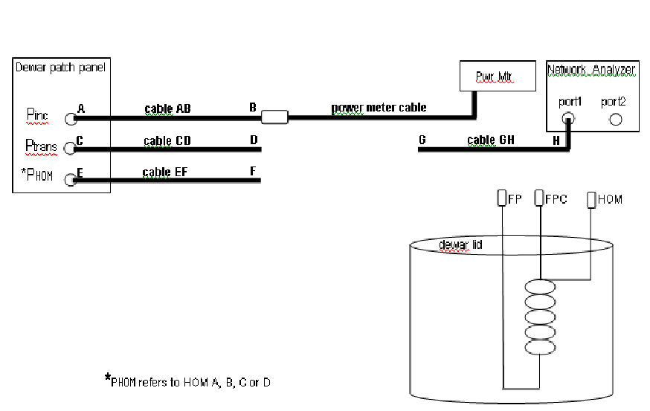

**Figure 2a.** Connect cable AB to cable GH to measure the reflected power from VTA.

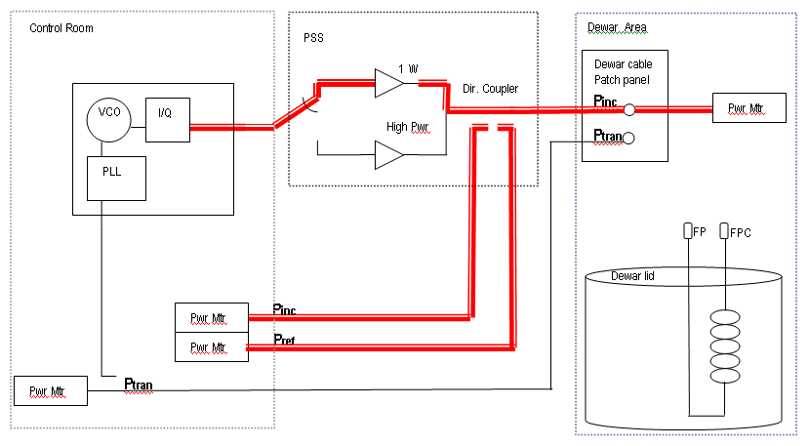

**Figure 2b.** Block diagram representation of ‘incidentpower measured at Dewar’ cable calibration step.

**Step 3 Ptrans to control room**

A. At Dewar, connect cable CD to cable GH as shown in Figure 3a.

B. In cable calibration VI, click button labeled 'Transmitted Power Into Control Room.

C. A pop-up screen will appear, enter the network analyzer power out measured in step 1B. Click Done button when finished.

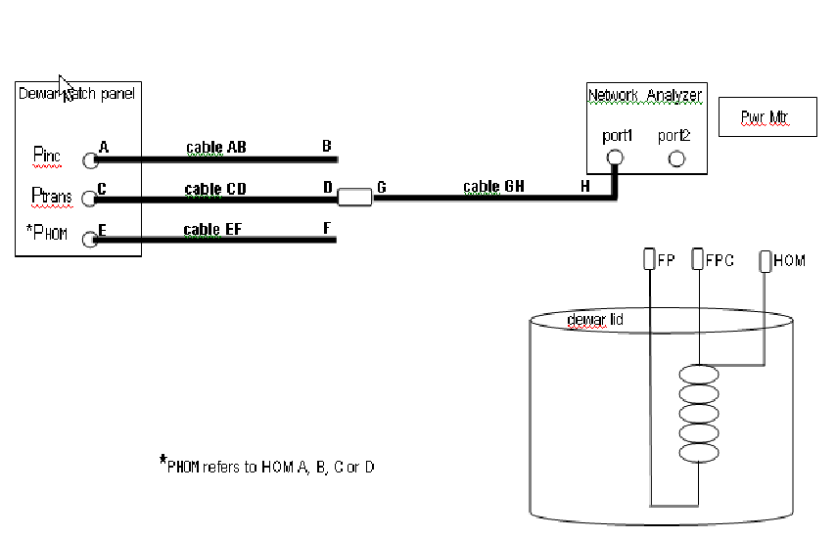

**Figure 3a.** Connect cable CD to cable GH to measure the transmitted power to control room.

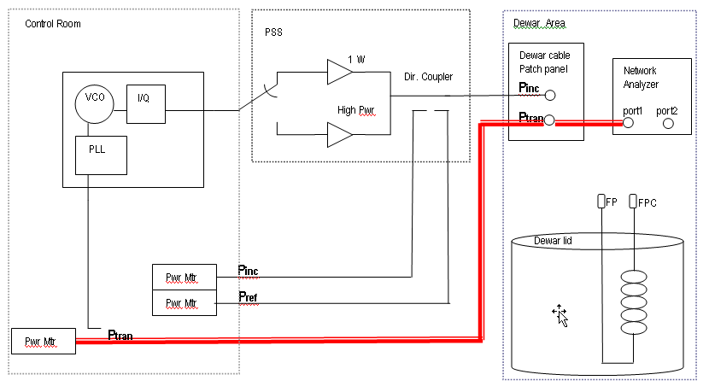

**Figure 3b.** Block diagram representation of ‘transmitted power to control room’ cable calibration step.

## Step 4 Transmitted Cable Return Loss

A. At Dewar, connect circulator ports 1, 2, and 3 as shown in figure 4a:

1 - Cable GH

2 - Calibrated open connector.

3 - Power meter sensor.

B. Write down the measured power in the logbook.

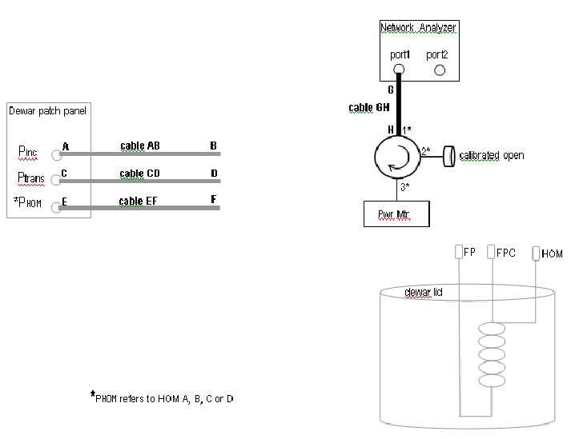

**Figure 4a.** **Cable GH, calibrated** open and power meter connected to circulator for ‘Transmitted Cable Return Loss ’ open measurement.

**Step 4 continued**

C At Dewar, connect circulator ports 1, 2, and 3 as shown in figure 4b:

1 - Cable GH

2 - Cavity field probe (FP) connector

3 - Power meter sensor.

D. Write down the measured power in the logbook.

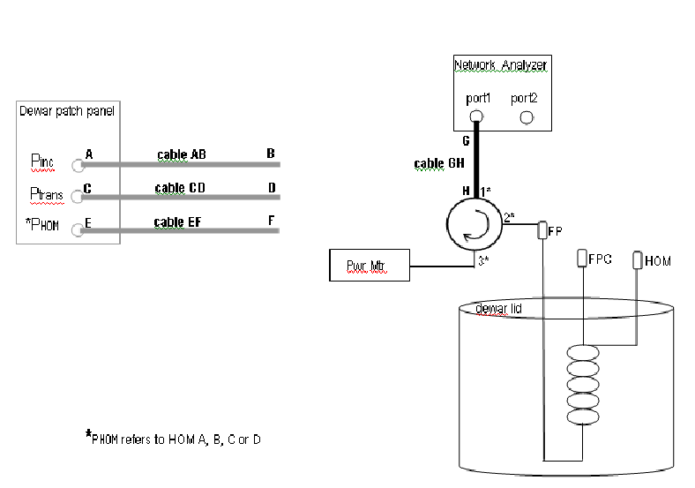

**Figure 4b.** Cable GH, cavity field probe (FP) and power meter connected to circulator for ‘Transmitted Cable Return Loss ’ field probe measurement.

E. In cable calibration VI, click button labeled 'Transmitted Cable Return Loss'.

F. A pop-up screen will appear, enter the open (Step 4B) and field probe (Step 4D) power measurements.

Click Done button when finished.

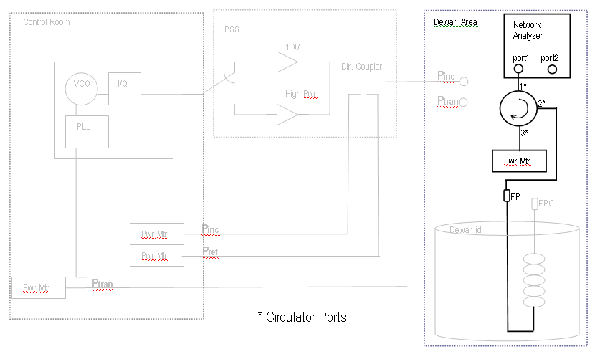

**Figure 4c.** Block diagram representation of ‘transmitted cable return loss’ field probe cable calibration step.

**Step 5 Fwd Pwr to detuned cavity**

1. Connect all cables from Dewar patch panel to Dewar as shown in figure 5a:

- cable AB to Fundamental Power Coupler [FPC] port

- cable CD to Field Probe [FP] port

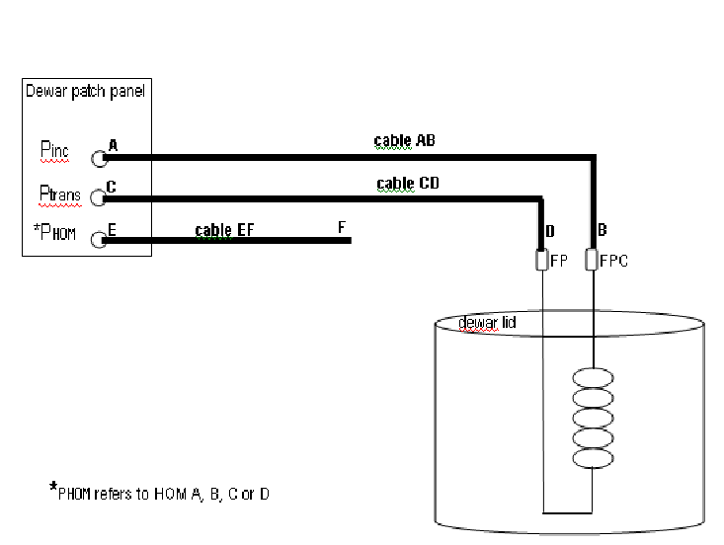

**Figure 5a.** Cable AB to Fundamental Power Coupler (FPC) port and Cable CD to Field Probe (FP) port for ‘forward power to detuned cavity’ cable calibration step.

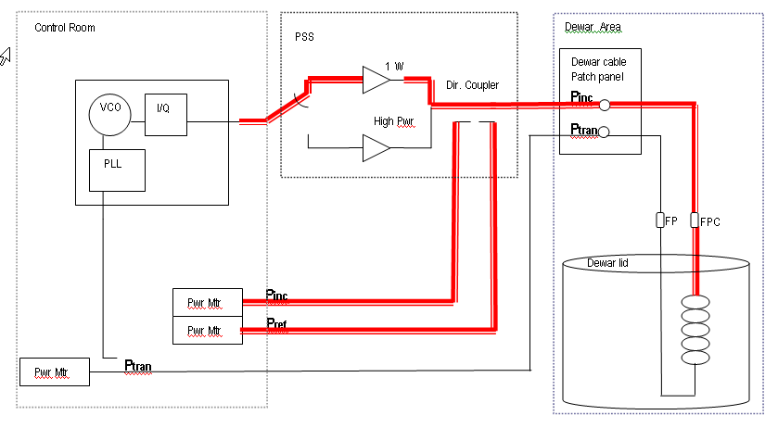

**Figure 5b.** Block diagram representation of ‘Forward Power to detuned cavity’ cable calibration step.

1. Clear area and close Dewar lid.
2. Turn low power RF on. In cable calibration VI, set Atten to 20dB using slide control.
3. Adjust frequency to be off resonance.
4. Verify Pt power meter reads ~ 0W.
5. In cable calibration VI, click button labeled 'Foward Power into Detuned Cavity'.
6. A pop-up screen will appear and quickly disappear without any operator interaction.
7. Turn RF power off.
8. Upon completing the cable calibration, click the button labeled ‘DONE’ in the cable calibration VI.
9. A window will open to display the difference between the current calibration and the last calibration performed in the Dewar. Percent difference = (10^(difference/10) – 1)*100

|  |  |
| --- | --- |
| Difference (dB) | Percent Difference |
| 0.01 | 0.23 % |
| 0.03 | 0.69 % |
| 0.05 | 1.16 % |
| 0.07 | 1.62 % |
| 0.10 | 2.33 % |
| 0.30 | 7.15 % |
| 0.50 | 12.2 % |
| 0.70 | 17.5 % |
| 1.00 | 25.9 % |
| 2.00 | 58.5 % |

Good calibrations will have a difference of 0.05 dB or less, provided that no cables have been replaced.

1. Click on the button labeled ‘done’ to exit the calibration comparison window.
2. A window will appear requesting the operator to replace or cancel overwriting the cable calibration file. Select replace to write the new calibration data to the calibration file. Partial calibration values can be written to the file without overwriting existing calibration data. Select cancel to skip writing the new calibration data to the calibration file.
3. The main VI will be displayed. The calibration is finished.
4. Write down the power meter correction factors from the 6_VTA_main.vi screen. They are displayed in the *PM corr fac* cluster as Ci, Cr and Ct.